Biodiversity Net Gain (BNG) Exemption Statement
For:
demolition of existing jet wash and redevelopment to provide a ‘food to go’ pod, new bin store, car parking and all other associated works

Planning Reference:
25/00932/FUL

At:
Littleborough Service Station , Church Street, Littleborough, OL15 8JA

Completed By:
JMS Planning

Date of Exemption Statement Completion:
01/10/2025

- Article 7 (‘General requirements: applications for planning permission including outline planning permission’) of Part 3 of The Town and Country Planning (Development Management Procedure) (England) Order 2015, as amended by Regulation 5 of Part 4 of The Biodiversity Gain (Town and Country Planning) (Modifications and Amendments) (England) Regulations 2024 has introduced national validation prerequisites for planning applications relating to Biodiversity Net Gain (BNG).

- Schedule 14 of the Environment Act 2021 introduced the concept of BNG into planning legislation, stating that “the biodiversity gain objective is met in relation to development for which planning permission is granted if the biodiversity value attributable to the development exceeds the pre-development biodiversity value of the onsite habitat by at least [10%]”.

- Schedule 14 of the Environment Act 2021 additionally mandates that biodiversity gain objectives will be achieved through the imposition of planning conditions, thus constituting a post-permission process.

- However, certain types of development for which planning permission is required are exempt from biodiversity net gain requirements and planning conditions. These are outlined in The Biodiversity Gain Requirements (Exemptions) Regulations 2024

- The development proposals for this application meets the following exemption criterion from the Regulations (reference wording from the Regulations):
De minimis

- State how this application meets the exemption criterion stated above (see worked example for reference):
Section 4 of The Biodiversity Gain Requirements (Exemptions) Regulations 2024, also known as the “de minimis exemption”, states the following: The biodiversity gain planning condition does not apply in relation to planning permission for development which: (Condition 1) does not impact an onsite priority habitat, and (Condition 2) impacts less than 25 square metres of onsite habitat that has a biodiversity value greater than zero; and less than 5 metres in length of onsite linear habitat.
The proposed development meets Conditions 1 and 2 of Section 4 of The Biodiversity Gain Requirements (Exemptions) Regulations 2024.

- Provide aerial imagery / photographs (or alternative sources), plans and captions to evidence your statement. For example, you may wish annotate images to show how the proposed development sits within the existing site/habitats, and how the proposals accord with the exemption claim. Add more photographs, plans or imagery of proposals if necessary.
Aerial imagery:
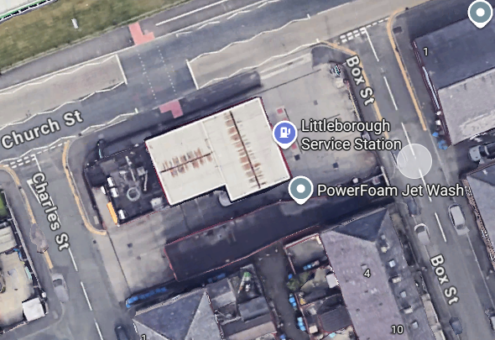

- Whilst the development may be exempt from statutory Biodiversity Net Gain (BNG) requirements, the application for planning permission will deliver measurable net gains for nature conservation which are proportional and locally appropriate, in the following ways:

The Biodiversity Gain Requirements (Exemptions) Regulations 2024: https://www.legislation.gov.uk/uksi/2024/47/made/data.pdf

