FULL PLANNING CONSENT APPLICATION FOR A GRADE II LISTED BUILDING

Erection of a single storEy rear extension/self-contained dwelling with glass link to existing house

1 Moorgate East Farm
Burnedge
Rochdale
OL16 4QL

SUPPLEMENTARY INFORMATION FOR AN APPLICATION FOR APPROVALS OF DETAILS RESERVED BY CONDITION

Prepared By Mark Herring Of Clear Architectural Services

On Behalf Of

Julian McBride

CM336

Version | 1
Author | Mark Herring | 20th October 2025
Checked | Julian McBride | 20th October 2025

CONTENTS

- Application Description

2.0 Details For Conditions

3.0 Conclusion

1.0 Application Description

The application relates to the following applications for approval of detail reserved by a condition:

- Application number 25/00860/DOC to submission of details to comply with condition 3 (stone sample panel), condition 4 (timber bi-fold doors detail and timber casement window details), condition 5 (fascia, soffit and gutter details), condition 6 (conservation roof window), condition 7 (glass link) and condition 8 (well retention) of planning permission 23/00894/LBC
- Application number 25/00861/DOC to submission of details to comply with condition 3 (stone sample panel), condition 4 (timber bi-fold doors detail and timber casement window details), condition 5 (fascia, soffit and gutter details), condition 6 (conservation roof window), condition 7 (glass link) and condition 8 (well retention) of planning permission 23/00893/HOUS.

2.0 Details For Conditions

Condition 3 for both applications requests the viewing of a stone sample panel and materials that are to be used for the opening surrounds. The new building is required to be constructed of materials that are the same or very similar to the host building. The new building will be constructed from locally sourced stone with lime mortar to match the host property. It is deemed that by nature of this requirement the existing building provides the sample.

The surrounds will be detailed so that they mirror the details used on the host dwelling albeit newer and less weathered.

The mortar will be NHL 3.5 Old White Ionic Washed Sherbourne yellow fine sand with a Washed Nosterfield grit. 3 fine2 grit 2 lime for pointing as used elsewhere on the host property.

The applicant has completed previous restoration work to the property to rectify rendering work completed by a previous owner of the property. The images below chart how the work has been executed sympathetically to the building.

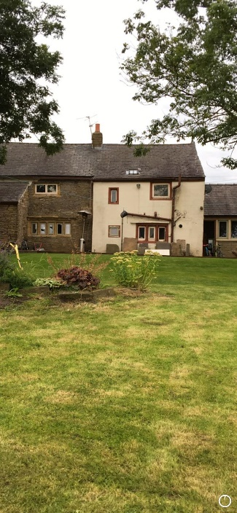
Picture 1. Image of part of the rear elevation with render applied

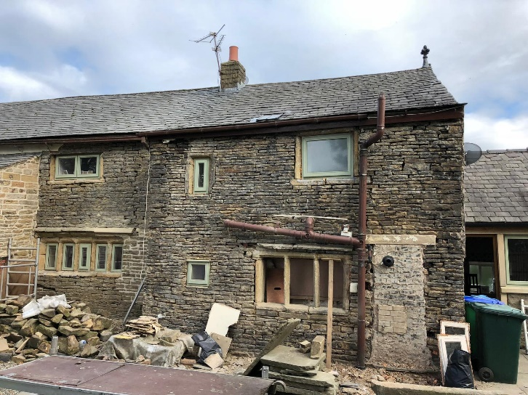
Picture 2. Image of part of the rear elevation with render removed.

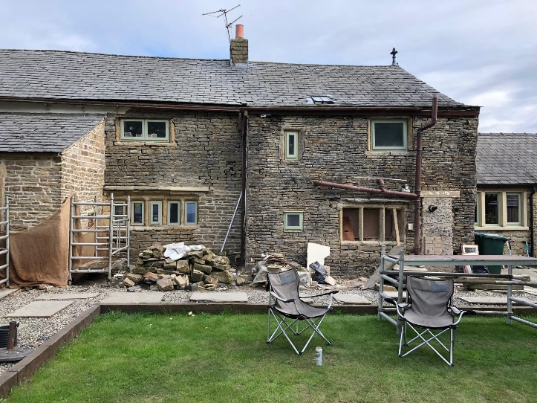
Picture 3. Image of part of the rear elevation with render removed.

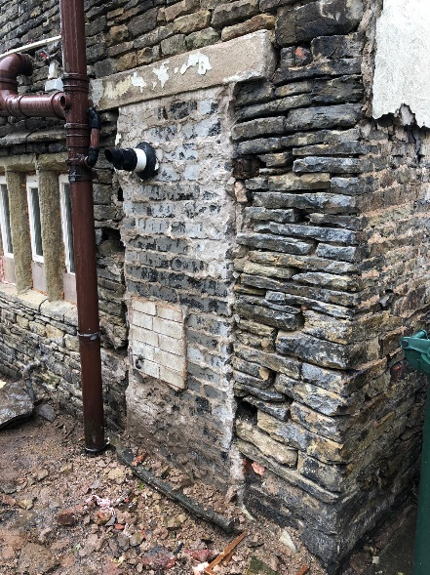
Picture 4. Image of part of the rear elevation with render removed showing an opening blocked with blue engineering brick.

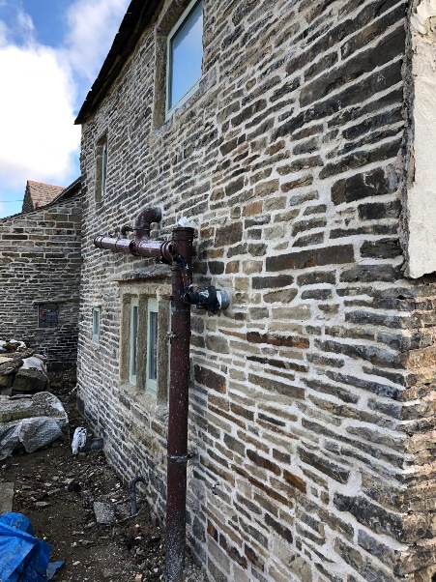
Picture 5. Image of the completed restoration work.

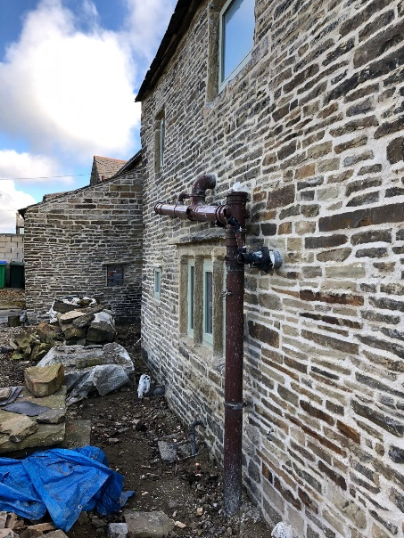
Picture 6. Image of the completed restoration work.

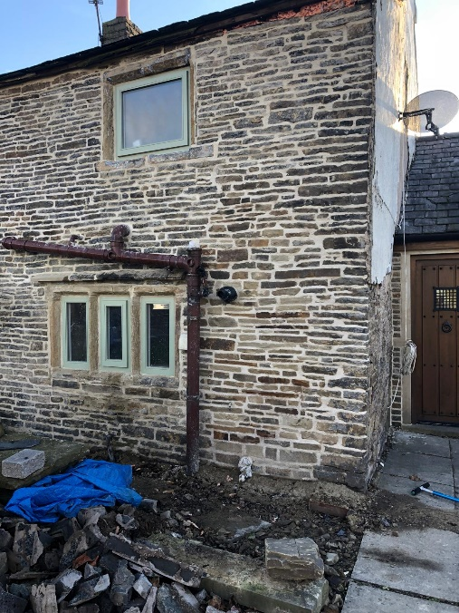
Picture 7. Image of the completed restoration work.

The slate will match the existing building and will be Welsh Natural Penrhyn Heather Blue Slate.

https://www.welshslate.com/roofing/penrhyn-welsh-slate-roofing/
https://www.welshslate.com/roofing/gallery/

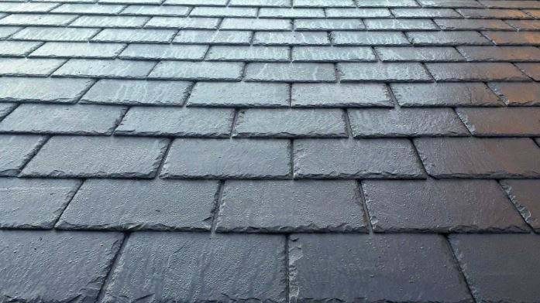
Picture 8. Image Of Welsh Natural Penrhyn Heather Blue Slate


Picture 9. Image Of Welsh Natural Penrhyn Heather Blue Slate

3.0 Conclusion

The images for the stone and mortar indicate a larger area than the 1m x 1m sample panel requested by the local planning authority and provide better representation of materials to be used on the new building. The local planning authority have been provided with the evidence and information required to discharge the conditions.

