Biodiversity Net Gain (BNG) Exemption Statement
For:
The addition of a two storey extension to an existing care home.

Planning Reference:
PP-14358237

At:
Thames house Care Home, Thames Street, Rochdale, OL16 5NY

Completed By:
Northmill Associates on behalf of Exemplar

Date of Exemption Statement Completion:
03.10.2025

- Article 7 (‘General requirements: applications for planning permission including outline planning permission’) of Part 3 of The Town and Country Planning (Development Management Procedure) (England) Order 2015, as amended by Regulation 5 of Part 4 of The Biodiversity Gain (Town and Country Planning) (Modifications and Amendments) (England) Regulations 2024 has introduced national validation prerequisites for planning applications relating to Biodiversity Net Gain (BNG).

- Schedule 14 of the Environment Act 2021 introduced the concept of BNG into planning legislation, stating that “the biodiversity gain objective is met in relation to development for which planning permission is granted if the biodiversity value attributable to the development exceeds the pre-development biodiversity value of the onsite habitat by at least [10%]”.

- Schedule 14 of the Environment Act 2021 additionally mandates that biodiversity gain objectives will be achieved through the imposition of planning conditions, thus constituting a post-permission process.

- However, certain types of development for which planning permission is required are exempt from biodiversity net gain requirements and planning conditions. These are outlined in The Biodiversity Gain Requirements (Exemptions) Regulations 2024

- The development proposals for this application meets the following exemption criterion from the Regulations (reference wording from the Regulations):
Section 4 of The Biodiversity Gain Requirements (Exemptions) Regulations 2024, also known as the “de minimis exemption”, states the following: The biodiversity gain planning condition does not apply in relation to planning permission for development which: (Condition 1) does not impact an onsite priority habitat, and (Condition 2) impacts less than 25 square metres of onsite habitat that has a biodiversity value greater than zero; and less than 5 metres in length of onsite linear habitat.
The proposed development meets Conditions 1 and 2 of Section 4 of The Biodiversity Gain Requirements (Exemptions) Regulations 2024.

- State how this application meets the exemption criterion stated above (see worked example for reference):
The site does not contain any priority habitats listed under the Government’s List of priority habitats and species in England (‘Section 41 habitats and species’) for public bodies, landowners and funders to use for biodiversity conservation, a copy of which can be found at the following website: https://www.gov.uk/government/publications/habitats-and-species-of-principal-importance-in-england
The proposed extension is less that 25m² and will be constructed on land partially occupied by hardstanding paved surfaces and grass.
As a result, the proposed development is exempt from biodiversity net gain requirements and planning conditions under the de minimis rule of Section 4 of The Biodiversity Gain Requirements (Exemptions) Regulations 2024.

- Provide aerial imagery / photographs (or alternative sources), plans and captions to evidence your statement. For example, you may wish annotate images to show how the proposed development sits within the existing site/habitats, and how the proposals accord with the exemption claim. Add more photographs, plans or imagery of proposals if necessary.
Aerial imagery:
Photograph 1: Existing site Photograph 2: Location of proposed extension.
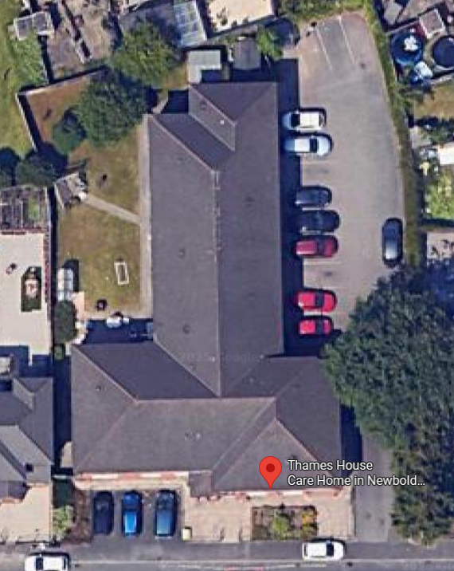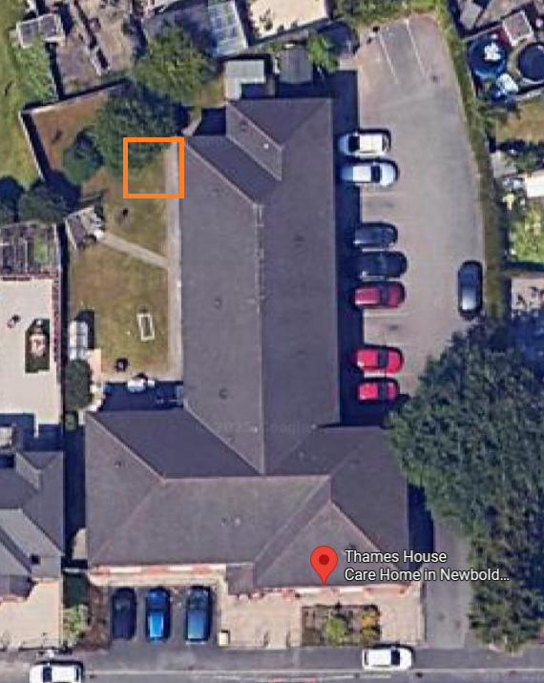

- Whilst the development may be exempt from statutory Biodiversity Net Gain (BNG) requirements, the application for planning permission will deliver measurable net gains for nature conservation which are proportional and locally appropriate, in the following ways:

- Due to the small nature of the proposal, we do not believe this is relevant.

The Biodiversity Gain Requirements (Exemptions) Regulations 2024: https://www.legislation.gov.uk/uksi/2024/47/made/data.pdf

