Application PP-13360151
8 Middle Newgate, Calderbrook Road, Littleborough, OL15 9NU

Summary of Proposed Works:

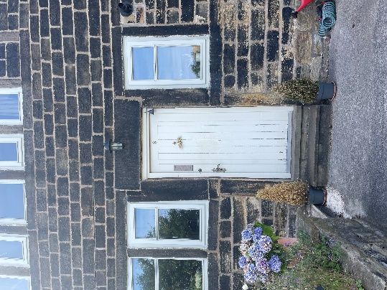 | Replace of timber door on the front elevation facing southeast with a new timber door as indicated on the photograph (left). The door is to replaced with a Accoya Wood finished with in Off White – Farrow and Ball Wimborne White or similar.  Indicative door elevation below:  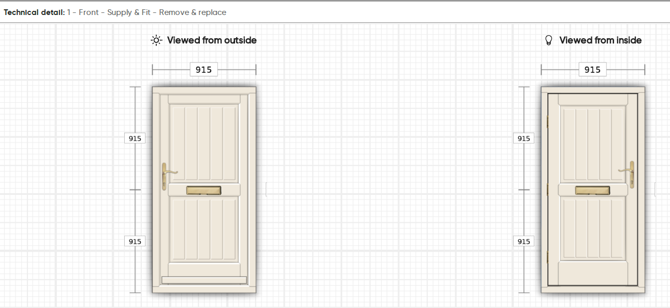
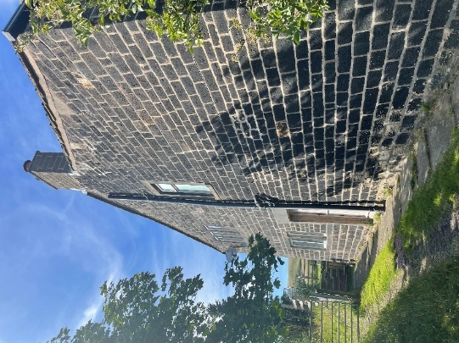  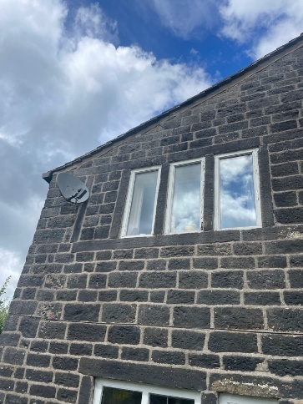 | Replacement of three windows on the first floor side elevation facing southwest and as indicated on the photograph (left).  The windows will be replaced with Accoya Wood and finished in Off White – Farrow and Ball Wimborne White or similar. Double glazing to be fitted to the frame (14mm max) with black spacers.  The windows would consist of one opening casement window and two fixed non-opening windows.  Indicative window elevations below:  