

Top O’th Meadow Farm
Meadowhead Lane
Norden, Rochdale
OL11 5UL
Tel: 01706 658771

5th October 2025

Martin Maders
Hopwood Hall College, Middleton Campus
Rochdale Road, Middleton
M24 6XH

As requested, please see the completed tree report, as discussed this offers no guarantees as trees are living organisms and can fail at any time. We would also like to advise that no indemnity or insurance cover is offered. This report is in “my opinion” only and covers only the trees that have been inspected.

Trees in question are subject to a Tree preservation order – TPO050

Local authority: Rochdale

Location
Hopwood Hall College, Middleton Campus.

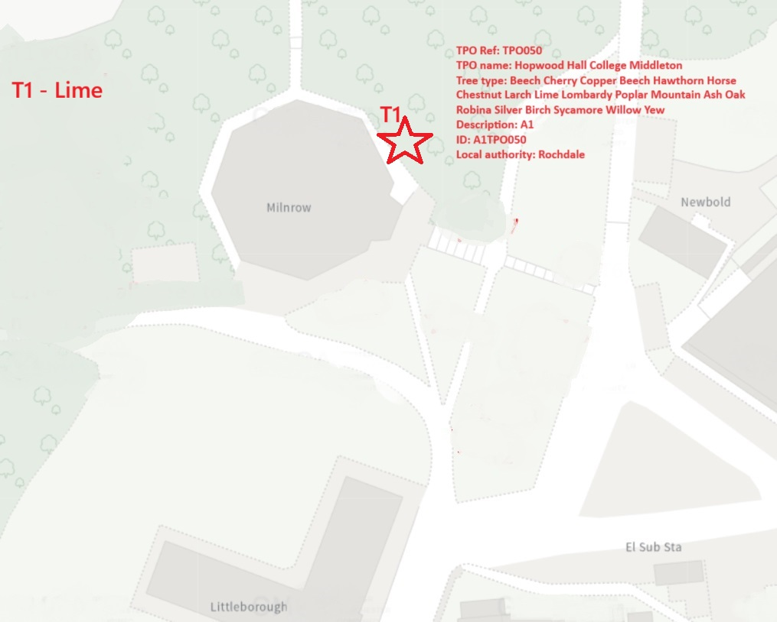

Work provided

Site visit, arboricultural inspection, photography, report, and quotation.
All trees have been thoroughly inspected and only the tree with any defects or concerns have been noted.

Trees included

T1 – Lime

Issues found

Mature Lime tree, no previous pruning work noticeable. T1 currently within 0.5 meter of the Milnrow building is undergoing a major revamp. Branches are impeding the workers who are trying to safely carry out their work from the scaffolding surrounding the building.

Recommendations

T1 – Lime, Reduce from property by 2-3 meters.

T1 Lime tree, situated near the property, requires pruning back by 2-3 meters to mitigate its current interference with safe scaffolding operations. This precautionary measure ensures that any ongoing work can be conducted in a secure environment, ultimately safeguarding workers and minimising any potential risks related to structural accessibility issues.

The recommended pruning practice will be executed by adhering to industry standards and professional guidelines, thereby safeguarding both the tree’s health and its aesthetic value. Skilled arborists will employ precise cutting techniques that prevent unnecessary stress or damage to the tree. Moreover, this strategic trimming ensures that the tree continues to thrive without compromising its natural form or vitality. Additionally, by being mindful of maintaining an appropriate distance from the structure, we preserve the overall amenity and elegance that the T1 Lime contributes to the landscape.

In summary, while enhancing safety for scaffolding work, the pruning work is careful to maintain the tree's health, aesthetics, and valuable contribution to the property’s ambiance, ensuring no adverse effects to its longevity or appearance.

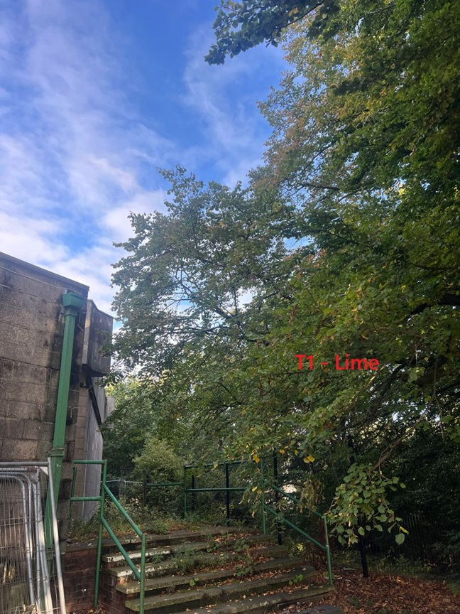
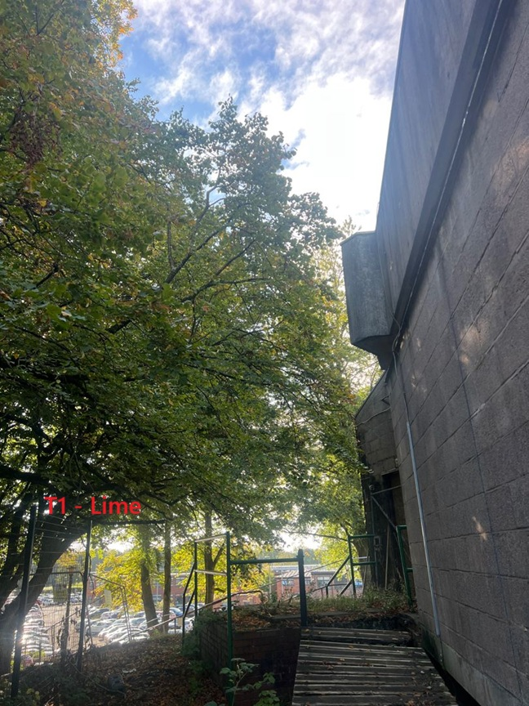
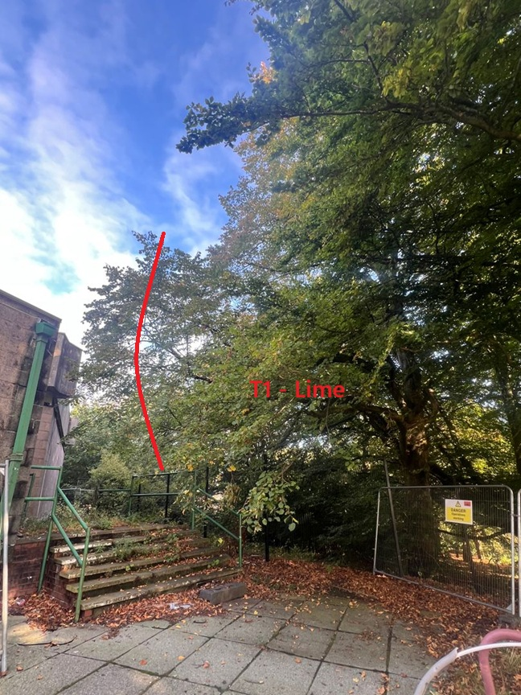

Kind regards,

Mr. Ryan Slack
General Manager and Director
SEG Award, Cert Arb L2 (ABC)

