DELEGATED DECISION CHECKLIST AND REPORT

APPLICATION NO. | CASE OFFICER
24/00733/TELE | Aimee Bovaird

DETERMINATION DATE 16.09.2024 EXT OF TIME 2.10.2024

Address: Proposed replacement greenfield site located on a field of Lower Stakehill Farm, Stakehill Lane, Middleton, Manchester, Greater Manchester, M24 2SA (E:388851, N:408637).

Proposal: Prior notification for a replacement 25m high telecommunication lattice tower and associated works

PUBLICITY | Weekly list expired? | Y | Site notice expired? | Y
PUBLICITY | Neighbour letters expired? | Y | Press Notice expired? | N/A

DELEGATION | Significant departure from local plan? | N/A | Contrary to national policy? | N/A
DELEGATION | Applicant a Council Member or officer? | N/A | Contrary to previous decision? | N/A
DELEGATION | Major with 10 or more objections and recommending approval? | N/A | Called in or Planning Panel objection? | N/A

COMMENTS | Planning Panel comments received? | N
COMMENTS | Neighbour comments received? | N

EIA | Screening opinion completed and saved to Onbase? | N/A

CONDITIONS | Pre-commencement conditions proposed? | N/A
CONDITIONS | Pre-commencement conditions agreed (or notification period expired)? | N/A

RECOMMENDATION | PRIOR APPROVAL REQUIRED AND REFUSED

CHECKED AND SIGNED OFF BY: LA DATE: 02.10.24

SITE

The site is located within a field off Stakehill Lane and the site is accessed via Stakehill Lane. The surrounding area is rural with the exception of the A627(M) running adjacent to the site and the site is located within the Green Belt.

North of the site is a reservoir and beyond that is St John Thornham Church, Grade 2 listed building and Thornham Parish First World War Memorial a Grade 2 listed monument.

PROPOSAL

The application seeks prior approval for the installation of a replacement 25m high telecommunication lattice tower and associated works. The existing tower is located approx. 300m south east of the site, therefore the same lattice tower is not being replaced.

RELEVANT PLANNING POLICY

The Town and Country Planning (General Permitted Development) (England) Order 2015 (As Amended).

National Guidance

National Planning Policy Framework (NPPF)
National Planning Practice Guidance (NPPG)

Places for Everyone

JP-S1 Sustainable Development

JP-P1 Sustainable Places
JP-P2 Heritage

JP-C2 Digital Connectivity

Adopted Rochdale Core Strategy (CS):

SO3 Improving design, image and quality of place
P2 Protecting and enhancing character, landscape and heritage
P3 Improving design of new development
DM1 General Development requirements

Unitary Development Plan (UDP):

G/D/1 Defined Urban Area

RELEVANT SITE HISTORY

23/00650/HYBR - Hybrid planning application (EIA development) seeking: Full Planning permission for the erection of residential development of 233 dwellings (Use Class C3) with associated landscaping, means of access, drainage, and other necessary supporting infrastructure. Outline planning permission with access (all other matters reserved) for residential development of up to 1147 dwellings (Use Class C3), mixed-use development, land for primary school extension, local centre and MUGA, landscaping, and supporting infrastructure. – Under consideration

CONSULTATION RESPONSES

Highways And Engineering

No objections.

Env Health - Noise/Odours

No objections.

Conservation

Summary

‘The proposal would result in less than substantial harm to the significance of the designated heritage asset. This harm should be weighed against any public benefits stemming from the proposal.’

REPRESENTATIONS

The application was publicised by way a site notice was displayed in the vicinity. No comments have been received.

ANALYSIS

Part 16, Class A of the Town and Country Planning (General Permitted Development) (England) Order 2015 (as amended) states that development consisting of the installation, alteration or replacement of electronic communications apparatus (other than on a building) is not permitted by Class A(a) if –

- in the case of the installation of electronic communications apparatus (other than a mast), the apparatus, excluding any antenna, would exceed a height of 15 metres above ground level;
- in the case of the alteration or replacement of electronic communications apparatus (other than a mast) that is already installed, the apparatus, excluding any antenna, would when altered or replaced exceed the height of the existing apparatus or a height of 15 metres above ground level, whichever is the greater;
- in the case of the installation of a mast, the mast, excluding any antenna, would exceed a height of—
  - 30 metres above ground level on unprotected land; or
  - 25 metres above ground level on article 2(3) land or land which is on a highway; or
- in the case of the alteration or replacement of a mast, the height of the mast, excluding any antenna, would when altered or replaced exceed the greater of the height of the existing mast or a height of—
  - 30 metres above ground level on unprotected land; or
  - 25 metres above ground level on article 2(3) land or land which is on a highway; or
- in the case of the alteration or replacement of a mast—
  - the mast is on any land which is, or is within, a site of special scientific interest; and
  - the mast would, when altered or replaced, exceed the original width of the mast by more than one third.

The erection of a pole up to 25m in height on the highway to support electronic communications transmission apparatus with associated street cabinet would be development permitted by the Town and Country Planning (General Permitted Development) (England) Order 2015 (as amended), Schedule 2, Part 16, Class A.

The application is therefore for a determination whether the prior approval of the Council will be required as to the siting and appearance of the installation, as required under paragraph A.3 of the Order.

Siting and appearance

Paragraph 119 of the NPPF requires installations to be kept to a minimum and encourages the reuse of existing electronic communications infrastructure such as existing masts, buildings and other structures. Where new sites are required such as for new 5G networks, equipment should be sympathetically designed and camouflaged where appropriate.

There is no requirement to have regard to the development plan as there would be for any development requiring planning permission. Nevertheless, Policies P1, P2, P3 and DM1 of the Core Strategy are material considerations as they relate to issues of siting, appearance and heritage. In addition, Policies JP-P1 and JP-P2 of the recently adopted Places for Everyone Joint Development Plan (PfE) are relevant given their aspirations to achieve high quality places and to conserve, sustain and enhance heritage assets and their settings. PfE Policy JP-C2 emphasises the ambition for Greater Manchester to become a digitally connected city region, however does explicitly set out that this should not come at the expense of townscape quality. The National Planning Policy Framework (the Framework) is also a material consideration, and this includes a section on supporting high quality communications. Paragraph 139 of the Framework is explicit in that development which is not well-designed should be refused.

The application site sits within an open field and the proposed lattice tower will be 25m in height. This is considered to be a substantial structure and top heavy due to the antenna. The upper part of the monopole will be seen against the sky as the proposed development will be taller than the existing street furniture and the limited vegetation will not mitigate the prominence and scale of the proposed structure.

The proposed development includes a 2.4m high galvanised fence around the boundary of the base of the tower and this would introduce a hostile and uninviting feature which would harm the character and appearance of the area. It is acknowledged this area may not be frequented by the public currently.

When considering the visual impact the proposed development will be seen from long range views in both directions from the motorway. There will be visibility of the tower from the Grade II listed building.

It is considered the proposal is not in compliance with Policies P1 and, P3, of the adopted Core Strategy and the National Planning Policy Framework.

Heritage

Section 72 of the Planning (Listed Buildings and Conservation Areas) Act 1990 requires that special attention shall be paid to the desirability of preserving or enhancing the character or appearance of a Conservation Area.

St Johns Church Of England is north of the site and is approx. 235m away for the site and Thornham Parish First World War Memorial is north of the site and approx. 225m away. The submitted Heritage Statement states there are trees to provide screening along Thornham lane, whilst there are trees they will not provide screening all year and the proposed development will tower over them.
When considering the visual impact, the proposed development will be clearly visible from the listed building and monument. The Council’s Conservation Officer has been consulted and set out ‘the proposal by virtue of its height, siting and massing would result in some harm. This harm would be less than substantial and should be weighed against the public benefits of the proposal.’ Figure 1 below shows the views from the site to the church. It is clear the proposed development will be seen in the context of the church and have a dominant appearance within the landscape.
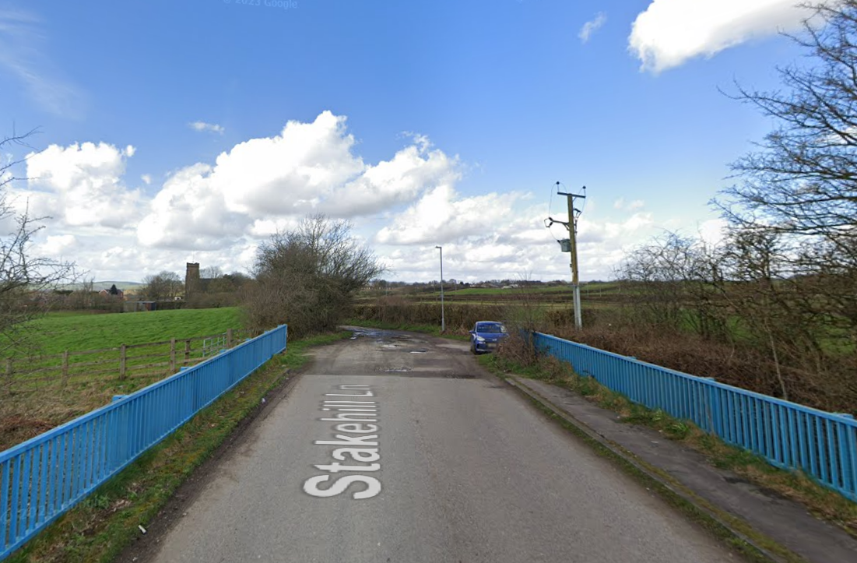
Figure 1 from Google Images

It is also acknowledged the wider landscape is due to undergo a change as the site is adjacent to JPA.2 Stakehill of the adopted Places for Everyone Joint Development Plan. The overarching spatial strategy for the allocation envisages residential development to be delivered in the northern part of the allocation. The footbridge over the A627(M) provides a valuable pedestrian link for both existing and future residents that sit within the southern part of the allocation, being able to access the various amenities such as the proposed local centre and open space which are to be delivered in the north. The visual link between between the Church and Stakehill Lane would be considerably impacted by the proposed mast and ancillary structures and would undermine the image of the allocation and its sense of place. It is envisaged that Stakehill Lane is to be a well-travelled route once the allocation is built out and whilst it may not be prominent now, this certainly will not be the case over the Plan period. The proposed development would also have an impact on the quality of place of any development to come forward.

The impact of the proposed development is a material consideration. Overall the proposed development comprises a wholly inappropriate form of development in a prominent location between heritage assets which will cause less than substantial harm to the significance of the designated heritage assets setting and the visual competition within the townscape which it would create contrary to Policy P2 of the adopted Core Strategy, PfE Policy JP-P2 and the NPPF. In accordance with paragraph 206 of the framework, any harm to the setting of a designated heritage asset should require clear and convincing justification.

Highways

Paragraph 111 of the NPPF states ‘Development should only be prevented or refused on highways grounds if there would be an unacceptable impact on highway safety, or the residual cumulative impacts on the road network would be severe.’

The Highways department has been consulted and raised no objections to the proposal as it will not have a negative effect on the highway.

It is considered, by reason of sitting the proposal is compliant with policies T2 and DM1 of the Rochdale Core Strategy as well as the National Planning Policy Framework.

Other Matters – Site Selection

The application sets out the need for an expansion of infrastructure as necessary for business development and meeting specific technical and operational requirements. No information has been provided on the extent of the coverage of the current network. An understanding of the broader network context is helpful to properly appreciate how a proposed mast fits into the network and to then be able to assess what alternatives have been investigated.

The application includes a Site Specific Supplementary Information, which details the site selection process providing details of alternative sites considered for development. No details have been provided in respect of the cell search area, or of the cell centre and other existing sites in the surrounding area, which would be useful in demonstrating the suitability of the site. A total of eight alternative sites have considered within this assessment, and have been discounted due to planning or physical constraints which discount the sites for development.

Within the Site Specific Supplementary Information three sites D4, D6 and D7 have been discounted based upon the reduced coverage versus the option currently proposed; it is not to say that they are unsuitable for operational requirements, merely bested by the proposed siting.

No further information has been provided to conclude that the eight sites in this assessment, plus the application site, are the only viable sites to fulfil the needs of the operator within this undefined area. No details have been received of existing installations within the vicinity of the site and any reasoning for discounting mast sharing.

Under Appeal ref. APP/P4225/W/20/3259908, the Inspector stated that the evidence provided in a directly comparable assessment was “less than compelling,” and that the applicant had failed to “robustly demonstrate that a satisfactory level of coverage could not be achieved in another location where a [mast] would not have such an adverse visual impact.” As this application demonstrates similar shortcomings in its assessment of alternative sites, it would not be possible to definitively conclude that there are no more suitable sites reasonably available that would result in a lesser degree of visual harm, harm to the amenity of nearby occupiers and harm to the significance of heritage assets. Taken as a whole, would fail to comply with the requirements of paragraphs 119 to 121 of the NPPF.

Public benefits

As required by para 208 of the NPPF the heritage harm is assessed against any public benefits. These are social and economic benefits such as offering online services for businesses and helping people stay in touch. It is acknowledged in the information submitted it is states stated the Slattocks area needs service and when the existing base station is decommissioned this may be lost. However is it not though that the public benefits outweigh the harm from the proposed development.

Conclusion

Within the context of paragraph 208 of the Framework, whilst it is acknowledged that the proposals would result in social and economic benefits through the improvements to local communications networks, it is not considered that the application suitably demonstrates that it would not be possible to achieve the desired coverage at a site which would be less harmful to the significance of designated heritage assets, and taken as a whole, would fail to comply with the requirements of paragraphs 119 to 121 of the NPPF. Prior approval for the siting and appearance is therefore required and the application is refused.

RECOMMENDATION

REFUSE for the following reason:

- The site is in the vicinity of Grade II listed St Johns Church. The proposed 25 metre lattice tower, by reason of its significant scale, siting and appearance, would fail to sit sympathetically in the context of the environment. The proposal would result less than substantial harm to the significance of St Johns Church. By reason of its siting and scale, the proposed lattice tower would also give rise to an unacceptable impact to the character and appearance of the area and would comprise a wholly inappropriate addition to the townscape generally and would undermine the goal of JPA.2 Stakehill of the adopted Places For Everyone Joint Development Plan. The proposals would set a dominant and incongruous feature in a prominent location relative to current and future development within Stakehill. In the absence of a comprehensive assessment of alternative sites for the proposed development, it is not possible to definitively conclude that there are no more suitable sites reasonably available that would result in a lesser degree of visual harm, and the public benefits of the proposal are not considered to outweigh the less than substantial harm identified. On this basis the application is contrary to Policies P1, P2, P3, and DM1 of the adopted Rochdale Core Strategy, Policies JP-P1, JP-P2 and JP-C2 of the adopted Places for Everyone Joint Development Plan and the National Planning Policy Framework.

