DELEGATED DECISION CHECKLIST AND REPORT

APPLICATION NO. | CASE OFFICER | DATE
24/00795/FUL | Nick Brookman | 29 October 2024

DETERMINATION DATE
1 November 2024 (Extension of time)

Address: Unit 9, Heywood Distribution Park, Heywood, OL10 2TL

Proposal: Alterations to the existing warehouse comprising the installation of a new 12m canopy on the north eastern access door and the construction of a new sprinkler tank and pump house, a new perimeter fence, new car park entrance gates and a new office and amenity block building

PUBLICITY | Weekly list expired? | Y | Site notice expired? | N/A
PUBLICITY | Neighbour letters expired? | Y | Press Notice expired? | N/A

DELEGATION | Significant departure from local plan? | N | Contrary to national policy? | N
DELEGATION | Applicant a Council Member or officer? | N | Contrary to previous decision? | N
DELEGATION | Major with 10 or more objections and recommending approval? | N | Called in or Planning Panel objection? | N

COMMENTS | Planning Panel comments received? | N
COMMENTS | Neighbour comments received? | N

EIA | Screening opinion completed and saved to Onbase? | N/A

CONDITIONS | Pre-commencement conditions proposed? | N
CONDITIONS | Pre-commencement conditions agreed (or notification period expired)? | N/A

RECOMMENDATION | GRANT SUBJECT TO CONDITIONS

CHECKED AND SIGNED OFF BY: LA DATE: 31.10.24

SITE

The application site is previously developed land and the surrounding area is designated as a ‘Primary Employment Zone’ in Rochdale Borough Council’s UDP Proposals Map (Policy EC/2).

The application site is located on the north east corner of Heywood Distribution Park. Access to the site is provided via Mulberry Way which also forms the Site’s southern boundary. The Site is circa 1 km from Heywood Town Centre and is situated approximately 4km from Bury Town Centre, 6km from Rochdale Town Centre and approximately 9.5 km from Oldham Town Centre.

The site area measures 2.78 hectares and comprises a warehouse building measuring approximately 13,800 sqm, a large area of hard standing to the east providing servicing and delivery access and car parking to the south of the site as shown below:

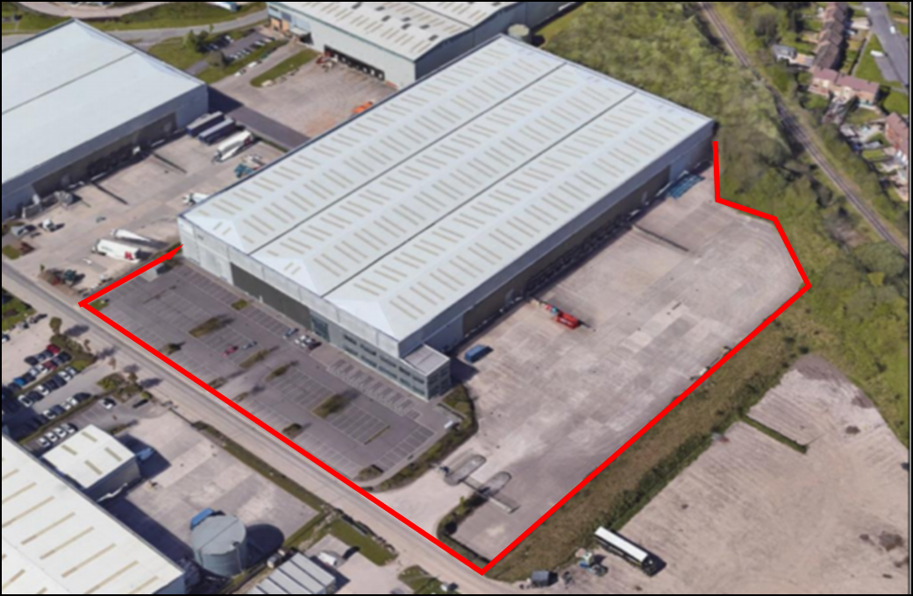

This application site itself is set in between Mulberry Way to the south and the East Lancashire Railway which runs across the north of the site with residential dwellings beyond. Dense vegetation screens the site to the north.

There are two access points into the Site itself on Mulberry Way which provide access into the car park at the south of the Site and access into the service yard at the southeastern corner. There is an existing control gate at the access to the service yard. Separate access points for private vehicles ensure that safety is prioritised for all users of the site and there is no conflict between private vehicles and HGV’s.

The east, south and west the Site is surrounded by other employment units that form Heywood Distribution Park. The Distribution Park is characterised by a range of typical industrial and storage units and associated hard and soft landscaping.

PROPOSAL

The proposed development seeks full planning permission for the following works:

- A new office amenity block;
- New car park entrance gates which are proposed to be bi-fold automated with access control;
- A new sprinkler tank and pump house;
- A new 12m canopy added to the northern level access door;
- A full perimeter fence allow 1200mm gap adjacent to the existing facility fence.

The submitted Planning Statement sets out that the rationale behind the design is to support the relocation of a new vault complex within the building. Due to the installation of the vault complex a new canopy, sprinkler tank and amenity building is proposed to support the vault.

The new proposal will introduce a new line of security around the north west and south perimeter of the site with the addition of new bifold gates into the existing car park.

The new two storey office/amenity block will measure 9.832m x 16.776m and will comprise of a canteen, two open plan offices with each including it’s own private office. Toilets and store rooms along with a central stair case will make up the rest of the building.

The building will measure 7.49m to the Apex and will be constructed of a prefabricated modular structure with aluminium ribbon windows inserted on the north and south facing elevations. One aluminium access door will be installed onto the principal elevation with no windows on the west or east facing elevation. An access ramp will also front the building which will effectively be of a portakabin structure.

The proposed sprinkler tank will have a diameter of 9.45m and will measure 9.7m tall. This will be made up on an 8.7m high tank and a 1m high ball valve housing on top. This tank is connected to the sprinkler pump house which sits immediately adjacent but detached from the tank. It has a diameter of 9m and an overall height of no more than 4m.

The proposed external canopy sits above the northern most service door on the north east elevation and will extend 12m out into the yard and measure 12.5m wide. This canopy will be constructed of a single skin cladding to match the cladding of the neighbouring warehouse to which it is attached.

RELEVANT PLANNING POLICY

National Guidance

National Planning Policy Framework (NPPF)
National Planning Practice Guidance (NPPG)

Places for Everyone Joint Development Plan (PfE)

The Places for Everyone Joint Development Plan was adopted and became part of the statutory development plan for each of the 9 authorities covered by the plan on 21st March 2024. The following policies are relevant:

JP-P1 Sustainable Places
JP-S1 Sustainable Development

Adopted Rochdale Core Strategy (CS):

SD1 Delivering sustainable development
DM1 General development requirements

SO1 To deliver a more prosperous economy
E2 Increasing jobs and prosperity
E3 Focusing on economic growth corridors and areas

SO3 Improving design, image and quality of place
P1 Improving image
P3 Improving design of new development

Unitary Development Plan (UDP):

G/D/1 Defined Urban Area
EC/2 Primary Employment Zones
EC/8 Development Sites in Employment Zone

RELEVANT SITE HISTORY

Application 21/00406/FUL – Extension to existing industrial unit and service yard together with temporary alterations comprising two loading doors under scaffold enclosures to allow for continued service access during construction – Approved with conditions 16 September 2021.

Application SPZ1/011 – Erection of two industrial/warehouse units – Approved 17 April 2011.

CONSULTATION RESPONSES

Highways

No objection to this proposal. The changes to the site will have a minimal impact upon the functional area of the site.

Lead Local Flood Authority

No comment received.

REPRESENTATIONS

5 letters of notification were sent to neighbouring properties, and no comments have been received.

ANALYSIS

Principle of Development

The use of the site for industrial purposes is already well established in principle given its historic use within the Heywood Distribution Park

The application site is located within the Defined Urban Area as designated under the Proposals Map of the Unitary Development Plan (UDP). New development, wherever possible and appropriate, should be concentrated within the urban area in order to support urban regeneration and to protect the countryside. In this instance the application lies within the Primary Employment Zone as identified in the UDP (Policy EC/2).

Paragraph 123 of the NPPF sets out that planning policies and decisions should promote an effective use of land in meeting the need for homes and other uses, while safeguarding and improving the environment and ensuring safe and healthy living conditions. More specifically, paragraph 124 (c) states that ‘planning policies and decisions should give substantial weight to the value of using suitable brownfield land within settlements for homes and other identified needs, and support appropriate opportunities to remediate despoiled, degraded, derelict, contaminated or unstable land’.

Paragraph 85 of the NPPF sets out that ‘Planning policies and decisions should help create the conditions in which businesses can invest, expand and adapt. Significant weight should be placed on the need to support economic growth and productivity, taking into account both local business needs and wider opportunities for development’.

The proposal comprises a new office building and ancillary facilities to help support an existing industrial business on previously developed land, on a sustainable site which would wholly accord with both local and national planning policies.

Given the intention of the proposed development coupled with the surrounding land uses and land allocation, the proposed development is acceptable in principle and is in accordance with the requirements of saved UDP Policy EC/2, NPPF and PfE.

Design

In terms of design Policies DM1 and P3 of the Council’s adopted Core Strategy require development proposals to adhere to high quality design and enhance the borough’s identity and sense of place, by respecting context where it is positive and having regard to the scale, density, massing, height, layout, landscape, materials and access of surrounding buildings and areas in general.

In addition, paragraph 131 of the National Planning Policy Framework (NPPF) states that the creation of high quality, beautiful and sustainable buildings and places is fundamental to what the planning and development process should achieve.

Paragraph 135 of the NPPF goes onto state that planning policies and decisions should ensure that developments function well and add to the overall quality of the area, are visually attractive as a result of good architecture, layout and appropriate and effective landscaping and are sympathetic to local character and history, including the surrounding built environment and landscape setting, while not preventing or discouraging appropriate innovation or change.

The proposed office amenity block, sprinkler tank and pump house are located off the north east elevation of the existing industrial warehouse and within the service and delivery yard associated with the warehouse. Their siting and development would remain entirely ancillary and subordinate to the primary use of the land associated with the warehouse and their design would remain wholly subservient. The proposed dark grey windows and anthracite elevations would correspond well with the existing character and appearance of the area.

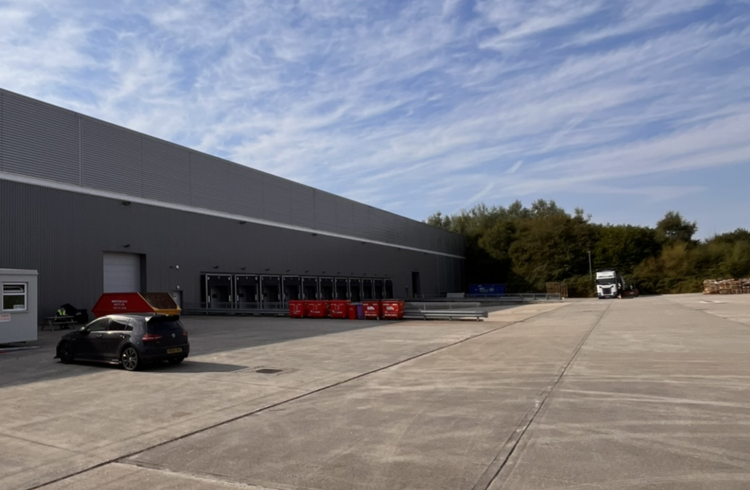

The proposed development looks to incorporate a new roof canopy above the north facing access door providing a form of shelter in inclement weather conditions. The proposed design, materials, building profile and overall appearance of this is in keeping with the existing warehouse building and prevailing character of the wider business park site to the west.

With regards to the design of the proposed security fencing, this would be of a Paladin design and measure 2.4m high. It would connect with the existing security fencing by the service entrance to the east and run west to enclose the existing staff car park before running north along the west elevation of the warehouse and then north before connecting with the existing security fence in the north.

The application proposes the installation of 2.4m high bi-fold car park entry gates to fully secure the site. The proposed fencing and bi-fold car park gates in this industrial location are considered to be of an acceptable design and their construction would be of a modern and contemporary appearance that would not harmfully impact upon the existing character and appearance of the wider industrial and employment area.

As such, it is considered that the proposals would accord with the requirements of Policies DM1 and P3 of the adopted Core Strategy and the National Planning Policy Framework and relevant policies in PfE.

Impact on Surrounding Land Uses, Residential Amenity and Noise

Core Strategy policy G9 sets out the Council’s requirements approach to all forms of pollution including the risk of noise, as they relate to new development.

Paragraph 180 of the NPPF also states that planning policies and decisions should ensure that new development is appropriate for its location, taking into account the likely effects of pollution on health, living conditions and the natural environment, as well as the potential sensitivity of the site or the wider area to impacts that could arise from the development.

Paragraph 135 also seeks to ensure that planning decisions create places which promote health and well-being, with a high standard of amenity for existing and future users. Policies DM1 and G9 of the adopted Rochdale Core Strategy seek to ensure that new development is compatible with surrounding land uses, both in terms of its impact upon those uses and the impact of the surrounding land uses upon the amenities of future residents / users, also requiring that development does not have impacts that lead to an unacceptable increase in air, water, noise, light or other pollution. Additionally, policy DM1 of the Core Strategy requires that proposals should not adversely affect the amenity of residents or users through visual intrusion, overbearing impact, overshadowing or loss of privacy.

PfE policy JP-P6 set out planning expectations for the protection of residential amenity. The “Guidelines & Standards for Residential Development” SPD also sets out guidelines for reducing or omitting the impact of new development on the amenities of residential occupiers.

The site is located within an existing employment area but there are residential properties within relatively close proximity of the northern boundary of the site. The proposed development would not give rise to unacceptable levels of pollution such as noise over and above those levels currently experienced on site.

Owing to the distance between the proposed development, the railway and large belt of trees on both sides of the railway line, it is not considered that the development would detrimentally affect the outlook of those properties in the north.

In terms of noise, it is important to note that Heywood Distribution Park was formerly a Simplified Planning Zone (SPZ) and this was adopted on 8 April 2010 and was in operation for a 10-year period, ending on 7 April 2020. At the end of the 10-year operation period, the scheme ceased to be in effect, except for development that had already commenced in line with Section 56 of the Town and Country Planning Act 1990. This application site fell within a ‘Noise Sensitive Zone’ and was subject to a specific condition limiting noise levels.

Evidently, whilst the SPZ is no longer in effect, this area remains sensitive to noise. Environmental Health were consulted on this application and have raised no objection subject to the inclusion of a noise sensitive condition in line with that attached to the former SPZ.

A further condition restricting construction work to appropriate hours is also included.

Subject to the inclusion of conditions it is considered that the proposal would be in accordance with the requirements of CS policy G9.

Highways

Highways were consulted on this application and they raised no objection. Accordingly, the proposed development is acceptable and would comply with DM1 and T2 of the Core Strategy, PfE and NPPF.

Flood Risk and Drainage

Policy G8 of the Core Strategy sets out the Council’s strategy for managing water resources and flood risk more effectively in the interests of public safety, protecting property and infrastructure and the conservation of the natural environment. Policy EM/7 of the saved UDP states that development will not be permitted in areas identified as flood plains, or other areas where development could contribute to increased flood risk. The NPPF also establishes that inappropriate development in areas at risk at flooding should be avoided and that when determining planning applications, local planning authorities should ensure flood risk is not increased elsewhere.

The application site falls within Flood Zone 1 and is therefore at a low risk of flooding (less than 1 in 1000 or 0.1% annual probability of river or sea flooding in any year).

The application is supported by a Drainage Statement prepared by Building Warranty which confirms that the proposed development is located over an existing concrete service yard and therefore there will be no increase in the impermeable area draining into the existing system and as such there will be no detrimental impact on the existing surface water drainage network.

The LLFA were consulted but have not provided any comment. Nevertheless, the proposed development would not increase or re-direct surface water elsewhere and Officers consider that the proposed development would accord with policy G8 of the adopted Rochdale Core Strategy, Policy JP-S4 of PfE and the NPPF.

Ecology and BNG

Core Strategy Policy G7 sets out that it is expected that development proposals will protect and include existing biodiversity and take opportunities to promote biodiversity and create new habitats using landscaping and building and construction features wherever possible. CS Policy G7 requires that no development should result in a net loss of biodiversity and geodiversity.

PfE Policy JP-G9 seeks to deliver a net enhancement of biodiversity resources through a collective of measures which are broadly aligned with the approach to BNG outlined within the Environment Act (2021), the NPPF and supporting guidance documents. The provisions of the Environment Act in respect of BNG are now a statutory requirement for planning applications but given the urban and built environment on and around the application site, it is acknowledged that this site does not impact any biodiversity and the site has a completely sealed surface and therefore has a biodiversity value of zero.

Accordingly, it is not considered that the statutory requirement to provide 10% BNG is applicable here.

Conclusion

The proposed development would support the objectives of Core Strategy policies E2, E3 and saved policy EC/2, and would therefore be acceptable in principle. The proposal would be acceptable in terms of impacts on design, residential amenity, highways safety and access arrangements, flood risk and drainage arrangements, ecology and biodiversity. For these reasons the proposal would comprise sustainable development because it complies with the development plan, and accordingly the application is recommended for approval, subject to conditions.

RECOMMENDATION

Grant subject to the following conditions:

- The development must be begun not later than three years beginning with the date of this permission.

Reason: Required to be imposed by Section 91 of the Town and Country Planning Act 1990 (as amended).

- This permission relates to the following plans and documents:

- Site Location Plan Drawing No 0601 Rev C
- Proposed Site Layout Drawing No 0610 Rev E
- Building Layout – Proposed Building Plan Drawing No 1010 Rev D
- Building Layout – Proposed Elevations Drawing No 1310 Rev B
- Amenity Building – Elevations – Drawing No 1350 Rev D
- Amenity Building – Plan – Drawing No 0150 Rev D
- Proposed Sprinkler Tank Location Drawing No 0620 Rev B
- Proposed Level Access Canopy Drawing No 1315 Rev A
- Proposed Fence Layout Drawing No 0611 Rev E
- Typical Fence Details Drawing No 0625 Rev A
- D6500 BI-Folding Gates Specification
- Design and Access Statement Revision P03 (Dated 28.08.2024)
- Sustainable Drainage Statement Dated 6th August 2024

and the development shall be carried out in accordance with these drawings hereby approved unless otherwise required by the conditions below.

Reason: For the avoidance of doubt and to ensure a satisfactory standard of development in accordance with the policies contained within the adopted Rochdale Core Strategy, the saved Rochdale Unitary Development Plan, Places for Everyone Joint Development Plan and the National Planning Policy Framework.

- Notwithstanding any details shown on Proposed Fence Layout Drawing No 0611 Rev E, Typical Fence Details Drawing No 0625 Rev A and D6500 Bi-Folding Gates Specification, the proposed paladin fencing and bi-folding gates shall be black in colour (RAL 9005 Jet Black).

Reason: For the avoidance of doubt and to ensure a satisfactory standard of development in accordance with the policies contained within the adopted Rochdale Core Strategy, the saved Rochdale Unitary Development Plan, Places for Everyone Joint Development Plan and the National Planning Policy Framework.

- All construction work associated with the development hereby permitted shall only take place between 08:00am and 18:00pm on Mondays to Fridays, between 09:00am and 14:00pm on Saturdays and not on Sundays or Bank or other National Public Holidays.

Reason: In the interests of the amenity of the area and adjoining and nearby residential properties.

- Noise from the proposed development or any associated plant and equipment permitted by this permission shall not exceed 50dB LAeq 1 hour when measured within the curtilage of noise sensitive premises between the hours of 07:00am and 23:00pm and 40dB LAeq 5 minutes at all other times.

Reason: To protect the amenity of nearby residents in accordance with Policy G9 of the Rochdale Core Strategy.

- Any lighting attached to or used in conjunction with the proposed development subject to this permission should be designed and controlled and used so as not to illuminate any area beyond the boundary of the site.

Reason: To protect the amenity of nearby residents in accordance with Policy G9 of the Rochdale Core Strategy.

BIODIVERSITY NET GAIN

The effect of paragraph 13 of Schedule 7A to the Town and Country Planning Act 1990 is that planning permission granted for development of land in England is deemed to have been granted subject to the condition (biodiversity gain condition) that development may not begin unless:

- a Biodiversity Gain Plan has been submitted to the planning authority,
and;
- the planning authority has approved the plan.
The planning authority, for the purposes of determining whether to approve a Biodiversity Gain Plan, if one is required in respect of this permission would be Rochdale Council.
Based on the information available this permission is considered to be one which will not require the approval of a biodiversity gain plan before development is begun because one or more of the statutory exemptions or transitional arrangements in the list below is/are considered to apply.
Statutory exemptions and transitional arrangements in respect of the biodiversity gain condition.
- The application for planning permission was made before 12 February 2024.

- The planning permission relates to development to which section 73A of the Town and Country Planning Act 1990 (planning permission for development already carried out) applies.

- The planning permission was granted on an application made under section 73 of the Town and Country Planning Act 1990 and
(i) the original planning permission to which the section 73 planning permission relates* was granted before 12 February 2024; or
(ii) the application for the original planning permission* to which the section 73 planning permission relates was made before 12 February 2024.
- The permission which has been granted is for development which is exempt being:

4.1 Development which is not ‘major development’ (within the meaning of article 2(1) of the Town and Country Planning (Development Management Procedure) (England) Order 2015) where:

- the application for planning permission was made before 2 April 2024;

- planning permission is granted which has effect before 2 April 2024; or

- planning permission is granted on an application made under section 73 of the Town and Country Planning Act 1990 where the original permission to which the section 73 permission relates* was exempt by virtue of (i) or (ii).

4.2 Development below the de minimis threshold, meaning development which:

- does not impact an onsite priority habitat (a habitat specified in a list published under section 41 of the Natural Environment and Rural Communities Act 2006); and

- impacts less than 25 square metres of onsite habitat that has biodiversity value greater than zero and less than 5 metres in length of onsite linear habitat (as defined in the statutory metric).

4.3 Development which is subject of a householder application within the meaning of article 2(1) of the Town and Country Planning (Development Management Procedure) (England) Order 2015. A “householder application” means an application for planning permission for development for an existing dwellinghouse, or development within the curtilage of such a dwellinghouse for any purpose incidental to the enjoyment of the dwellinghouse which is not an application for change of use or an application to change the number of dwellings in a building.

4.4 Development of a biodiversity gain site, meaning development which is undertaken solely or mainly for the purpose of fulfilling, in whole or in part, the Biodiversity Gain Planning condition which applies in relation to another development, (no account is to be taken of any facility for the public to access or to use the site for educational or recreational purposes, if that access or use is permitted without the payment of a fee).

4.5 Self and Custom Build Development, meaning development which:

- consists of no more than 9 dwellings;

- is carried out on a site which has an area no larger than 0.5 hectares; and

- consists exclusively of dwellings which are self-build or custom housebuilding (as defined in section 1(A1) of the Self-build and Custom Housebuilding Act 2015).

4.6 Development forming part of, or ancillary to, the high speed railway transport network (High Speed 2) comprising connections between all or any of the places or parts of the transport network specified in section 1(2) of the High Speed Rail (Preparation) Act 2013.

* “original planning permission means the permission to which the section 73 planning permission relates” means a planning permission which is the first in a sequence of two or more planning permissions, where the second and any subsequent planning permissions are section 73 planning permissions.

Procedure Statement

The proposal complies with the development plan and would improve the economic, social and environmental conditions of the area. It therefore comprises sustainable development and the Local Planning Authority worked proactively to issue the decision without delay.

