URBAN DESIGN CONSULTATION RESPONSE
Design Officer | Azhar Kapadi
Date | 11.07.25
Application Reference | 25/00405/FUL
Address | Land South Of Greenvale, , Bamford, Rochdale
Proposal | Demolition of existing dwelling and construction of a residential development for 43 no. dwellings with access and associated works

Introduction

The National Design Guide sets out the ten characteristics of a well-designed place. Well-designed places have individual characteristics which work together to create its physical Character. The ten characteristics help to nurture and sustain a sense of Community. They work to positively address environmental issues affecting Climate. They all contribute towards the cross-cutting themes for good design set out in the National Planning Policy Framework.

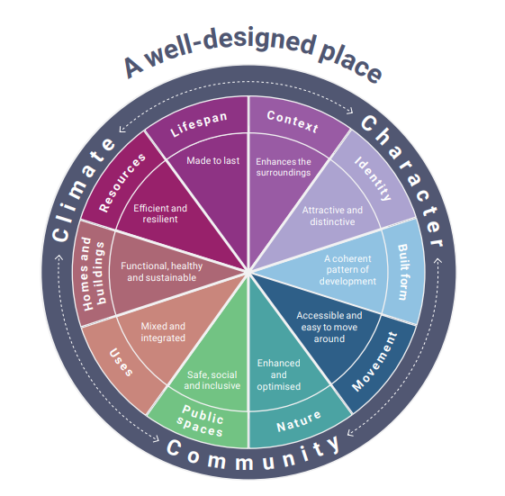
Figure: The ten characteristics of a well-designed place
Source: National Design Guide, 2021
Reproduced under the Open Government Licence

Reason(s) for Consultation
Building / Urban design

Scheme Image(s)
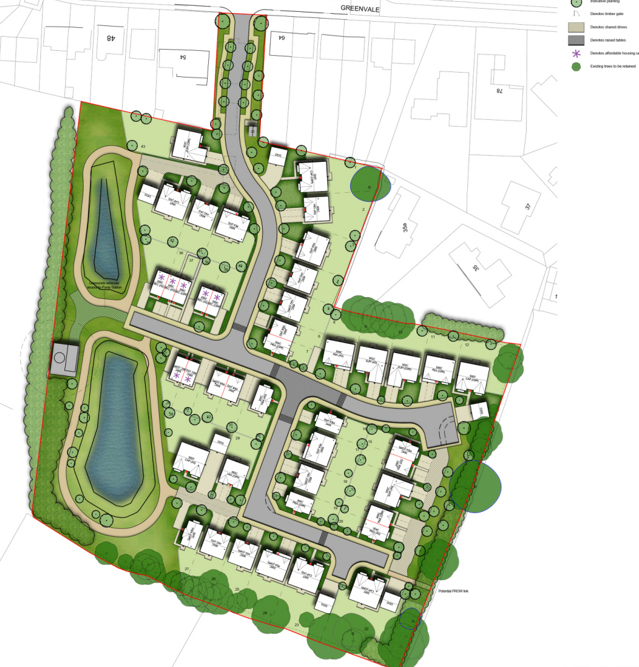
Source: Application submission

Assessment
This assessment has been made against:
National Guidance:
- The National Planning Policy Framework
- The ten characteristics of a well-designed place contained within the National Design Guide
- National Model Design Code
- Building for a Healthy Life design toolkit
Local Policy:
Rochdale Core Strategy policies:
- S03 – To improve design, image and quality of place
- P1 – Improving Image
- P2 – Protecting and enhancing character, landscape and heritage
- P3 – Improving design of new development
- DM1 (General Development Requirements)
Supplementary Planning Documents:
Oldham and Rochdale Urban Design Guide
Oldham and Rochdale Residential Design Guide
The Unitary Development Plan:
➢ G/BE/1 - Design Quality
➢ BE/2 - Design Criteria for New Development

Greater Manchester’s Streets for All Design Guide
Emerging Planning Policy - Places for Everyone (PfE) joint development plan

SUMMARY
The application has not taken on the comments from the Pre-App response effectively. The scheme needs to tie in with the wider PfE allocation more successfully with an approach to design that is less generic, less car dominated and landscape driven. House types need some significant improvement.

PfE Context
JPA.17 seeks to deliver up to 450 dwellings across the allocation with a focus on the delivery of larger, higher value dwellings, in addition to the significant enhancement of on-site sports pitches and the formation of a sports hub to serve the local community

PreApp
It was requested at the Pre-App stage for detail in respect of the design and appearance of dwellings in order to understand whether they fit the aims of the allocation, where it would be expected that higher-value dwellings are completed to a higher architectural standard. Any development should be informed by a sound understanding of positive local characteristics and compliance with the relevant local and national design guidance. It was related that the site layout was at an unacceptable standard, heavily dominated by frontage parking, leaving little space for landscaping.
Variations in density would be required to satisfy the various needs for affordable housing and larger housing.
It was understood that the constraints of the site may only lend itself to a certain proportion of larger, higher value dwellings, however this must be determined through a comprehensive site analysis and masterplanning process. A design code with well resolved character areas was advised once the masterplan was finalised.

Wider PfE
It is not evident in the application how this site integrates itself in the wider PfE site allocation.

Design
Whilst this proposal has a better approach to the site entry (than the pre-app) there are still many areas for improvement. I think this specific part would have been better if dwellings lined the entry route to both sides and was supplemented with sufficient landscaping.
Generally, across the scheme, there is an absence of street trees that are independent of private curtilages. Across the scheme, a landscaped led approach to the front of properties would improve the design of the development. The key to this being successful is how these trees will be preserved over time; placing in such proximity to parking spaces, and under private ownership would likely result in vast quantities being removed in the short to medium term. There is a notable over-reliance on frontage parking which does not demonstrate high quality design. This is particularly disappointing considering this was advised against in the pre-app consultation.
House Types
There is a lack of diversity in the house types; this includes typologies, colour / material palettes, plot shapes, and design styles. This makes the overall development appear very generic and uninspiring, failing to distance itself from a typical volume housebuilder prototype development The lack of specific architectural features or varied articulation in the proposed elevations, results in a development that would be visually bland and fails to contribute positively to the area's sense of place, contrary to good design principles outlined in local and national policy.
Similarly, the over proliferation of poor-quality boundary treatments, particularly at prominent locations does not help. This alongside with hard surfacing materials (reference to parking at the front of properties) leads to an uninspiring development.
There was an opportunity to make better use of the SUDS ponds. At the moment, the limited space and route around this area provide little recreational value and with it being tucked away wholly to one part of the site it does not encourage residents to experience such a space.
As the site accommodates 43 dwellings, it would be difficult to truly distribute the affordable housing effectively. Nevertheless, the design and layout of these dwellings should not appear as a lower quality relegation to the rest of the dwellings. This is unfortunately the case with the dwelling appearing squeezed to this portion of the site with no/little landscaping provision.
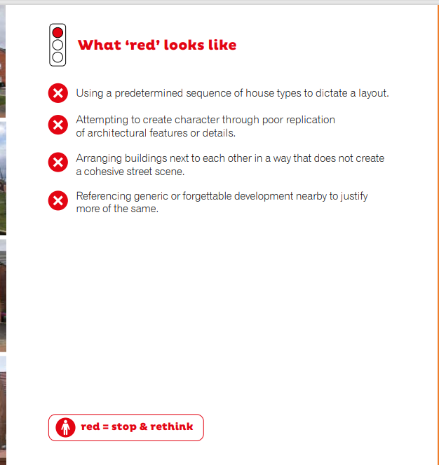

Design
There are several poorly executed examples of development within the immediate context and this should not be the yardstick for any new development. Recent reforms to the national planning policy have emphasised the importance for design quality. The National Planning Policy Framework sets an expectation that good quality design will be approved while poor quality will be rejected. Good design should not just be for the short term but over the lifetime of the development.
Materials / Architectural detailing
There are very few examples of well-built architecture in the immediate area, but the designer can take some inspiration from the former mill and some selective examples along Manchester Street. The material palette put forward by the designer is not positive and will do little to improve the area. I can accept the upvc frames and concrete tiles if the brickwork could be improved; consider looking at a multi-stock blend reflective of the brick that could be found on the site historically.
The window pod surrounds in particular represents poor quality design, having a history of becoming outdated very quickly. Simply, I would omit completely. Similarly do not introduce render as a material. Better architectural detailing and articulation will improve the elevation design with longevity in mind. The designer may point towards a similar scheme at Gregge Street where window pods have been used. This housing development is another example of poor development which we do not want to see replicated for this site. The proposal at Schofield Street should be more cohesive in design with a better approach to fenestration details. The brickwork in this scheme however is more positive than the product put forward and potentially could work for the proposed site.

Window size and style
The primary elevations would benefit from relocating kitchens to the rear. This would allow a large window (to the lounge) along the front elevation adding more interest along the street. I would ask the designer to represent the window details properly in the elevations / CGIs as they currently are misleading.
View on approach to plot 9
Ensure the gable elevation is adequately addressed to show visual interest. Will there be any landscaping? The dwelling should not impede a future development to come forward where the single storey part of the mill once stood. Generally I do not think the designer has overlooked the design of side elevations for dwellings that are visible from the street. Side elevations are blank and monotonous and these should be addressed.
Lack of visual interest / Poor architectural approach
The Rochdale Borough Unitary Development Plan requires developments to demonstrate good design by creating visual interest in areas or buildings lacking character. I would like to see the elevation design further developed so it can satisfactorily demonstrate high quality design.
In its current guise, the design is flat and lacking much character. The designer is encouraged to introduce architectural detailing to the scheme. This is prevalent in the surrounding built environment (see pictured) and whilst the designer is not expected to mimic historic architectural styles, such features can still be reinterpreted to the benefit of the scheme.
There are examples of good architectural detailing in the area and it is a missed opportunity for the designer not to have picked up on this. Drawing upon these elements would contribute to the ‘higher quality design’ requirement, intrinsically improving the character and distinctiveness of the area.

The current materiality shown for the elevations is unconvincing. There is no specific detail attributed to the brickwork and considering there are several elevations without much fenestration, it would be hoped that the designer may have gone into further detail regarding the materials.

Other
- Biodiversity appears to be glanced over in the design and access statement with the site appearing quite different to previous years. The development would generally welcome a more concise strategy to soft landscaping.
- Has privacy / overlooking been fully addressed for neighbouring properties?
- A street elevation in context would be beneficial

