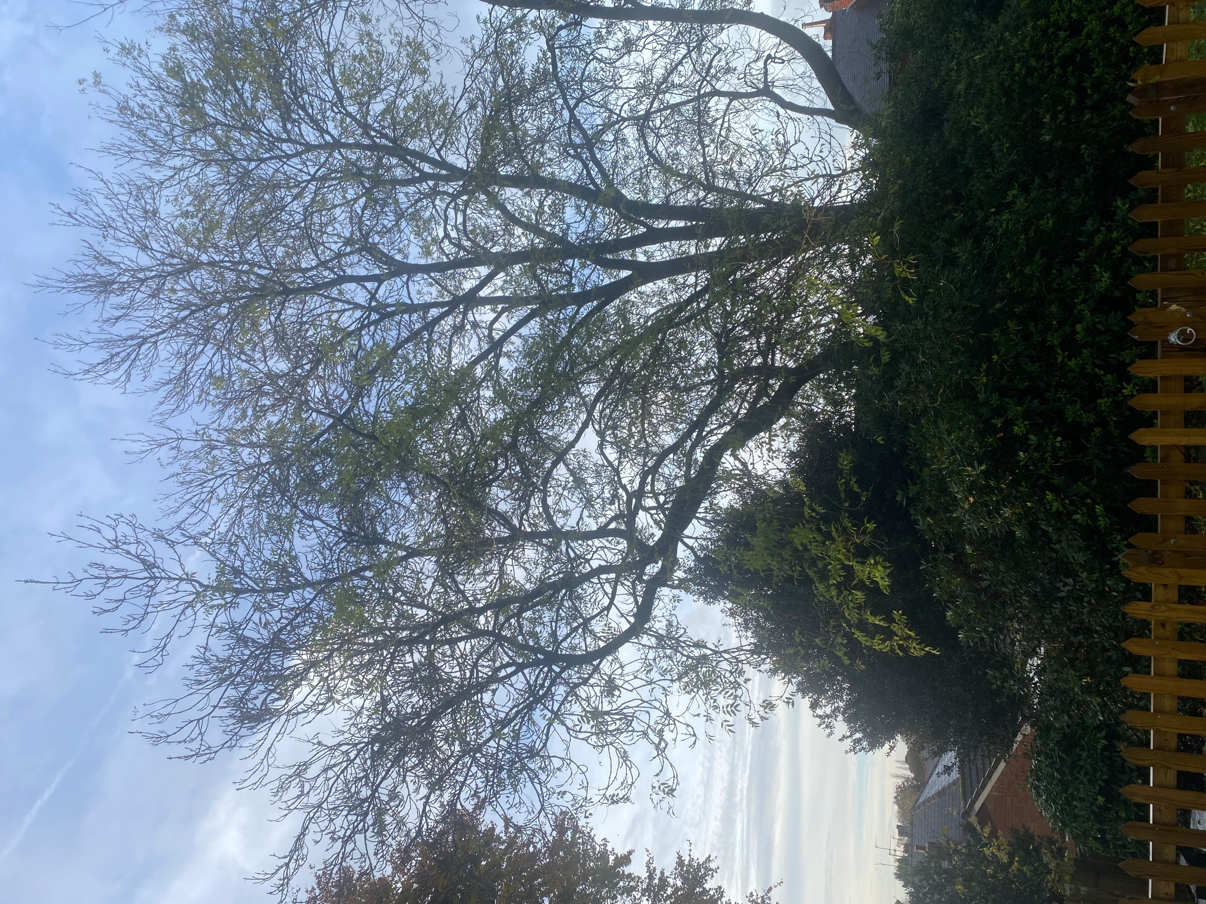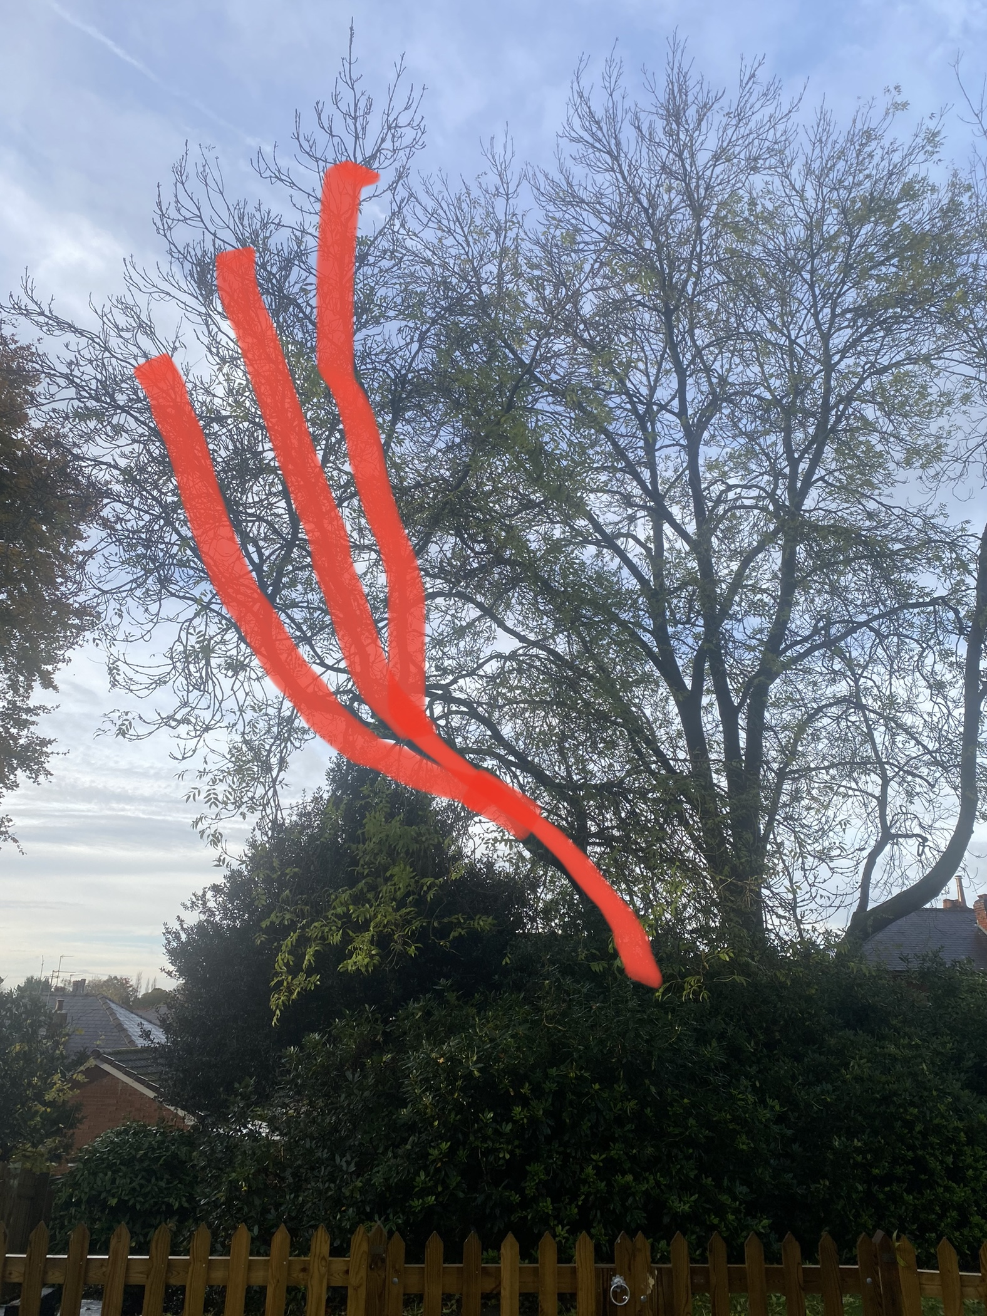
TREE 3 – MATURE ASH TREE WITH SWEEPING LIMB – HIGHLIGHTED IN RED
REDUCE SAIL AREA 30% EAST

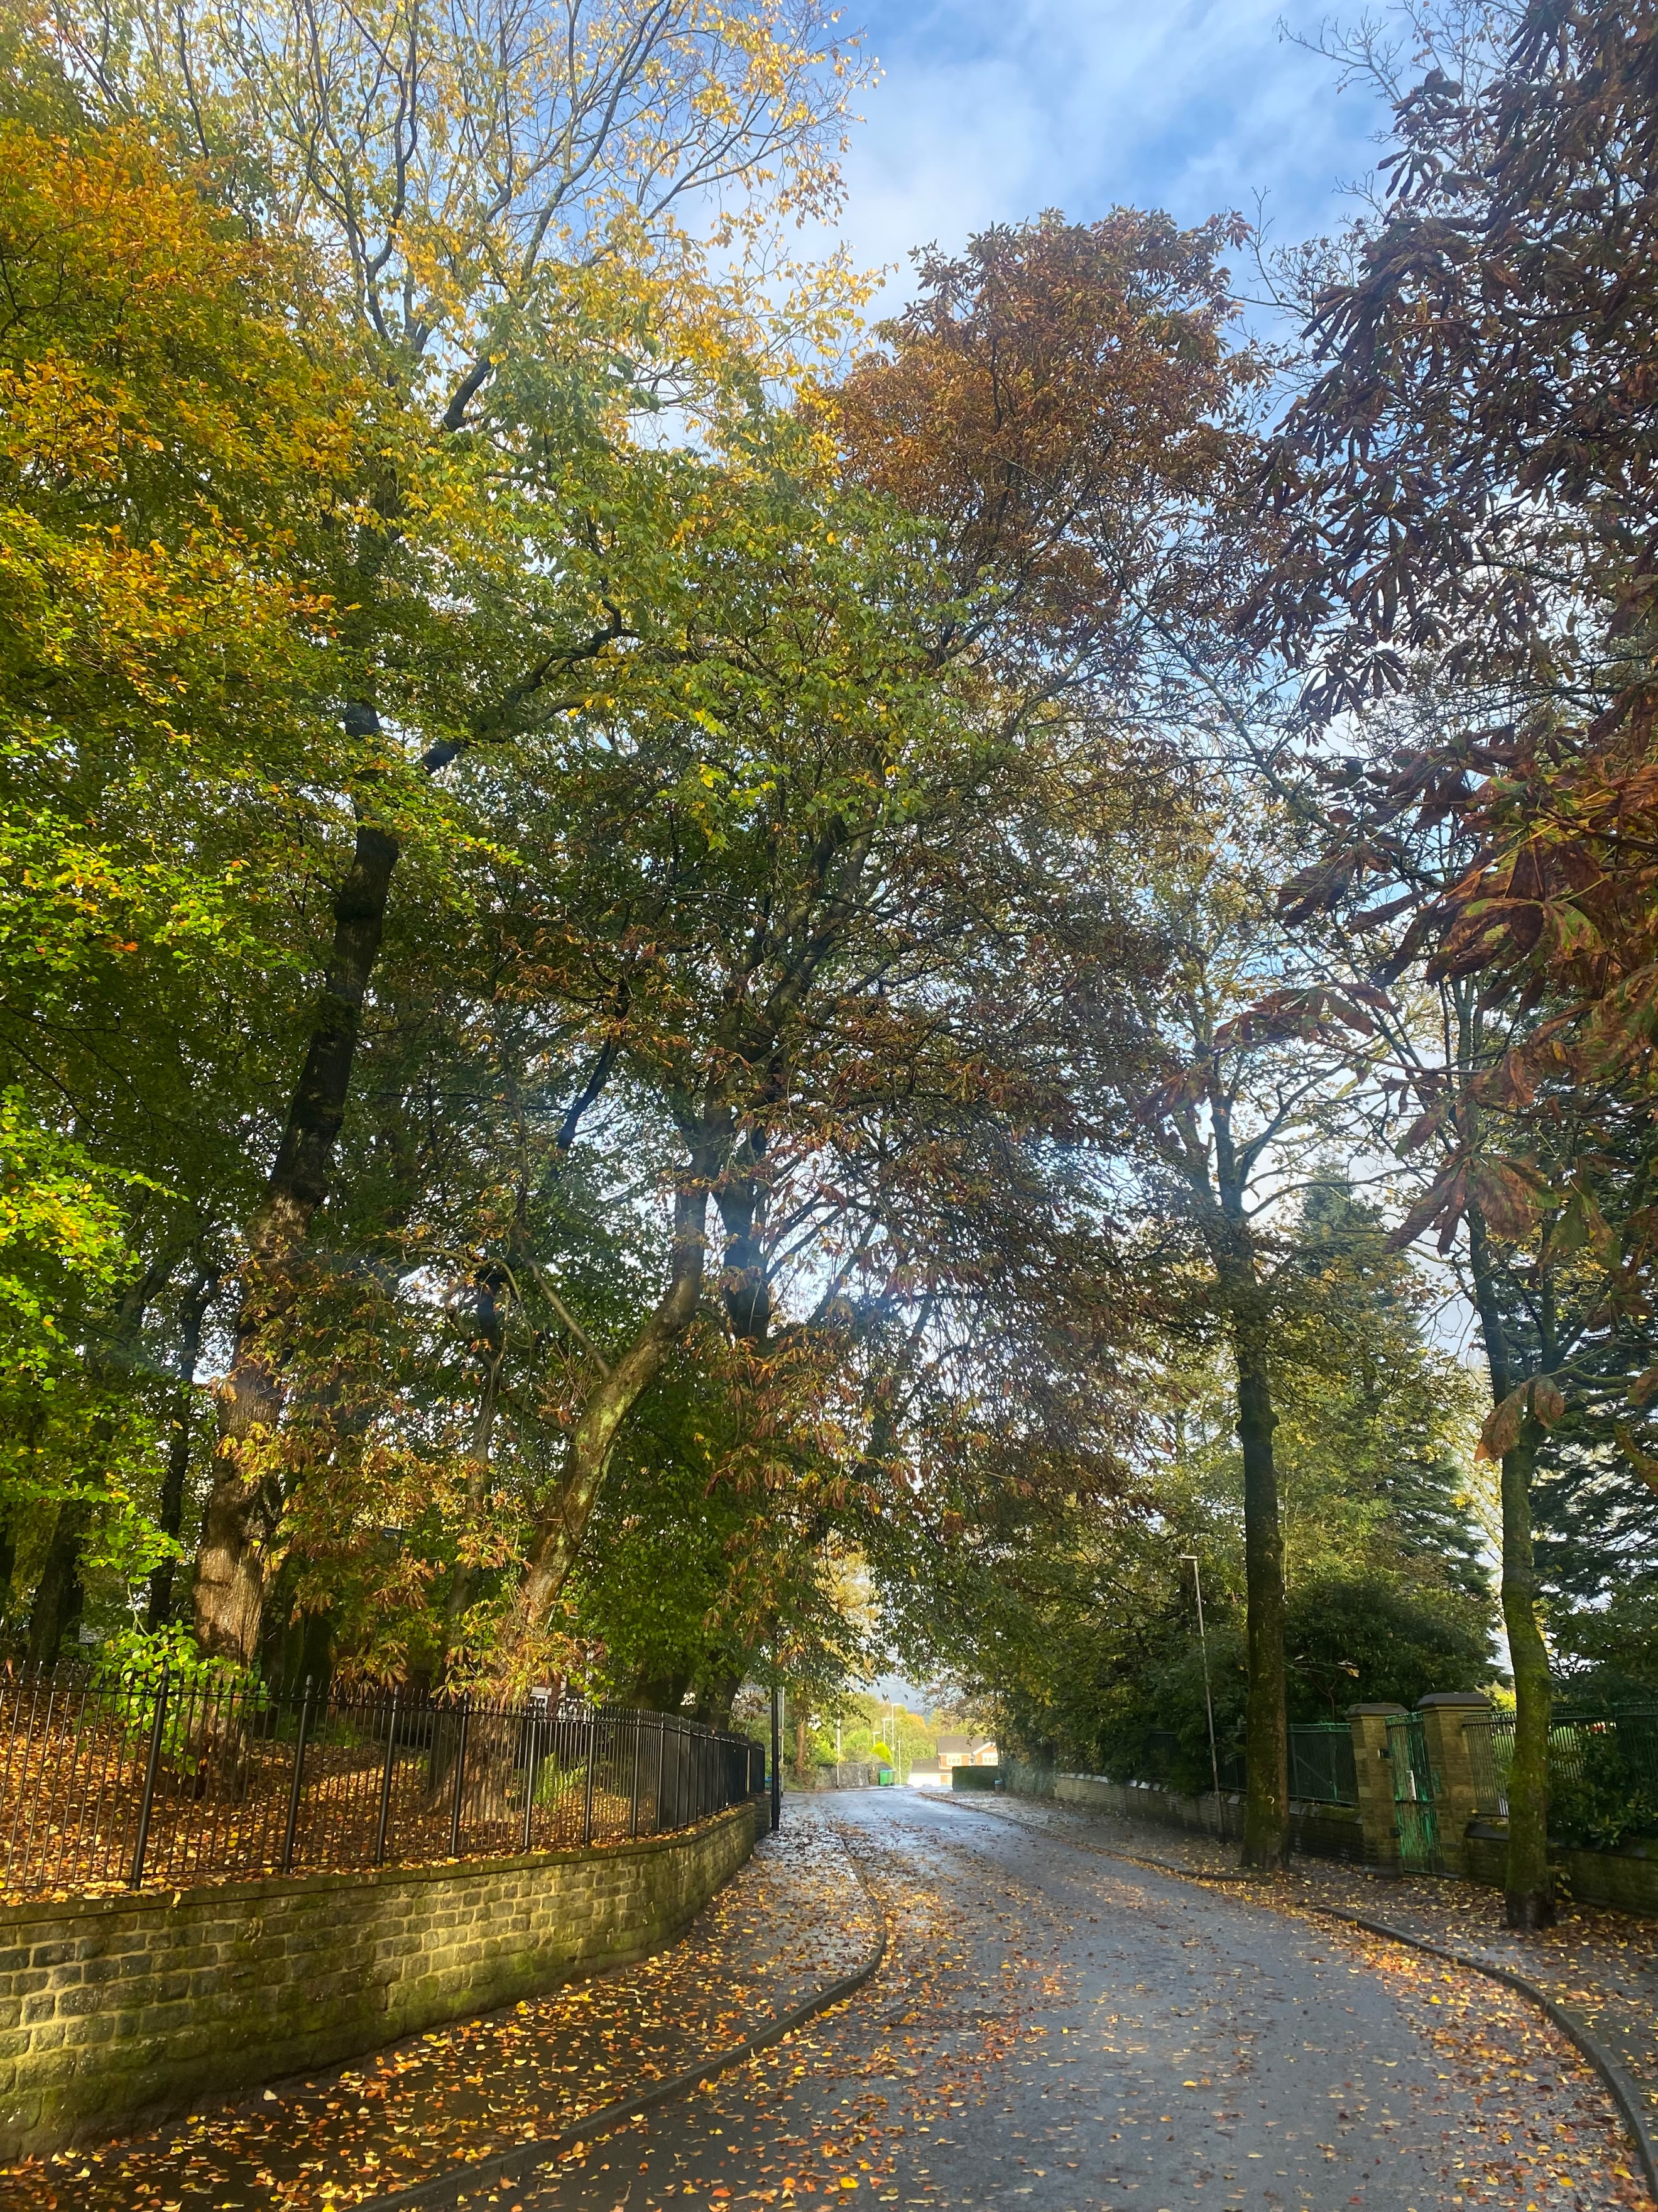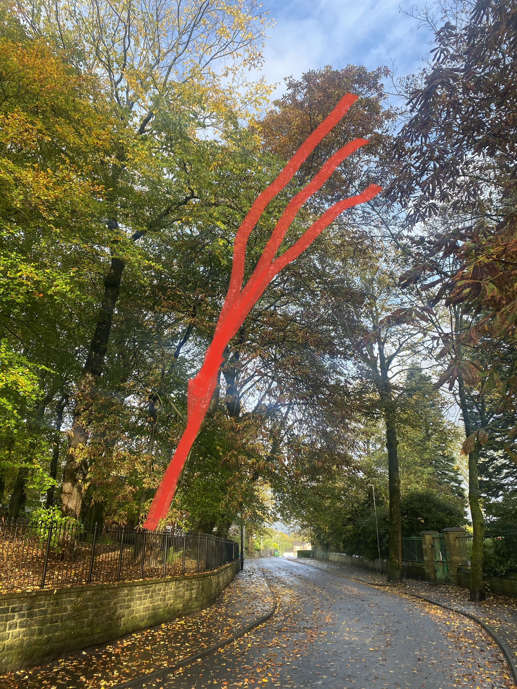
TREE 4 – HORSE CHESTNUT TREE WITH END WEIGHTED CANOPY – HIGHLIGHTED IN RED
CROWN THIN 15% EAST

