Schedule of materials for residential development at former High Birch School, Bolton Road, Rochdale, OL11 4RA.

- Breedon Flat Anthracite concrete roof tiles.

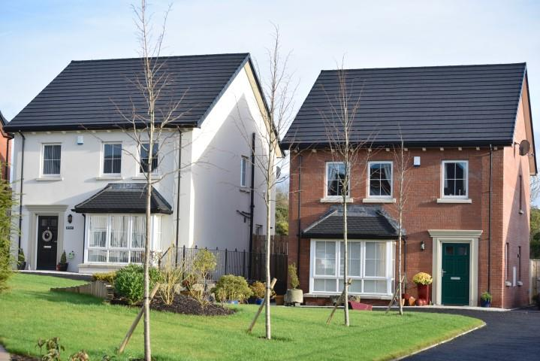

- Weinerberger Sunset Red Multi facing brickwork.

