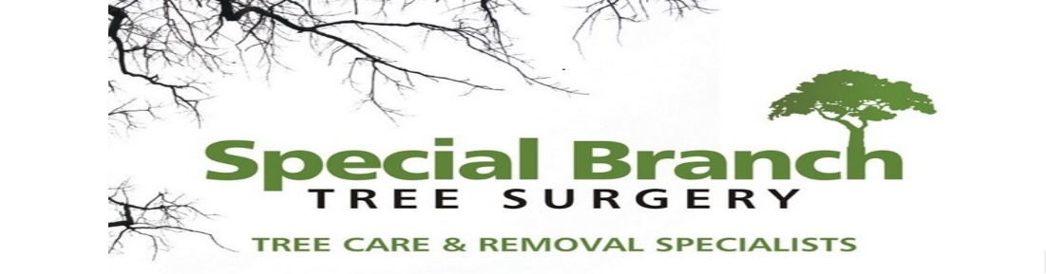

Top O’th Meadow Farm
Meadowhead Lane
Norden, Rochdale
OL11 5UL
Tel: 01706 658771

22nd November 2023

Vivian Buckley
3 Broadhalgh
Bamford, Rochdale
OL11 5LX

As requested, please see the completed tree report, as discussed this offers no guarantees as trees are living organisms and can fail at any time. We would also like to advise that no indemnity or insurance cover is offered. This report is in “my opinion” only and covers only the trees that have been inspected.

Trees in question are subject to a Tree preservation order – TPO079

Local authority: Rochdale

Location
Broadhalgh.

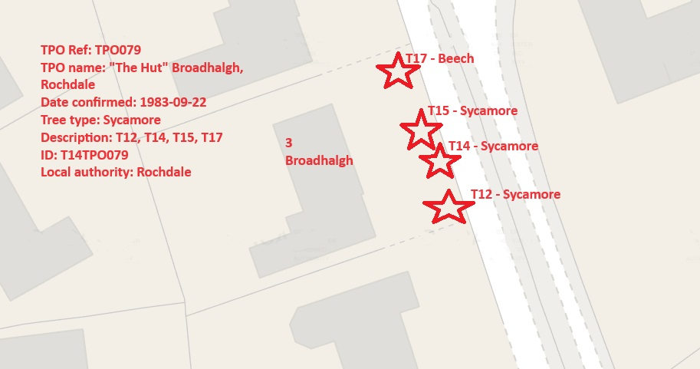

Work provided

Site visit, arboricultural inspection, photography, report, and quotation.
All trees have been thoroughly inspected and only the tree with any defects or concerns have been noted.

Trees included

T17 – Beech
T15 – Sycamore
T14 – Sycamore
T12 – Sycamore.

Issues found

All trees are situated at the front of the property causing excessive shading towards the property and are all of a mature size. Three out of the four trees have a healthy balanced crown. T14 is a poor specimen tree which has been secluded from T15 and T12 causing it to be predominantly top heavy, T14 I also showing signs of stem decay and potentially root rot. T14 will also be suffering from root compaction due to the small driveway entry and being located on the edge of the drive.

Recommendations

T17 – Sever ivy at base, crown thin up to 20%
T15 – Crown reduce from property by 1-2 meters, crown thin up to 20%
T14 – Remove, allowing more space for T15 and T12 to thrive and eradicating and future issues of T14.
T12 – Sever ivy at base, crown thin up to 20%

Crown Reduction of a Mature Tree
Crown reduction is a pruning technique used to reduce the size and shape of a tree’s canopy. This process involves selectively removing branches and foliage from the outer edges of the crown, resulting in a more compact and balanced tree structure. There are several reasons why crown reduction may be necessary for a mature tree:
1. Safety One of the primary reasons for crown reduction is to mitigate potential safety hazards. Overgrown trees with large, heavy branches can pose a risk of falling during storms or high winds. By reducing the overall size of the crown, the weight and leverage on individual branches are decreased, making the tree less susceptible to structural failure.
2. Health Crown reduction can also benefit the overall health of a mature tree. By removing dead, diseased, or damaged branches, the tree’s vitality and longevity can be improved. Additionally, reducing the density of the canopy allows for better air circulation and sunlight penetration, which can help prevent fungal diseases and promote new growth.
3. Aesthetic Purposes In some cases, crown reduction is performed to enhance the visual appeal of a tree. By shaping the canopy and maintaining a more uniform silhouette, the tree can complement its surroundings and contribute to an aesthetically pleasing landscape.

Reasons to Remove a Poor Specimen Tree
There are several reasons why it may be necessary to remove a poor specimen tree from a property. These reasons can range from the tree posing a safety hazard to it being diseased or damaged beyond repair. Here are some of the most common reasons for removing a poor specimen tree:
1. Safety Concerns: One of the primary reasons for removing a poor specimen tree is when it poses a safety risk. This can occur if the tree is leaning precariously, has large dead branches, or shows signs of decay. Such trees can pose a danger to people and property, especially during storms or high winds. In such cases, it is crucial to remove the tree to prevent potential accidents and damage.
2. Structural Issues: Poorly developed root systems, weak trunk structure, or other structural issues can make a tree unstable and prone to failure. In such cases, the tree may need to be removed to avoid potential hazards.
3. Aesthetic Considerations: In some cases, a poor specimen tree may detract from the overall aesthetic appeal of a landscape due to its unattractive appearance or poor form. Removing such a tree can enhance the visual appeal of the surroundings.
Tree root compaction issues can arise when the soil surrounding a tree's roots becomes densely packed or compressed. This compression limits the root's ability to absorb nutrients, water, and oxygen, leading to stunted growth or even the decline of the tree's health. It's crucial to avoid heavy machinery or excessive foot traffic around trees to prevent root compaction. Implementing techniques like mulching, aeration, or creating protective barriers can help alleviate this problem and support the tree's health.
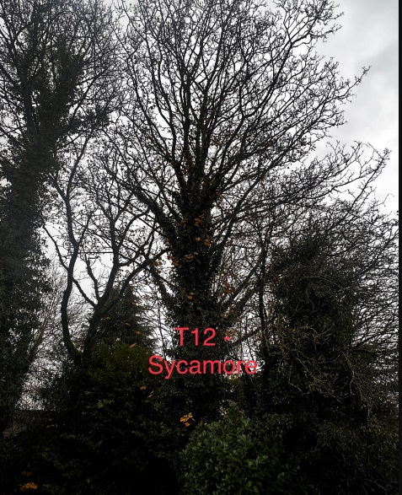

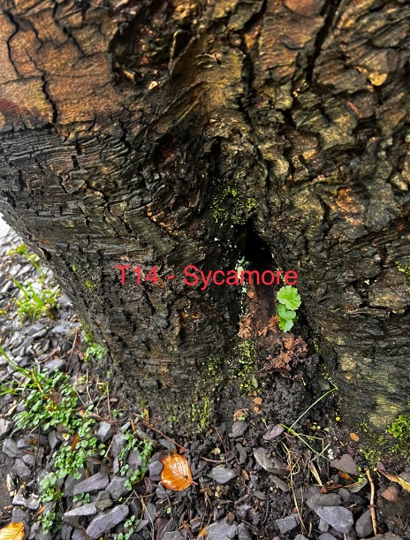

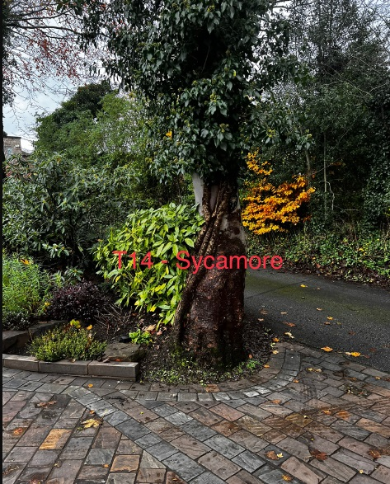

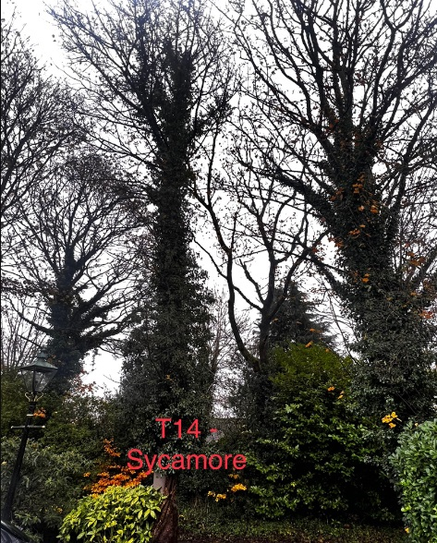

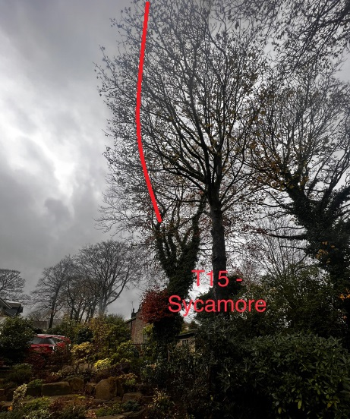

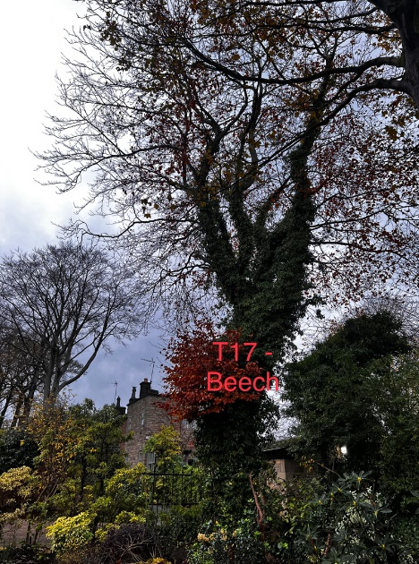
Kind regards,
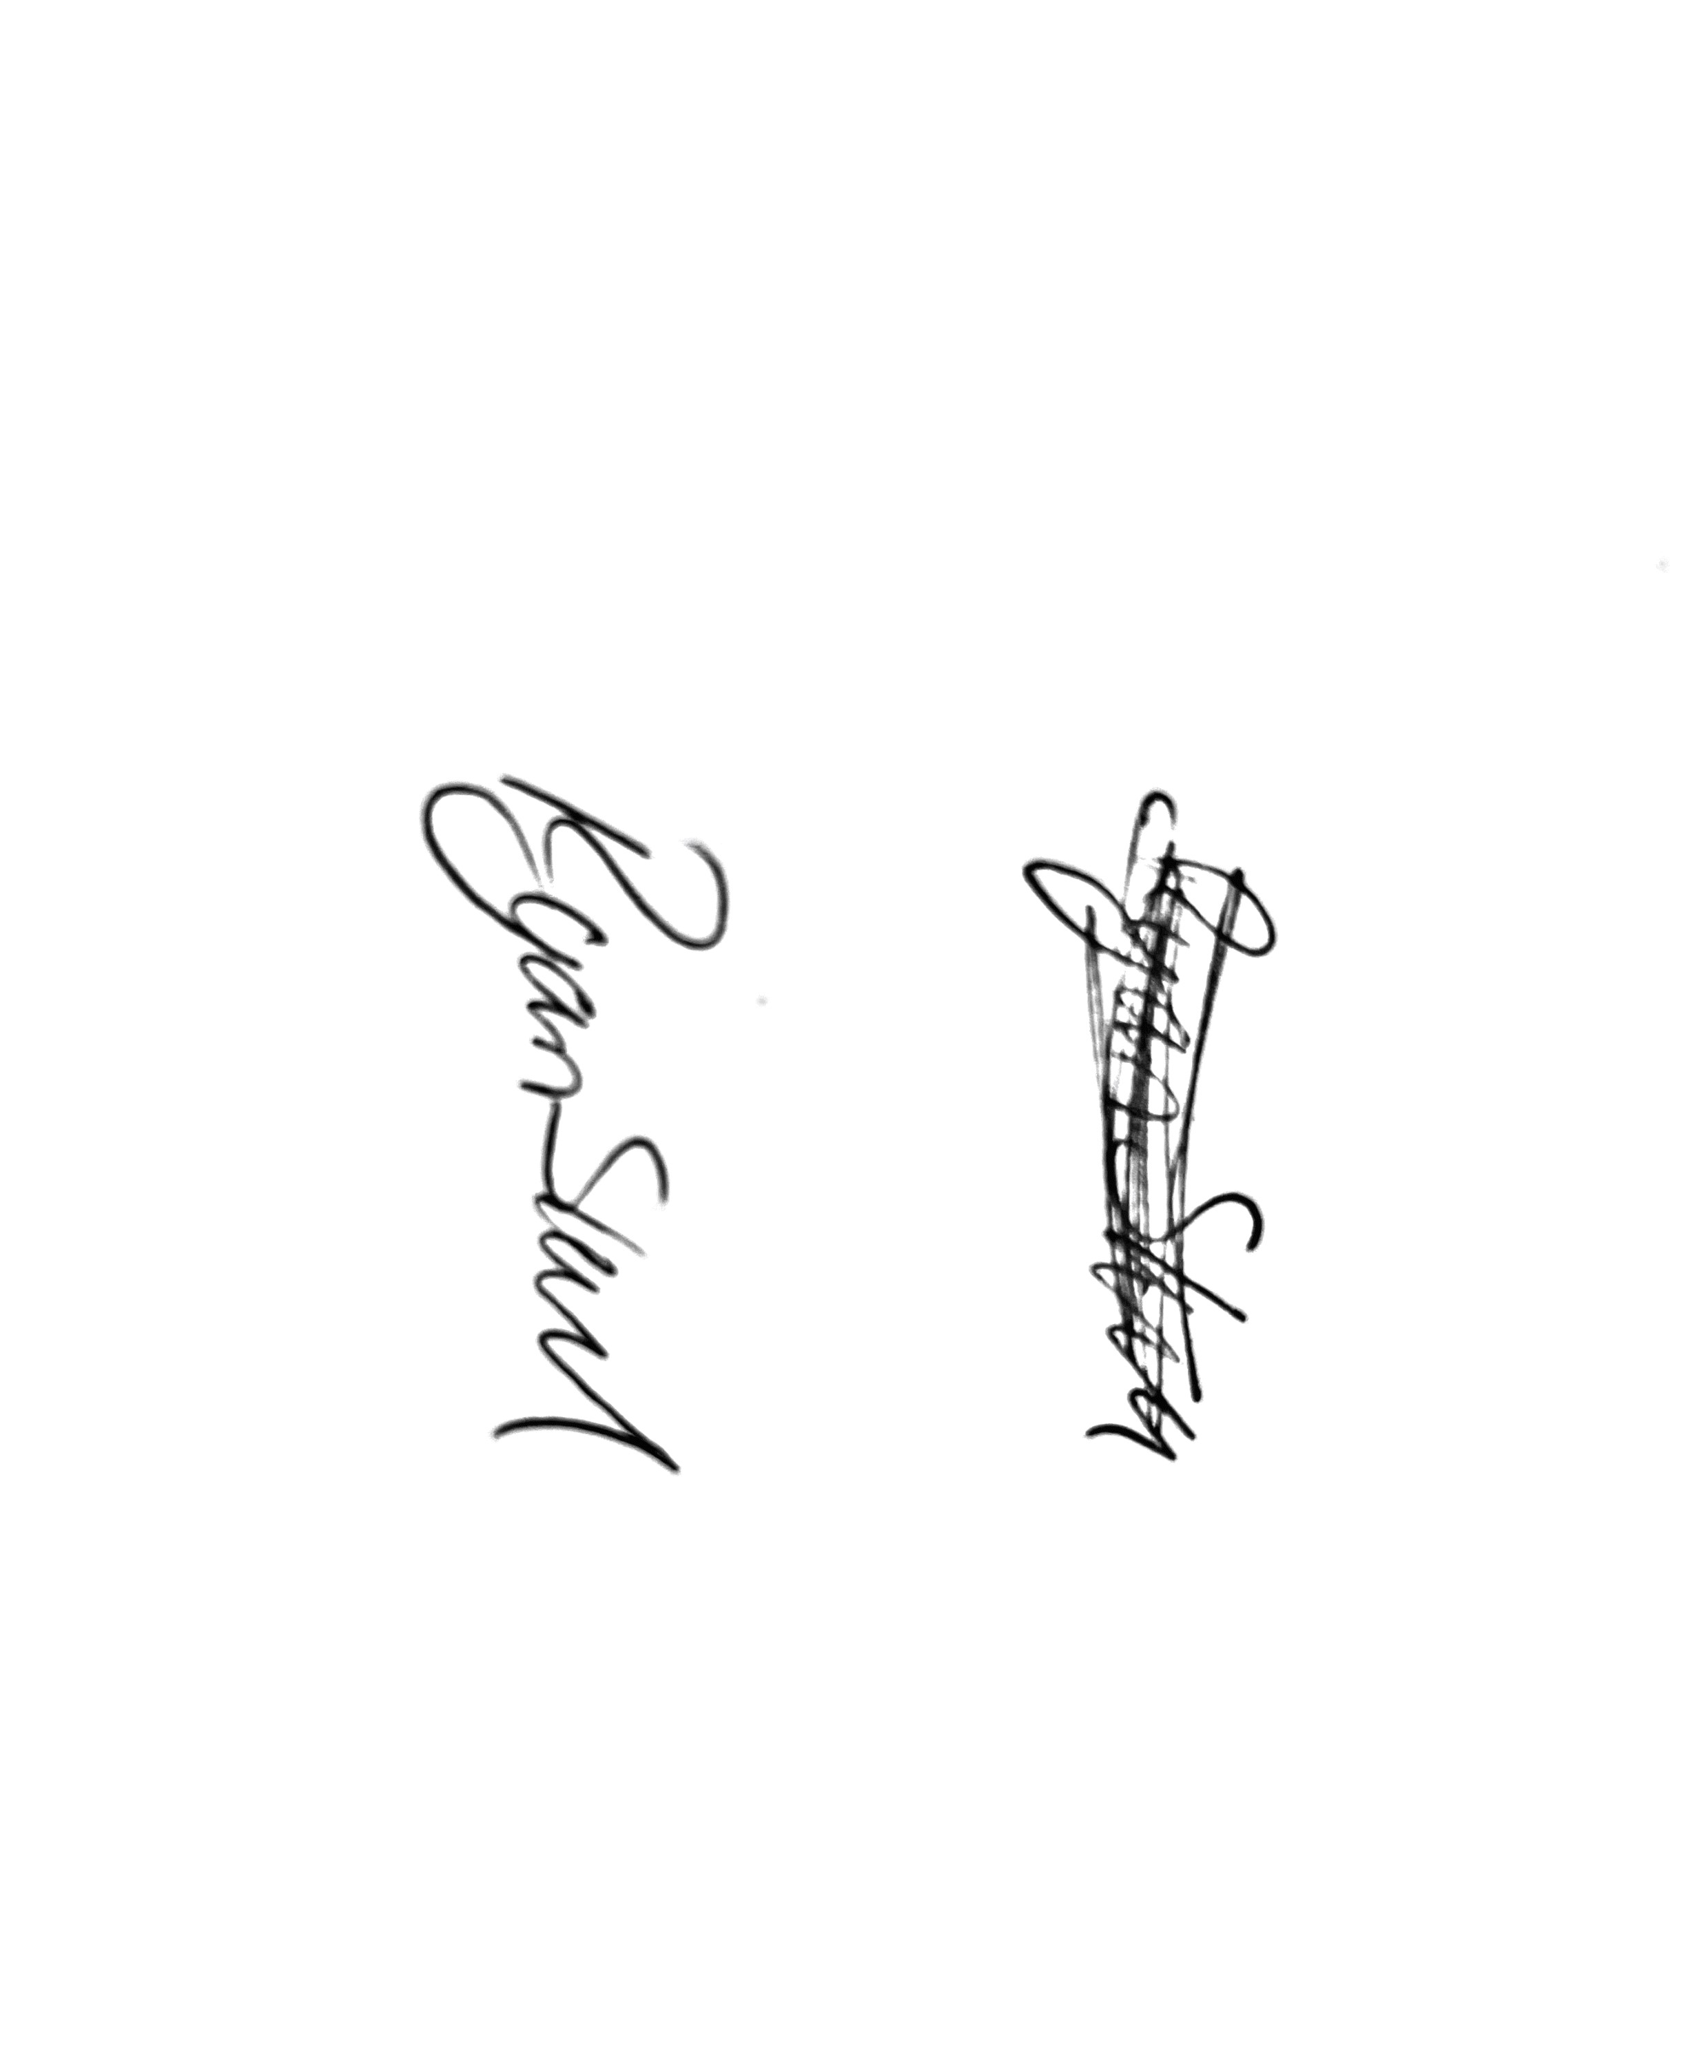
Mr. Ryan Slack
General Manager and Director
SEG Award, Cert Arb L2 (ABC)

