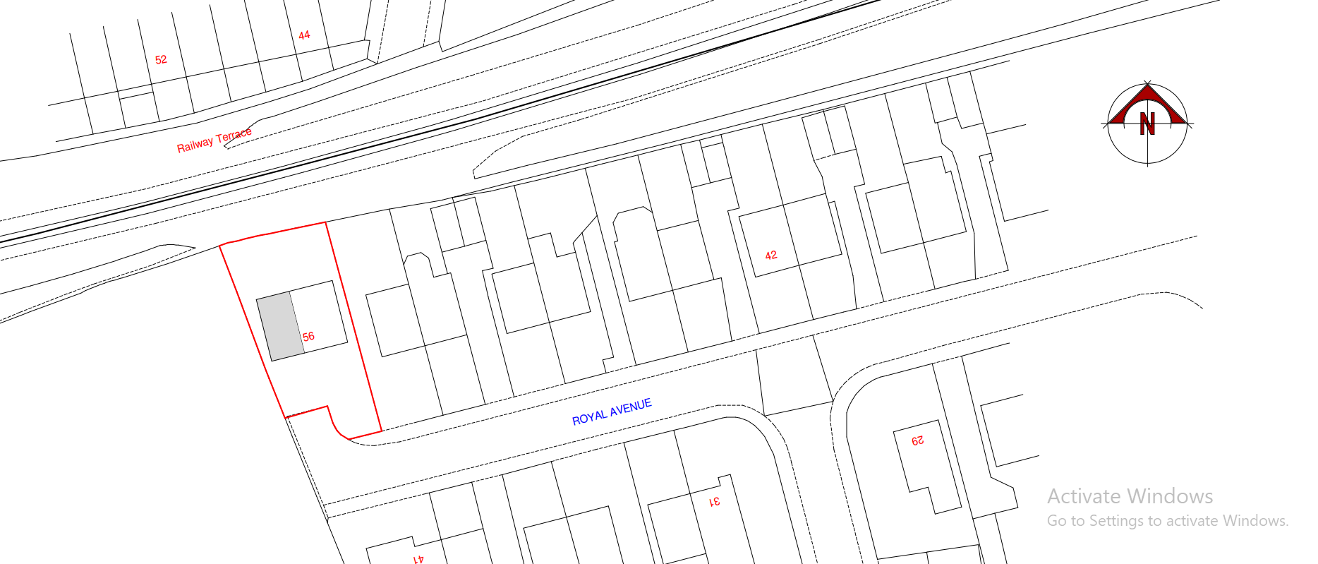
Two Parking Spaces
Off road – Driveway

