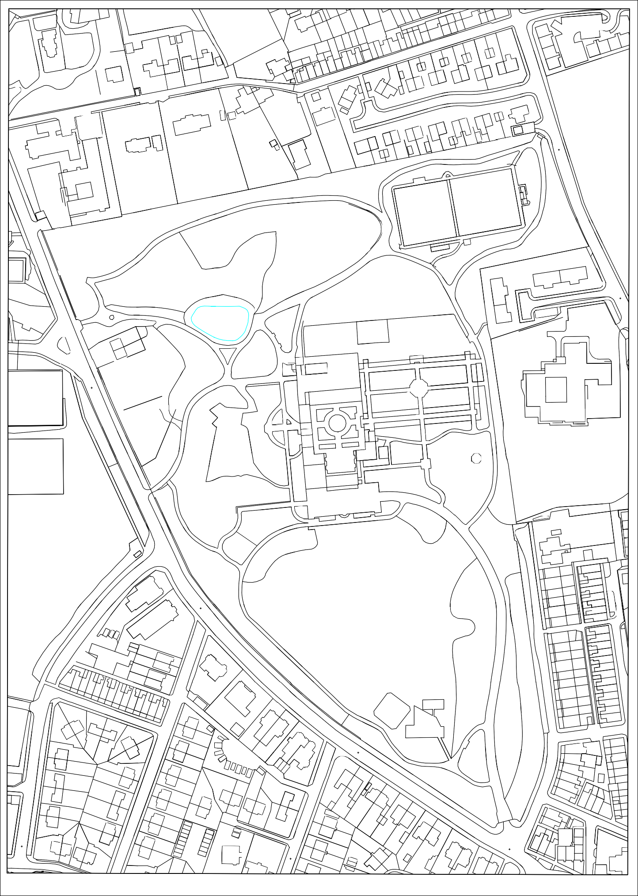
The Heights
2
10

Bentfield
18
20
4
34

The Coach House
2
30
32
22 20a 20

Meadow Lodge
14
16
60
48
BENTMEADOWS
14
2
62
68

Falinge Lawn East
1
28
BENCH CARR
Falinge Lawn
29
35
BENTMEADOWS

Falinge Corner
31a
25
13
El Sub Sta

Falinge Corner
ROAD

El Sub Sta
HEIGHTS LANE
13 to 18
7 to 12
1 to 6
BROWNHILL VIEW

Brownhill School
102 100
19 to 21

Bandstand
FALINGE ROAD
118
11
77

El Sub Sta
14
28
GREENHILL AVENUE
2
24
90
94
STANLEY STREET
84
SHERIFF STREET
106
80
22
24
36
26
1
7
71
77
81
89
35
37
45
63
49
STREET
SHERIFF
33
CHASELEY ROAD
35
27
39
CLARKE'S
LANE
CLARKE'S
LANE
Chaseley
KNOWSLE

The Vicarage
20
116
114
2
WILTON TERRACE
2
8
TIFLIS STREET
30
ROAD
FALINGE
12
14
14
70
124
26
68
66
57
69
25
3 1
GREEN LANE
93
15
CHASELEY ROAD
91
CLEMENT ROYDS STREET
12

39
110

The 0ld Vicarage

H

Pente C
47

Oc Crown Copyright Reserved. Licence Number 100023108

