SPECIAL BRANCH
`

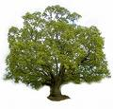
Tree Surgeons Ltd
Top O’th Meadow Farm
Meadowhead Lane
Norden, Rochdale
OL11 5UL
Tel: 01706 658771

Mini Tree Report Date: 25th September 2023

Joanne Elcock
26 Marland Old Road
Rochdale
OL11 4QY
As requested, please see my mini tree report, as previously mentioned this offers no guarantees as trees are living organisms and can fail at any time. We would also like to point out no indemnity or insurance cover is offered. This report is in “my opinion” only and covers only the trees that have been inspected.

Tree in question subject to Tree Preservation Order
TPO Ref: TPO036
TPO name: High Birch School Rochdale
Tree type: Oak Beech Elm Sycamore Lime Silver Birch Horse Chestnut Hawthorn Holly
Description: A1
ID: A1TPO036
Local authority: Rochdale

Location

Rear garden of No.26 Marland Old Road

Work done

Site visit, arboricultural inspection, photography and report.

Trees in question

T1, T2 & T3 all mature Beech trees (see plan attached)

Problem

- The trees are causing excessive shading to the two gardens and patio areas
- The trees are encroaching on the property
- The trees have not been maintained and contain dead wood and overhang to the rear of the property.

Recommendation

T1 Beech 550mm DBH x 25 meters high - 2-3meter reduction back from the property to give room for the house, improve light and improve form and balance of the tree, plus remove any deadwood. Also, to crown lift to 5 meter to help improve tree and garden amenity.

T2 Beech 500mm DBH x 22 meters high - 2-3meter reduction back from the property to give room for the house, improve light and improve form and balance of the tree. plus remove any deadwood. Also, to crown lift to 5 meter to help improve tree and garden amenity.

T3 Beech 600mm DBH x 25meters high - 2–3-meter reduction back from the property to give room for the house, improve light and improve form and balance of the tree. plus remove any deadwood. Also, to crown lift to 5 meter to help improve tree and garden amenity.

This maintenance will help with a number of problems while not affecting the health of the trees and improving the amenity value.

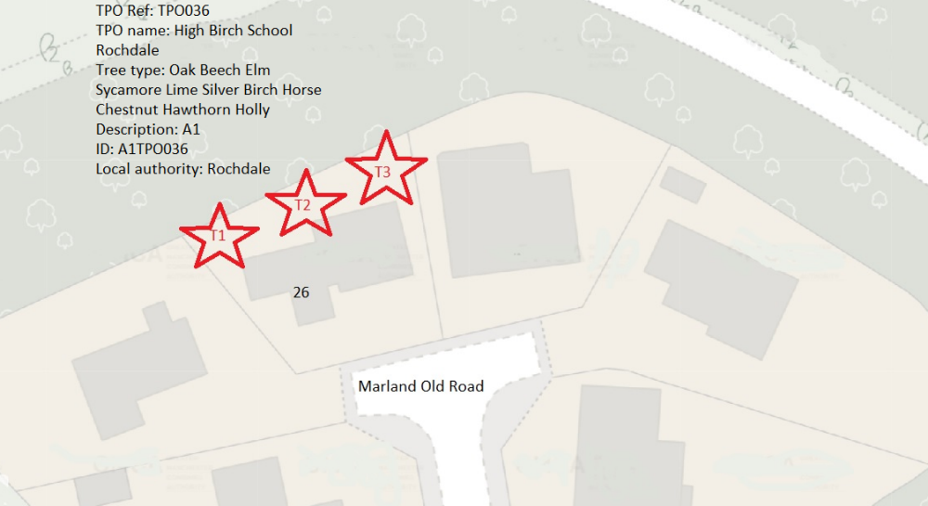

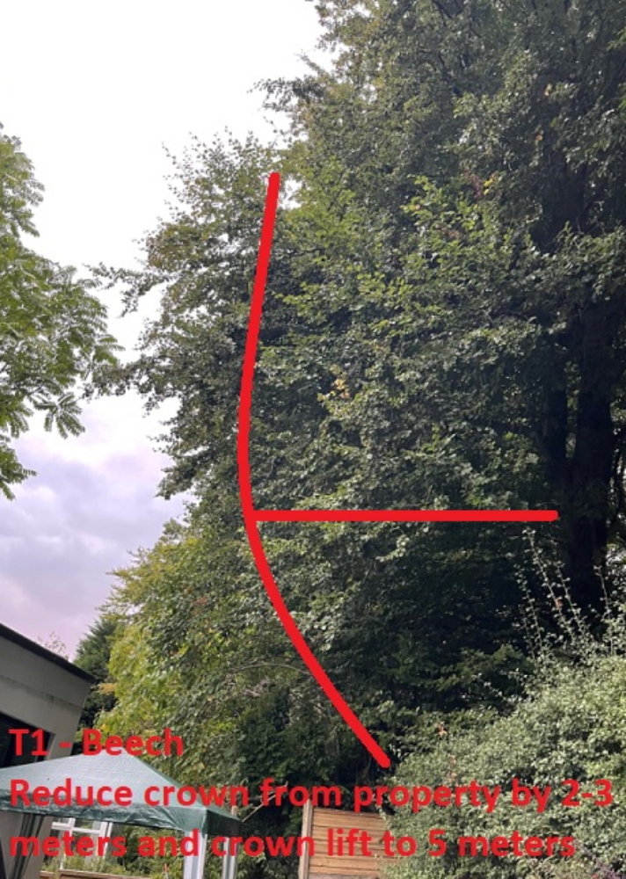

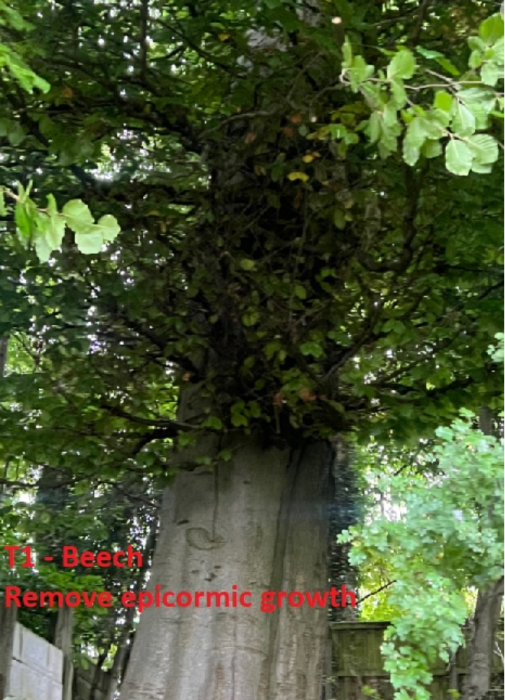

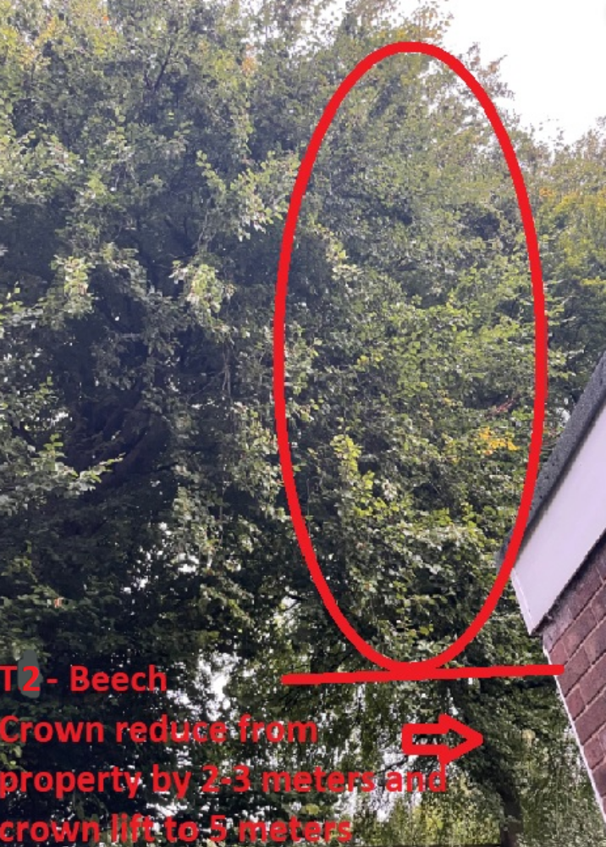

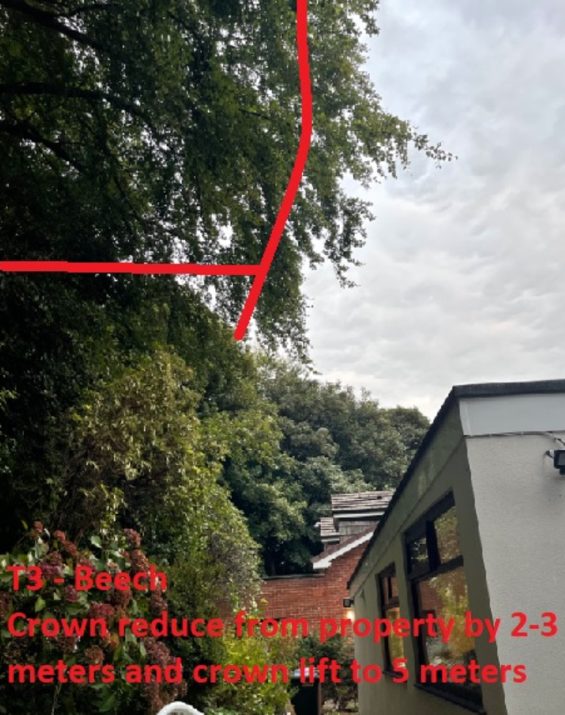

Regards

C.Ashton
Mr C. Ashton cert Arb L2 (ABC)

