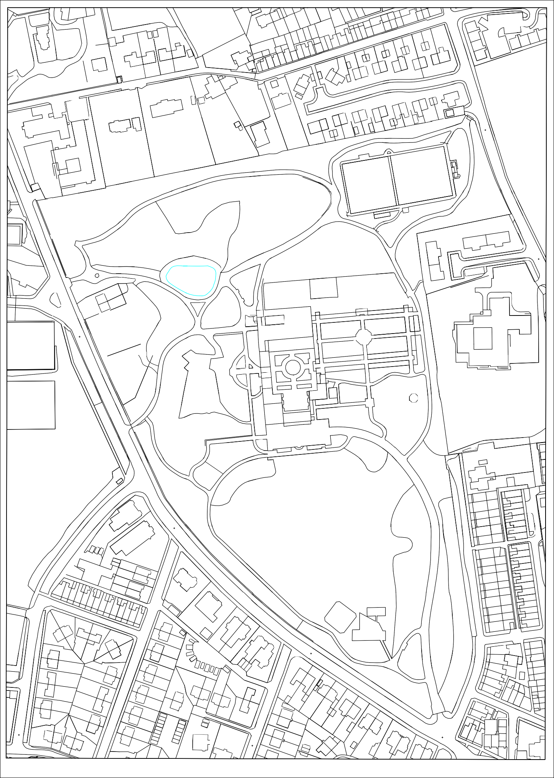
The Heights
2
10

Bentfield
18
20
4
34

The Coach House
2
30
32
22 20a 20

Meadow Lodge
14
16
60
48
BENTMEADOWS
14
2
62
68

Falinge Lawn East
1
28
BENCH CARR
Falinge Lawn
29
35
BENTMEADOWS

Falinge Corner
31a
25
13
El Sub Sta

Falinge Corner
ROAD
APEX Roofs
New roofs to be installed reusing tiles where possible and matching tiles where this is not

El Sub Sta
HEIGHTS LANE
13 to 18
7 to 12
1 to 6
BROWNHILL VIEW

Brownhill School
102 100
19 to 21

Flat roof with corrugated metal sheeting
Corrugated roof to be removed & replaced with new felt roof

Bandstand
FALINGE ROAD
118
11
77

Flat roofs
Repair only

El Sub Sta
14
28
GREENHILL AVENUE
2
24
90
94
STANLEY STREET
84
SHERIFF STREET
106
80
22
24
36
26
1
7
71
77
81
89
35
37
45
63
49
STREET
SHERIFF
33
CHASELEY ROAD
35
27
39
CLARKE'S
LANE
CLARKE'S
LANE
Chaseley
KNOWSLE

The Vicarage
20
116
114
2
WILTON TERRACE
2
8
TIFLIS STREET
30
ROAD
FALINGE
12
14
14
70
124
26
68
66
57
69
25
3 1
GREEN LANE
93
15
CHASELEY ROAD
91
CLEMENT ROYDS STREET
12

39
110

The 0ld Vicarage

H

Pente C
47

Oc Crown Copyright Reserved. Licence Number 100023108

