

Top O’th Meadow Farm
Meadowhead Lane
Norden, Rochdale
OL11 5UL
Tel: 01706 658771

29th January 2024

Vivian Buckley
3 Broadhalgh
Bamford, Rochdale
OL11 5LX

Newly planted trees and aftercare
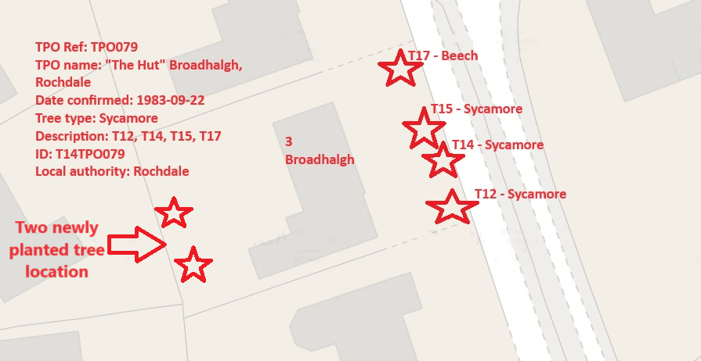

Vivian will choose from the list of which tree’s he will plant to replace the Sycamore removal from the list below.

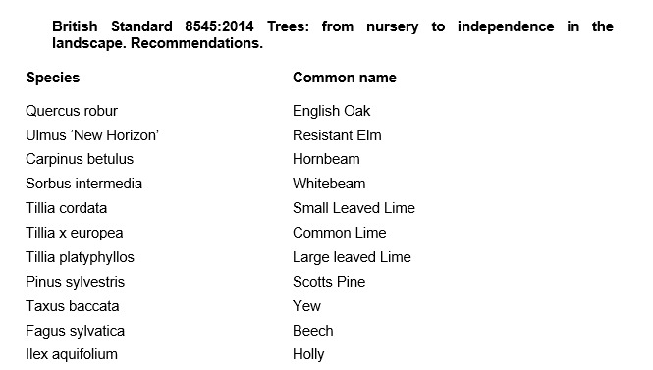

Aftercare

To ensure success when planting trees, providing good aftercare is as important as good planting practice. The first two to three years after planting are critical for a tree’s establishment. Planted well and cared for correctly, it should flourish and become a valuable feature in your garden. It is an investment of time and money, and it would be a shame to lose the benefit of a fine tree through post-planting neglect. The first challenge is moving the plant from the nursery to its new home: this can cause stress to any tree. Give it attention for the first few years to ensure re-establishment and survival in its new location. Watering, weeding, staking, mulching and formative pruning are important for successful establishment, but none are onerous or time consuming. Tree aftercare the guidelines on these pages apply primarily to ornamental trees: fruit trees are established in the same way, but pruned and managed differently to maximise fruit production. Newly planted trees ideally need regular watering in dry spells for three to five years to ensure good root growth. After planting a tree, pruning may be necessary to enhance the natural shape or improve its structure and strength. In the first few years, identify and correct problems with the main framework of the tree – prune early, as this helps avoid future complications. With a young tree, one of the most common tasks is to remove lower branches that begin to interfere with other gardening activities, create shade or block views. Look out, too, for pests such as aphids and diseases such as canker – they can reduce the vigour of your tree and make establishment slower. If you keep your tree vigorous and healthy, it is less likely to succumb to pests and disease

For the first two to three years, irrigate newly planted trees weekly during dry spells in spring and summer. Too much water, and roots will not extend in the search for moisture – but underirrigation results in slow establishment and symptoms of stress, such as canopy dieback and bark splits on the trunk. Water directly at the base of the tree and, particularly if the ground is dry, apply slowly to stop it running off. Make sure water has penetrated the soil; on our well-drained soil, we apply two to three full watering cans of water per week to new plantings.

From initial planting, mulch annually in spring or autumn to suppress weedy competitors and help retain soil moisture. ✤ Organic or inorganic materials can be used; composted wood chippings, leaf mould and well-rotted manure. ✤ Organic materials should be part composted: six-month-old wood chip is ideal. ✤ Mulch should be 7–10cm (3–4in) deep; avoid piling it round the trunk as this can soften the bark.

New trees should be staked until their roots provide good anchorage – this can take several years. If loose, the tree will rock in the wind and its root ball will move, which hinders plant establishment and could even result in death. ✤ Check ties are secure and a padded cushion is between the tree and stake. Rubbing against a stake can create a scar, which leaves the tree open to disease. ✤ Check regularly: ties left too tight cause serious bark damage. Fast-growing trees may need ties loosening every year.

Formative pruning trees
Formative pruning is the process of shaping a tree when it is young. Every variety has a different natural growth habit, but unpruned trees will for the most part produce a crown cluttered with branches. The aim is to develop an open, balanced network of strong, unshaded branches and at a height that allows for good management such as grazing livestock and machinery. This is achieved by creating a good height trunk and pruning young growth back to encourage the tree to grow in the right direction and develop thick branches.

Kind regards,


Mr. Ryan Slack
General Manager and Director
SEG Award, Cert Arb L2 (ABC)

