Demolition Site Notices – 6 Blocks on Lower Falinge Estate
Ollerton OL12 6QZ
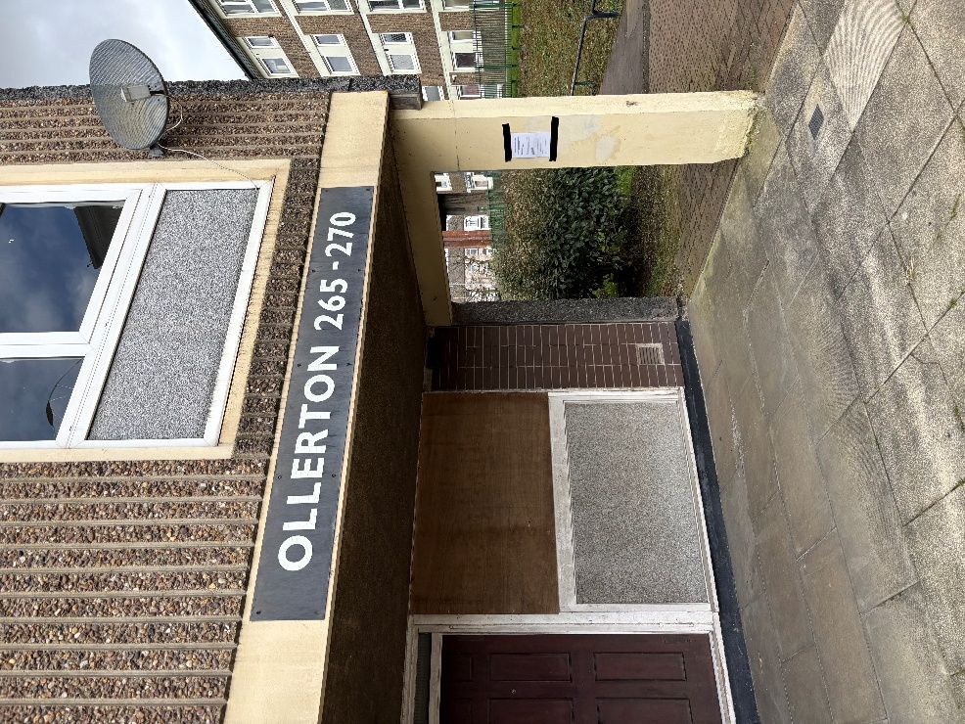 | 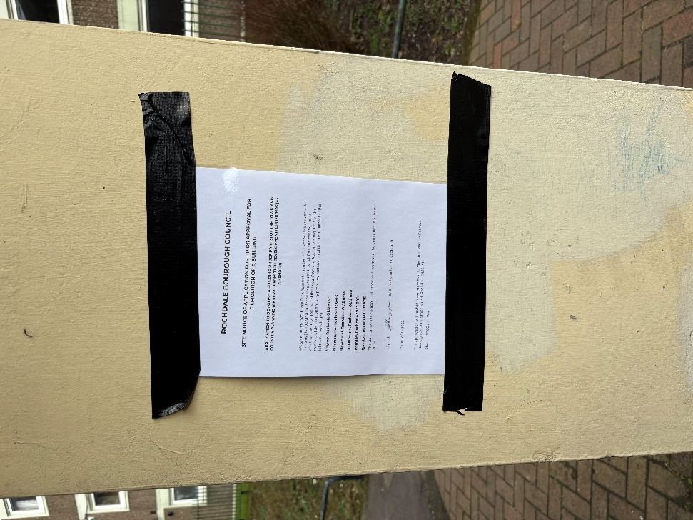

Newstead OL2 6PQ
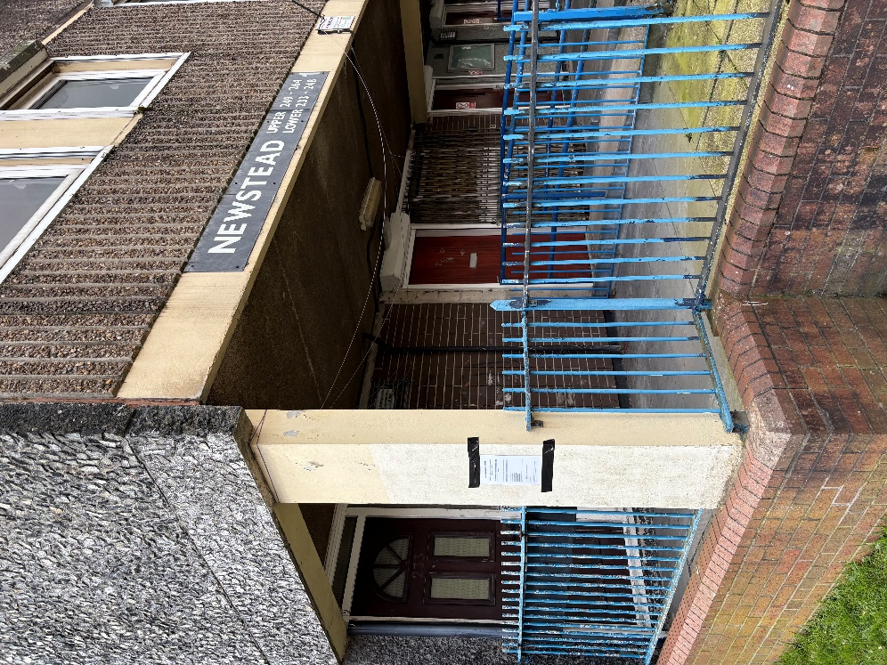 |  | 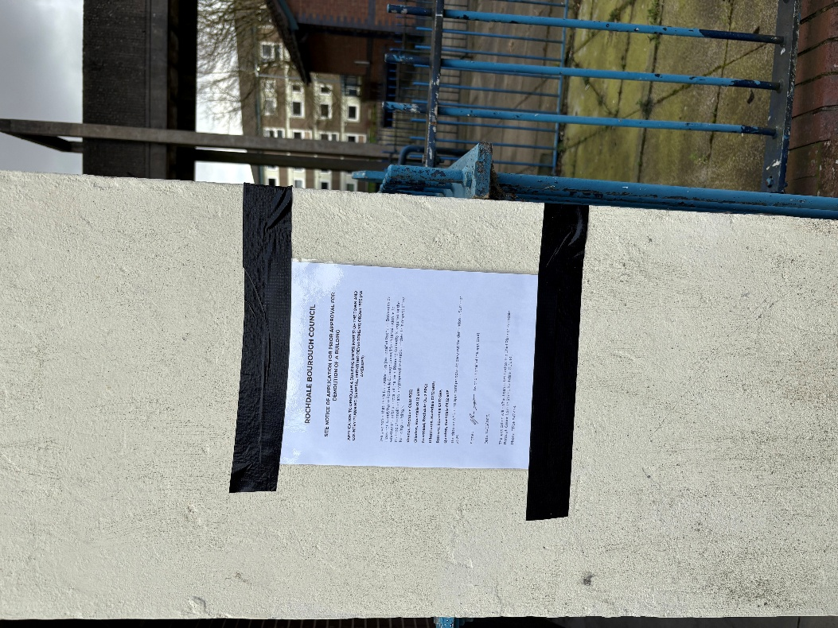
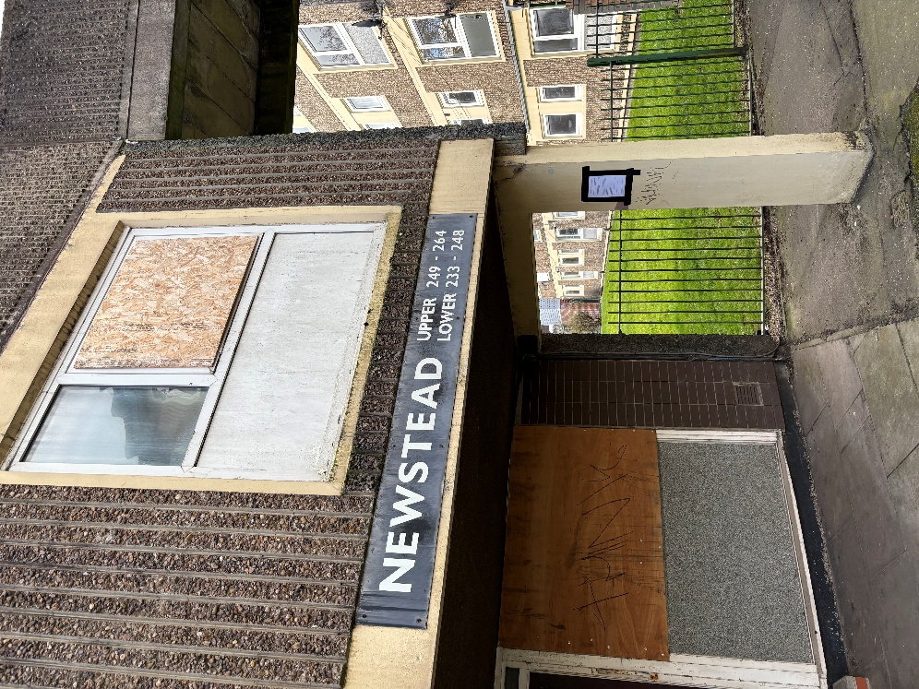 |  | 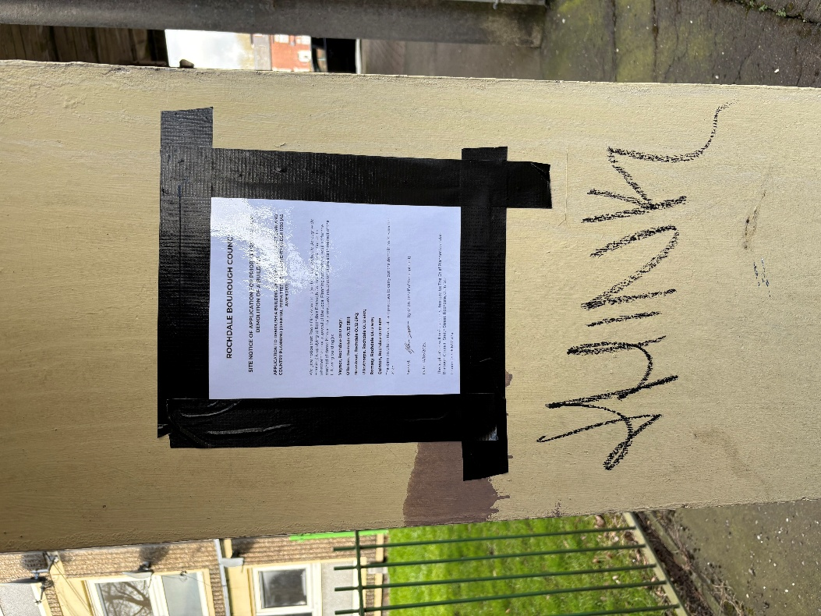
 | Vaynor OL12 6QZ
 | 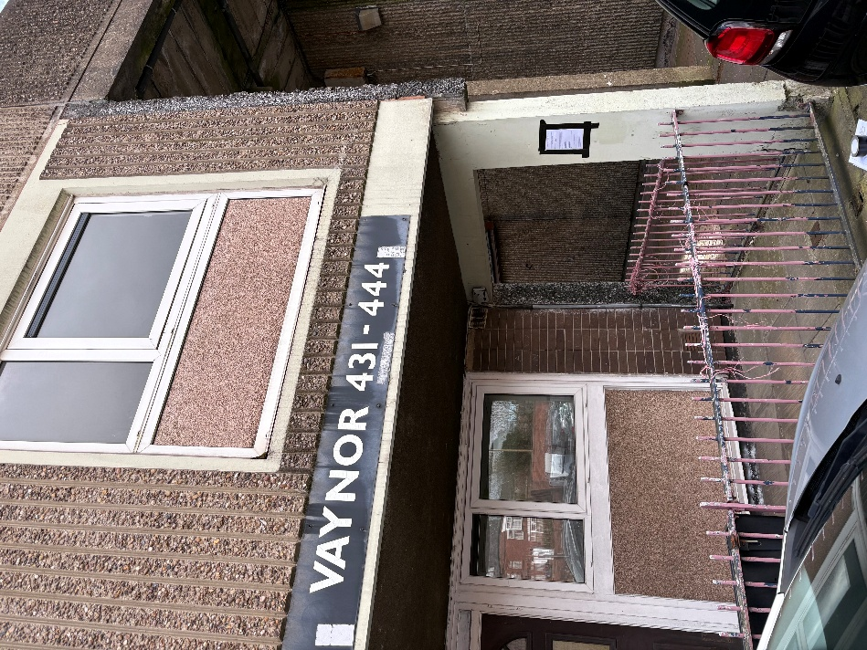 |  | 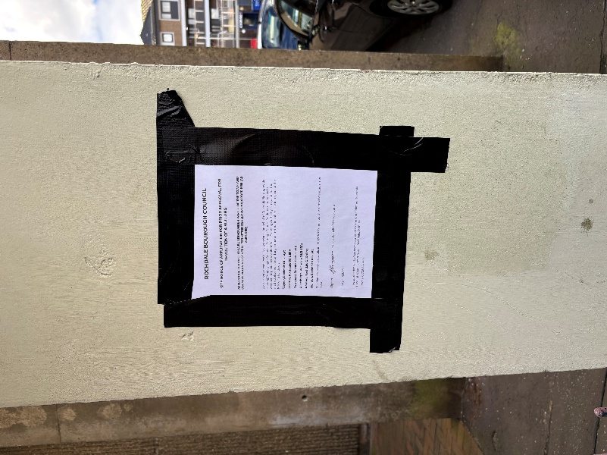
 | 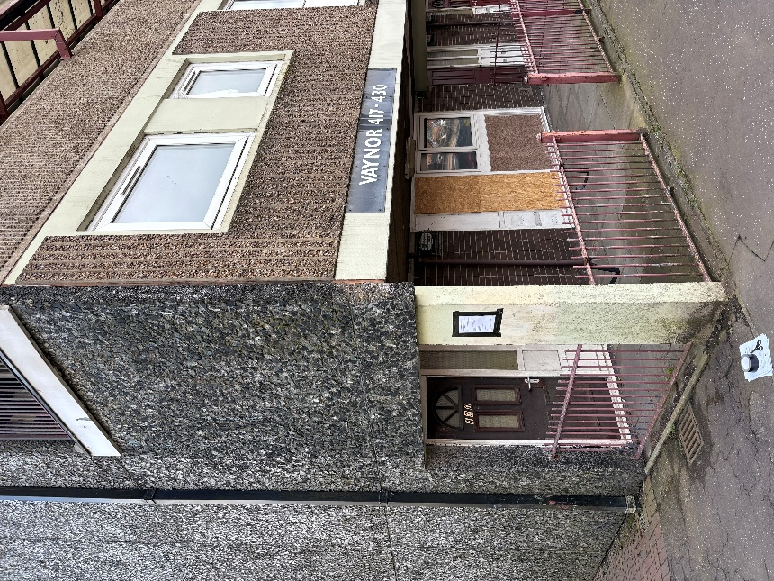 |  | 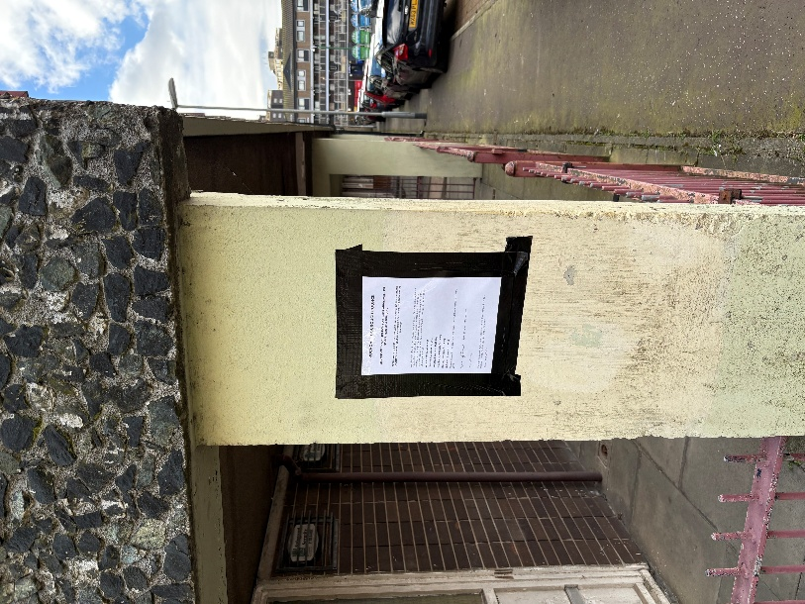

Ullesthorpe OL12 6RA
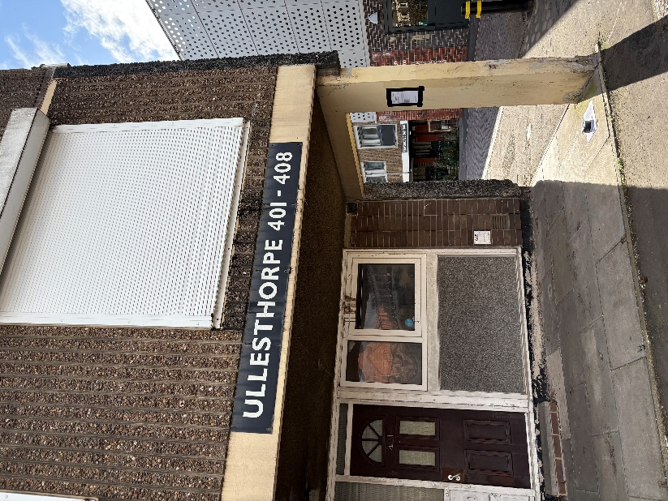 | 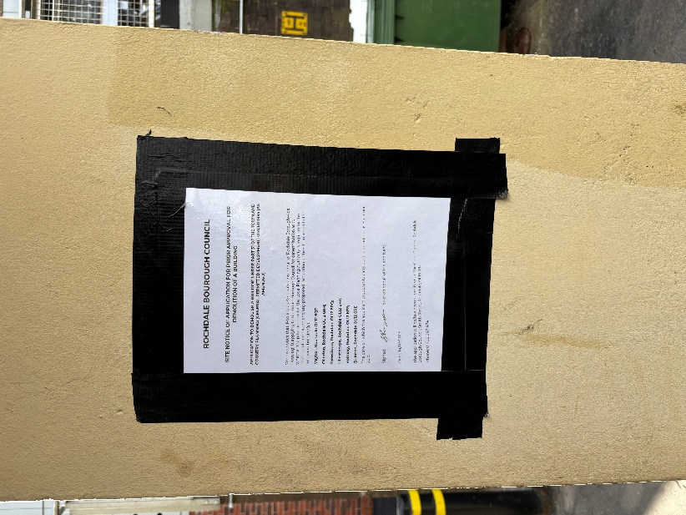
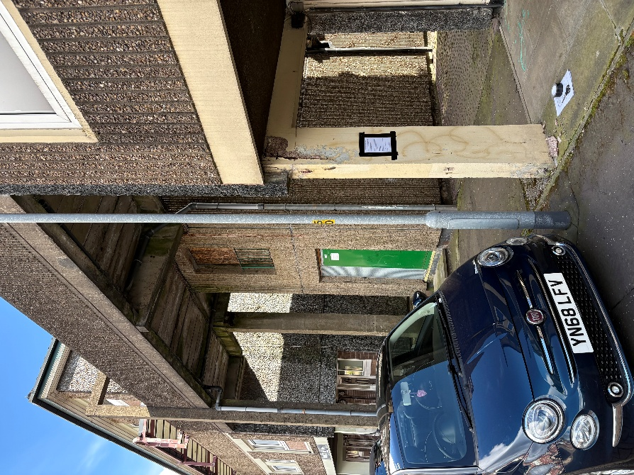 | 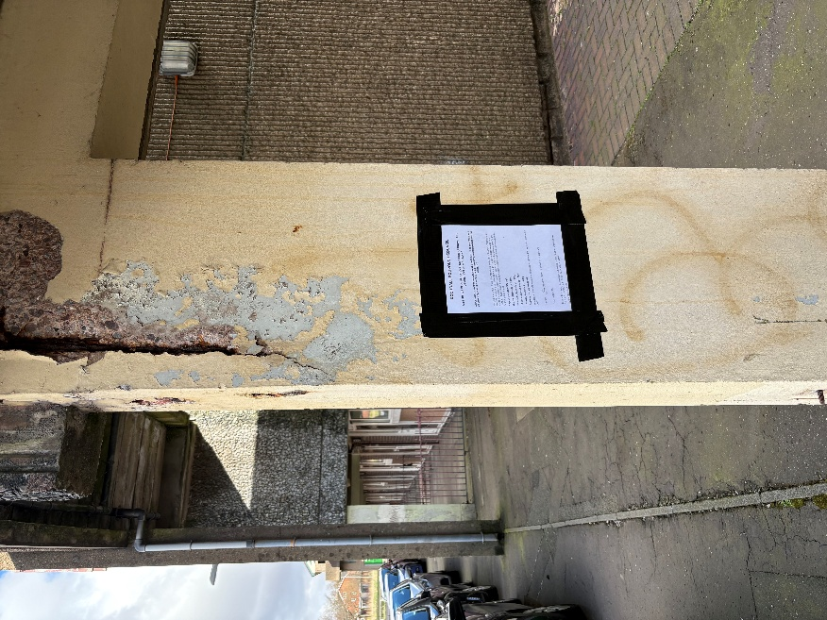

Quinton OL12 6RE
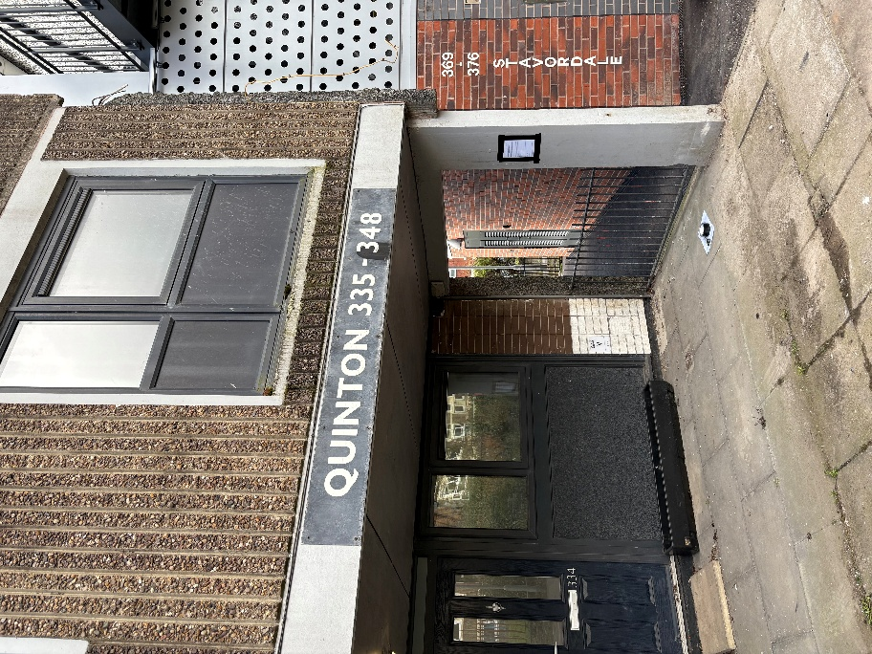 | 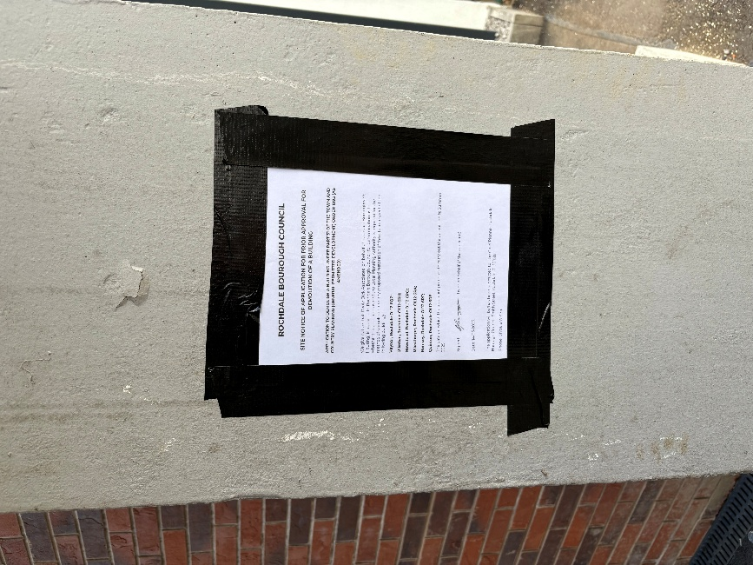

Romsey OL12 6RF
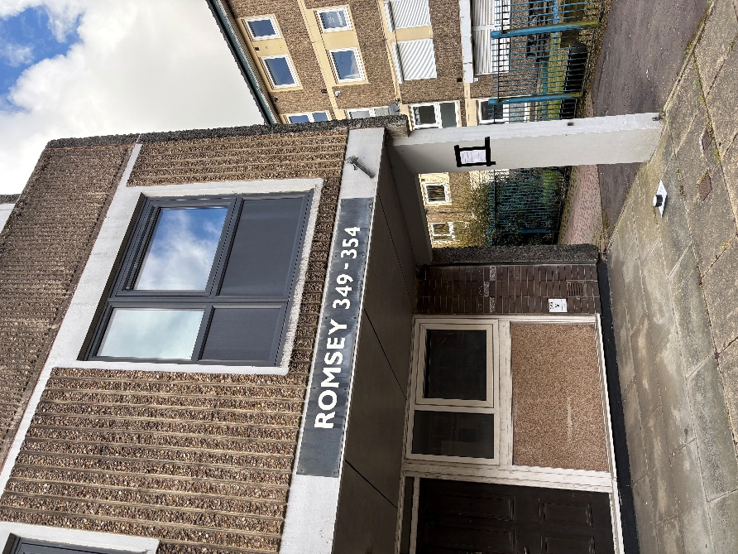 | 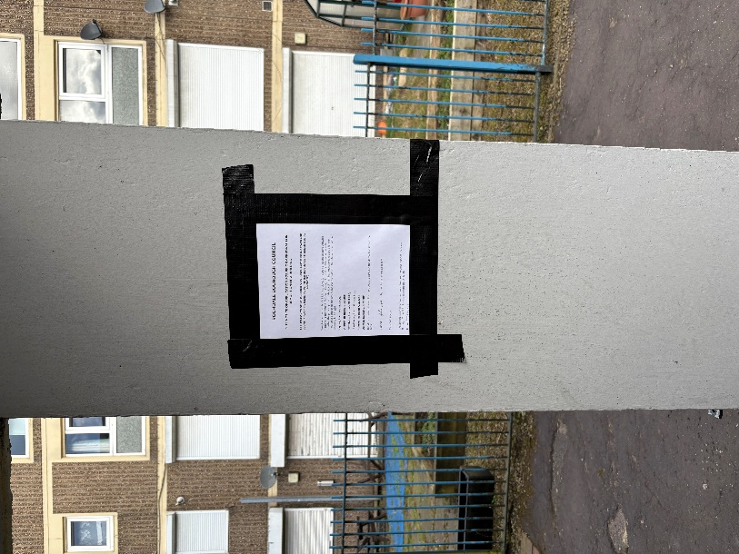
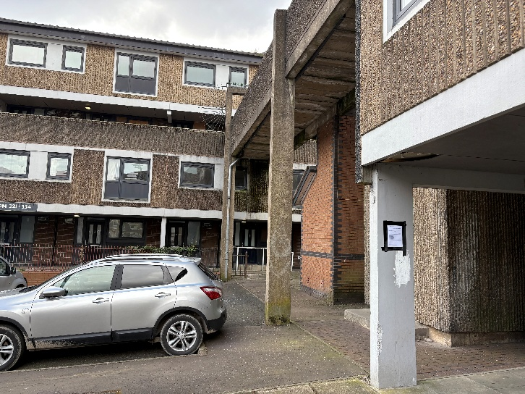 | 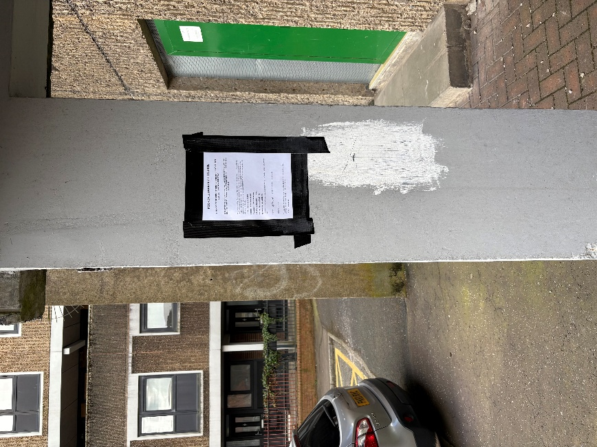

Below is an example of the Notice erected

ROCHDALE BOUROUGH COUNCIL

SITE NOTICE OF APPLICATION FOR PRIOR APPROVAL FOR DEMOLITION OF A BUILDING

APPLICATION TO DEMOLISH A BUILDING UNDER PART 31 OF THE TOWN AND COUNTRY PLANNING (GENERAL PERMITTED DEVELOPMENT) ORDER 1995 (AS AMENDED)

We give notice that: Poole Dick Associates (on behalf of Rochdale Boroughwide Housing) is applying to Rochdale Borough Council for determination as to whether the prior approval of the Local Planning Authority is required for the method of demolition and any proposed restoration of the site in respect of the following building(s):
Vaynor, Rochdale OL12 6QZ;
Ollerton, Rochdale OL12 6RH;
Newstead, Rochdale OL12 6PQ;
Ullesthorpe, Rochdale OL12 6RA;
Romsey, Rochdale OL12 6RF;
Quinton, Rochdale OL12 6RE
The date on which the applicant proposes to carry out the demolition is: Summer 2025

Signed: by or on behalf of the applicant)

Date: 14/03/2025.

The application will be/has been submitted to: The Chief Planner Rochdale Borough Council, Smith Street, Rochdale, OL16 1XU
Phone: 01706 647 474

