2
10

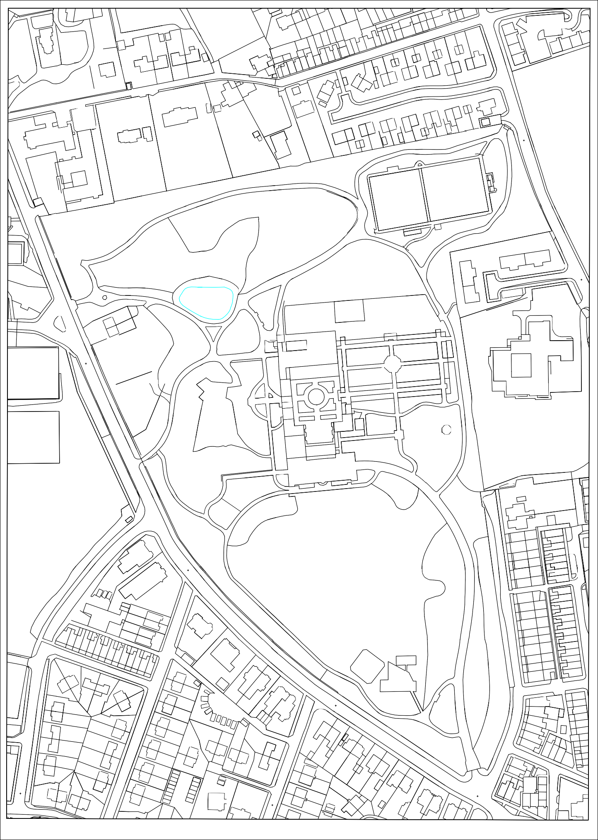
Fencing proposed to be; STYLE - palisade fencing,
COLOUR - green
HEIGHT - 2.4m
Proposed security fence installation

