
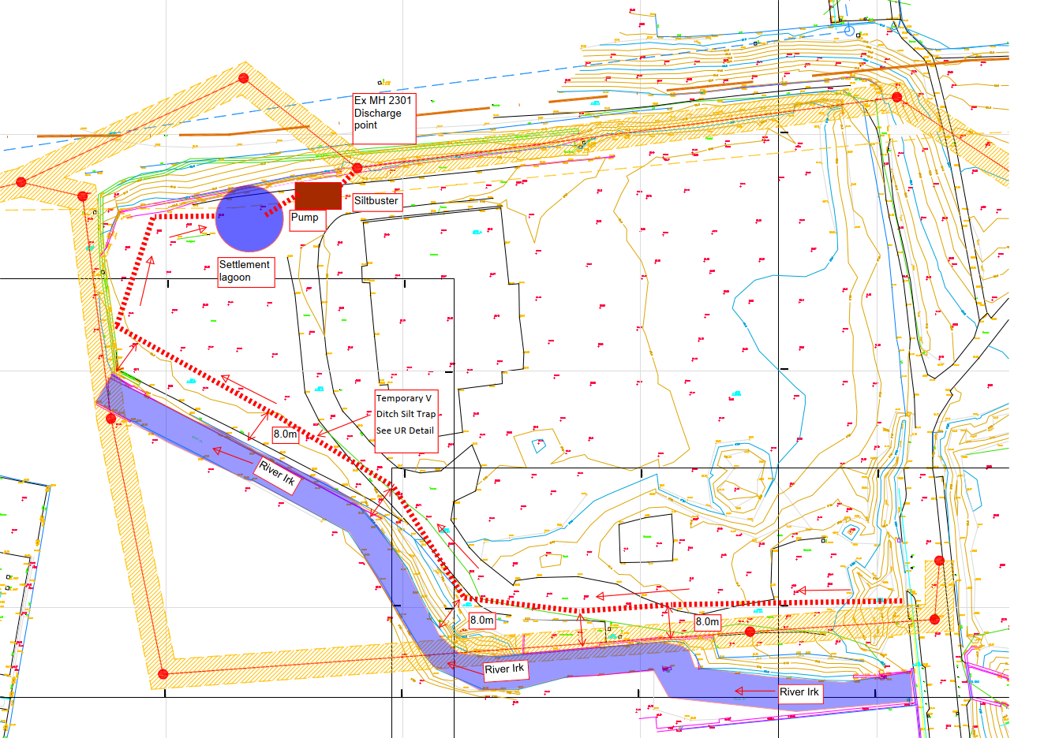
Water monitoring and sample point
Notes
Any redundant outfalls identified during V ditch excavation shall be stoppered up to prevent discharge to River Irk.
Discharge points subject to UU formal discharge consent
River Irk watercourse will be subject to daily visual inspection recorded on record sheet ENV-08-UR Watercourse Inspection sheet, supplemented with record photos, for retention on site for inspection. sampling known outfalls tbc by E3P / Kellen Homes
367 Don Street
Dewatering Sketch
Area 1
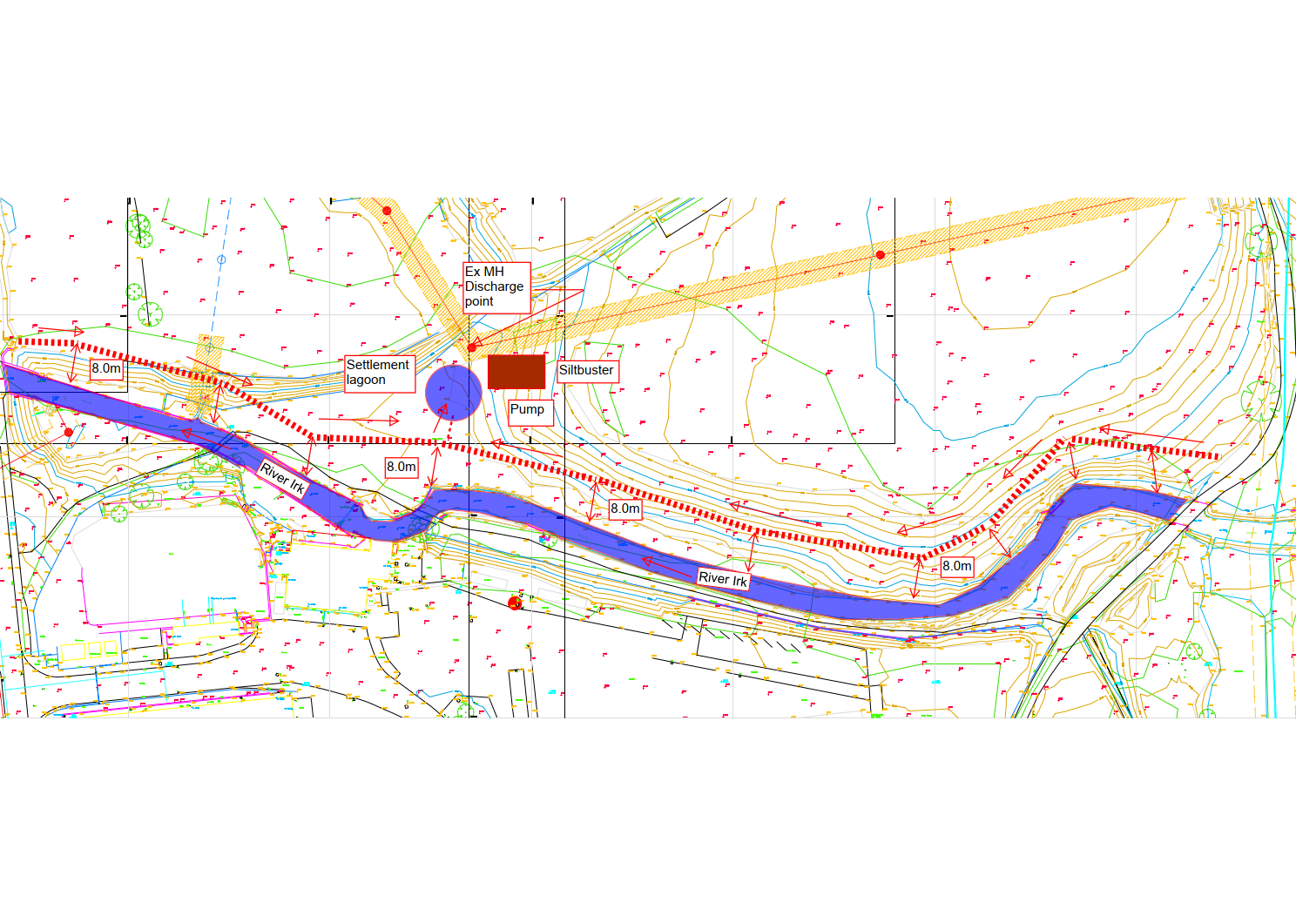
Notes
Any redundant outfalls identified during V ditch excavation shall be stoppered up to prevent discharge to River Irk
Discharge points subject to UU formal discharge consent
River Irk watercourse will be subject to daily visual inspection recorded on record sheet ENV-08-UR Watercourse Inspection sheet, supplemented with record photos, for retention on site for inspection. sampling known outfalls tbc by E3P / Kellen Homes

Water monitoring and sample point
367 Don Street
Dewatering Sketch
Area 2/4
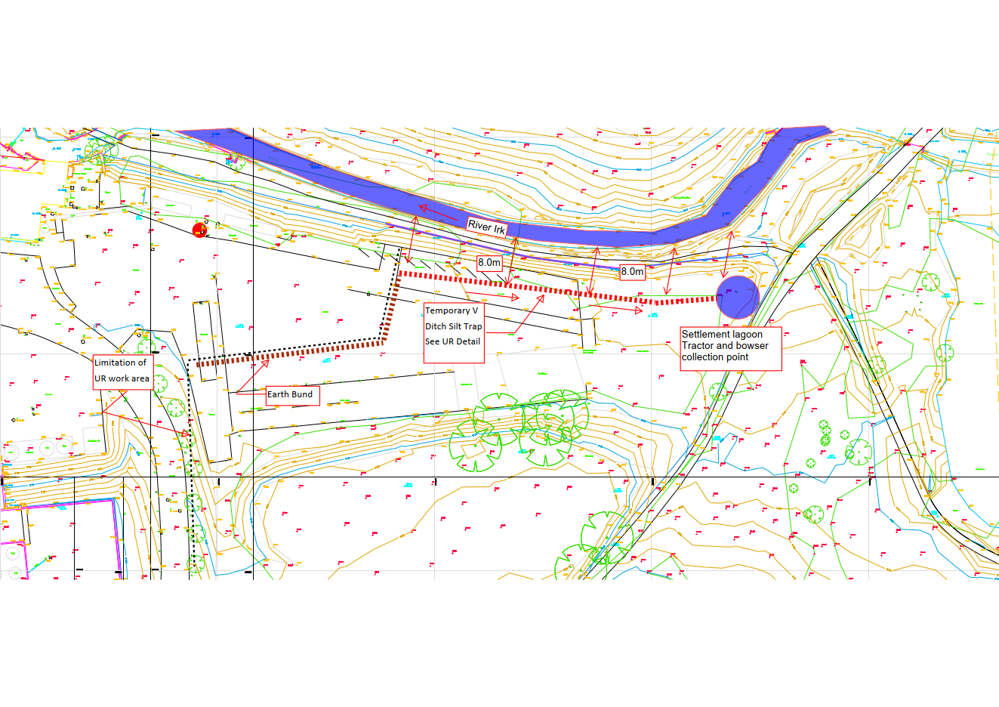
Notes
Any redundant outfalls identified during V ditch excavation shall be stoppered up to prevent discharge to River Irk

River Irk watercourse will be subject to daily visual inspection recorded on record sheet ENV-08-UR Watercourse Inspection sheet, supplemented with record photos, for retention on site for inspection. sampling known outfalls tbc by E3P / Kellen Homes

Water monitoring and sample point
367 Don Street
Dewatering Sketch
Area 5
Notes
Any redundant outfalls identified during V ditch excavation shall be stoppered up to prevent discharge to River Irk
Ditch Embankment
straw bales places at Intermittent intervals along cut off trench
Approx. 1.0m
Original Ground

Typical Temporary Silt Trap Detail

367 Don Street
Typical Temporary V Ditch Silt Trap Detail
Don Street
Area 1
River Irk Min. 8.0m easement

