Proposed Landscaping
Ref: SR.141124.A

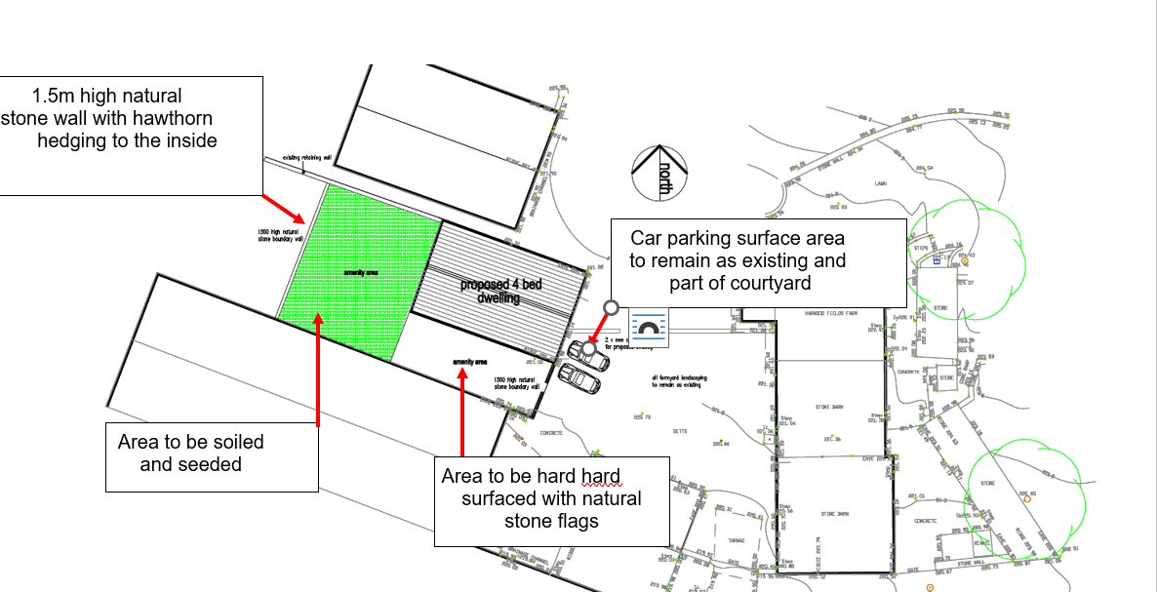

Lawned area
• All planting operations shall comply with BS 4428 (1989) & AMD, Code of Practice for General Landscaping Operations
• Total minimum soil depths: 150 mm topsoil, minimum 450 mm subsoil
• Subsoil shall conform to BS 8601:2013 Specification for Subsoil and requirements for use.
• Topsoil conforming to B.S. 3882: 2015 shall be multi-purpose soil of uniform composition throughout, of light to medium texture, and shall be capable of being broken down to a fine tilth.
• Lawn with rye grass mix shall be:
PM51 Greenscape by Olivers seed www.oliver-seeds.co.uk or similar comprising:
40% Double, 4turf tetraploid ryegrass
30% Maxima, Strongcreeping red fescue
30% Esquire, Perennial ryegrass
• Sowing rate: seed at a rate of 35 – 50 g per m2
Hedge planting
Hedge planting as shown on the plan and on the inside of the 1.5m stone boundary wall.

Whip planting details
% | Botanic | Common | Nursery size
50 | Crataegus monogyna | Hawthorn | Min 750mm
50 | Prunus spinosa | Blackthorn | Min 750 mm

Planting to be in two rows 1 metre apart and at 0.75 metre centres, staggered.
Maintenance
Any plants failing within first 5 years to be replaced by same

