Photographs of Land next to 17 Prospect Place, Heywood OL10 4JQ

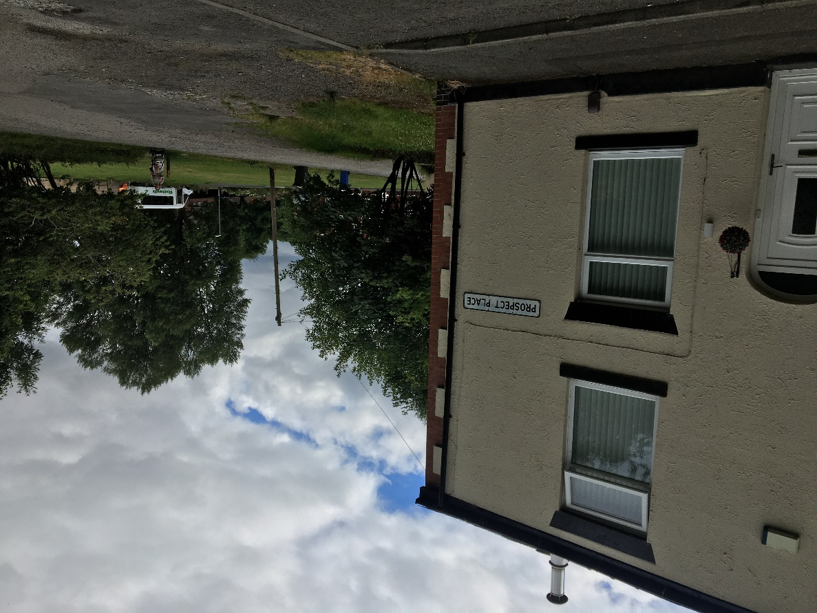
Photograph of front of land including no. 17 Camera facing South West
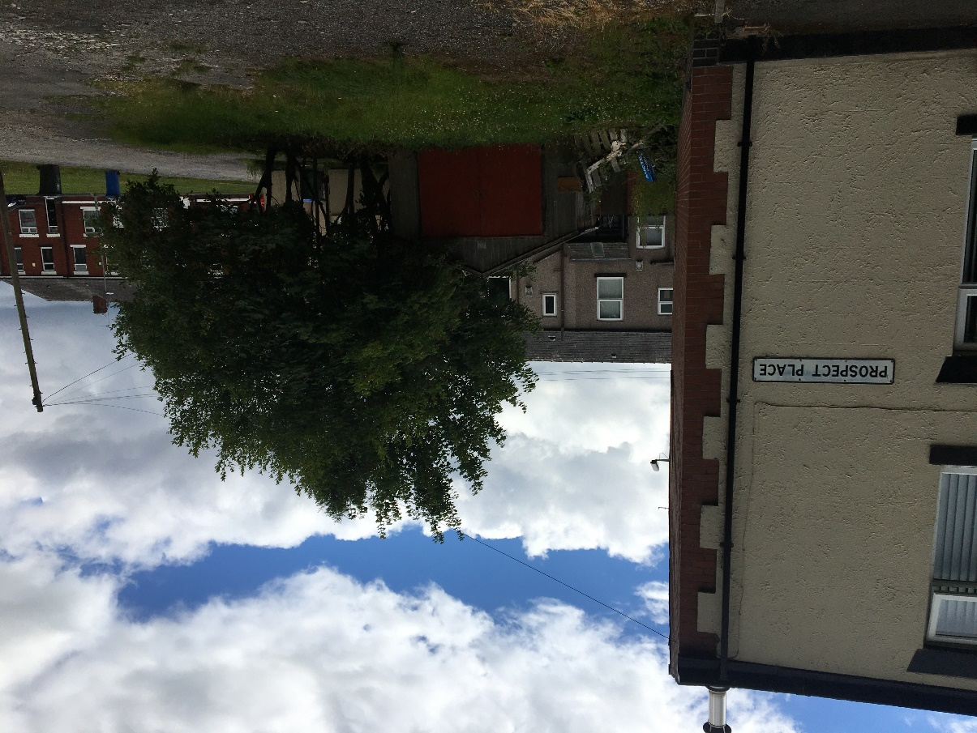
Photograph of Land Camera Facing South
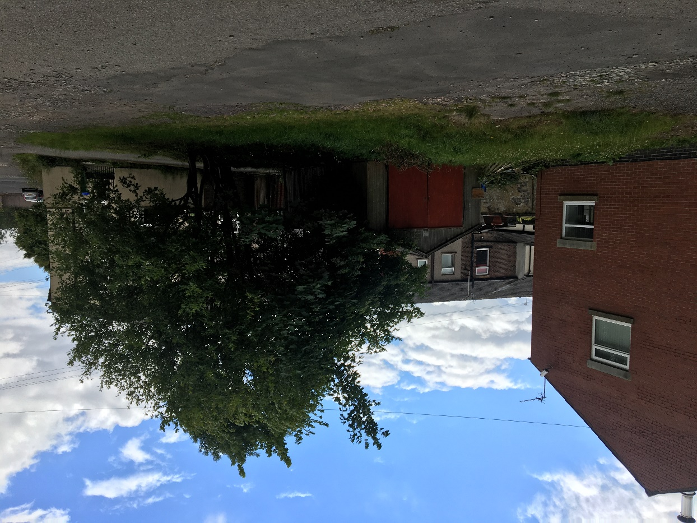
Photograph of Land Camera facing South East
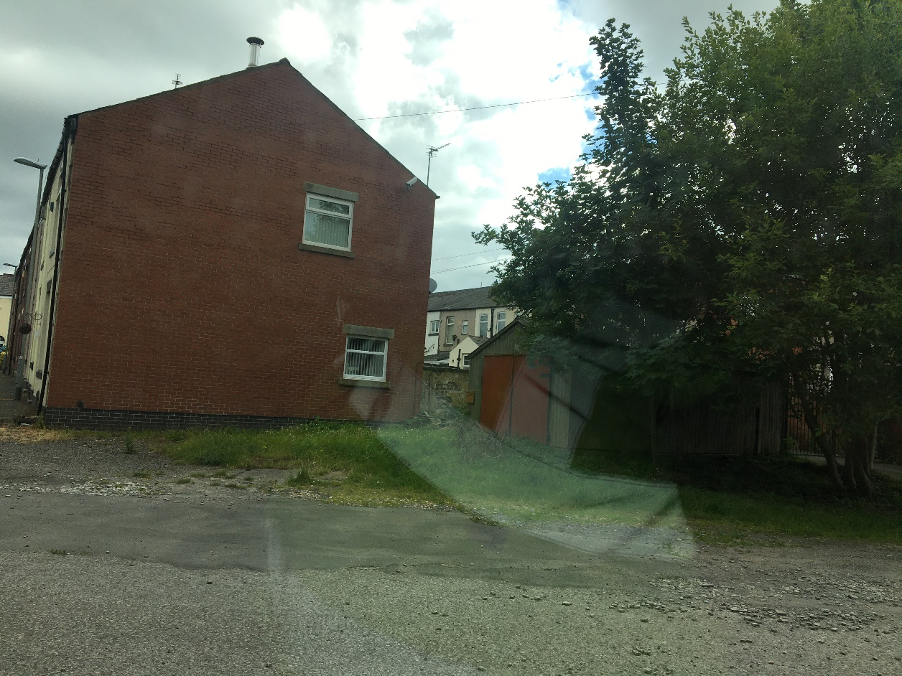
Photograph of Land Camera facing East

