Tobermore Tegula paving to be installed on permeable driveways:
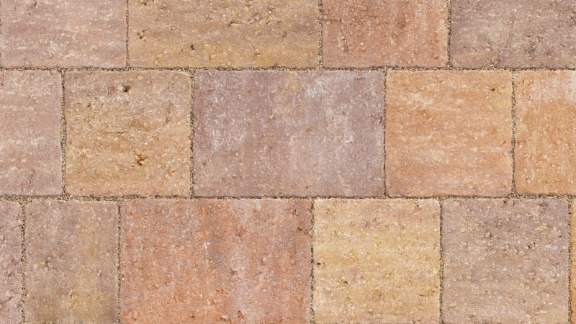

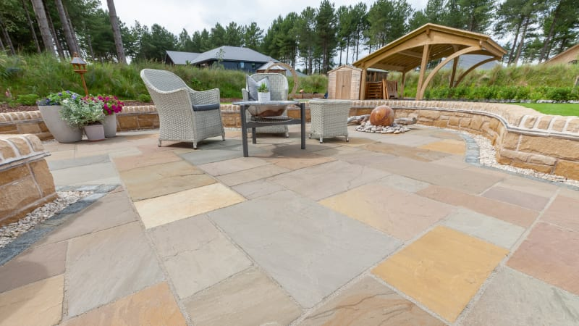
Indian stone flags to be installed to form pathways around dwellings:

