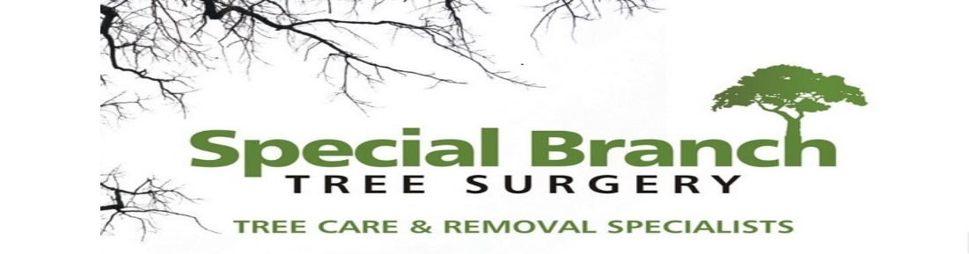

Top O’th Meadow Farm
Meadowhead Lane
Norden, Rochdale
OL11 5UL
Tel: 01706 658771

19th November 2024

Neil Hickford
Mayroyd
Norden Road
Rochdale OL11 5PT

As requested, please see the completed tree report, as discussed this offers no guarantees as trees are living organisms and can fail at any time. We would also like to advise that no indemnity or insurance cover is offered. This report is in “my opinion” only and covers only the trees that have been inspected.

Trees in question are subject to a Tree preservation order TPO 098

Local authority: Rochdale

Location
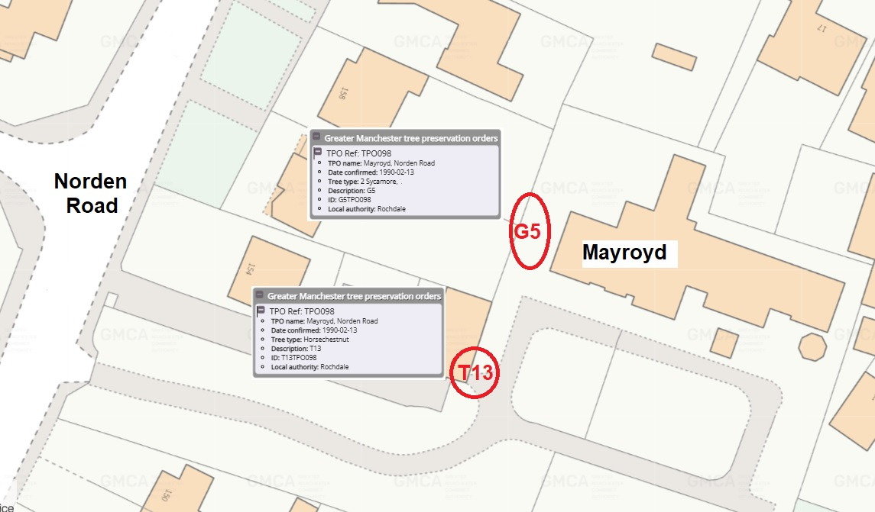

Work provided

Site visit, arboricultural inspection, photography, report, and quotation.

Trees included

T13 Horse Chestnut
G5 two Sycamore

Issues found

T13 low hanging secondary branched causing access issues for delivery vehicles

G5 two Sycamore trees encroaching on the property
Recommendations

T13 Crown lift to 4 meters above the drive. Removal of the low drooping branches of less than 100 mm in diameter, this will improve access and the aesthetics of tree giving a more balanced look without harming the long-term viability of the tree.

G5 (Two Sycamores) Prune back 1-2 meters to give a greater clearance from the property before the branches thicken. See pictures. As the cuts will be small and done with precision there will not be any harm to the tree.

It is essential to conduct this tree work with precision and care to minimize stress and damage to the tree. Pruning cuts should be made at the branch collar to promote proper healing and reduce the risk of disease entry. It is advisable to perform this pruning during the dormant season to lessen the impact on the tree and maximize its recovery ability.
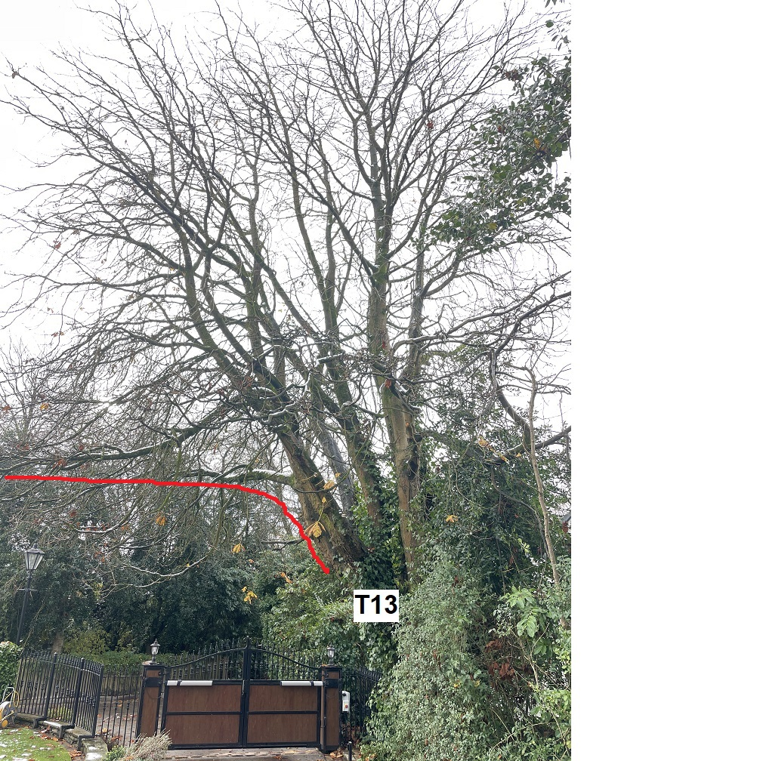
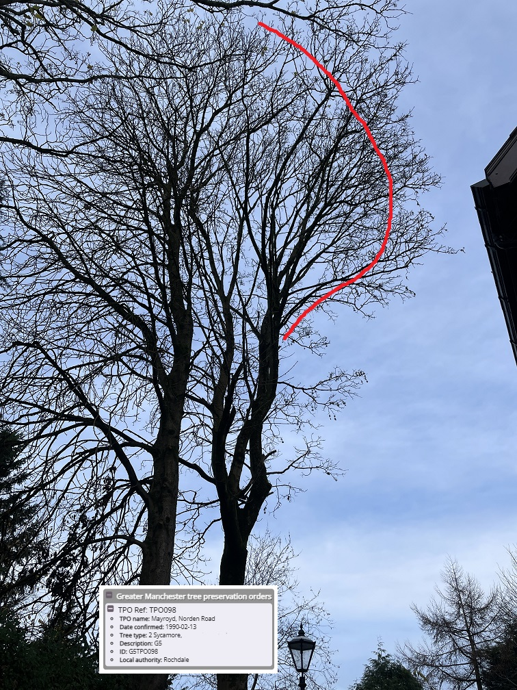

Kind regards,
Mr. Chris Ashton
Managing Director
SEG Award, Cert Arb L2 (ABC)

