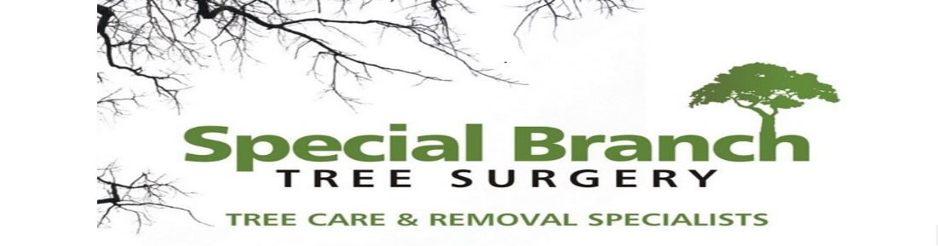

Top O’th Meadow Farm
Meadowhead Lane
Norden, Rochdale
OL11 5UL
Tel: 01706 658771

25th January 2025

Michelle Hurst
Springhill Hospice
Broad Lane
Rochdale
OL16 4PZ

As requested, please see the completed tree report, as discussed this offers no guarantees as trees are living organisms and can fail at any time. We would also like to advise that no indemnity or insurance cover is offered. This report is in “my opinion” only and covers only the trees that have been inspected.

Tree in question is subject to a Tree preservation order TPO 045

TPO Ref: TPO045
- TPO name: Springhill Hospice Rochdale (Broad Lane)
- Date confirmed: 1977-12-12
- Tree type: Sycamore
- Description: T31
- ID: T31TPO045
- Local authority: Rochdale

Location

Rear of the property.

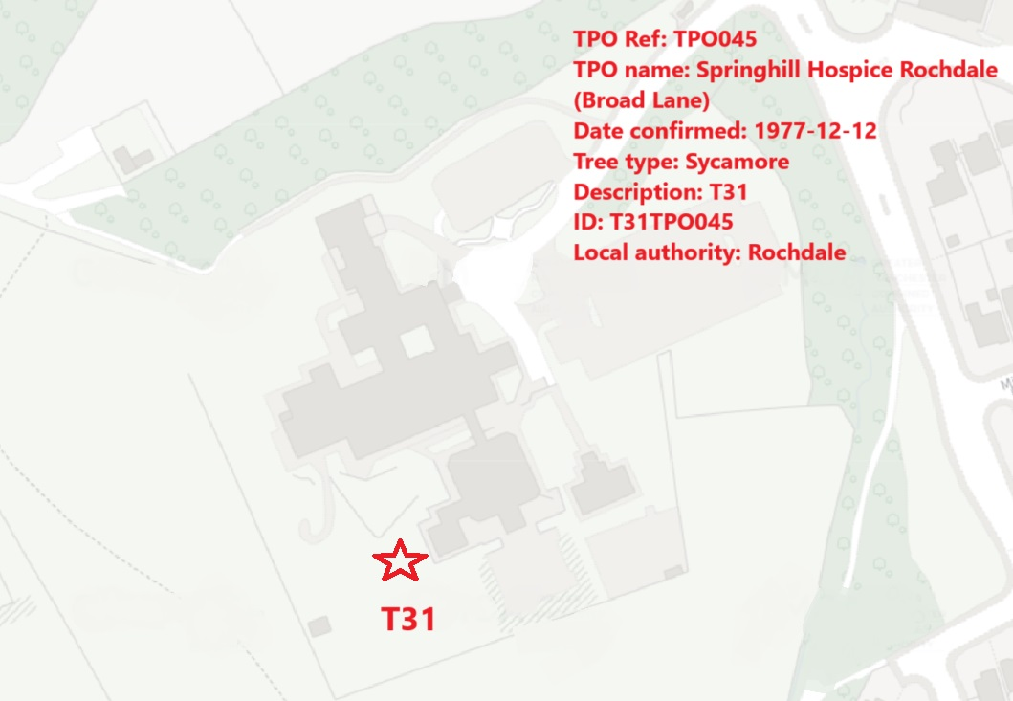

Work done

Site visit, arboricultural inspection, photography and report.

Trees in question

T31 Sycamore

Problem

- The tree is causing excessive twig/branch dropping into the gardens.
- The tree is now showing signs of stem decay, included bark and a stress fracture below the included bark. The hospice want to make the site safe for their staff, patients and visitors.
- The residents, staff and visitors are suffering anxiety over fears the tree will completely fail or a larger limb would snap off.

Recommendation

Removal of T31, Sycamore to ground level. No recommendations are in place to plant new trees as the hospice has planted numerous trees throughout the grounds.

Removing T31 (Sycamore) to ground level is imperative due to the presence of stem decay, included bark, and a stress fracture below the included bark. Stem decay weakens the structural integrity of the tree, making it prone to failure. Included bark creates a weak attachment between branches or stems, increasing the risk of breakage. The stress fracture below the included bark further compromises the tree's stability.
As a mature tree reaching its end of life expectancy, T31 poses a significant safety hazard, especially considering its proximity to the hospice building and the high foot traffic in the garden. Patients, workers, and visitors frequent the area, making the risk of injury or property damage from falling branches or tree failure unacceptably high.
Removing T31 to ground level is the most responsible course of action to mitigate these risks and ensure the safety of individuals in the vicinity. It will eliminate the danger posed by the tree while also allowing for replanting or regrowth in a safer location. Proactive management of tree health and safety is essential in any setting, but particularly in areas such as hospices where the well-being of vulnerable individuals must be safeguarded.

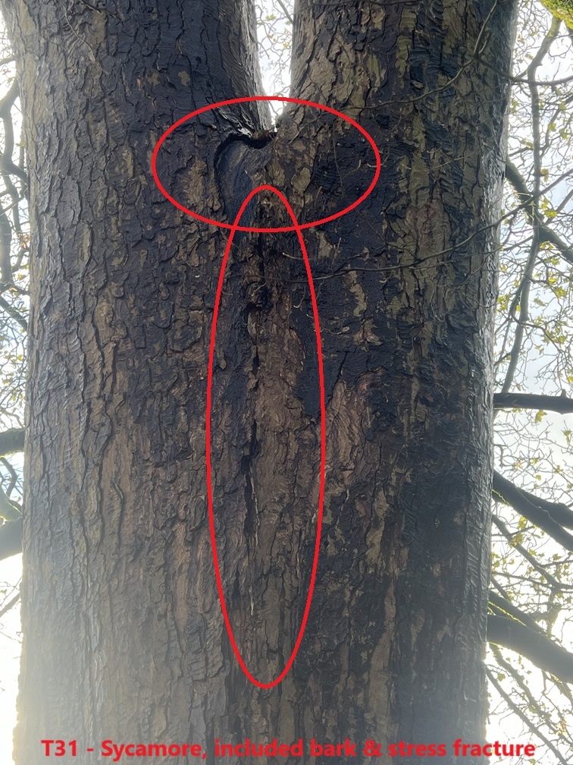

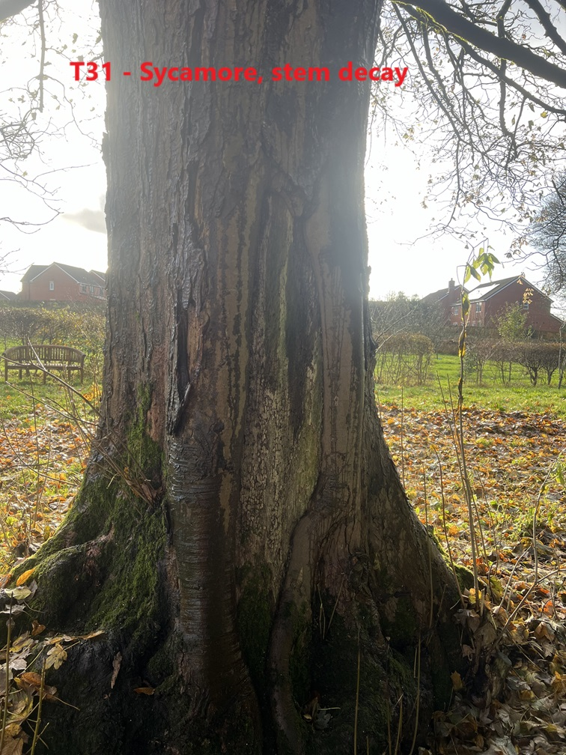

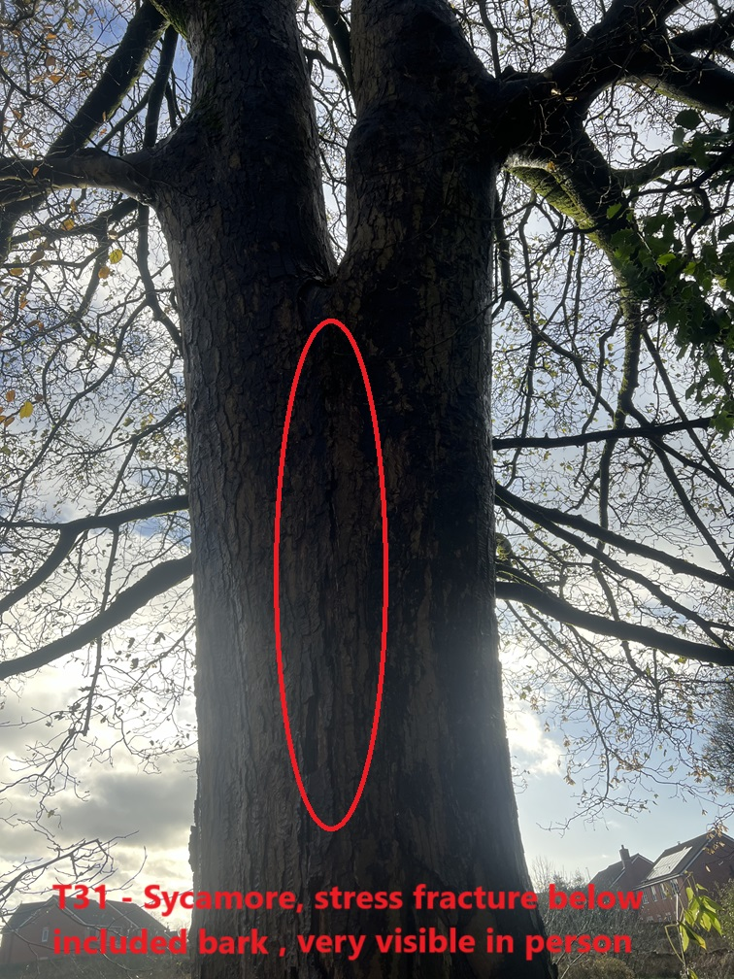

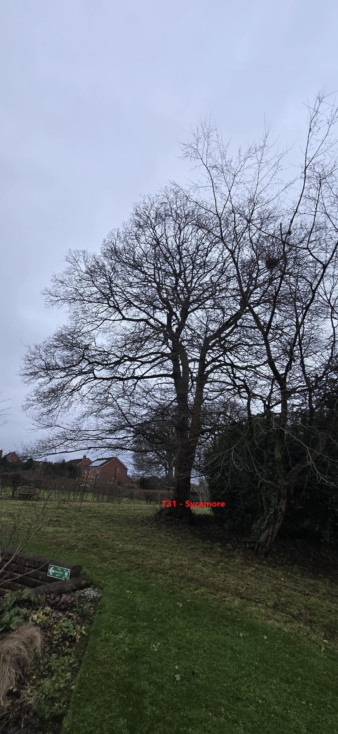
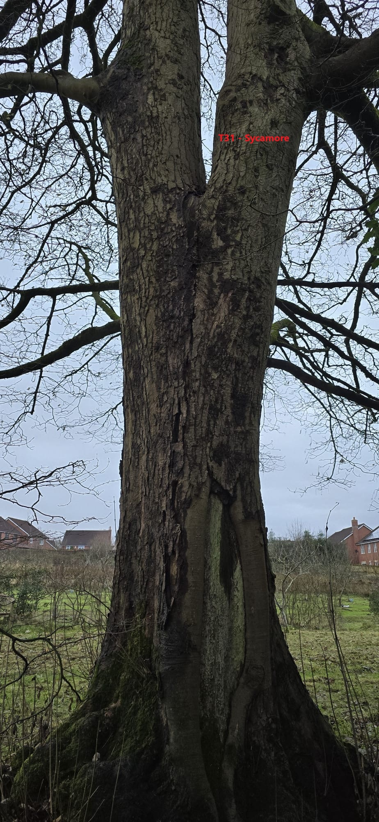
Kind regards,

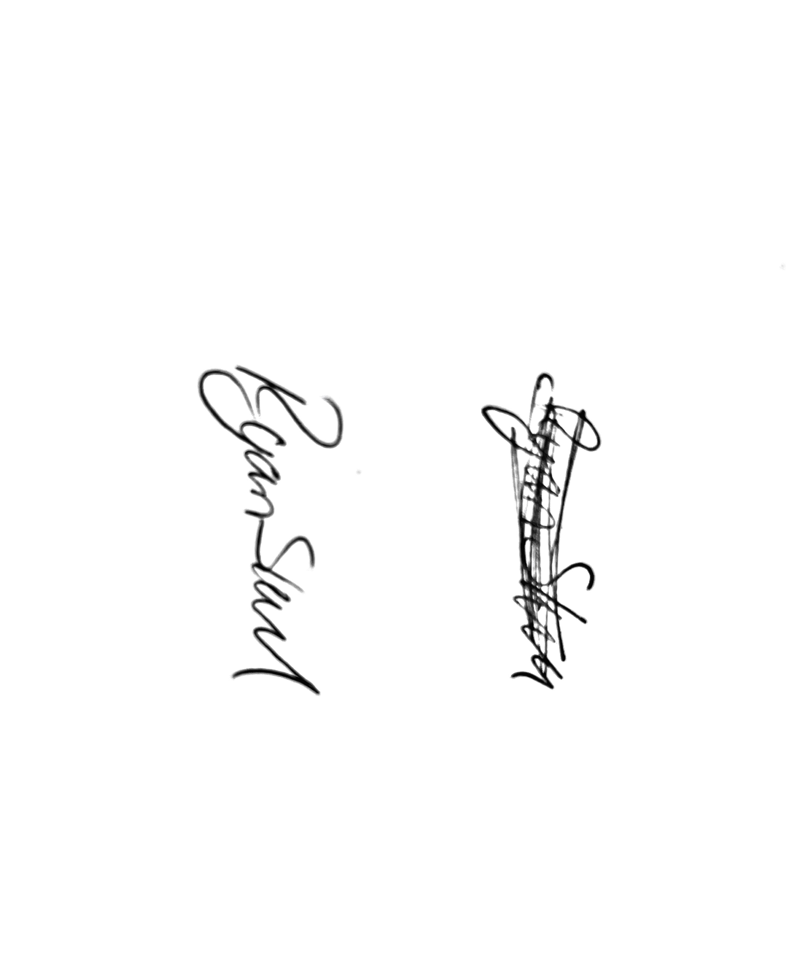
Mr. Ryan Slack
General Manager and Director
SEG Award, Cert Arb L2 (ABC)

