DESIGN AND ACCESS STATEMENT

2 Mavis Grove, Milnrow, OL16 3EE.

PROPOSED TWO STOREY SIDE EXTENSION

client

Mr & Mrs A. Treece

CONTENTS
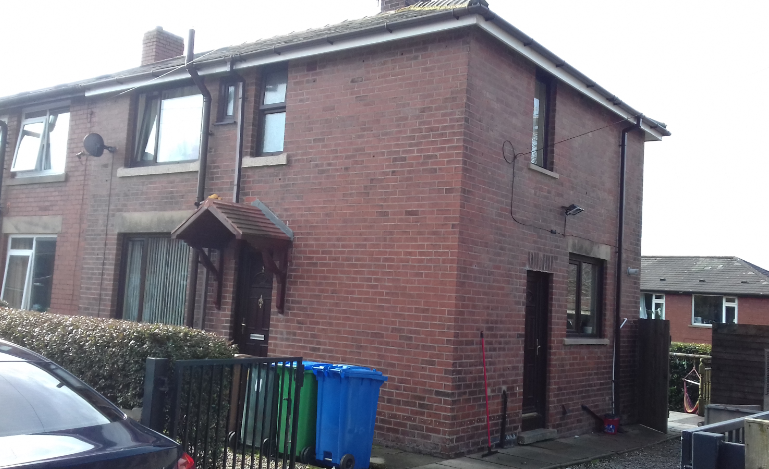

1. Scheme Background
2. Design
3, Use
4. Layout
5. Summary

1.0 Scheme Background

1.1 This design and access statement supports a planning application to Rochdale Borough Council for the extension of 2 Mavis Grove, Milnrow.
Full Householder planning permission is sought for a two storey side extension to existing dwelling.
1 .2 The proposal is to build a new pitched roof building using traditional building methods to the side of the existing dwelling.
1 .3 This supporting statement aims to demonstrate how the application proposal is wholly appropriate to the site and its location without affecting the amenities of the neighbouring properties.
1 .4 This design and access statement provides an explanation and justification for the proposals and contains the following sections.

2. Design
2.1 The following drawings will be submitted as part of the application.
1 Existing Layouts and Elevations
2 Proposed Ground Floor Plan
3 Proposed First Floor Plan
4 Proposed Elevations
5 Block & Site Plans

2.2 The application site is in the Milrow area . The site is flat and the property fronts onto Mavis Grove.
2.3 The site comprises of an two storey dwelling. The site lies adjacent to the junction of Mavis Grove and Highfield Road.
2.4 The surrounding land use is residential in nature all typically associated with the Milnrow area.
2.5 The proposed extension is set back at the front elevation with set down at the ridge to comply with subserviant guidlines.
2.6 Materials to be used to match existing materials.

3. Use
3.1 The existing dwelling is a family home of 2 bedrooms with box room
3.2 The proposed extension is to provide an additional bedroom with ground floor ammenities.
3.3 The application retains existing access to car parking space to the front of the building.
3.4 The proposed first floor will provide a master bedroom and the box room will become an office/study
3.5 The key benefits will be to provide at home care for the family’s son, who is severely mentally impaired, Autistic with significant learning difficulties and sensory processing disorder. To enable him to use the ground floor room as a sensory therapy room to give him the privacy and space to carry out the daily therapies that he requires and; also, access to downstairs toilet as he has toileting issues. First floor will have a bedroom with ensuite wet room to meet his needs with minimal input from carers and for his dignity around other household family members.
3.6 This project would provide home care accommodation and would not have to depend external providers.

4. Layout
4.1 The existing dwelling has principal windows to its side elevation which overlook the rear of properties on Highfield Road.
4.2 The development although being closer would alleviate this situation.

7.0 Summary
This statement and accompanying plans highlight the comprehensive benefits of the proposed development for the family. These proposals have been developed in direct consultation with the family and the future
in mind. The space provided represents the area required to enable the need for flexibility and future proofing of the dwelling and the families needs. It is hoped that this statement clearly describes the applicants requirments in sufficient detail and that your support for the proposal.

