Brownhill Commuity Learning School
Design and Access Statement
Background
Brownhill Community Learning School Darnhill Site is situated on Sutherland Road on the Darnhill housing estate in Heywood and is a Special Education Needs and Pupil Referral Unit
Catering for 80 pupils ranging from Key Stage 2 to 4.

The school is a single storey building and was built in 2012 by Carillion. The numbers of
Pupils and staff varies, but the maximum at the BLC, Darnhill site is 40 primary and 40
Secondary age pupils with 20 staff.
Location: Sutherland Road, Darnhill, Heywood
District: Rochdale Borough
National Grid Reference: SD 83762 10091

Details
Four Classroom/office extension and drop off /turning circle.
Proposal
As part of the additional Place planning School capital programme we have prepared the following design and access statement
The purpose of this statement is to highlight the proposals to extend the existing school to accommodate four number additional classrooms, additional office space and a drop off / vehicle turning area.
Currently in the borough of Rochdale there is pressures for places for special Educational needs {SEN). To accommodate this a number of sites and options have been reviewed and following on from the feasibility undertaken an option to further accommodate at the Brownhill Learning Centre has been approved..
The formation of a four classroom and office extension by way of traditional build with outer brick face finish to match existing. The classroom extension will be located to the rear of the site leading away from the existing school block adjacent to the sports hall. The office extension will be located to the left hand side of the school based on looking at the front elevation from Sutherland Rd
There is also a proposal to form a drop off/turning circle to be formed directly off Sutherland Rd allowing for taxis, mini buses and cars to drop off some of the children brought in from outer areas which is a requirement.

Site Plan
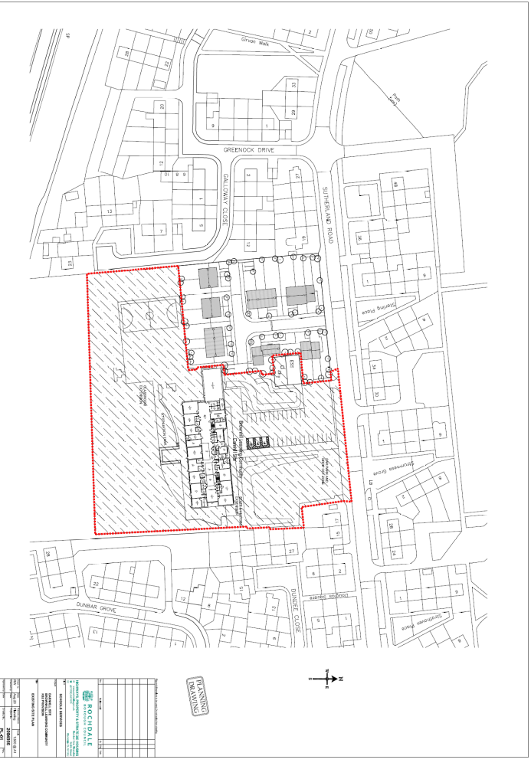

Proposed Plan
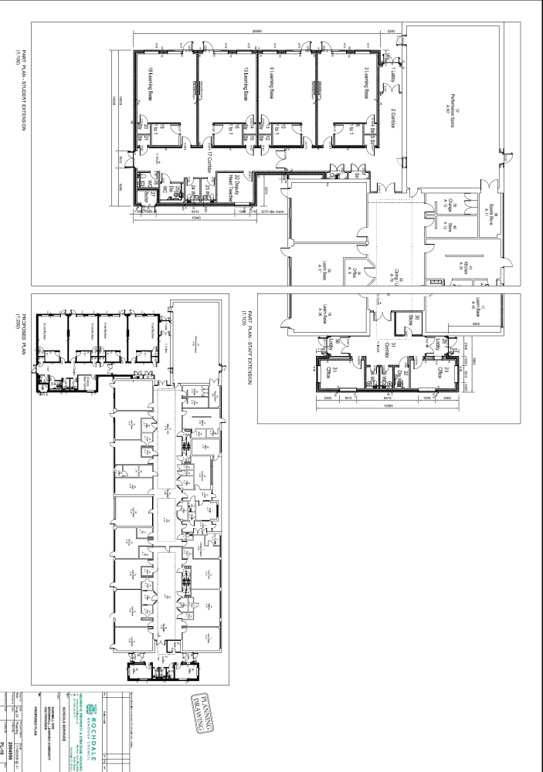

Site Access and Egress

Phase 1 Classroom extension

Access to the site will be directly from Galloway Close. This will provide direct access to the main compound area for deliveries, plant etc. The main compound will be situated within the school perimeter close to the proposed classroom extension. At some point a small number of deliveries will be required however kept to a minimum. Movement of plant within the school ground is to be undertaken with the assistance of a banksman at all times.

Deliveries to the school are to be via the site access from Sutherland Rd.A designated area will be allocated to all delivery vehicles

Phase 2 office extension and turning circle/drop off

Access to the site for phase 2 works will be from Sutherland Rd giving access to the compound area. This access would be separate to the main school access point At some point a small number of deliveries will be required however kept to a minimum. Movement of plant within the school grounds is to be undertaken with the assistance of a banksman at all times

Parking

There are additional parking spaces proposed as part of the application.
RBC Core Strategy Parking Standards recommend 1.5 parking spaces per classroom.
There are 4 no additional classrooms to be added so this would normally require 6 additional spaces. As part of this scheme there will be 11 additional spaces proposed.

Existing Parking 28No
Existing Disabled Parking 3No
Proposed in existing car park 7No
Proposed In Drop Off Zone 4No

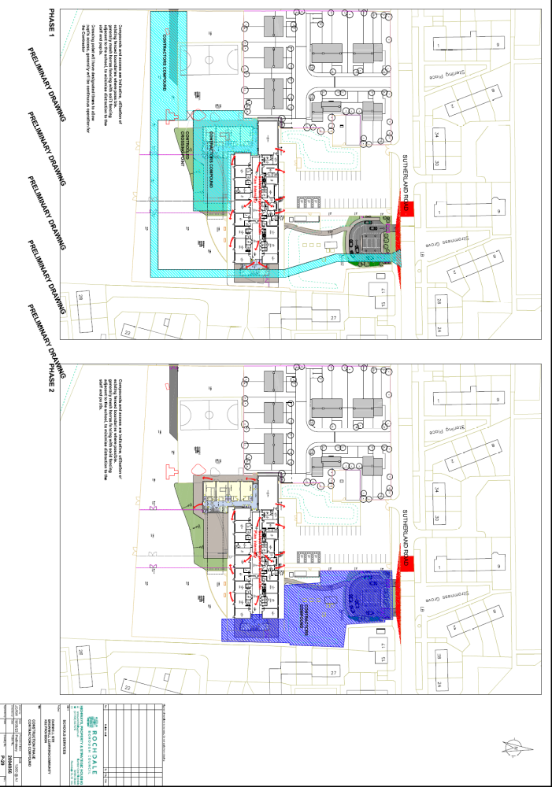

Heritage

The school is not located in an area of Heritage interest.

