HERITAGE & DESIGN STATEMENT

For
Proposed re-roofing of existing slate roof and installation of roof mounted Solar panels, one row of eleven and one row of thirteen panels. Fitted to the south facing pitch of the Preschool Nursery.
at

St Joseph’s Preschool Nursery, Hind Hill Street, Heywood, OL10 1AQ

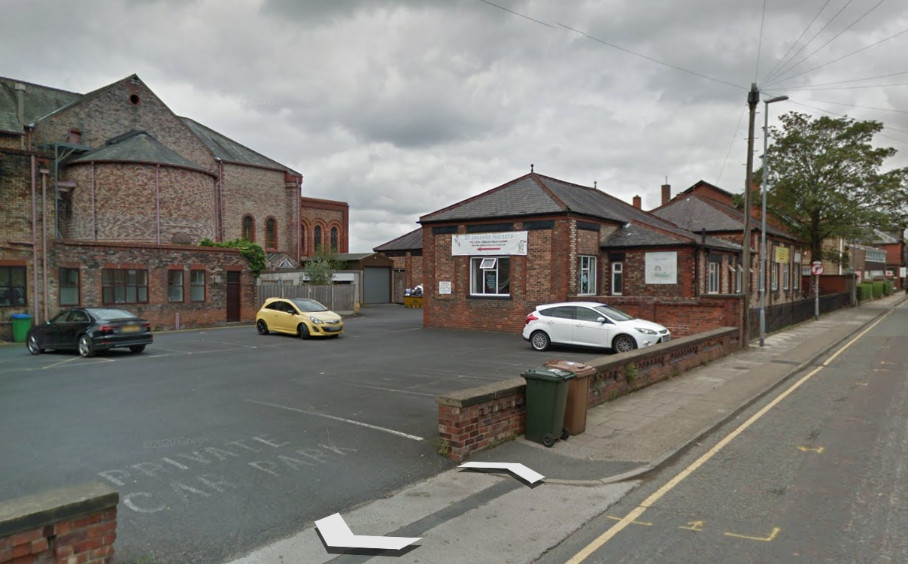



Introduction
This statement has been prepared to support planning application 2024/***** for the re roofing and the installation of 24 integrated solar panels fitted to the south facing pitch of St Joseph’s Preschool Nursery.
The Site
The site is a Roman Catholic church and presbytery. Built in 1913-1916. There is a preschool nursery in the grounds of the church, which consists of three single story adjoining buildings with a pitched slate roof.
The Church is sited in Heywood in an urban area which is characterised by a range of uses such as; family homes, Churches, commercial and domestic industrial buildings.
National Planning Policy Framework
Conserving & Enhancing the Historic Environment (126) Local planning authorities should set out in their Local Plan a positive strategy for the conservation and enjoyment of the historic environment, including heritage assets most at risk through neglect, decay or other threats.
The Church is a grade II listed building. However the subject property is not listed.
Existing Building
The property is in the grounds of the church and comprises of 3 adjoining single storey buildings built in red brick and with slate pitched roofs.

Proposals
It is proposed to re-roof the pre school nursey with reclaimed slate to match the existing building which was re-roofed in the summer of 2022. At the same time it is proposed to fit 24 solar panels to the south facing pitch of the roof. The panels will be partially shielded from view of Hind Hill Street.
The south facing roof location of the proposal was chosen as there will be limited visual impact on the surrounding area.

Conclusion & Summary
Due to the design considerations taken, there will be minimum impact to the listed building and surrounding properties.
The solar panels will have a significant positive impact on the parish electricity bill and help to reduce carbon emissions.

