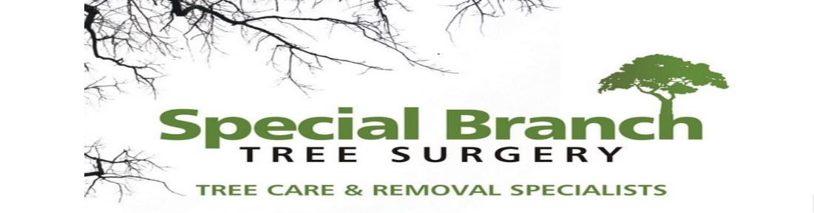

Top O’th Meadow Farm
Meadowhead Lane
Norden, Rochdale
OL11 5UL
Tel: 01706 658771

27th February 2025

Report for
Janine Parry
7 Barathea Close
Rochdale
OL11 3LY

Tree/ land owner
Gary Mayo
Owner of Mayo Civils Limited
Unit D, Rochdale Central Industrial Estate, Norman Road, Rochdale, OL11 4HS

As requested, please see the completed tree report, as discussed this offers no guarantees as trees are living organisms and can fail at any time. We would also like to advise that no indemnity or insurance cover is offered. This report is in “my opinion” only and covers only the trees that have been inspected.

Trees in question are subject to a Tree preservation order – TPO076

Local authority; Rochdale

Location
Rear of 7 Barathea Close.

TPO Ref: TPO076
  - TPO name: Chamber House, Heywood
  - Date confirmed: 1983-10-20
  - Tree type: Area of woodland comprising Ash, Beech, 1 Elm (field), Elm (Wych), Horsechesnut, Lime, Mountain Ash, Oak (Turkey), Sycamore
  - Description: W1
  - ID: W1TPO076
  - Local authority: Rochdale

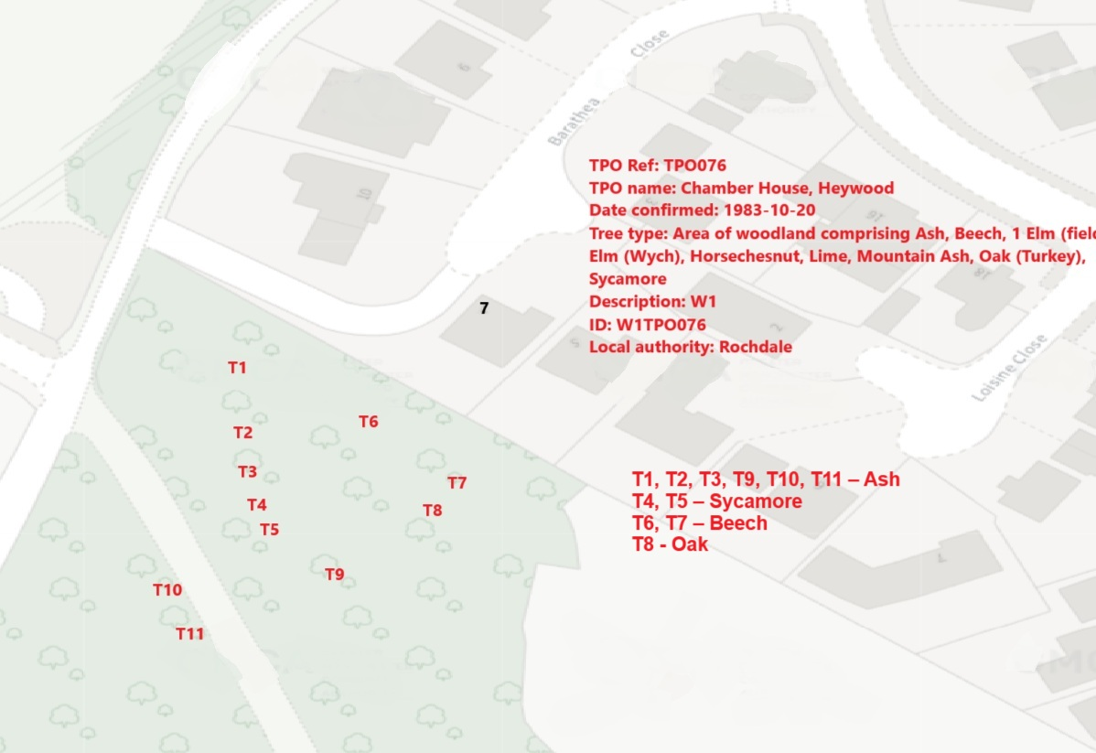

Work provided

Site visit, arboricultural inspection, photography, report, and quotation.
All trees have been thoroughly inspected and only the tree with any defects or concerns have been noted.

Trees included

T1, T2, T3, T9, T10, T11 – Ash
T4, T5 – Sycamore
T6, T7 – Beech
T8 - Oak

Issues found

T1, T2, T3, T9, T10, T11 – Ash. All trees showing significant levels of the Ash Die Back Disease.
T4, T5 – Sycamore. Two secluded poor specimen trees. Trees are in decline.
T7 – Beech. Burrs present, cavities and exposed bark and deadwood present.
T8 – Oak. Uprooted tree, currently hung up in T7.
T6 – Beech. Mature tree reaching end of life expectancy. Heavily weighted towards the property. Will be seriously exposed to the wind due to surrounding trees being removed posing a high risk towards the property.

Recommendations

T1, T2, T3, T9, T10, T11 – Ash – Fell to ground level.
T4, T5 – Sycamore – Fell to ground level.
T6, T7 – Beech – Fell to ground level.
T8 – Oak – Fell to ground level.

Ash Dieback Disease, caused by the fungus Hymenoscyphus fraxineus, poses a significant threat to Ash trees (Fraxinus excelsior) across Europe. In order to effectively manage this devastating disease, it is essential to remove trees that are infected. Here are the key reasons why trees with Ash Dieback Disease should be removed:
1. **Prevent Spread**: Infected trees act as a source of the pathogen, allowing it to spread to nearby healthy trees through airborne spores or root contact. Removing infected trees helps to contain the disease and prevent it from further spreading within the ecosystem.
2. **Reduce Environmental Impact**: Ash trees are an important component of many ecosystems, providing habitat for diverse wildlife and contributing to biodiversity. By removing infected trees promptly, we can minimize the environmental impact of Ash Dieback Disease and preserve the health of the overall ecosystem.
3. **Ensure Safety**: Ash trees affected by the disease become structurally compromised, making them prone to branch failure and tree collapse. This poses a significant risk to human safety, especially in urban areas where infected trees are in close proximity to buildings, roads, and people. Removing infected trees is crucial to prevent accidents and injuries caused by tree failure.
4. **Promote Regeneration**: Removing infected ash trees creates space for new plantings or natural regeneration of alternative tree species. This helps to maintain forest resilience and promote the recovery of ecosystems affected by Ash Dieback Disease.
5. **Implementing Control Measures**: Removing infected trees is a key component of integrated disease management strategies aimed at controlling the spread of Ash Dieback Disease. Combined with other measures such as monitoring, sanitation, and genetic resistance breeding, tree removal plays a critical role in mitigating the impact of the disease on ash populations.
In conclusion, the removal of trees with Ash Dieback Disease is a proactive and essential step in managing this infectious disease, safeguarding ecosystems, ensuring public safety, and supporting the regeneration of affected forested areas. By taking decisive action to remove infected trees, we can help mitigate the impact of Ash Dieback Disease and promote the long-term health and sustainability of our forests.

There are several reasons why two secluded Sycamore trees that are in decline need to be felled to ground level:
1. Safety: Trees in decline are prone to becoming unstable and potentially falling, posing a risk to nearby structures, people, and property. Felling them to ground level eliminates this hazard.
2. Health: When a tree is in decline, it may be suffering from diseases, pests, or structural weaknesses that cannot be easily remedied. Removing the trees prevents the spread of diseases to other trees in the area and promotes overall forest health.
3. Regeneration: By felling the declining Sycamore trees, space is opened up for new growth and regeneration. This allows for younger, healthier trees to take their place and ensures the continuation of the ecosystem.
4. Aesthetics: Declining trees can detract from the visual appeal of the landscape. Removing them to ground level can improve the overall aesthetic quality of the environment.
In conclusion, the decision to fell two secluded Sycamore trees in decline to ground level is essential for safety, health, regeneration, and aesthetic reasons. By taking proactive measures to remove these trees, we can promote a safer, healthier, and more visually pleasing environment for all.

Leaning Beech removal justification.

The removal of surrounding mature trees has significantly altered the wind exposure dynamics around the mature Beech tree, increasing the potential risk of structural failure. As a mature tree heavily weighted towards properties, the Beech tree poses a heightened threat to nearby structures and individuals due to its increased susceptibility to wind-induced stresses. The absence of neighbouring trees that previously provided windbreak and support has left the Beech tree more vulnerable to strong winds, potentially leading to compromised structural integrity and posing a safety hazard.

The phenomenon of windthrow, which occurs when a tree is uprooted or breaks due to wind force, is a critical concern in this context. The removal of neighbouring trees has disrupted the natural wind distribution patterns, exposing the Beech tree to stronger and more direct wind forces. This could result in increased mechanical stress on the tree's root system and trunk, jeopardizing its stability and increasing the likelihood of windthrow. Additionally, the loss of neighbouring trees has removed the valuable buffer that previously helped dissipate wind energy, further exacerbating the risk of structural failure for the mature Beech tree.

In considering the decision to remove the mature Beech tree, it is essential to prioritize the safety of surrounding properties and individuals. The tree's current exposure to heightened wind forces, coupled with its significant weight and proximity to structures, presents a clear and present danger that cannot be ignored. Proactively addressing the risk posed by the mature Beech tree through its removal is a prudent course of action to mitigate potential damage and ensure the safety of the surrounding environment.

In conclusion, the removal of neighbouring mature trees has fundamentally changed the wind dynamics around the mature Beech tree, rendering it more susceptible to wind-induced stresses and increasing the risk of structural failure. Given its heavy weight towards properties and the absence of natural windbreaks, the mature Beech tree poses a significant safety hazard that necessitates timely and decisive action. Removal of the tree is not only a preventative measure to safeguard against potential damage but also a responsible decision to prioritize safety in the face of changing environmental conditions.

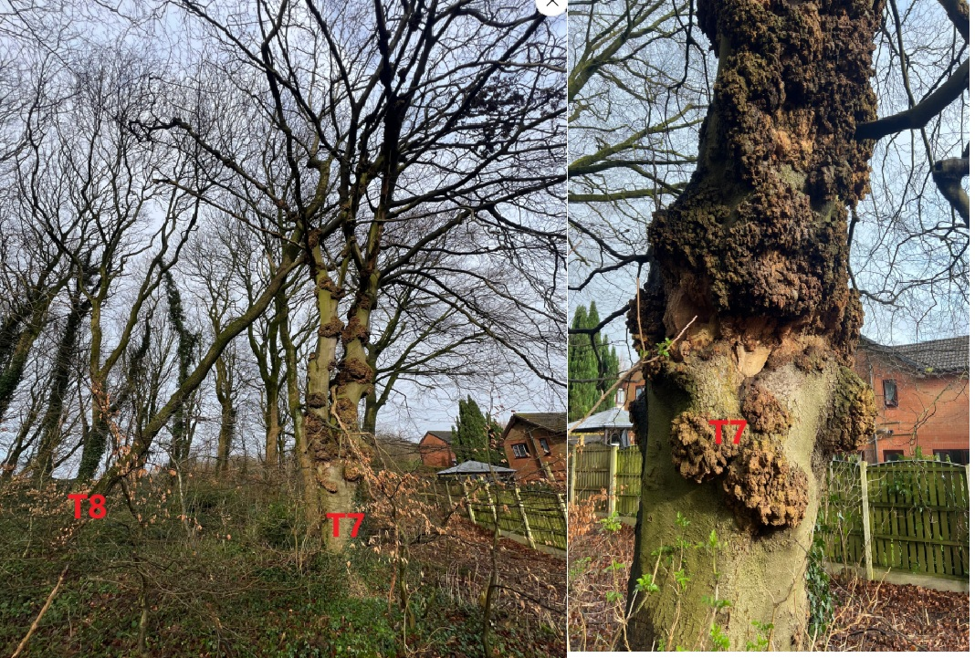

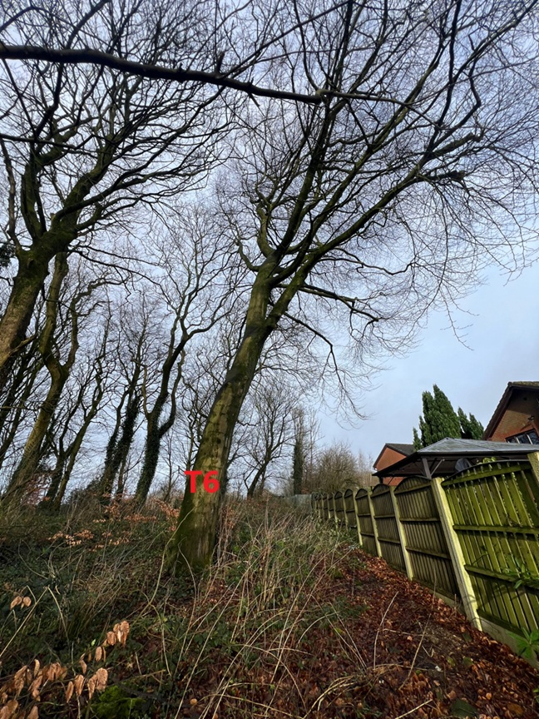
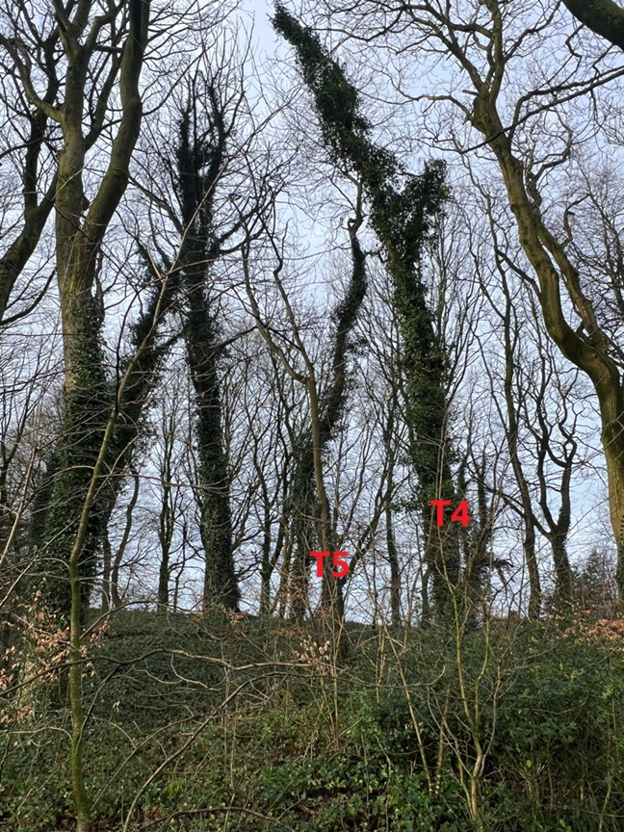

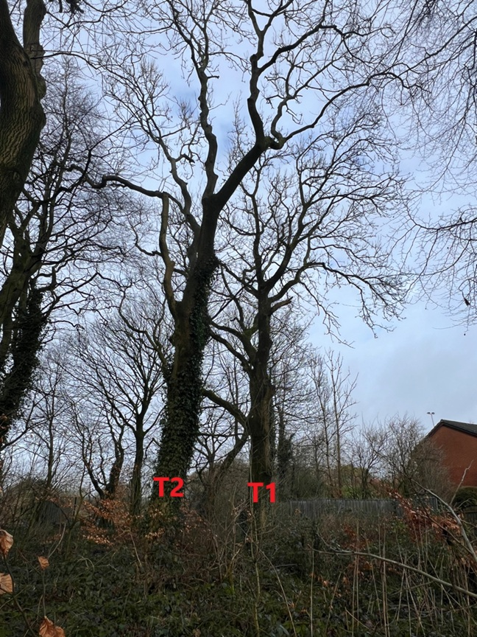

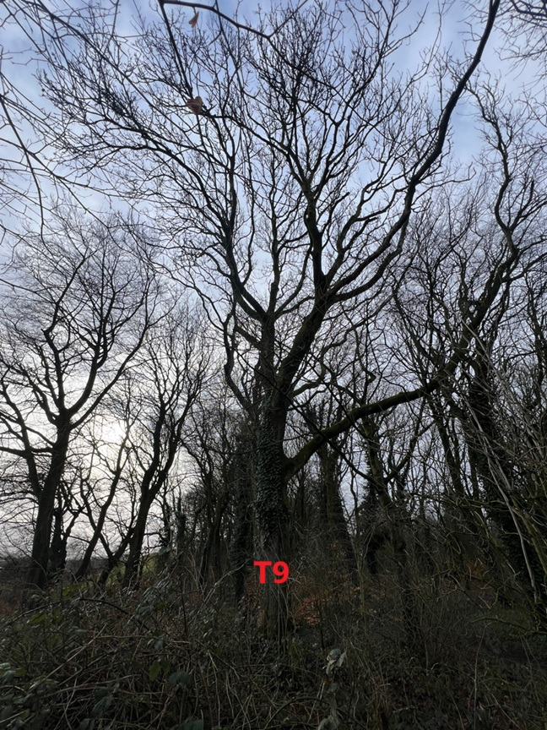
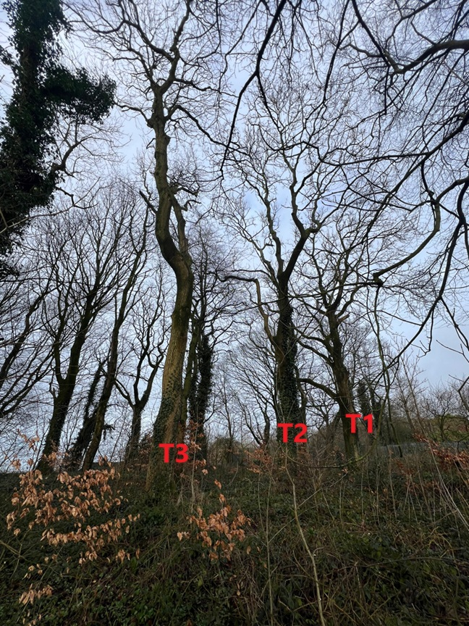
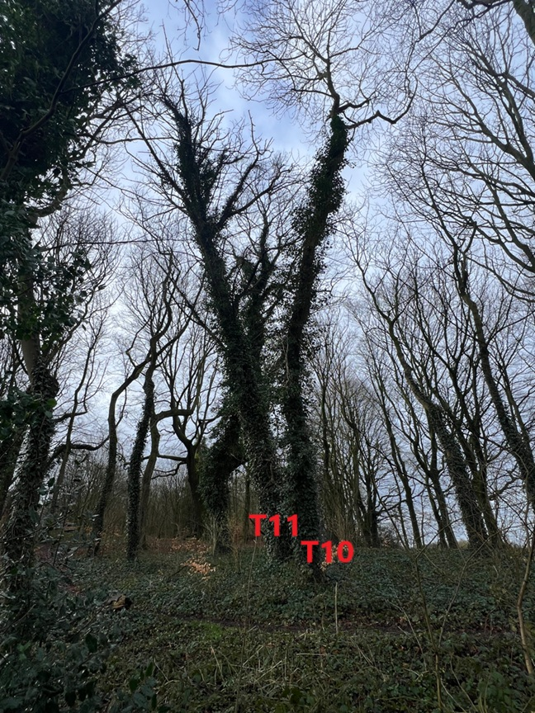
Kind regards,
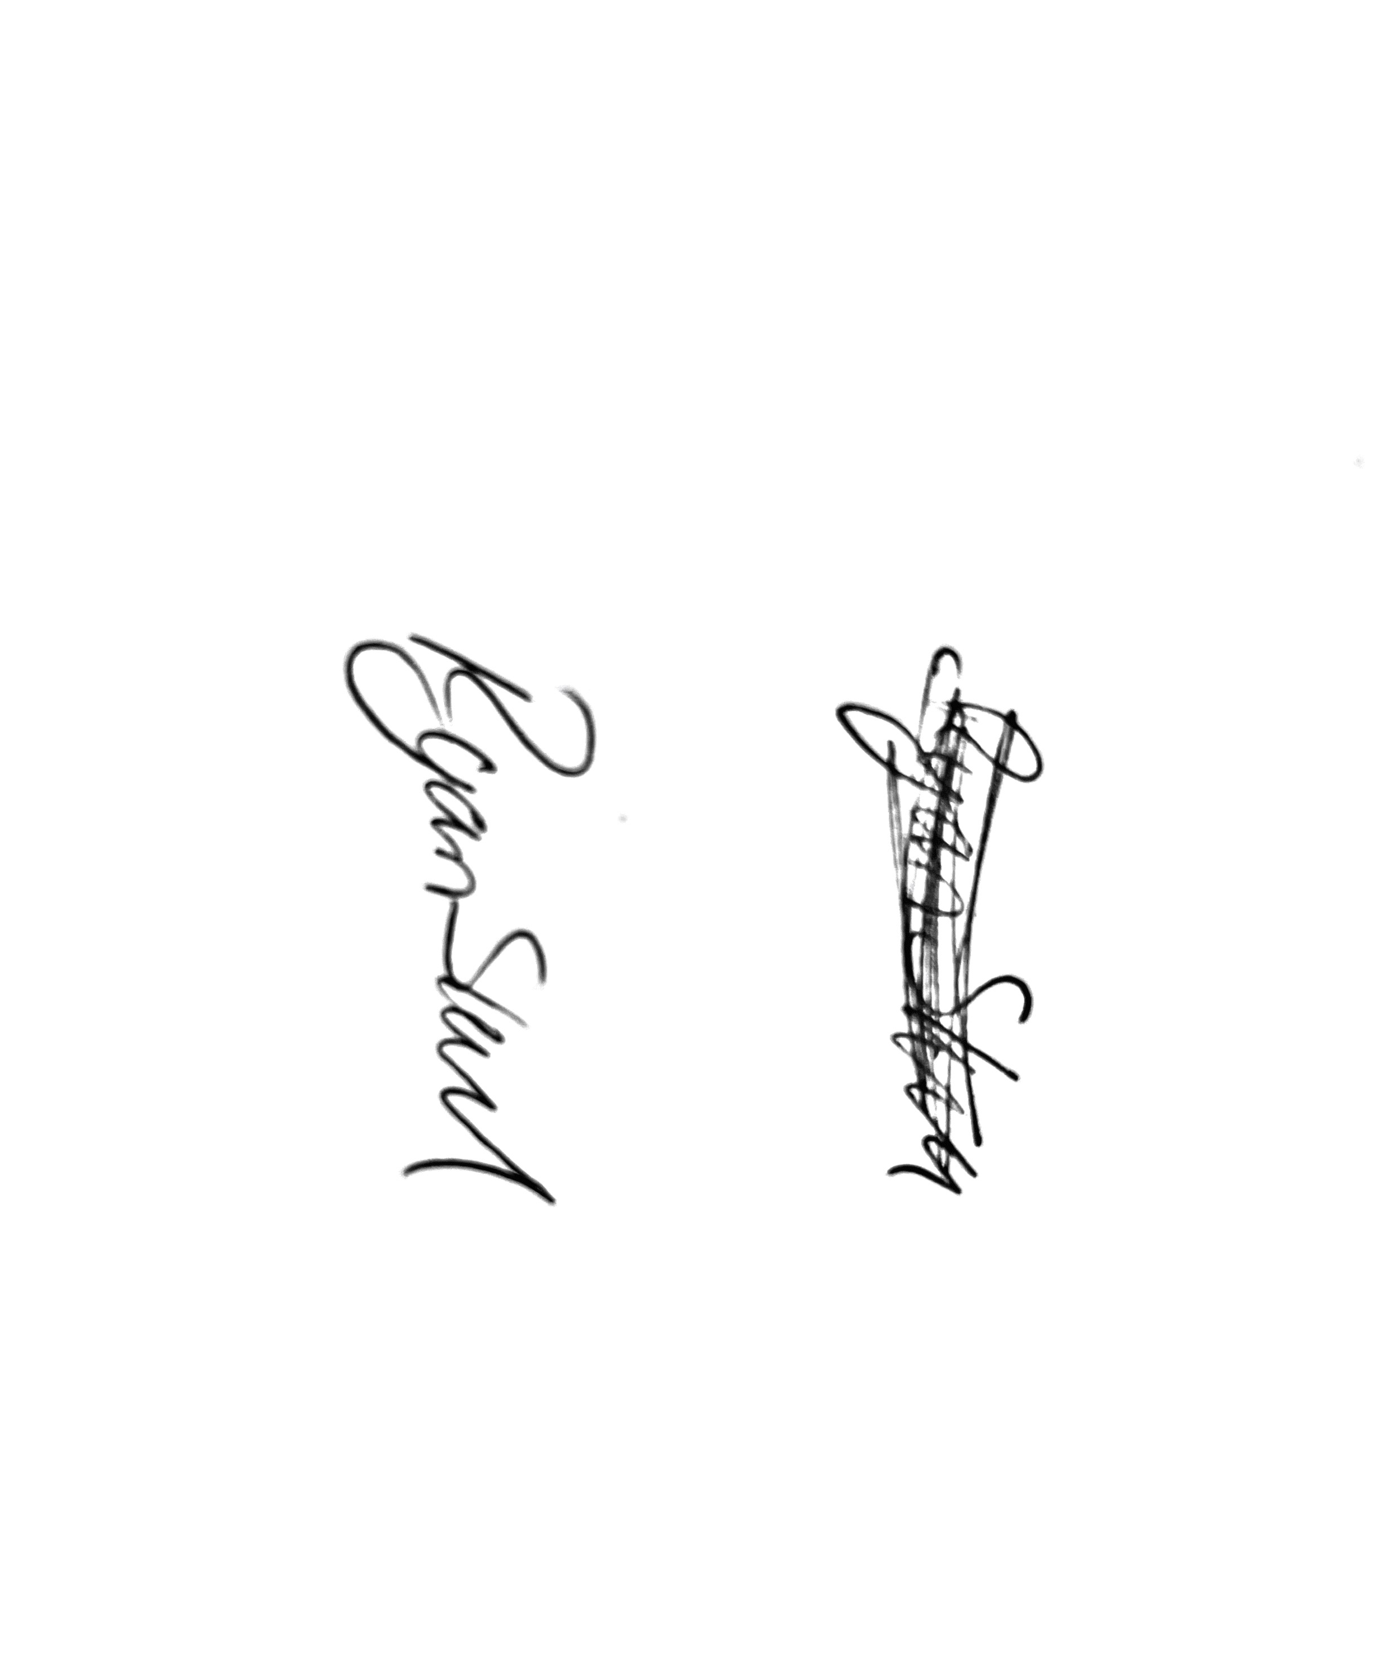
Mr. Ryan Slack
General Manager and Director
SEG Award, Cert Arb L2 (ABC)

