SPECIAL BRANCH
`

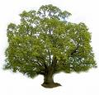
Tree Surgeons Ltd
Top O’th Meadow Farm
Meadowhead Lane
Norden, Rochdale
OL11 5UL
Tel: 01706 658771

Mini Tree Report Date: 2nd May 2023
Omar Ali
447 Edenfield Road,
Cutgate, Rochdale
OL11 5RY
As requested, please see my mini tree report, as previously mentioned this offers no guarantees as trees are living organisms and can fail at any time. We would also like to point out no indemnity or insurance cover is offered. This report is in “my opinion” only and covers only the trees that have been inspected.

Map
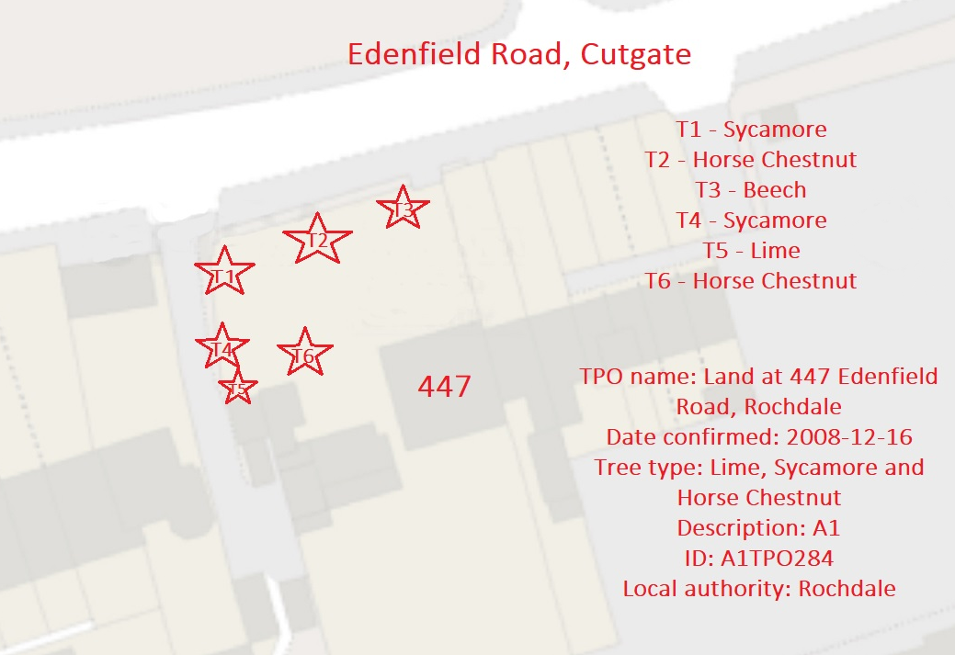

Tree in question subject to Tree Preservation Order; A1TPO284

T1- A 19meter mature Sycamore. We recommend removal as this tree has a major cavity starting from the base to approximately 1.8 meters high. Whilst the tree is ready to leaf the major concern is the excessive internal damage, we feel it would be prudent to remove this tree now before it worsens anymore and becomes dangerous. As shown in the photos the cavity starts beneath ground level, possibly weakening the root structure and has caused damaged to the dry-stone wall. We feel this tree is in a high-risk area between populated buildings with the foot and vehicular traffic underneath and as such there is an unacceptable risk to people and property.

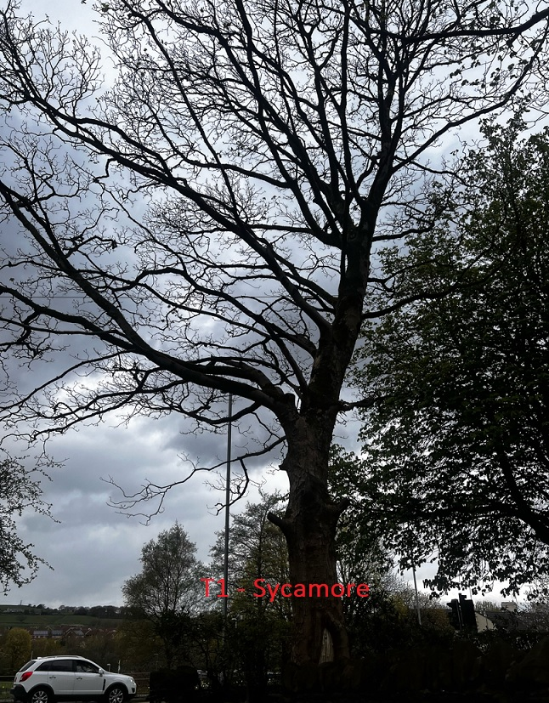

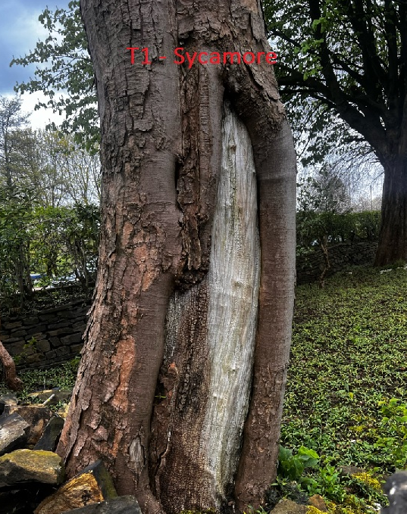

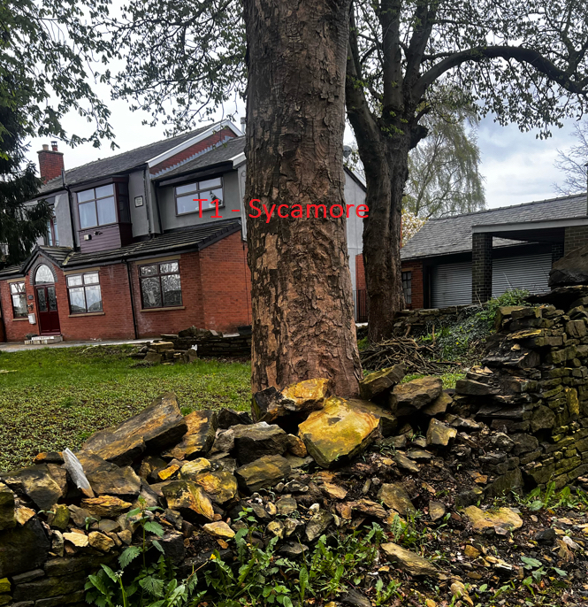

We recommend replanting with three replacement trees upon the agreement of the removal of T1 (Sycamore).

Regards
R.Slack
Mr Ryan Slack, cert Arb L2 (ABC)

