Application for a holiday- let cabin known as Summit Cabin, adj. Salley Street, Calderbrook Road. Littleborough OL15 9NG
Retrospective
Landscaping, boundary treatment and bio-diversity enhancement
Ref: DC-081024-A

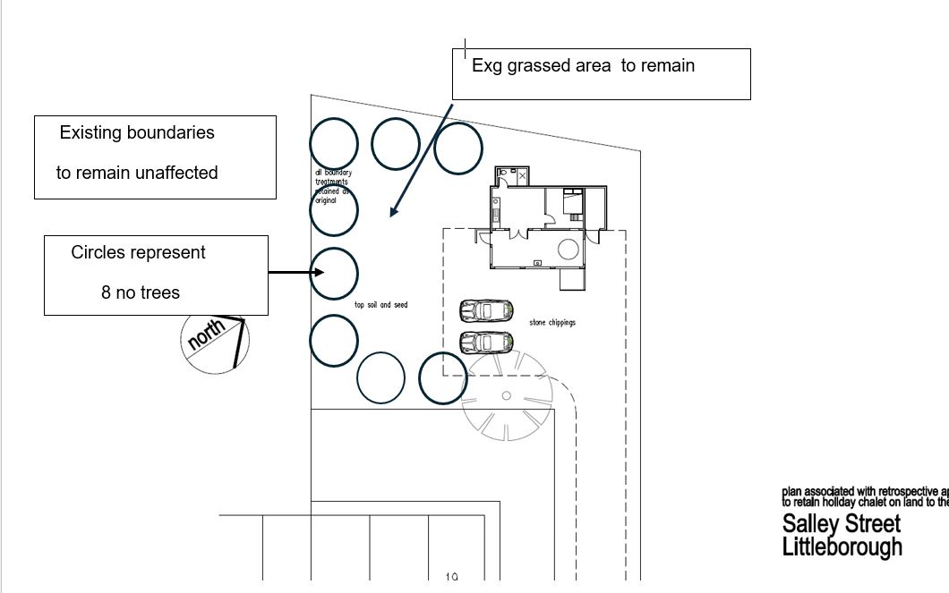

General
All planting operations shall comply with BS 4428 (1989) & AMD, Code of Practice for General Landscaping Operations.
Trees (as shown on the above plan)

8 no silver birch (Betula pendula) with diameters of between 7.5 and 30 cms (dbh). Trees to be root balled or container grown and to be planted in 150mm topsoil with 50 mm pulverised bark.
General Plant Quality

All plant material to be supplied in accordance with BS 3936 Parts 1 – 4 and 9 – 10. All plants to be correct species and stock size specified and to be good specimens characteristic of species. All plants to be supplied free from pest and disease

Maintenance
Any trees failing within the first 30 years to be replaced with similar

Other Biodiversity enhancement
One no. sparrow box to be attached either to the building under the highest part of the ridge or else to a retained tree, as follows: -
