Proposed agricultural building, Long Clough Farm, Clough Road, Littleborough OL15 9PA

Planning Statement

Ref:AG.270125.B

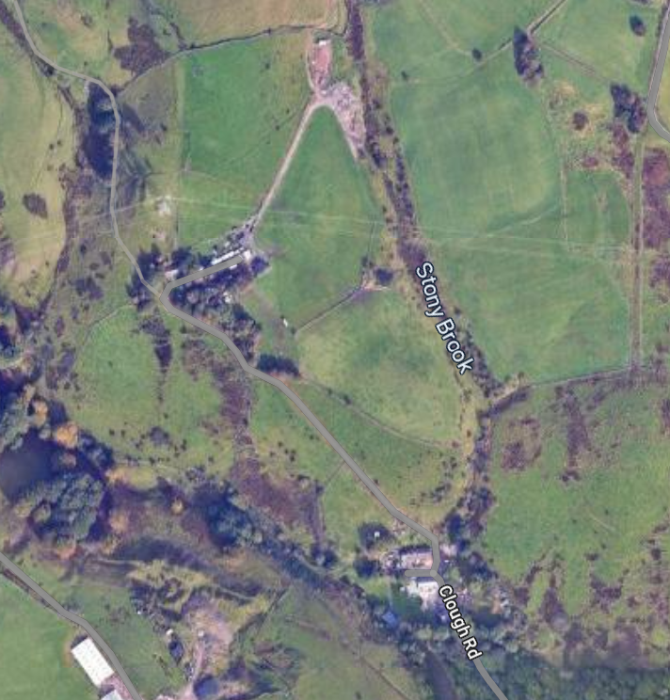

H | P
D | A

January 2025

Prepared by Hartley Planning and Development Associates Ltd
The application relates to land at the above farm where the agricultural unit extends to some 6.5ha, excluding other associated agricultural land in the area.
The building would be used for the housing of animals, mainly cows, and for general storage purposes.

The application site is within the Green Belt

The main issues
The main issues are (i) whether the proposal would be inappropriate development in the Green Belt; (ii) the effect of the development upon the character and appearance of the area and (iii) whether any harm by reason of inappropriateness, and any other harm, is clearly outweighed by other considerations so as to amount to very special circumstances required to justify the proposal.

Whether inappropriate development

Policy G4 of the Rochdale Core Strategy 2016 (CS) states that ‘Development will be restricted to those limited types of development which are deemed not to be inappropriate by national planning policies unless very special circumstances can be demonstrated’.

Policy JP-G9 of the Greater Manchester Places for Everyone 2024 (PfE) has little to say about development in the Green Belt other than referring to the 5 purposes of the Green Belt as outlined in national policy, and also that ‘ the beneficial use of the Green Belt will be enhanced where this can be achieved without harm to its openness, permanence or ability to serve its five purposes’. There is no reference to those exceptions which might be not inappropriate in the Green Belt, and as stated in national policy.

Paragraph 153 of the National Planning Policy Framework 2024 (the Framework) states that inappropriate development is, by definition, harmful to the Green Belt and should not be approved except in very special circumstances. However, paragraph 154 lists certain categories of development which form an exception to the general policy of restraint. Part (a) of that paragraph relates to ‘buildings for agriculture and forestry’.

The exception does not require an assessment of the impact in terms of openness or upon the purpose of the Green Belt.

Therefore, the proposed development would not be inappropriate in the Green Belt.

Moreover, and while the proposed building is not excessive, there are numerous appeal decisions where inspectors have concluded that need is not a requirement to be addressed in the Framework.

Character and appearance

The proposed development is relatively small both in area and height and would be located in a fold of the hills, largely inconspicuous from the public domain.

The proposed external materials, including Yorkshire boarding, are those commonly found in the area for agricultural buildings. It would assimilate with the rural scene.
While there are footpaths in the general area, the proposed building would not be incongruous in this rural area, being the sort of building commonly seen in Pennine locations, and would not adversely affect its character or appearance.

Other considerations

Need

There are no other modern agricultural buildings on the land. Existing stone buildings are no longer suitable for animal welfare reasons for the keeping of livestock.

In any event, numerous appeal decisions indicate that the establishment of ‘need’ is not a requirement of the Framework (See submitted, highlighted appeal decisions)

Local Authority high risk area

The proposed development lies outside the high risk area

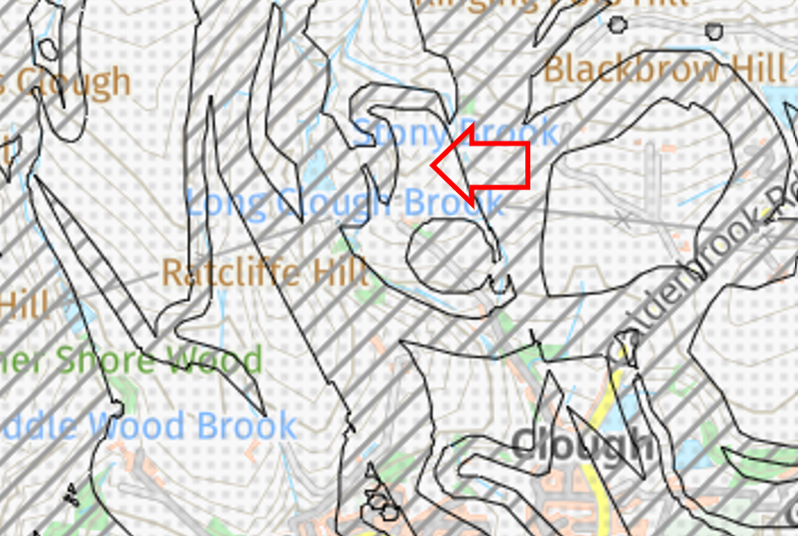

Flood risk

The proposed development is in the least risk category (Flood zone 1)

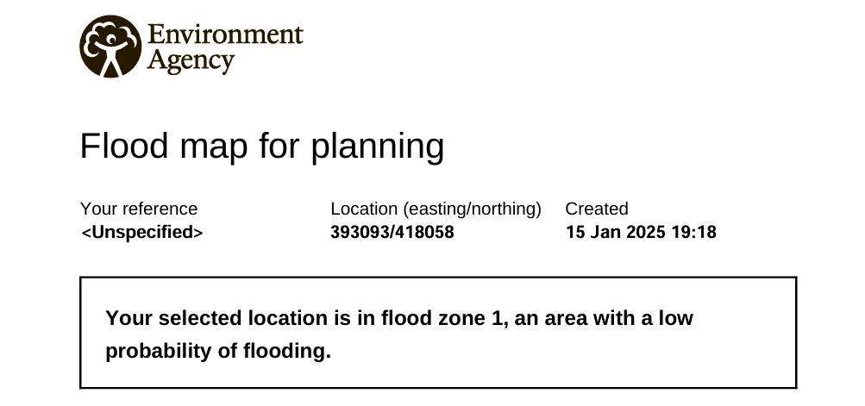

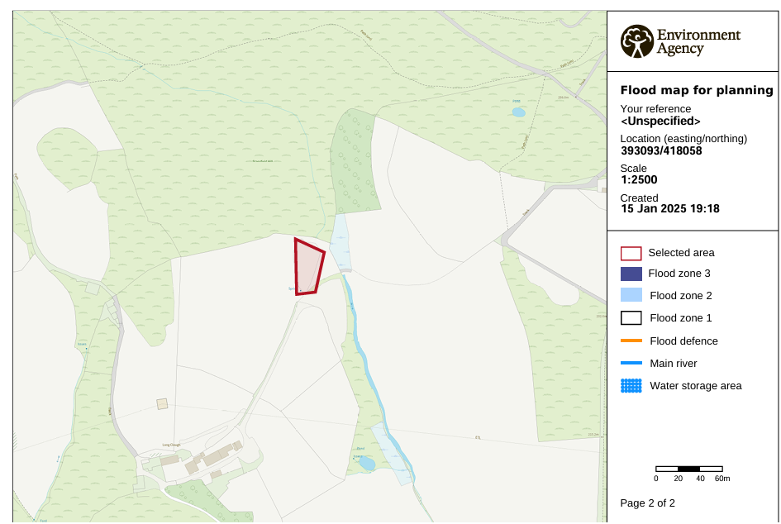

Biodiversity net Gain

There is no vegetation on the site and the proposal will not impact any habitats (including priority habitats), hedgerows or watercourses.

Therefore, in accordance with Regulation 4 (De minimis exemption) of The Biodiversity Gain Requirements (Exemptions) Regulations 2024, the proposal is exempt from biodiversity net gain regulations requiring at least a 10% improvement.

Nevertheless, bird boxes are proposed, to be fixed to the building. (See separate report)

Manure

Manure would be stored in a midden immediately adjoining the building. It would have a concrete base and blockwork sides to prevent spillage and would be stored ready for spreading on the adjoining farmland

Summary

Policy G4 of the Core Strategy states that proposals for development in the Green Belt will be judged against the contents of the Framework.

The Framework considers that the construction of agricultural buildings are not inappropriate in the Green Belt.

There would be no adverse or significant impact on the character and appearance of the area.

Consequent to the above there is no need to show very special circumstances in this case.

