SUSTAINABLE DRAINAGE AND LANDSCAPE MANAGEMENT PLAN FOR MILL VALE, DON STREET, MIDDLETON

An introduction to sustainable drainage systems or SuDS
SuDS are an environmentally friendly approach to managing rainfall that uses landscape features to deal with surface water. SuDS aim to:
    - Control the flow, volume and frequency of water leaving a development area
    - Prevent pollution by intercepting silt and cleaning runoff from hard surfaces
    - Provide attractive surroundings for the community
    - Create opportunities for wildlife

SuDS at Don Street, Middleton
The SuDS are designed to aid the drainage of the development site, ensure the overflow of the Rochdale Canal which runs along the northern boundary of the eastern parcel is maintained and to aid the discharge of surface water from the public right of way to the north of the western portion of site by using attractive landscape features.
    - Prior to redevelopment of the site an overflow from the Rochdale Canal flowed via a ditch and culvert to the River Irk, however the culvert was in a poor condition and had collapsed causing localized flooding. It was therefore agreed through the planning process to abandon the culver and construct a new longer swale and new culverted section therefore making a positive contribution to urban biodiversity and improve water quality.
    - The everyday flow from the footpaths and embankment to the north of the have been directed to drain into a new land drain which discharges via a headwall into the River Irk.

Managing the SuDS
The SuDS at Robinswood Hill Primary School have been designed for easy maintenance to comprise:
    - Regular day to day care - litter collection, grass cutting and checking the inlets and outlets where water enters or leaves a SuDS feature
    - Occasional tasks - managing vegetation and removing any silt that builds up in the SuDS features
    - Remedial work - repairing damage where necessary

Contact
In the event of concern over any matter to do with the SuDS please contact: Abbey Hitchenson C/O Trust Green – Unit 7 Portal Business Park, Fairfield, Eaton Lane, Tarporley, Cheshire, CW6 9DL, Tel: (01829) 708457 Email: abbey.hitchenson@trustgreen.com; Website: www.trustgreen.com

Fig 1: Adoptable Drainage Layout Sheet 1

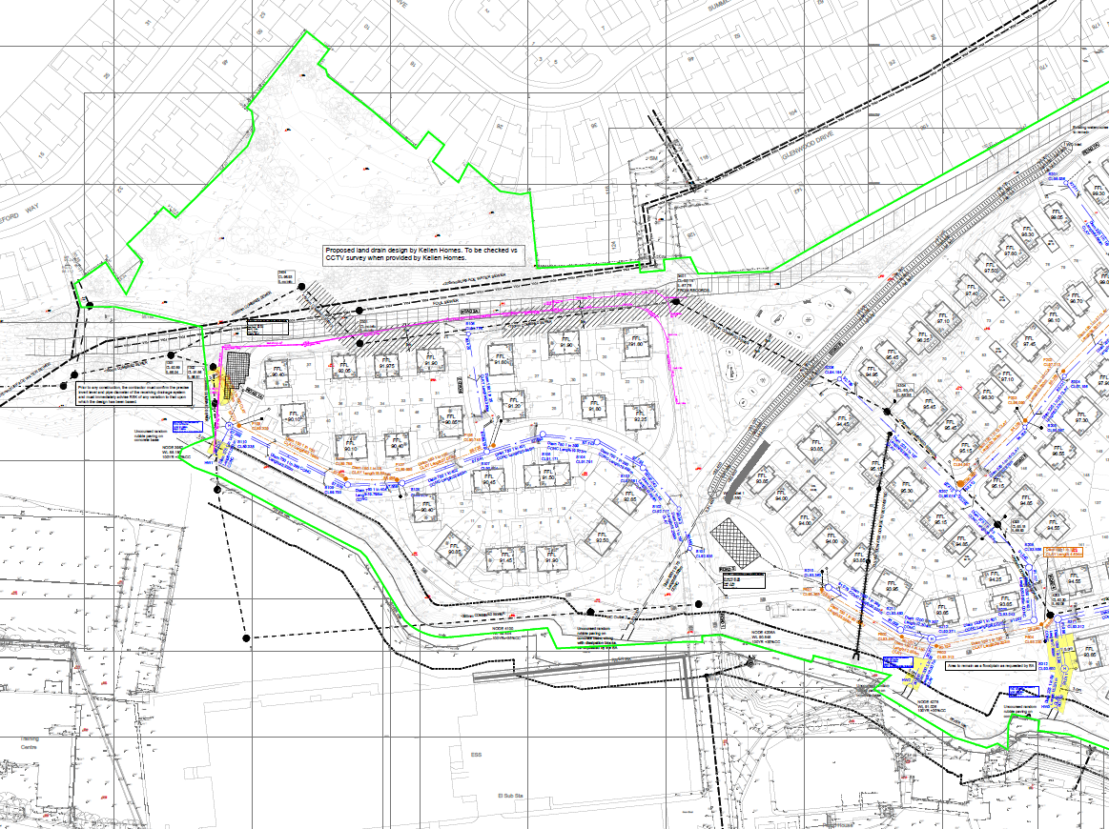
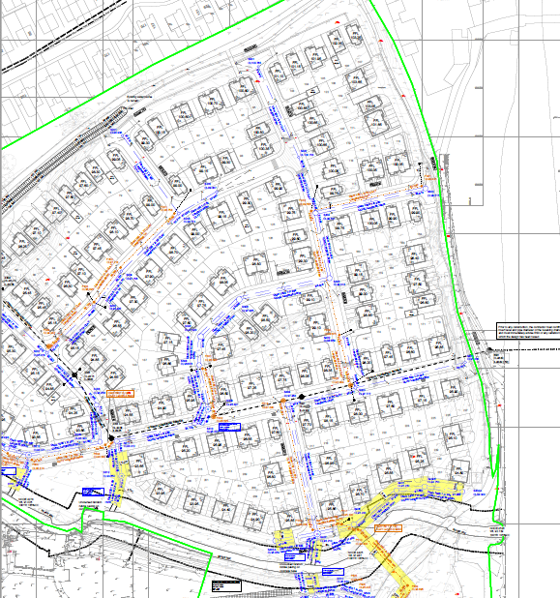

Fig 2: Adoptable Drainage Layout Sheet 2

Land Drain to Public Right of Way SuDS Management
The SuDS sequence begins to the east of plots 19 -22 on the public footpath and takes a route west capturing surface water run off before discharging in the River Irk.

ACTION:
    - Check and empty silt traps quarterly
    - Check and clear headwall quarterly

Rochdale Canal Overflow Swale SuDS management
Water from the Rochdale Canal flows via a swale along the northern boundary in periods of rainfall. The water arrives on the site through a ditch channel to the east (see Figure 2) and continues along the site in a grass swale before culverting to go under Don Street and remains culverted to its outfall at the River Irk (See Figure 1).

ACTION:
    - Cut the grass in the swale channel once each year, September – November at 100mm removing cuttings to wildlife piles
    - Occasionally remove vegetation if it spreads beyond the swale by hand clearing or raking
    - Check the headwalls quarterly and clear any detritus/silt build up.

SuDS and Landscape Maintenance – Summary

 |  | Frequency | Unit Rate | Total
 | REGULAR MAINTENANCE
1 | LITTER MANAGEMENT
1.1 | Pick up all litter in SuDS and Landscape areas and remove from site | 12 visits  monthly
2 | GRASS MAINTENANCE – all cuttings to wildlife piles
2.1 | Mow all grass verges, paths and amenity at 35-50mm with 75mm max. Leaving grass in situ | As required or monthly
2.2 | Mow all dry swales, dry SuDS basins and margins to low flow channels and other SuDS features at 100mm with 150mm max. Cut wet swales or basins annually  as wildflower areas | 4-8 visits as required Annually
2.3 | Wildflower areas strimmed to 50mm in Sept or at end of school holidays  Or  Wildflower areas strimmed to 50mm on 3 year rotation 30% each year | 1 visit  annually  1 visit  annually
3 | INLETS AND OUTLETS
3.1 | Inspect monthly, remove silt from slab aprons and debris. Strim 1m round for access | 4 visits yearly
4 | WETLAND AND POND VEGETATION
4.1 | Wetland vegetation to be cut at 100mm on 3 – 5 year rotation. 30% each year. All cuttings to be removed to wildlife piles or from site. | As required
5 | SILT MANAGEMENT
5.1 | Inspect swales, ponds, wetlands annually for silt accumulation | 4 visits yearly
5.2 | Excavate and remove silt | As required
 | REMEDIAL WORK
6 | Inspect SuDS system regularly to check for damage or failure.  Undertake remedial work as required. | As Required

7.0 SPILLAGE – EMERGENCY ACTION

Most spillages on development sites are of compounds that do not pose a serious risk to the environment if they enter the drainage in a slow and controlled manner with time available for natural breakdown in a treatment system.
Therefore small spillages of oil, or other known organic substances should be removed where possible using soak mats as recommended by the Environment Agency with residual spillage allowed to bio-remediate in the drainage system.
In the event of a serious spillage, either by volume or of unknown or toxic compounds, then isolate the spillage with soil, turf or fabric and block outlet pipes from chamber(s) downstream of the spillage with a bung(s). (A bung for blocking pipes may be made by wrapping soil or turf in a plastic sheet or close woven fabric.)
Contact the Environment Agency immediately.

8.0 QUERIES REGARDING A DESIGN FEATURE.
In the event of a concern or failure of a SuDS design feature contact Trust Green
Unit 7 Portal Business Park,
Fairfield,
Eaton Lane,
Tarporley,
Cheshire,
CW6 9DL,

Tel: (01829) 708457
Email: abbey.hitchenson@trustgreen.com;
Website: www.trustgreen.com

