Design and Access Statement

for:

Single Storey extension to existing school to provide additional classroom space.

at

Deeplish Primary Academy
Derby Street
Rochdale
OL11 1LT

On Behalf of:

The Board of Governors
Deeplish Primary Academy
Derby Street
Rochdale
OL11 1LT

1.00 | Site Location
1.01 | The proposed area of development is located within Deeplish Primary Academy’s site in Rochdale.  The site is situated off Derby Street within a densely populated residential area.  The development area is located on the West side of the site, South West of the main school building and to the southern elevation of the existing annexe building.  The site boundary subject to this application is depicted by the red-edged area and the specific area of development is depicted by the blue-edged area on the Site Location Plan (drawing reference 2023.036.PL01) submitted as part of this application.
1.03 | The site is bounded to the North by Exeter Street, to the East by Derby Street, to the South by Milkstone Road and to the West by residential housing. The area surrounding the site predominantly residential housing.
1.04 | It is our understanding that the site does not stand within a Conservation Area.
 | 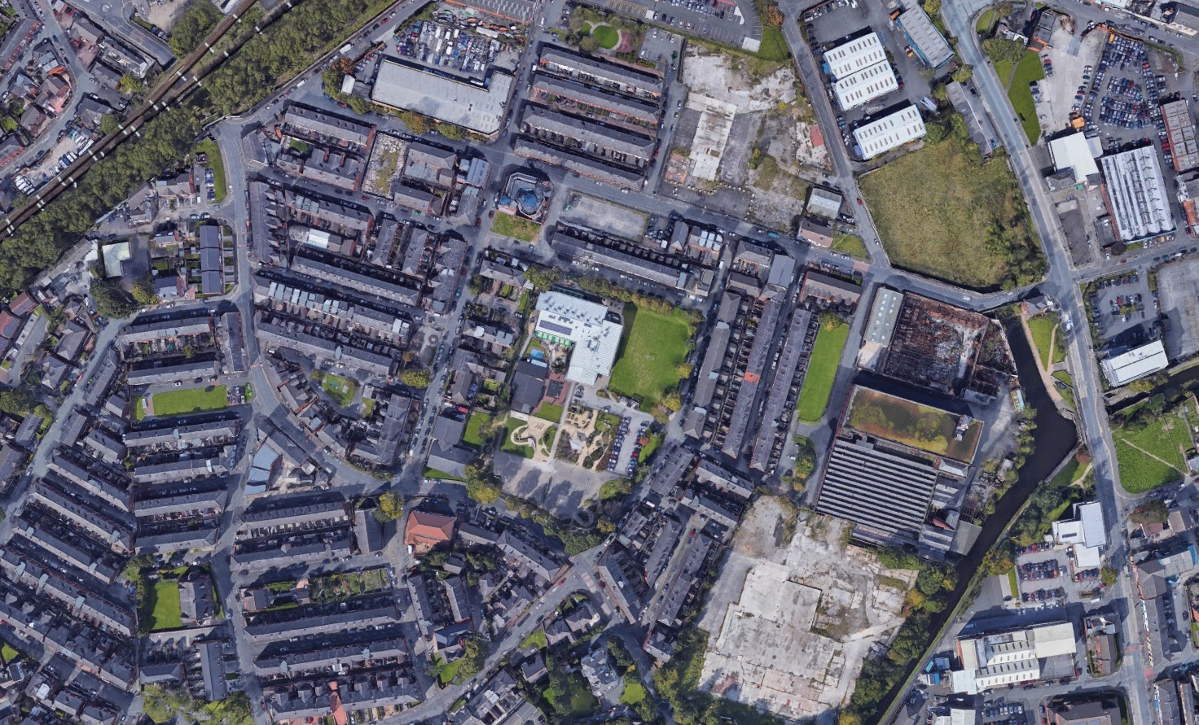
Figure 1)
Ariel Image of existing site and immediately adjacent properties.
2.00 | Existing Site
 | The school site consists of a hard landscaped playground, a soft landscaped playing field and 2 buildings, the main 2-storey school building, and a single storey annexe building. The main school building is of steel frame construction with a mix of brickwork and metal sheet cladding to the external walls, with a profiled metal roof covering. The annexe building, which is to receive the extension for which this application applies, is of masonry cavity wall construction with partial brickwork and partial rendered façade and the roofs are of majority pitched construction with a metal tile covering, with a small area of flat roof with a felt covering.
 | The existing buildings have pedestrian footpaths to their perimeter, with a car park area and site access road, all of which are laid to tarmac. The car park on site provides 29No. standard size car parking bays, including 3No. accessible parking bays.
3.00 | Site Access
Vehicle and pedestrian access to the site is provided via the main site entrance gates off Derby Street to the East of the site.

The proposal will not alter the existing site access routes as per the Proposed Site Plan (drawing reference 2023.036.PL10)

4.00 | Proposal & Design  The proposed single storey extension to the existing annexe building seeks to provide the school with much needed additional classroom space, including alterations and improvements to the existing school yard.
5.00 | Amount of Development  The application seeks to construct a new extension which of 87m² GIA, to provide additional teaching space, breakout rooms and WC facilities.
6.00 | Appearance
 | The proposed structure has been designed to sympathetically match that of the host building. The extension will be of cavity wall construction with a matching facing brickwork as per the existing building. The existing flat roof will be removed and replaced with a pitched roof structure of the same pitch and style of the existing, tied in at the ridge and with a matching metal tile covering. The proposed windows, doors, rainwater goods and the canopy structures have been designed to match the style of those of the main school building, including the colour scheme, and it is proposed that those retained will be altered / changed to match the colour scheme.
7.00 | Scale
 | The new unit will provide 87m² GIA. The proposed extension will match, and tie into the existing structure, with roofline and ridgeline of the same height.
8.00 | Landscaping
 | The proposed works will require a minimal amount of external landscaping works, with the adjacent play area to be resurfaced with a matching tarmac finish. There will be no change to the existing green / recreational open spaces.
9.00 | Accessibility
 | The tarmac surfacing to all external doors will be graded to provide wheelchair access to the building in accordance with Approved Document K of the Building Regulations. All external and internal doors will be sized in accordance with BS8300 and the building will be constructed in full accordance with the requirements of Approved Document M of the Building Regulations.
10.00 | Accessible WC provision is provided for people with disabilities and / or additional access requirements in full accordance with the requirements of Approved Document M of the Building Regulations.  Sustainable Design  We aim to deliver a development that is in accordance, as far as is practicable, with best practice principles of sustainable development, and the scheme has been designed to positively contribute to long term objectives of environmental protection and resource management.  The design process is a key part of sustainable practice, and there is a need to ensure that, on completion, the quality of the environment supports and reflects the principles of sustainability.  During the construction of the new building envelope the materials used within the construction will be sourced locally where practicable and appropriate. This approach helps to reduce CO2 emissions created by excessive travel distances needed to transport materials. The life cycle of the building should and will be considered during its design and construction. Materials and construction methods will be employed that allow materials removed during maintenance or at the end of the building’s life to be taken away and recycled.

