

Top O’th Meadow Farm
Meadowhead Lane
Norden, Rochdale
OL11 5UL
Tel: 01706 658771

19th September 2023

Mr Gary Marland
51 Marquess Way
Middleton
M24 4QS

As requested, please see the completed tree report, as discussed this offers no guarantees as trees are living organisms and can fail at any time. We would also like to advise that no indemnity or insurance cover is offered. This report is in “my professional opinion” only and covers only the trees that have been inspected.

Tree in question is subject to a Tree preservation order TPO 123

TPO Ref: TPO123
TPO name: Land north of Manchester Old Road, east of Heywood Old Road, Rhodes, Middleton
Date confirmed: 1993-12-02
Tree type: Beech
Description: T29
ID: T29TPO123
Local authority: Rochdale
Location: Rear Garden of 51 Marquess Way

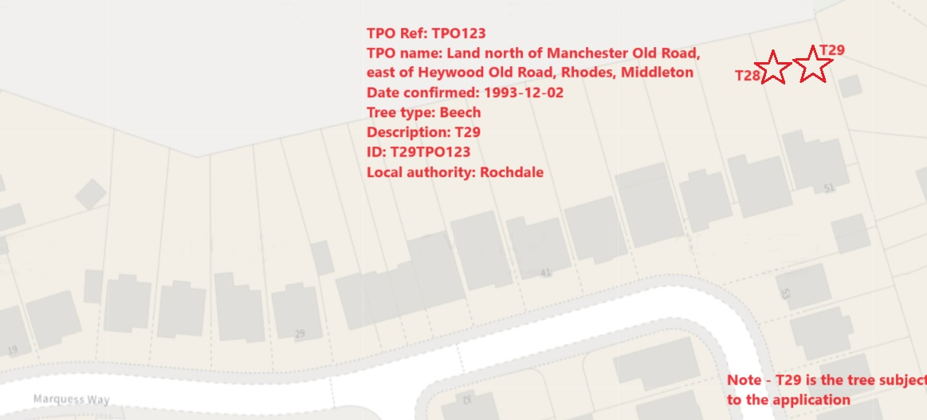

Work done

Site visit, arboricultural inspection, photography, and report.

Tree in question

T29 Beech

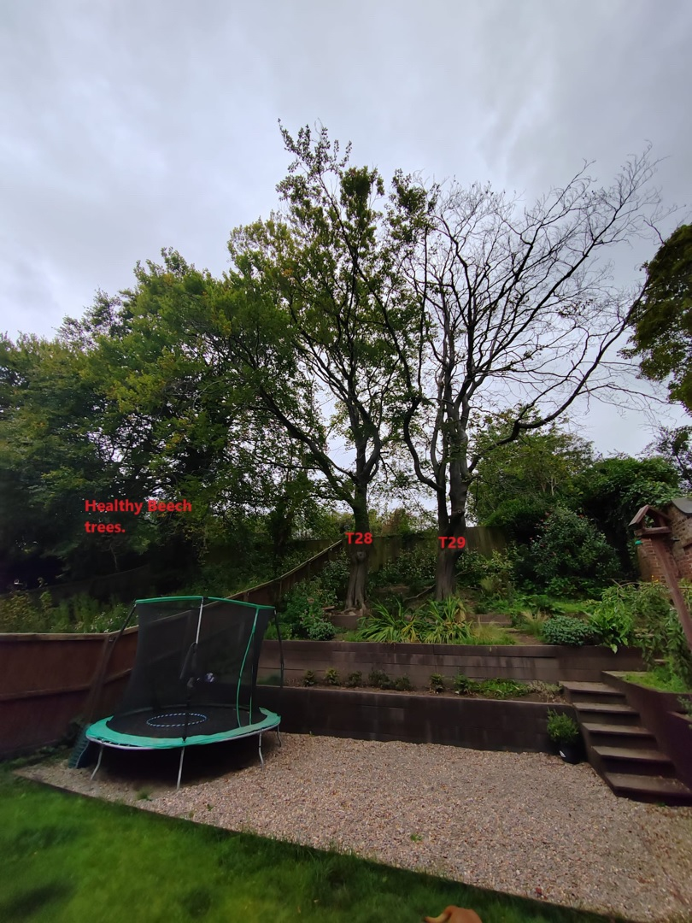

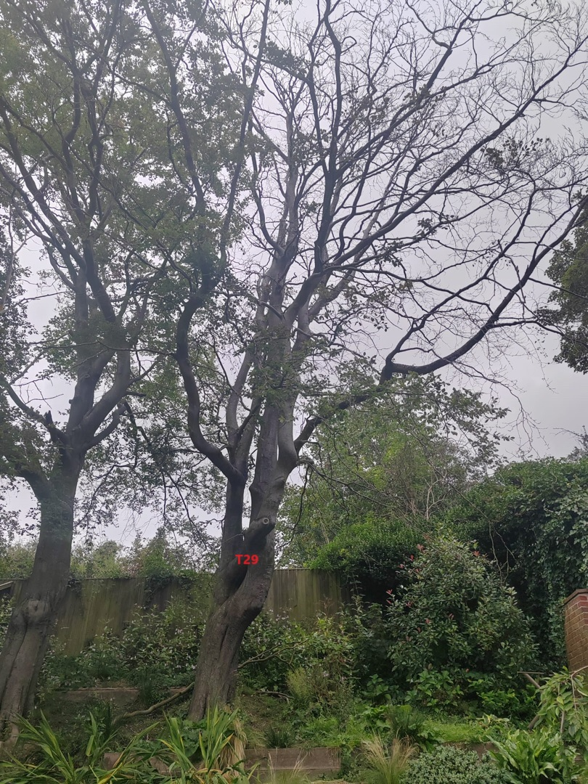

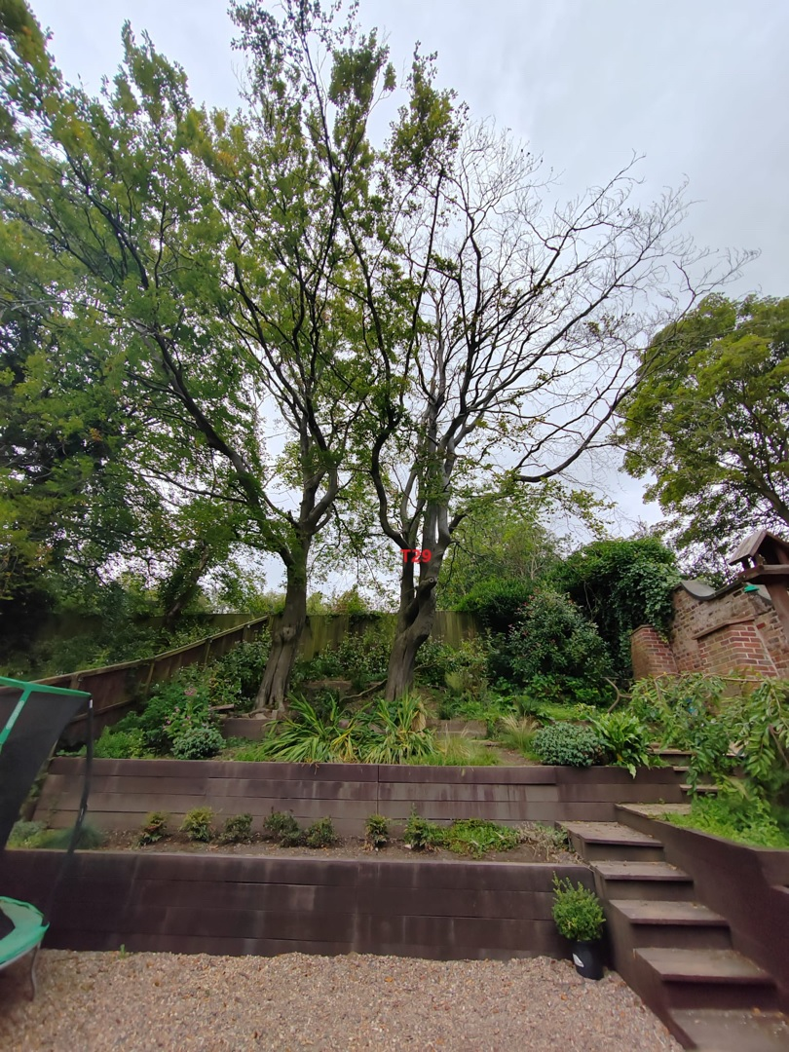

Findings
.
T29. Beech – A standing dead tree with extensive deadwood throughout the whole canopy. This tree poses a high risk to life and property due to the sheer decline.
T29 frequently loses branches during high winds and the main fear is if the tree was to completely fail. Residents within close proximity have all raised safety concerns over the tree.
Please see photographs of T29 next to healthy Beech trees showing the comparison of tree health.

Recommendations

I strongly recommend the removal of T29 (Beech) as soon as practically possible.
Mr Marland agrees to replant two new trees if permission is granted for the removal.

Kind regards,

Mr. Ryan Slack
General Manager and Director
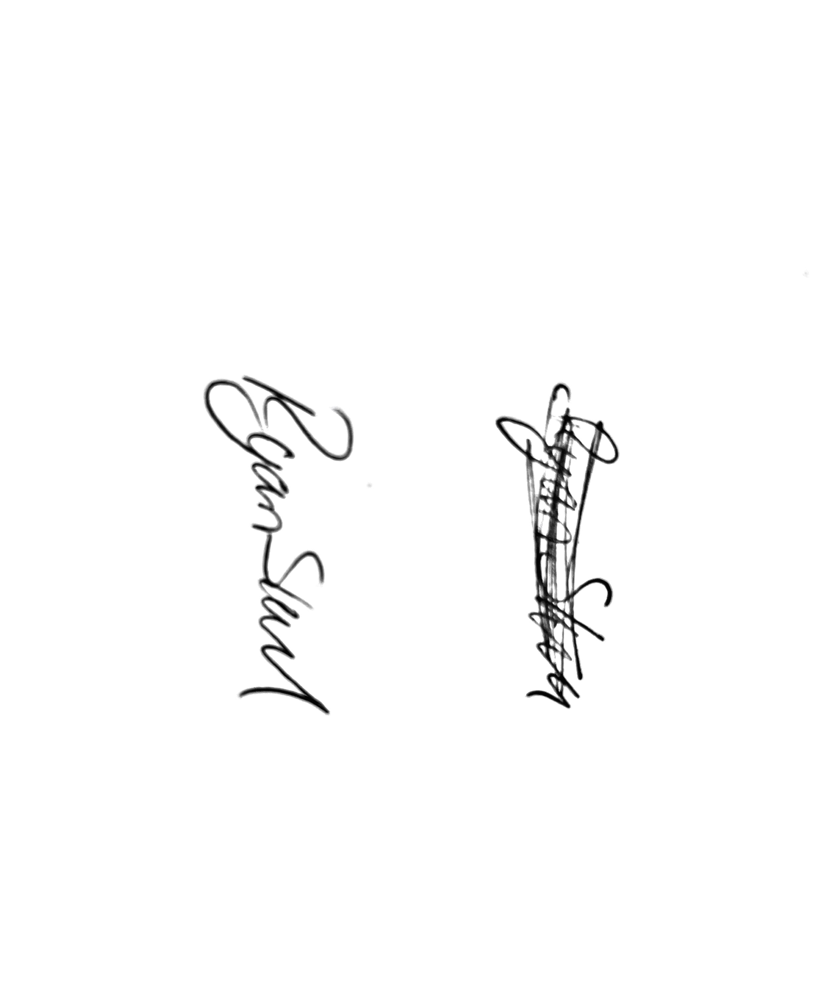
SEG Award, Cert Arb L2 (ABC)

