SPECIAL BRANCH
`

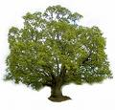
Tree Surgeons Ltd
Top O’th Meadow Farm
Meadowhead Lane
Norden, Rochdale
OL11 5UL
Tel: 01706 658771

Mini Tree Report Date: 06/011/2022

Mr Herbert
Grange Barn
Trows Lane
Rochdale
OL11 2EU

As requested, please see my mini tree report, as previously mentioned this offers no guarantees as trees are living organisms and can fail at any time. We would also like to point out no indemnity or insurance cover is offered. This report is in “my opinion” only and covers only the trees that have been inspected.

Trees in question are not subject to a Tree Preservation order 042

Local authority: Rochdale
TPO Ref: TPO042
- TPO name: Trows Lane, Castleton
- Tree type: Beech Horse Chestnut Elm Whitebeam Lime Sycamore Hawthorn
- Description: A7
- ID: A7TPO042
- Local authority: Rochdale

Location
Grange barn
Trows Lane
Rochdale

Work done

Site visit, arboricultural inspection, photography and report.

Trees in question

1 tree Sycamore

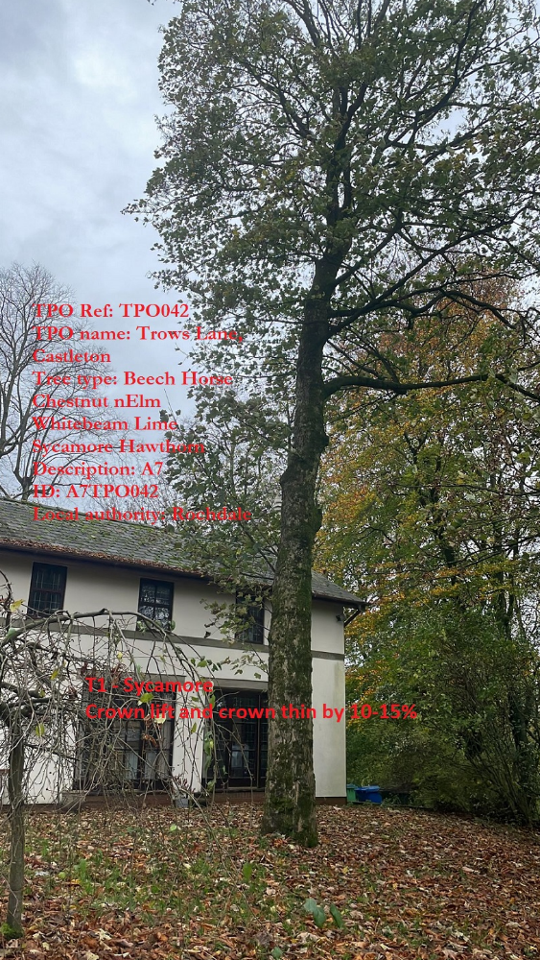
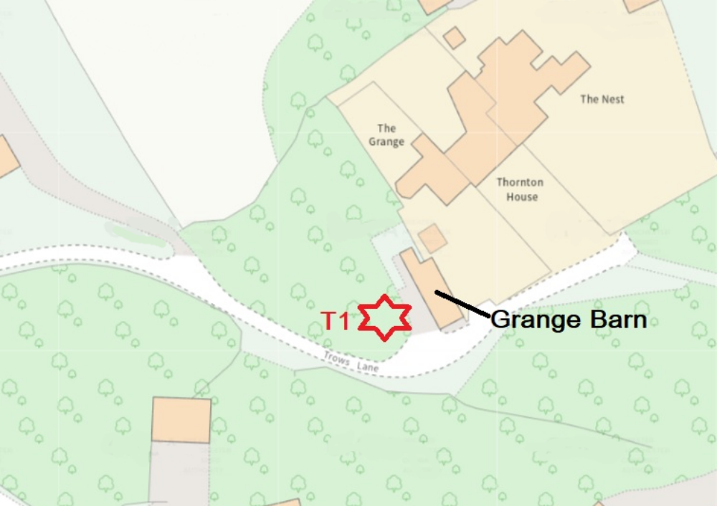

Problem

Tree T1 Sycamore identified in the location plan and shown in the picture has a very dense canopy.

Recommendation

We would recommend crowning lifting of minor secondary branches and a crown thinning the tree by 10-15% and removing the small amount of epicormic growth to improve the aesthetics of the tree allowing more light and wind to pass through the canopy. These works will not affect the health of the tree.

Regards

C.Ashton
Mr C. Ashton cert Arb L2 (ABC)

