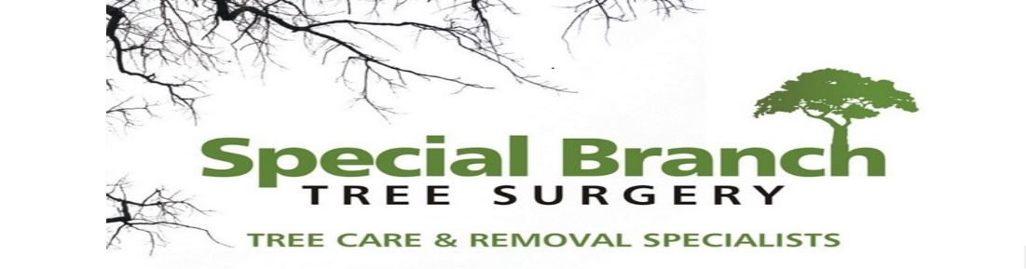

Top O’th Meadow Farm
Meadowhead Lane
Norden, Rochdale
OL11 5UL
Tel: 01706 658771

3rd October 2024

Mrs Hough
455 Edenfield Road
Norden, Rochdale
OL11 5YR

As requested, please see the completed tree report, as discussed this offers no guarantees as trees are living organisms and can fail at any time. We would also like to advise that no indemnity or insurance cover is offered. This report is in “my opinion” only and covers only the trees that have been inspected.

Trees in question are subject to a Tree preservation order – TPO157

Local authority: Rochdale

Location
455 Edenfield Road.

TPO Ref: TPO157
TPO name: Palatine Road/Palatine Avenue, Norden
Tree type: Sycamore
Description: T13, T14
ID: TPO157
Local authority: Rochdale

Work provided

Site visit, arboricultural inspection, photography, report, and quotation.
All trees have been thoroughly inspected and only the tree with any defects or concerns have been noted.

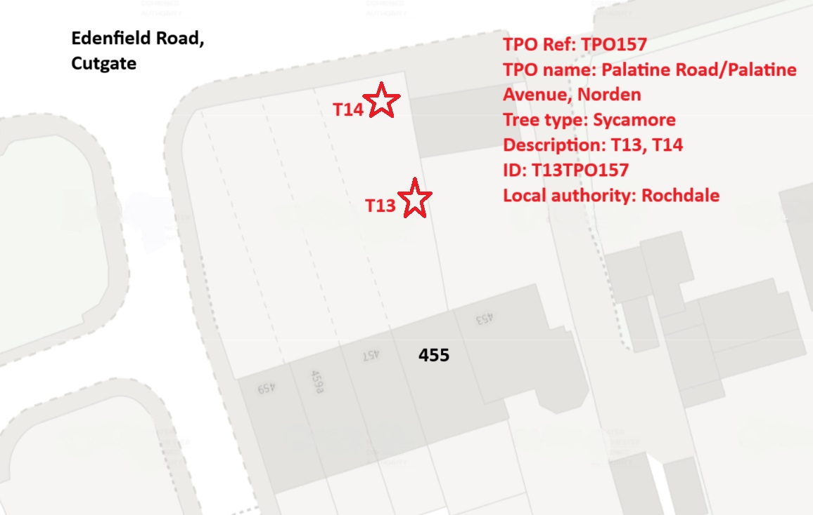

Trees included
T13, T14 – Sycamore

Issues found

Mature Sycamore trees located at the front of the property. Both trees have started to tangle into the BT wires

Recommendations

T13, T14 – Sycamore – Prune delicately away from the BT wires. Gaining a 0.5 meter clearance.

Pruning back the branches of your T13 and T14 sycamore trees that have tangled into the BT wires is crucial for several reasons. Firstly, allowing the branches to become entwined with the wires poses a significant safety hazard. As the branches grow and thicken, they can exert pressure on the wires, potentially leading to their breakage. This can result in disrupted communication services, electrical hazards, and even fires in extreme cases.
Secondly, neglecting to prune back the branches can also have a detrimental impact on the health of the trees themselves. When branches are in direct contact with wires, they can become damaged due to friction and abrasion. This damage creates entry points for pests and diseases, compromising the overall health and structural integrity of the trees. By pruning the branches away from the wires, you not only mitigate the risk of immediate safety hazards but also promote the long-term health and vitality of the trees.

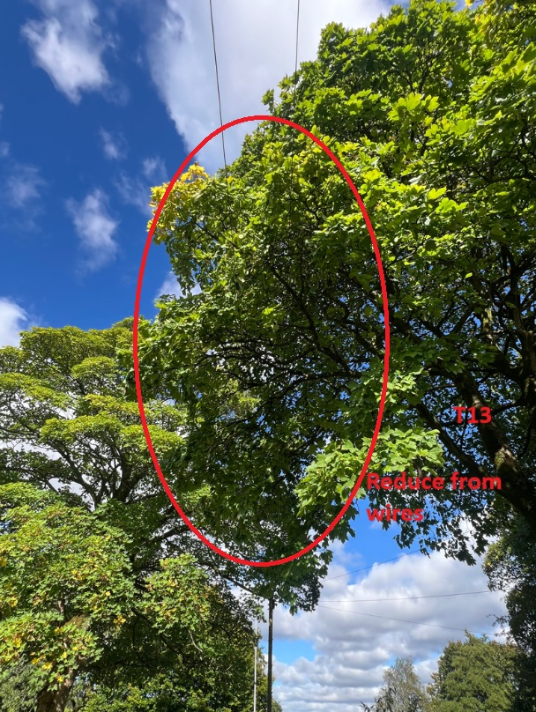

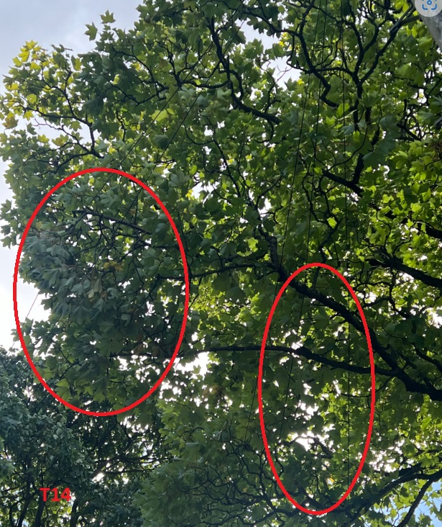

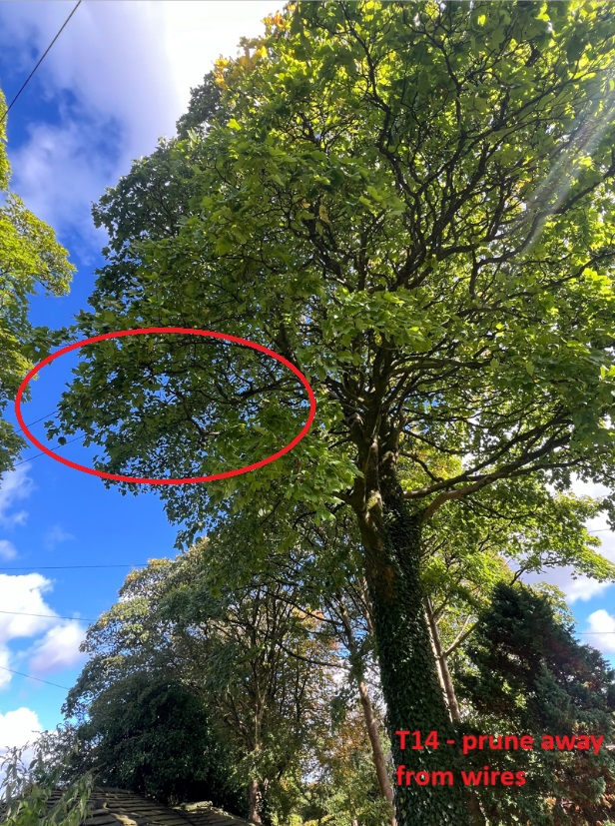

Kind regards,
Mr. Ryan Slack
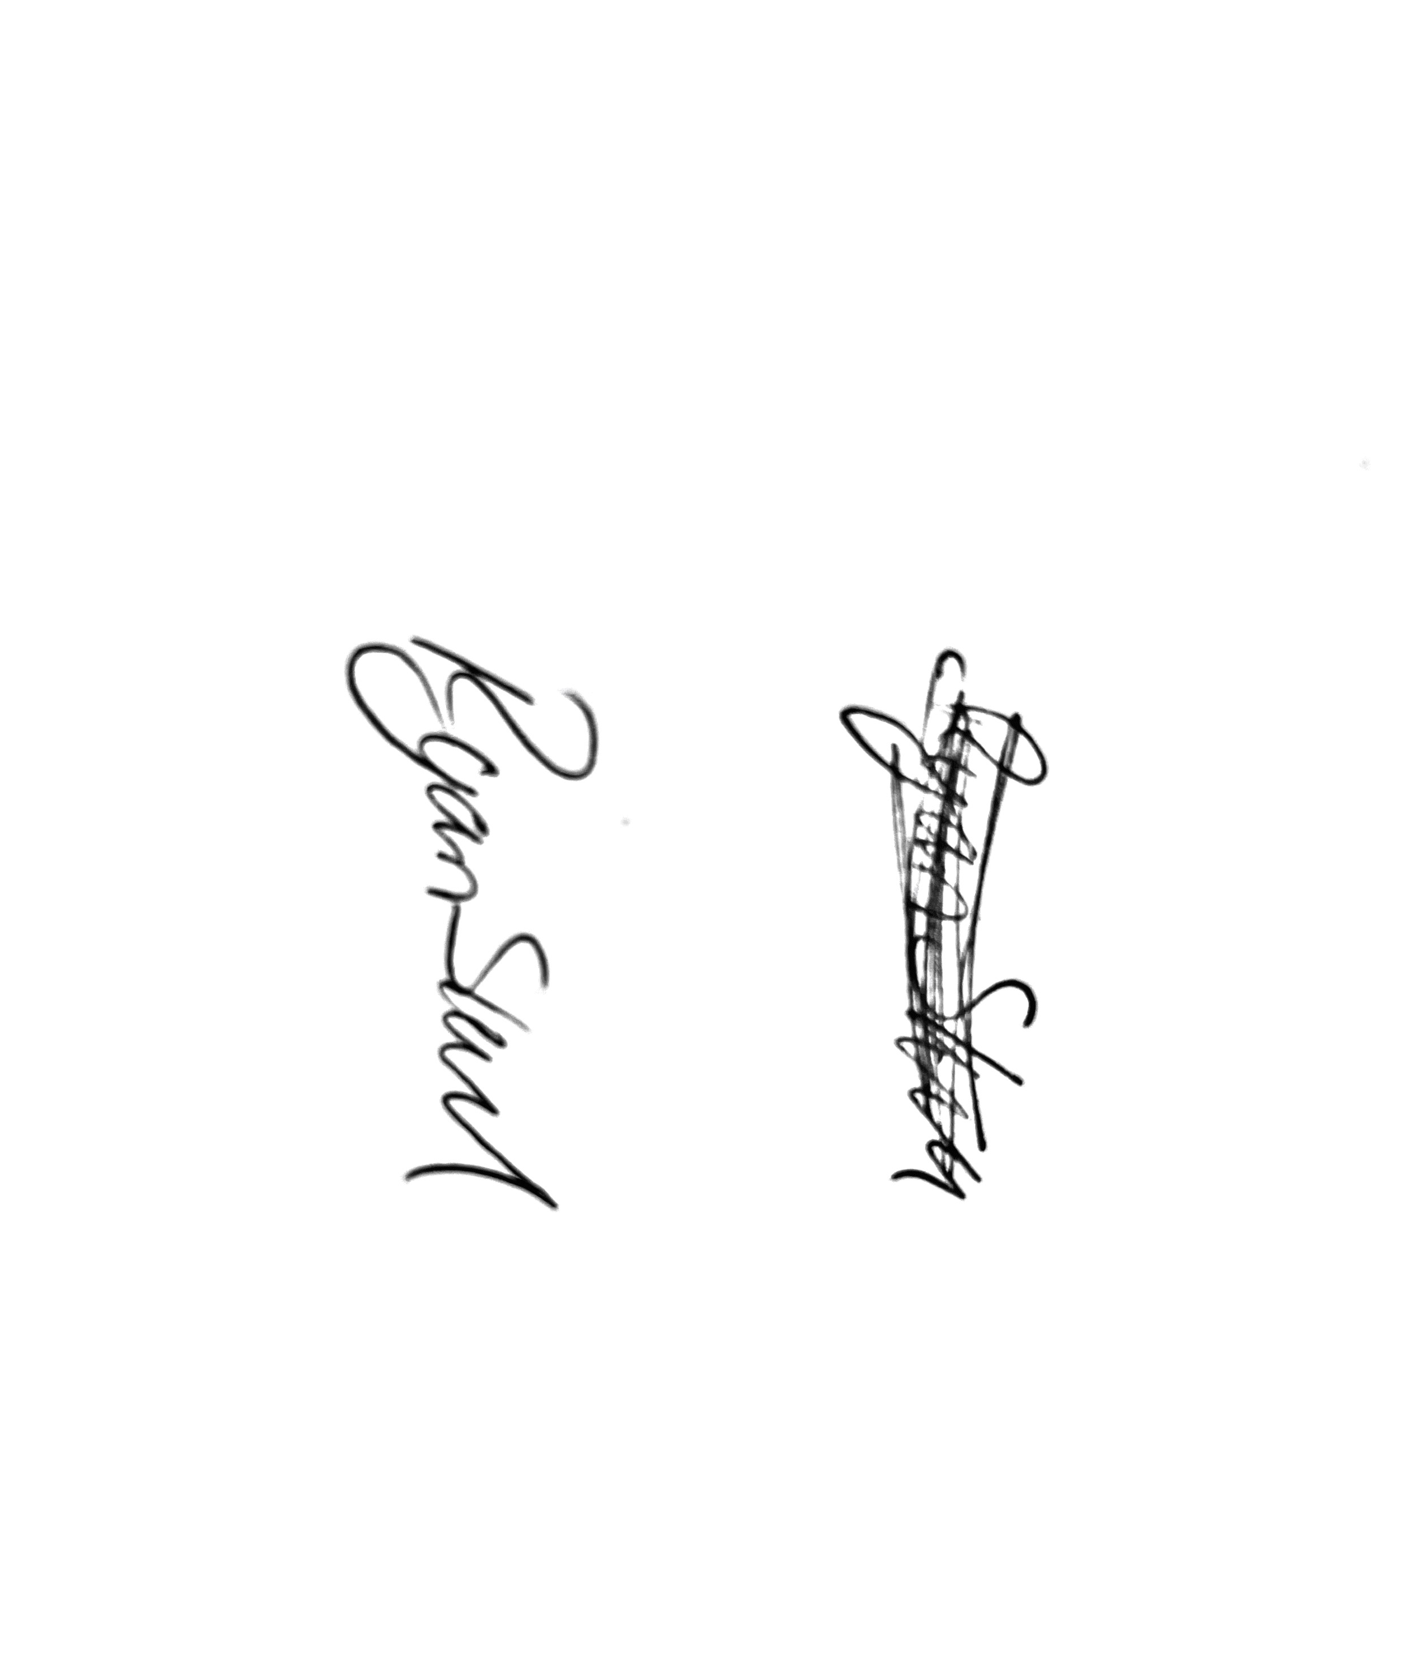
General Manager and Director
SEG Award, Cert Arb L2 (ABC)

