

Planning Statement

77 Church Street Littleborough OL15 8AB

Proposed Change of Use of Use From Office to Private Hire Taxi Base at 77 Church Street
Littleborough OL15 8AB

September 2022

Building Design Services (BDS)

77 Church Street Littleborough OL15 8AB
June 2022

CONTENTS

Page

- INTRODUCTION - 2

- SITE AND SURROUDINGS - 3

- PROPOSED DEVELOPMENT - 4

4 INVOLVEMENT- 7

- HISTORY - 8

- RELEVANT PLANNING POLICY - 9

- ASSESSMENT - 11

- CONCLUSION -17

Prepared by: Building Design Services (BDS), 6 Stock Close, Shawclough, Rochdale, OL12 7BB.

E-mail: bds2000@live.co.uk

77 Church Street Littleborough OL15 8AB
Sept 2022

1.0 INTRODUCTION

1.1 This Planning Statement is submitted by Building Design Services (BDS on behalf of the applicant who owns the building at 77 Church Street Littleborough OL15 8AB. The building is two stories high and currently the building is unoccupied and were previously being used for storage at first floor and ground floor commercial use as an office. The applicant would like to secure planning permission to refurbish and make use of the unused building by moving from his current business to 77 Church Street Littleborough from 2 Howarth Place Littleborough and make a positive change to the town centre. 77 Church Street is not a listed building; however, it is located in an area with a number of Graded Listed Buildings

1.2

1.3
This Planning Statement accompanying full floor and elevation plans submitted as part of this proposal refer to the land use, constraints, policy, guidance and possible issues, and addresses these matters categorically.

1.4

The applicant would like to work with the Council to secure approval for the proposed use.

77 Church Street Littleborough OL15 8AB June 2022

2.0

2.1

SITE AND SURROUNDINGS

The application relates to a mid-terrace building a two storey mid-terraced property positioned in

Littleborough town centre, primary district shopping area, and situated within the Littleborough Town Centre.

77 church street is not a listed building; however, it is in an area with a number of Graded Listed Buildings. Holy Trinity Church, Littleborough War Memorial, Coach House Heritage Centre, the Round House, wheatsheaf Centre and the Railway Viaduct

  - The terrace is occupied by a variety of shop/commercial properties and is within a group of similarly occupied terraces. The building apparently dates from the late C19th, with shop frontage at ground floor and an open passage to the side leading to the back of the building. A stairway internally provides access to the upper floors of the building.

  - In more recent years the upper floor of the building have stood empty. Queens Road runs behind to the back of the building. The front and rear elevations retain original materials. Bins are stored to the rear along the highway. There are car parking spaces provided at the rear of the building.

  - It is understood that the interior of the building was subject to considerable change from its original form given its previous uses, with measures including partitions and stud walling. Though the building appears cosmetically sound from the exterior.

  - The site is considered to be in a sustainable location being well served by public transport and well related to an adequate range of existing services and facilities within a short walking distance. The location plan shows the building has external curtilage with the built footprint occupying part of the site and leaving parking area to the rear.

  - The site is located in a close-knit urban area in littleborough town centre. Servicing is provided from the rear.

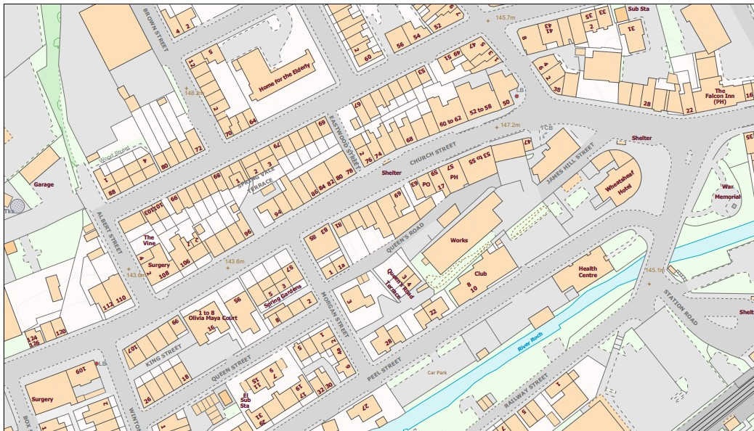77 Church Street Littleborough OL15 8AB
Sept 2022

The Proposals map indicates the site positioned towards the north of Littleborough Town Centre

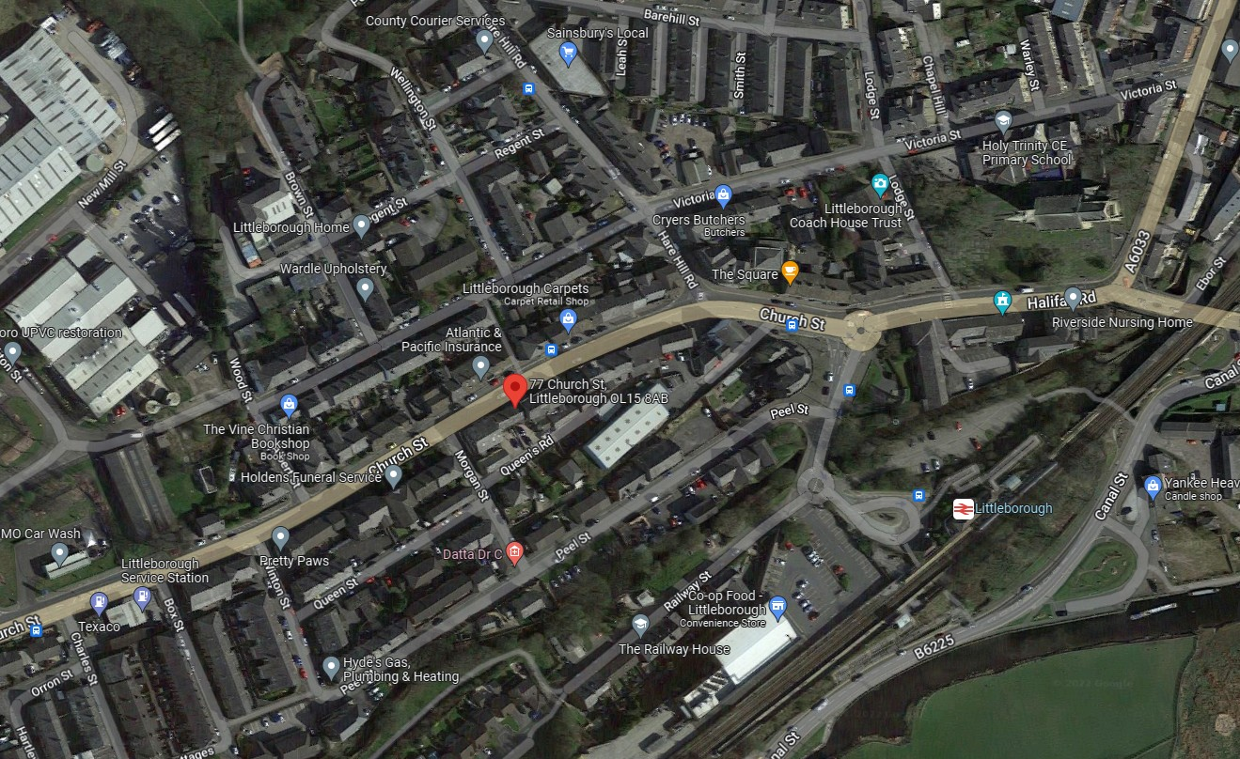

Image above taken from The Proposals Map.

77 Church Street Littleborough OL15 8AB Sept 2022

3.0 PROPOSED DEVELOPMENT

  - The applicant is applying for full planning permission to change the use of the building from office to Private Hire Taxi base. There would be no external changes to the building’s elevations

  - Internally it would remain the same and access to the upper floors would be via a flight of stairs. The first floor would provide the staff room together with a tearoom and the bathroom would remain as it is.

  - The applicant expresses that an extended period of vacancy of this building would place the building at risk of deterioration. This is a situation that the applicant would wish to avoid and as such seeks to ensure a sustainable future for the building that is conducive with its conservation. As previously stated, the applicant is willing to work with the Council to secure permission for the appropriate use of sufficient high quality as demonstrated by this Statement and the submitted drawings.

  - The Town Centre represents an appropriate location for such initiatives, offering the prospect of increased diversity, security, and a general revitalization, especially at nights and weekends, The Town Centre has the potential to provide unique housing opportunities which cannot easily be found elsewhere in the town, or indeed in the surrounding region. Such opportunities are likely to be particularly suitable for the young, single and small families. All represent groups whose housing needs are projected to expand considerably.

Above plan shows the mid terrace property on 77 Church Street

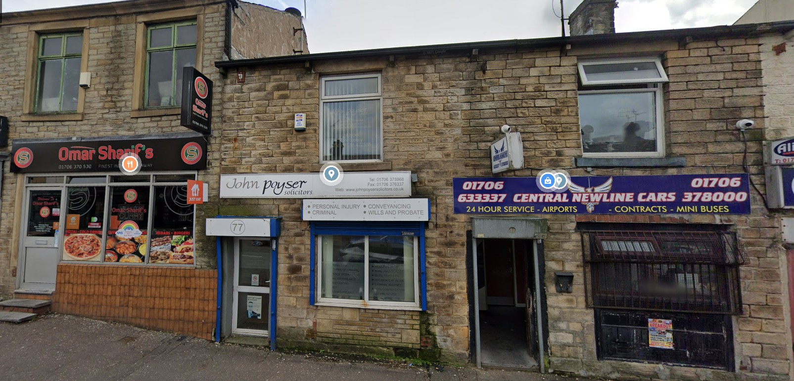

Above image shows the front of the building.

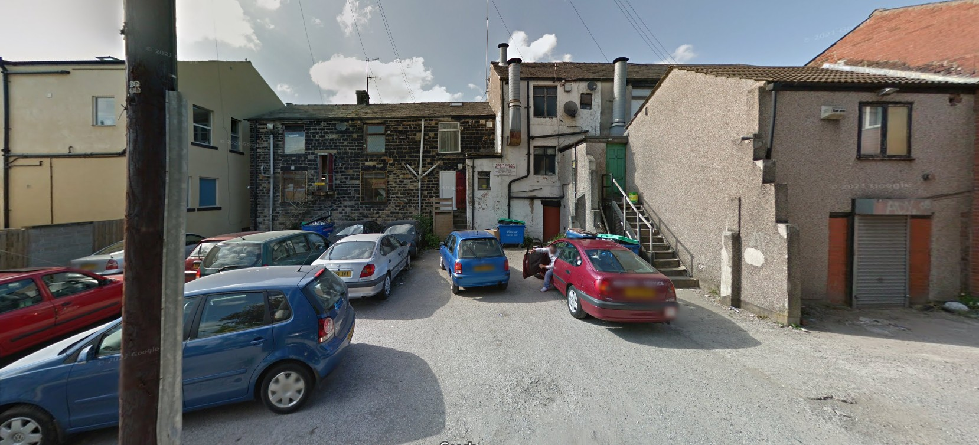

Above image shows the rear of the building with access and bin storage at rear and parking

4.0. INVOLVEMENT

  - It was not considered necessary in this instance for a formal pre-application advice to be sought from the Councils planning officers regarding the type of business provided. It is considered the scheme put forward is an acceptable proposal that would provide a quality business in this town centre area further increasing growth in Littleborough.

  - Paragraph 39 of the NPPF states;

“Early engagement has significant potential to improve the efficiency and effectiveness of the planning application system for all parties. Good quality preapplication discussion enables better coordination between public and private resources and improved outcomes for the community.”.

  - This Statement has been submitted as part of this planning proposal to provide a reasoned justification of the proposal using local and national planning policy and guidance.

  - The issues of Highways safety, amenity of the surrounding area, design, heritage, and the principle of the development are taken into consideration in the assessment below.

5.0 HISTORY

5.1 A history check has been undertaken which has revealed no relevant planning history for the site.

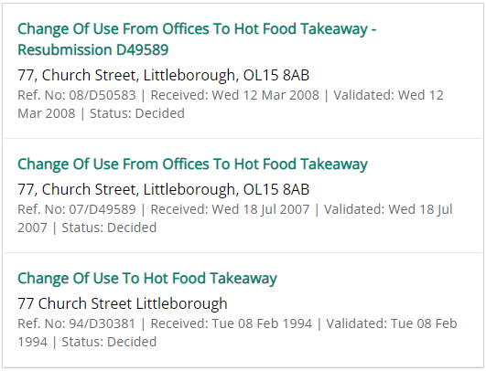

6.0 RELEVANT PLANNING POLICY

  - Section 38(6) of the Planning and Compulsory Purchase Act 2004 states that decisions should be made in accordance with the development plan unless material considerations indicate otherwise.

  - The Core Strategy forms only one part, albeit an important one of the planning frameworks for Littleborough. It is one element of the Local Development Framework (LDF), library of documents that will form the Development Plan for the Borough. The Core Strategy is an overarching document that sets the main direction and amount of development for the next 15 years. It puts into a physical form the content of the Sustainable Community Strategy (SCS). Together the Core Strategy and the SCS provide direction on how key issues affecting the Borough will be tackled over the next 10-15 years.

  - Littleborough is characterized by its stone-built terraced housing, most of which was constructed before 1919 which forms a third of the housing stock in the Borough. Partly as a result of the abundance of this type of housing stock, Littleborough has suffered from housing market failure, particularly in the east of the Borough. To tackle the problems of housing market decline, low demand and abandonment, which aims to improve the quality and diversity of the housing stock, along with improving economic prosperity, the environment and community life within these areas.
  - Littleborough looks to build on the borough's assets, heritage and identity and on its connections and relationships with neighbouring towns. In particular, the borough needs.

  - The following Local Plan policies have relevance to the proposal:

POLICY 1 GENERAL DEVELOPMENT LOCATIONS AND PRINCIPLES

POLICY 2 MEETING ROCHDALE & LITTLEBOROUGH HOUSING REQUIREMENT

POLICY 8 TRANSPORT

POLICY 9 ACCESSIBILITY

POLICY 11 RETAIL & OTHER TOWN CENTRE USES

POLICY 16 PRESERVING & ENHANCING THE BUILT ENVIRONMENT POLICY 24: PLANNING APPLICATION REQUIREMENTS

NPPF (2021)

  - The NPPF clearly states ‘that the purpose of the planning system is to contribute to the achievement of sustainable development’ (paragraph 7). Paragraph 10 confirms that ‘in assessing and determining development proposals, local planning authorities should apply the presumption in favour of sustainable development’. Paragraph 11 states that a presumption in favour of sustainable development is at the heart of the NPPF. It goes on to say that ‘for decision-taking this means:

    - approving development proposals that accord with an up-to-date development plan without delay; or

    - where there are no relevant development plan policies, or the policies which are most important for determining the application are out-of-date, granting permission unless:

- the application of policies in this Framework that protect areas or assets of particular importance provides a clear reason for refusing the development proposed; or

- any adverse impacts of doing so would significantly and demonstrably outweigh the benefits, when assessed against the policies in this Framework taken as a whole.

Paragraph 130 of the NPPF, advises that Planning policies and decisions should ensure that developments create places that are safe, inclusive and accessible and which promote health and well-being, with a high standard of amenity for existing and future users.

Paragraph 111 of the NPPF states that Development should only be prevented or refused on highways grounds if there would be an unacceptable impact on highway safety, or the residual cumulative impacts on the road network would be severe.

The general perspective of the NPPF is that planning should proactively drive growth and support sustainable economic development. It also states that planning should make effective use of land by reusing land that has been previously developed and sets out a presumption in favour of sustainable development. The government is committed to ensuring that the planning system does everything it can to support sustainable economic growth.

In terms of retail uses the NPPF states at Paragraph 121;

“Local planning authorities should also take a positive approach to applications for alternative uses of land which is currently developed but not allocated for a specific purpose in plans, where this would help to meet identified development needs.

  - National Planning Practice Guidance (NPPG)

The government published its NPPG on 6 March 2014. This is intended to complement the NPPF and to provide a single resource for planning guidance, whilst rationalizing and streamlining the material. Almost all previous planning Circulars and advice notes have been cancelled. Specific reference will be made to the NPPG or other national advice in the Analysis section of the report, where appropriate.

7.0 ASSESSMENT

Principle

  - The business proposed would be located in Littleborough Town Centre. Policy 2 of the Council Core Strategy is therefore relevant and which states
1. Supporting the reuse and conversion of appropriate buildings for commercial use

  - Policy 9 of the Core Strategy states that new development within the urban boundary should be concentrated close to main public transport corridors within 400metres of a bus stop with regular services. Enhanced links to key services and employment opportunities, including in adjacent Boroughs.

  - The application site is Defined Urban Area as allocated under the Development Plan. As such policies establish that development should be located in the urban area so as to support urban regeneration and protect the countryside.

  - The site is sustainably located within the town centre and provides easy access to local facilities, and public transport connections. It is not considered that the proposal would compromise the ability to achieve the Local Plan’s strategic objective of sustainable development as set out in Policy. Neither are there any direct conflicts with the development strategy for the Town as set out in Policy resultant from the proposal by virtue of its location within the defined development boundary and the Town.

  - The proposed change of use of the building would bring the building into use which has stood empty for a while, and the site could appear unsightly in this prominent location. The site is in need of investment to bring the property back to a suitable functional use and where it would not have a negative impact on the surrounding area.

  - The site is well located in a mixed-use urban area so as to support urban regeneration and protect the countryside. The proposal would provide good business which is much needed in this inner urban area in the town centre. It would enhance the character of the area by bringing an existing site back into use, it would consider the needs of local and residing students, protect the surrounding built environment and provide the future occupiers with services in the town Centre within walking distance.

  - The proposal for this development would be appropriate within the town Centre where it would not lead to a concentration of uses which undermines the overall mix of main town centres uses. In addition, the development would not prejudice the lawful operating conditions or viability of adjacent land uses.

  - The effect on residential amenity by reason of noise or other nuisance would be minor given its location in the town Centre amongst other noise generating uses and the general make up and character of the area which in themselves produce a level of noise.

  - Given the building is existing so it will remain as it is and is a suitable internal layout which is feasible.

However, the internal design provided given the town center location is considered to show that there would be no unacceptable adverse impact on the amenity of neighboring occupants or adjacent land users, including by reason of overlooking or for the conditions for future users and occupiers of the development.

  - Furthermore, the development would provide adequate storage for bins and recycling containers. This would be located to the rear of the building, which is easily accessible to future business but placed away from the main public vantage points.

  - It is also considered that the proposal would not have a detrimental effect on the safe and efficient operation of the existing transport and road infrastructure. Highways safety is further discussed in the relevant section below.

  - For the reasons set out above, the principle of development is considered to be acceptable subject to consideration against the following (main) matters including the impact on the significance of the designated heritage asset; visual impact (design and appearance); highway safety and parking; the impact on neighboring amenity; and the living conditions of the future occupiers. Other matters include refuse and recycling arrangements, and cycle storage.

  - In light of the above it is considered that the principle of providing residential units at the application site is acceptable.

  - The NPPF indicates that local planning authorities should identify and bring back into residential use empty homes and buildings in line with empty homes strategies and, where appropriate, acquire property by compulsory purchase.

  - It has already been established above that the principle of providing commercial use at the site is considered acceptable. The area is established as mixed use, and the proposal would therefore be in keeping with existing land uses around the area. It is however important to ensure that the proposal would not impact unduly on matters such as noise and other pollution effects, with regards given to the impact of each room within the building as well as the impact of the development upon existing surrounding properties.

  - In relation to noise, it should be acknowledged that there would be some noise from neighboring commercial land uses as well as road noise from the busy Church Street. However, given its location amongst existing noise generating uses, the noise from neighboring uses is not considered to have a significant impact on the amenity of future occupiers of the business or from external noises.

  - In terms of noise from the neighboring retail units, these would probably open from 8am until 8-10pm at the latest each day.

  - In terms of internal noise, there should be no high levels of noise generated from the nature of the business.

  - In respect of other matters, it is important that the development provides adequate space about buildings, it is considered that there would be no concerns regarding the distance to the front of the building which would face the main highway.

  - Therefore, about the working conditions of future occupiers of the property, it is noted that each room within the building does have natural light and ventilation, with an outlook to the street on the front property. The existing windows all provide an outlook and ventilation which would be sufficient.

  - Considering the above, it is considered that the development would provide adequate space about buildings.

Design and Heritage Impact

  - Policy AVP 2 of the adopted Core Strategy requires that the distinct local heritage and sense of place of the area will be conserved and enhanced, particularly through regeneration initiatives. Whilst Policy 1 states that the Council will seek to enhance the quality and sustainability of places and individual developments by taking into account the following criteria when preparing LDF documents and considering individual planning applications:

Complement and enhance the surrounding area(s) of the development using inclusive design and locally distinctive materials which enhances the character and heritage of Rochdale

  - Paragraph 127 of the revised National Planning Policy Framework states that ‘decisions should ensure that developments will function well and add to the overall quality of the area and are visually attractive as a result of good architecture, layout and appropriate and effective landscaping’.

  - The NPPF refers to historic physical remains collectively as ‘heritage assets’ and includes those that are designated through legislation as Designated Heritage Assets e.g. listed buildings; scheduled monuments, registered parks and gardens, and conservation areas and those that are identified by the local planning authority for their local interest as Non-Designated Heritage Assets. Each type of Designated Heritage Asset has its own legal framework.

  - A separate Heritage Statement is submitted as part of this proposal given the sites location in a Conservation Area and amongst a number of Listed Buildings. Nevertheless, the acceptability of the proposal in terms of its heritage impact is provided below.

  - Vacant and poorly maintained heritage assets are more likely to fall into disrepair and this can ultimately lead to the partial, or complete, loss of the asset itself and the character of the area of which they are irreplaceable components.

  - The poor management and maintenance of heritage assets can detract from their ability to meet their intended function, as well as significantly detract from the environmental quality and attractiveness of the Town. This can have a wider range of impacts, such as acting as a disincentive to investment in the area, increasing crime and the fear of crime and creating a poor image of a neighborhood. Securing appropriate, viable and continued use of Littleborough heritage assets should therefore be an important priority as this will help manage those heritage assets already at risk and prevent further assets falling into disrepair.

  - As such, given the changes and use of the building there would be no detrimental impact on the character of the building or surrounding area.

  - Internally, this proposal seeks to refurbish and redecorate the building with a suitable use and function.

  - Overall, there is no external change to the building and would not result in the loss of the original form that would be harmful to the heritage asset, the Conservation Area of the town Centre and surrounding Listed Buildings. The reuse of the building would ensure and secure a viable and complementary use for this building. As such, and on balance, the changes are considered to have a neutral impact and are justified. The building through this application would revitalize an area which currently makes a small but negative contribution to the town Centre area and setting of surrounding important buildings. This proposal would neutralize the impact where this can be achieved through the sympathetic reuse of the redundant building located within the Town Centre and should be supported by the Council.

  - In light of the above, the proposal would result in no undue harm to visual amenity and would improve the overall character and appearance of the area and the street scene. The application would therefore accord in this regard with policies, the NPPF and SPD.

Parking and Accessibility in the Town Centre

  - Policy 9 of the adopted Core Strategy relates to accessibility.
  - Policy 9 requires the following principles be applied to all new development within Littleborough:

‘New development within the urban boundary should be concentrated close to main public transport corridors Enhanced links to key services and employment opportunities, including in adjacent Boroughs, such as Kingsway in Rochdale, will be pursued. Supporting innovative “demand responsive “transport will be pursued for hard to access locations. Accessibility planning will be used as a tool to identify the most appropriate form of response’.

  - As part of the strategy to reduce reliance on the private car, the Council is keen to encourage the use of sustainable modes of transport. Walking, particularly over shorter distances, is an important mode of transportation for journeys such as visiting shops and going to school. It is beneficial to personal health and is environmentally friendly. There is a need to ensure that routes for pedestrians are pleasant and direct as well as safe. Encouraging walking can reduce the number of car journeys made and thus contribute to reducing congestion and pollution levels.

  - The property does benefit from some parking spaces to the rear. It should be noted that the town center is served by a train station, where it is only a 5min walk from the site which has recently undergone infrastructure and service improvements. The railway station is well integrated into the town center. The role of the bus to enhance linkages to the rail stations, as well as its role as a transport mode more generally is also important.

  - The current site has been vacant, as such the proposed development would be quite by comparison.

The site is in the town centre and therefore in an accessible location. As such, although no parking spaces are proposed and there are only existing, this would be sufficient provision for a development in a location as sustainable as this (in a town center and on a major bus route); as such no parking is justified and adheres with the aims of Littleborough’s Plan.

  - It is not expected that this proposal would impact negatively upon the surrounding highway network by the business, parking restrictions are in place where poor and awkward parking would be avoided.

  - As demonstrated, this would be in accordance with Policies of the Councils Local Plan and the NPPF where the proposal would not have a severe cumulative impact to warrant refusal of the application.

  - Bin storage would be provided in the rear where refuse would also be collected from.

  - Therefore, it is considered the proposed development can safely be provided without resulting in harm to pedestrian and highway safety. The proposed development as demonstrated would be in accordance with Policies of the Councils Local Plan and the NPPF where the proposal would not have a severe cumulative impact to warrant refusal of the application.

8.0 CONCLUSION

  - It has been demonstrated that the proposed development can be carried out in full compliance with the Council’s polices in the adopted Local Plan, including SPD’s and the National Planning Policy Framework. The development would provide good quality business which would bring a positive contribution into the town Centre of Littleborough without creating a significant detrimental impact on the amenity of the local occupiers and residents. In addition, the development would bring an existing empty property back into an appropriate use, providing neutral impact to the Town Centre Conservation Area and an enhancement to the surrounding area in general.

  - The applicant’s intension is to run a taxi booking office, which could be better classed as a telephone call center, with absolute majority of works taking telephone calls with other light office duties. The cars would not be at the site, but would be stationed elsewhere, and they would pick up the nearest booked paid fare to them through the telephone operating system.

  - The business will not result in increases rise of traffic or people calling at the premises, nor could it be considered unusual in a mixed-use area as there are other commercial business and public buildings located with proximity of the site.

  - The proposed will also not also result in an increased rise in traffic or people calling at the premises, nor could it be considered unusual in a mixed-use area as there are other commercial business and public buildings located with proximity of the site. The proposal will also not disturb neighbors or generate noise and is therefore acceptable in this location. Access and parking arrangements remain unaltered by this proposal.

  - Given the above, the proposal should be supported in full by the Council.

