Supporting Statement and Technical Justification – Rooley Moor
Electricity North West is the power operator for the North West. We are one of 14 distribution network operators in the UK regulated by Ofgem and the majority of electricity enters our network from the National Grid.
We are responsible for maintaining and upgrading 13,000 km of overhead power lines and more than 44,000 km of underground electricity cables and much more. This covers the diverse communities between the beautiful Lake District landscapes to the bustling city of Manchester and all the wonderful towns and villages located in-between.
Our network in the North West is one of the most reliable in the country and we are investing £1.7bn between 2023-28 to ensure we continue to deliver an excellent, safe and affordable service to all our customers.
Essential to the operation of this network is our Telecommunications infrastructure where we install the most cost-effective communications medium to control our assets. Dependant on availability we use several different communications mediums including Fibre, copper and Radio. These assets are wholly owned by us, as third-party communications networks are unsuitable for our core networks.
In rural locations which are very difficult to reach, we use Radio Communication Systems.
As part of its regulatory obligations ENWL has an obligation for managing unplanned (faults) and planned outages on the network. The operational system used to do this is called FLISR (Fault Location, Isolation and Supply Restoration). FLISR represents a set of applications used for location and isolation of fault and supply restoration of de-energised customers.
An algorithm is currently deployed on the 11/6.6kV system in ENWL for fault identification, sectionalisation and restoration of supply using SCADA (Supervisory Control and Data Acquisition) devices.
The company has relied upon analogue mission critical Land Mobile Radio (LMR) infrastructure voice systems for field staff and data control for automation. ENW are seeking to transfer from an analogue to digital LMR system.
Advancements in LMR digital technology can double the existing channel capacity providing support for advanced data services to support machine to machine (M2M) critical needs.
Private LMR systems are designed to meet specific coverage and capacity needs. Unlike a commercial carrier, ownership of a mission critical network, gives the ability to design it for optimum performance during a crisis.
As LMR networks are transitioning from analogue to digital, they now can support data communications and M2M devices in addition to the existing voice communications services – all over a highly reliable and available network that they have relied upon and trusted for years.
The works are intended to expand the coverage of the LMR system. The existing installation of folded dipole antennas mounted at 23.5m and 20.5m provides coverage to 1040 points on the network. The installation is intended to improve this support, by quickening the restoration of supply in these areas.

Calculation of coverage (land area of map) at antenna height = 24.5m:
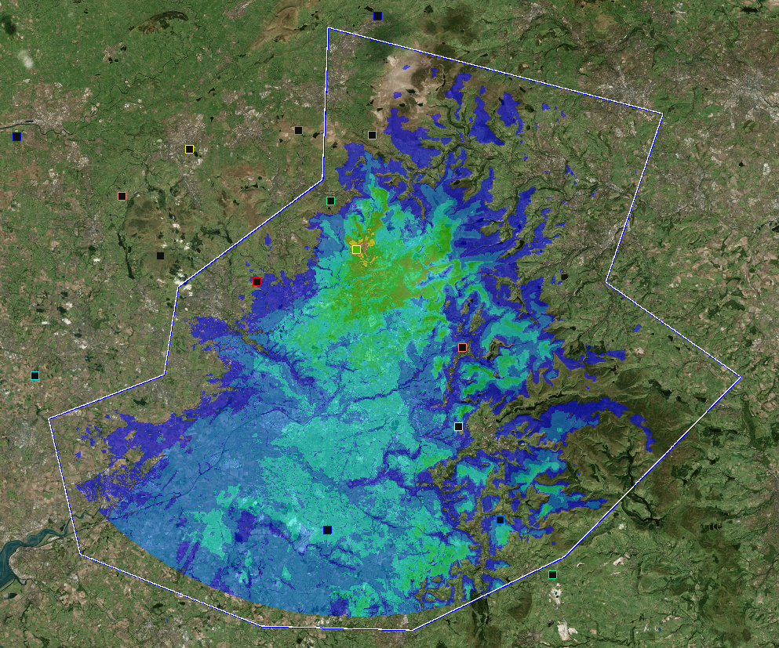
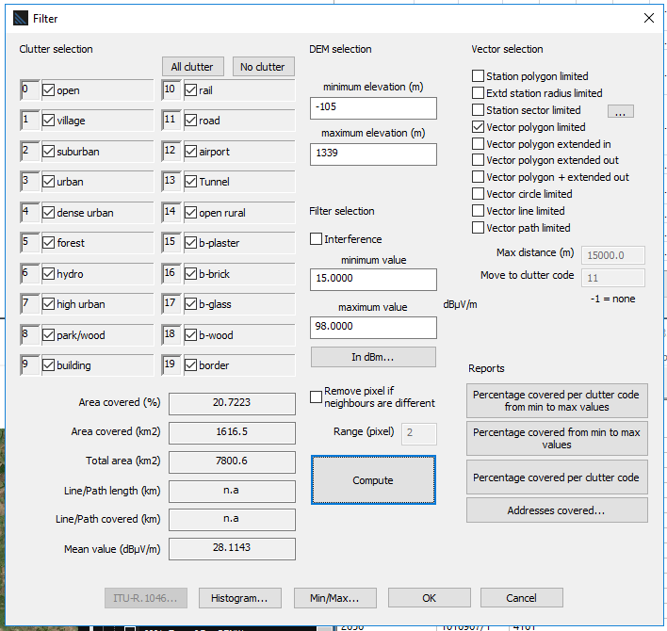

At present we control the radio site at Rooley Moor using 1.4GHz microwave system, located on the tower. This frequency was chosen because it enabled us in some locations to use smaller antennas while covering longer distances.

Unfortunately, OFCOM have given notice to revoke our point to point fixed link licences in the 1492 – 1517 MHz band (“1.4 GHz licences”) on 31 December 2022 for the purpose of securing compliance with an international obligation of the United Kingdom (“May 2019 Notice”).2
The utility companies have spent several months challenging this decision stating the following in its objection: -
The proposal provides no insight into its effect on our operational network, these include: -
• Inability to manage and effectively Control the Electricity Network assets thus failing a directive to maintain electricity supplies to customers.
• Inability to meet Statutory and License obligations in service restoration.
• Failure of electrical feeder Safety Protection Equipment.
• Substantial customer Interruptions and 'Customer Minutes Lost' penalties from OFGEM.
• Placing Electricity North West Limited's license to operate at risk.
• Places personnel and plant at risk of potential Failure and Injury or damage
The operation of ENW infrastructure is in line with the government’s own definition of CNI
https://www.cpni.gov.uk/critical-national-infrastructure-0
The UK government’s official definition of CNI is:
‘Those critical elements of infrastructure (namely assets, facilities, systems, networks or processes and the essential workers that operate and facilitate them), the loss or compromise of which could result in:
a) Major detrimental impact on the availability, integrity or delivery of essential services – including those services whose integrity, if compromised, could result in significant loss of life or casualties – taking into account significant economic or social impacts; and/or
b) Significant impact on national security, national defence, or the functioning of the state.’
The suitability of 1.4GHZ spectrum in rural locations cannot be overemphasised, the OFCOM proposal to remove this spectrum within 3.5 years ignores the impact on the ENW business and its customers.
The resulting stay of execution was changed that all 1.4 GHz links are removed from the band no later than 30 April 2024.
The resultant elimination of 1.4GHz frequency requires alternative frequency bands must be used, these alternatives have different propagation characteristics resulting in the requirement higher antennas to be used. The proposal at Rooley requires the replacement of 1 Gridpak antennas at 20m with 2 flat panel sector antennas at 30m. The additional height is required to maintain the correct operation of the new radio equipment.
Coverage Analysis
The following Coverage analysis for the point to Multipoint sectors at the Rooley moor Site were carried out. The site connects with our substation site at Kingsway on Sector 01.

The site has been designed for 4 protected Point to Multipoint HUBs working on the 10.5GHz frequency band.

The sectors, following the JRC (the licensing authority) code of practice, have been designed to be deployed on 0,90,180 and 270 degrees with the following labelling.

Sector-00 for the 0 º
Sector-01 for the 90 º
Sector-02 for the 180 º
Sector-03 for the 270 º

The sectors of interest that will be analysed in this document are the

Sector-01 for the 90 º

Intracom’s Planning Tool R11_0 was used for the analysis of the links.

Target link availability has been designed for 99.999%.

Radio Equipment for links is as follows:
Intracom WiBAS OSDR 10.5GHz PtMP Full Outdoor radio operating on a 7MHz channel.

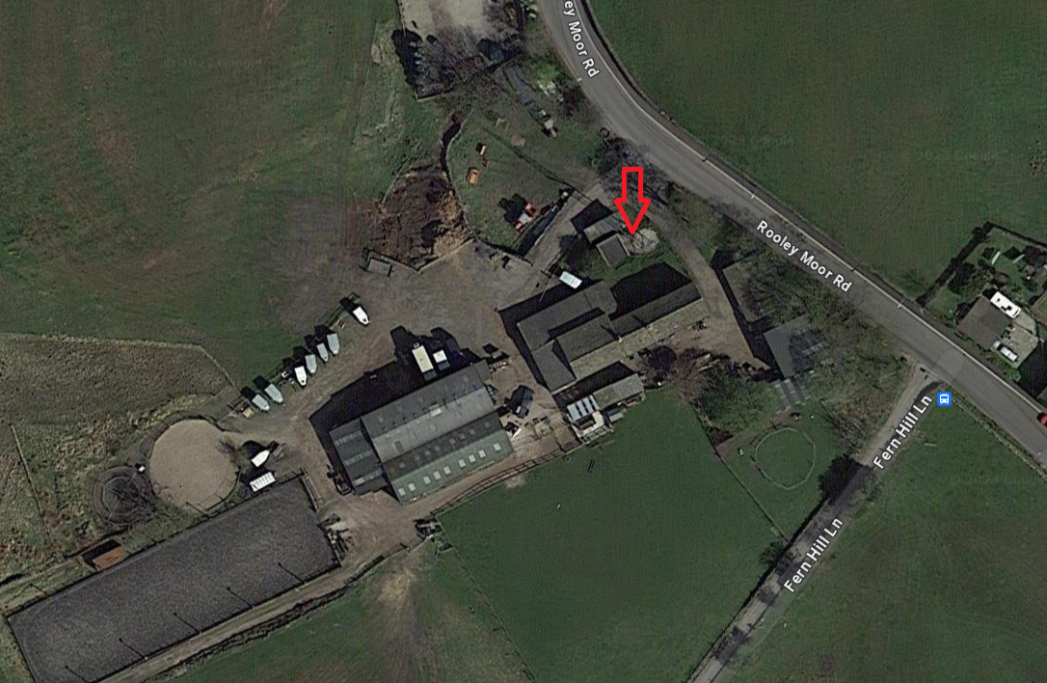

Site from a Google Earth perspective.
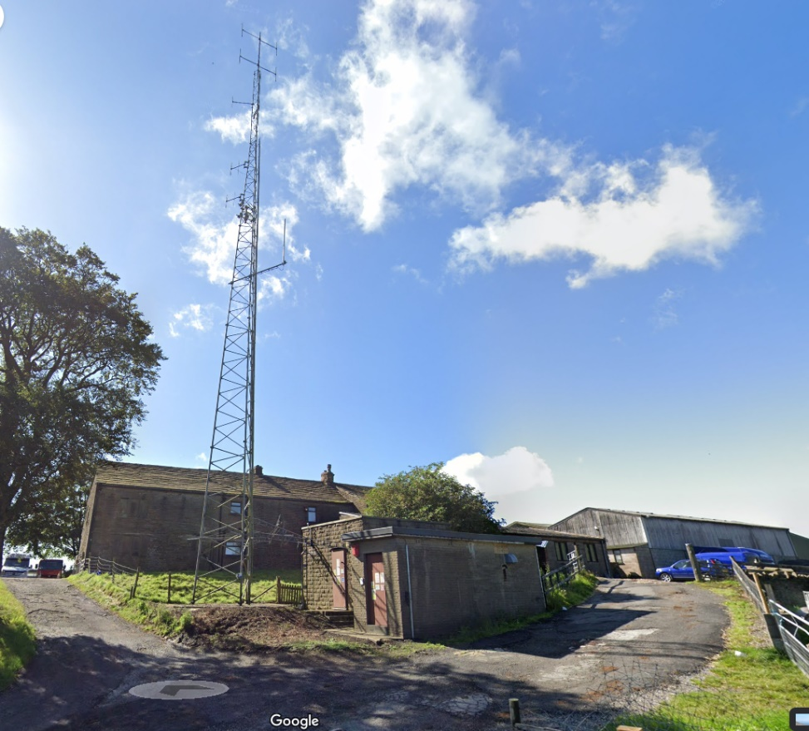

Coverage Maps

Sector-01
Picture below shows the Sector-00 coverage heatmap for a 20km radius.
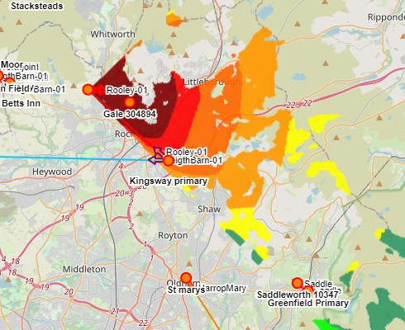

2 The international obligation we refer to is European Commission Implementing Decision 2015/750 of 8 May 2015 on the harmonisation of the 1452-1492 MHz frequency band for terrestrial systems capable of providing electronic communications services in the Union, as amended by European Commission Implementing Decision 2018/661 of 26 April 2018 harmonising the 1492 – 1517 MHz band for downlink-only wireless broadband electronic communications services on an EU wide basis (the “EC Decision”).

