Client: | Rochdale MBC
Project: | MCF Castleton
Subject: | Manchester Road / Royle Barn Road / Partington Street - Traffic Impact Assessment
Doc: | MCFCastleton_RoyleBarnRd_TIA_RevA_020721
Author: | Charles Taylor
Date: | 2nd July 2021
Ref: | (New Site)
Contact: |  |  | E-Mail: | Tel:
Ed Coventry |  |  | ed.coventry@TfGM.com | 0161 244 1876
Charles Taylor |  |  | charles.taylor@TfGM.com | 0161 244 1800
- Introduction
  - The following report considers the traffic impact resulting from the latest proposed changes to the layout and operation of the junction of Manchester Road / Royle Barn Road / Partington Street (layout option 6 included in Appendix A).
  - The proposals involve introducing a signal junction arrangement to a priority control site, with addition of controlled pedestrian and cycle faciltites.
  - The following considers the likely operational efficiency of the junction during the morning peak and evening peak periods of the assessment year.
  - This document supersedes the previously issued modelling report with reference ‘MCFCastleton_RoyleBarnRd_TIA_CAT_090421’.
- Junction Layout and Signal Stage Sequences
  - The proposed junction layout is included in Appendix A.
  - The proposals require an area of land currently owned by Rochdale Borough Housing which would need to be acquired.

  - Manchester Rd / Royle Barn Rd / Partington St – Proposed Staging
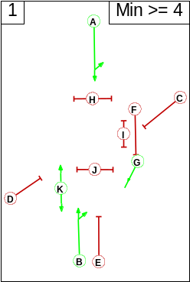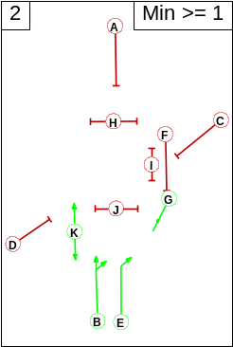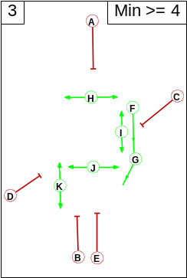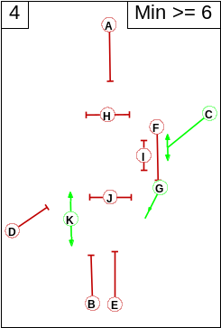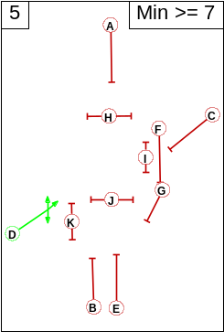
Phases F and G are cycle phases; phases H, I, J, K are pedestrian phases.
  - The existing site layout is included in Appendix B.
- Traffic Flows
  - The counts have been derived from surveys commissioned by Highways Forecasting and Analytical Services (HFAS) on 28th November 2019.
  - Flows associated with Keswick Street have been reassigned to Manchester Road in the proposed model.
- Modelling Details
  - The proposed junction has been modelled using LINSIG (version 3.2.4) for the weekday morning and evening peak periods, in the assessment year.
  - The existing junction has been modelled using PICADY for the weekday morning and evening peak periods, in the assessment year.
  - A cycle time of 100 seconds has been used – a cycle time greater than this would introduce a level of delay likely undesirable to pedestrians and cyclists.
  - The following scenarios have been modelled:
    - Base model of existing site layout.
    - Option 6 proposed junction layout and staging.

- Results of Modelling
  - The table below indicates the predicted degree of saturation, queue length and delay for each modelled scenario.
  - The degree of saturation is a measure of how close to capacity a link is predicted to operate, with 90% taken to be the maximum practical level (between 90% and 100% delay begins to increase exponentially).
  - Queues are mean maximums and will be exceed for half the modelled period (where a link is at practical capacity the queue could be up to twice indicated).
  - Morning Peak Period
Link Description | Existing Layout  (Priority Arrangement) |  |  | Proposed Option 6  100s Cycle Time
Link Description | Degree of saturation (%) | Delay  (s/pcu) | Queue length (metres) | Degree of saturation (%) | Delay  (s/pcu) | Queue length (metres)
Royle Barn Road | 26 | 10 | 2 | 84 | 105 | 34
Manchester Road Southbound Ahead and Left | - | - | - | 92 | 52 | 139
Partington Street | 33 | 13 | 3 | 87 | 116 | 37
Manchester Road Northbound Ahead and Right (RT only in ‘existing’) | 14 | 7 | 1 | 80 | 32 | 108
Total Delay (pcu-hours) | 1 |  |  | 26

  - Evening Peak Period
Link Description | Existing Layout  (Priority Arrangement) |  |  | Proposed Option 6  100s Cycle Time
Link Description | Degree of saturation (%) | Delay  (s/pcu) | Queue length (metres) | Degree of saturation (%) | Delay  (s/pcu) | Queue length (metres)
Royle Barn Road | 29 | 9 | 2 | 98 | 173 | 56
Manchester Road Southbound Ahead and Left | - | - | - | 68 | 30 | 76
Partington Street | 24 | 14 | 2 | 61 | 77 | 17
Manchester Road Northbound Ahead and Right (RT only in ‘existing’) | 24 | 8 | 2 | 101 | 94 | 252
Total Delay (pcu-hours) | 1 |  |  | 39

- Conclusion
  - The results of the modelling indicate that the junction as illustrated in Appendix A (layout option 6) is likely to operate above practical capacity in both peak periods, in assessment year 2019, if the pedestrian / cycle stage is called every signal cycle.
  - If the pedestrian / cycle stage were to be called less frequently than this then the junction would operate more efficiently – Appendix C details likely junction efficiency if the junction were to be called every other cycle.
  - The site does not currently operate under signal control – introducing signals in this location will inevitably introduce additional delay to vehicles. This should, however, be balanced against the significant qualitative benefits afforded to pedestrians and cyclists.
  - There are additional delay benefits afforded by adaptive signal control such as SCOOT or MOVA that have not been considered by this fixed-time modelling.

  - These assessments are based on surveys undertaken prior to the COVID crisis. It is not yet clear what the long-term effects of COVID will be on traffic demand and distribution in Greater Manchester.

Appendix A – Manchester Road / Royle Barn Road / Partington Street – Proposed Layout (Option 6)
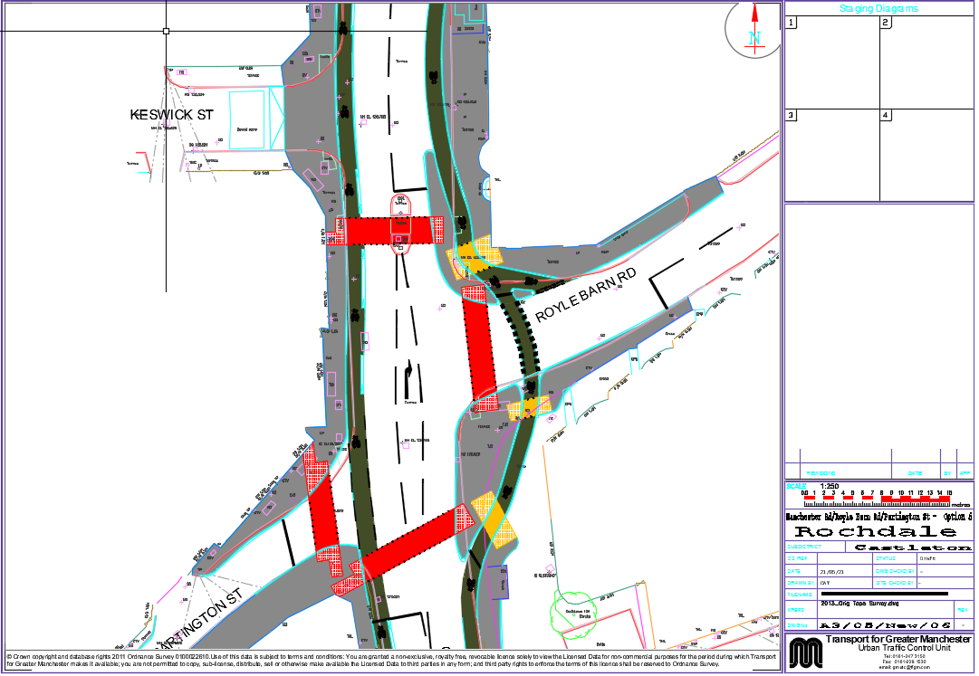
Appendix B – Manchester Road / Royle Barn Road / Partington Street – Existing Layout
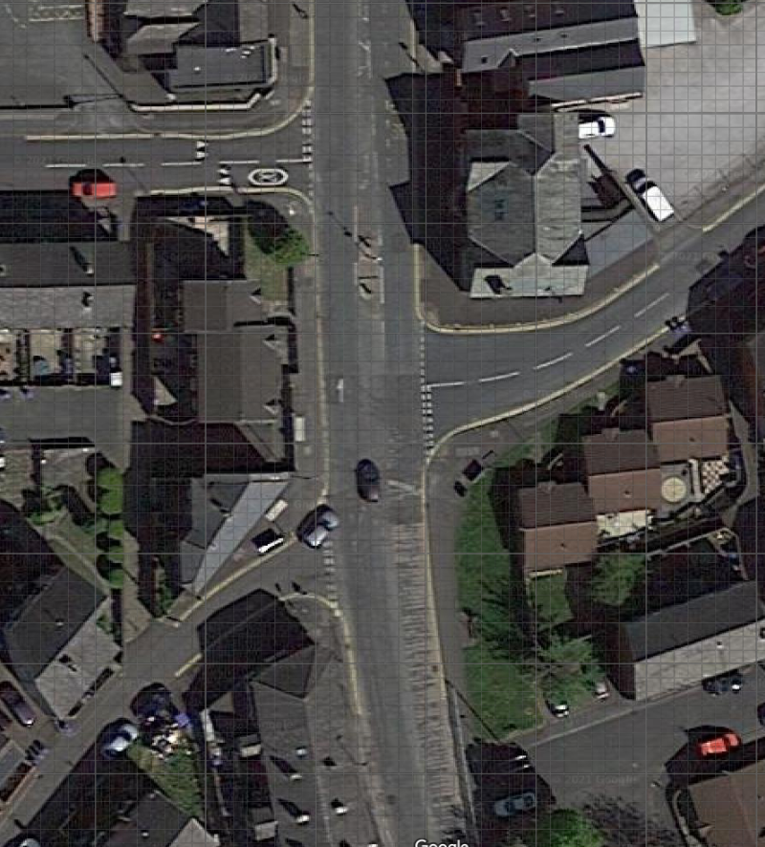
Keswick Street
Manchester Road
Partington Street
Royle Barn Road

Appendix C – Modelling results with Peds/Cyclists called every other cycle.
Morning Peak Period
Link Description | Existing Layout  (Priority Arrangement) |  |  | Proposed Option 6  (pedestrian alt cycles)  100s Cycle Time
Link Description | Degree of saturation (%) | Delay  (s/pcu) | Queue length (metres) | Degree of saturation (%) | Delay  (s/pcu) | Queue length (metres)
Royle Barn Road | 26 | 10 | 2 | 77 | 85 | 30
Manchester Road Southbound Ahead and Left | - | - | - | 79 | 32 | 118
Partington Street | 33 | 13 | 3 | 79 | 89 | 33
Manchester Road Northbound Ahead and Right (RT only in ‘existing’) | 14 | 7 | 1 | 70 | 23 | 98
Total Delay (pcu-hours) | 1.0 |  |  | 17.6

Evening Peak Period
Link Description | Existing Layout  (Priority Arrangement) |  |  | Proposed Option 6  (pedestrian alt cycles)  100s Cycle Time
Link Description | Degree of saturation (%) | Delay  (s/pcu) | Queue length (metres) | Degree of saturation (%) | Delay  (s/pcu) | Queue length (metres)
Royle Barn Road | 29 | 9 | 2 | 85 | 101 | 40
Manchester Road Southbound Ahead and Left | - | - | - | 58 | 23 | 76
Partington Street | 24 | 14 | 2 | 61 | 78 | 19
Manchester Road Northbound Ahead and Right (RT only in ‘existing’) | 24 | 8 | 2 | 87 | 32 | 170
Total Delay (pcu-hours) | 1.0 |  |  | 17.9

