

CONSTRUCTION METHOD

STATEMENT

Rochdale 6th Form College

Building Extension

May 2023

Contents
Contents
Introduction 2
Site Set up 3
Management Structure 5
This will be determined by the successful Principal Contractor, however it is envisaged 5
that for a project of this nature 5
Programme Details 5
Hours of Operation for Construction Work 5
Extended Hours of Operation for Construction Work 6
Construction Method Statement 6
Control Measures 10
Dust: 10
Noise: 10
Surface water drainage during construction: 11
Details of Site Compound & Storage of Plant and Materials 11
Temporary Highway Works or Closures 11
Access For Deliveries and Unloading 11
Parking of Vehicles for Operatives and Visitors 12
Wheel Wash Facilities 12
A Scheme for the Recycling and Disposal of Waste 12
Site Safety 12
Security 12

Introduction

The purpose of this document is to detail, in draft format, the high level strategy requirements to enable the yet to be appointed Principal Contractor, to create and maintain a working environment that is:-

- Mindful of the construction works required and the impact on Rochdale 6th Form College, local residents and amenities.
- Understanding of key planning to deviate from unnecessary disruptions.
- Values and operations within the local area are respected.
- To maintain a proactive approach and attitude when working alongside local occupiers and authorities.

This Method Statement relates to the erection of a 5-storey extension to the existing Building at Rochdale 6th Form College. The building will provide valued teaching and learning space for the staff and students.

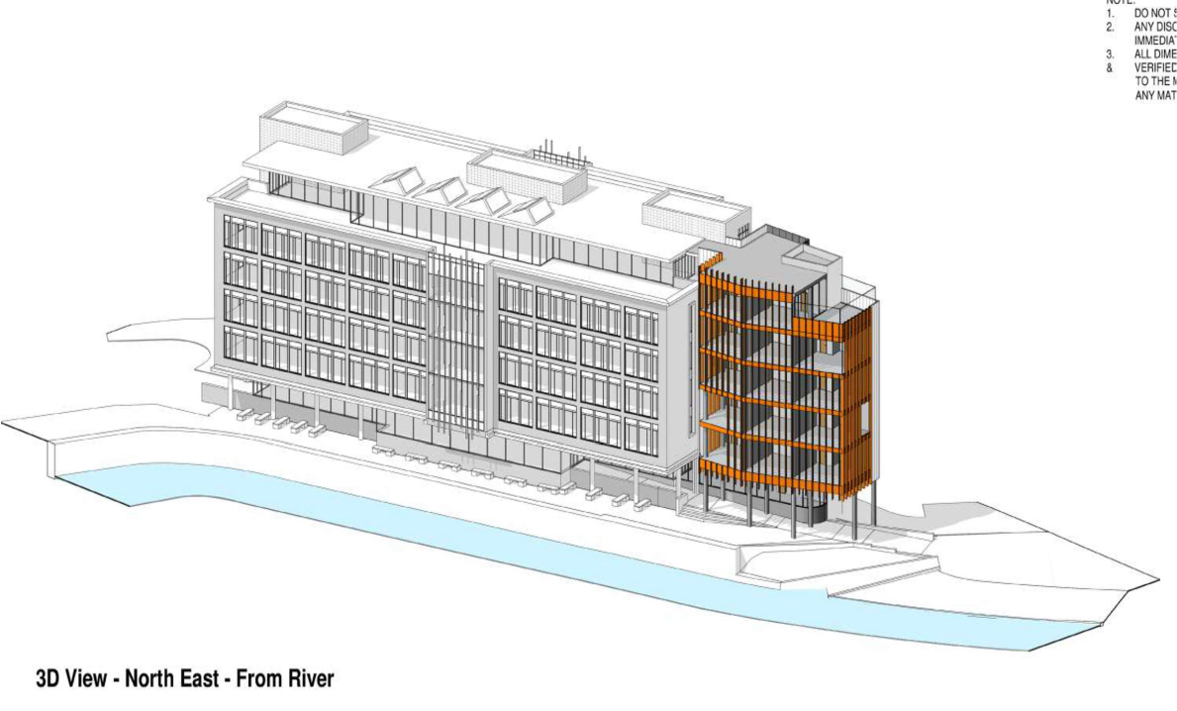

Site Set up

The proposed site set up can be seen below.

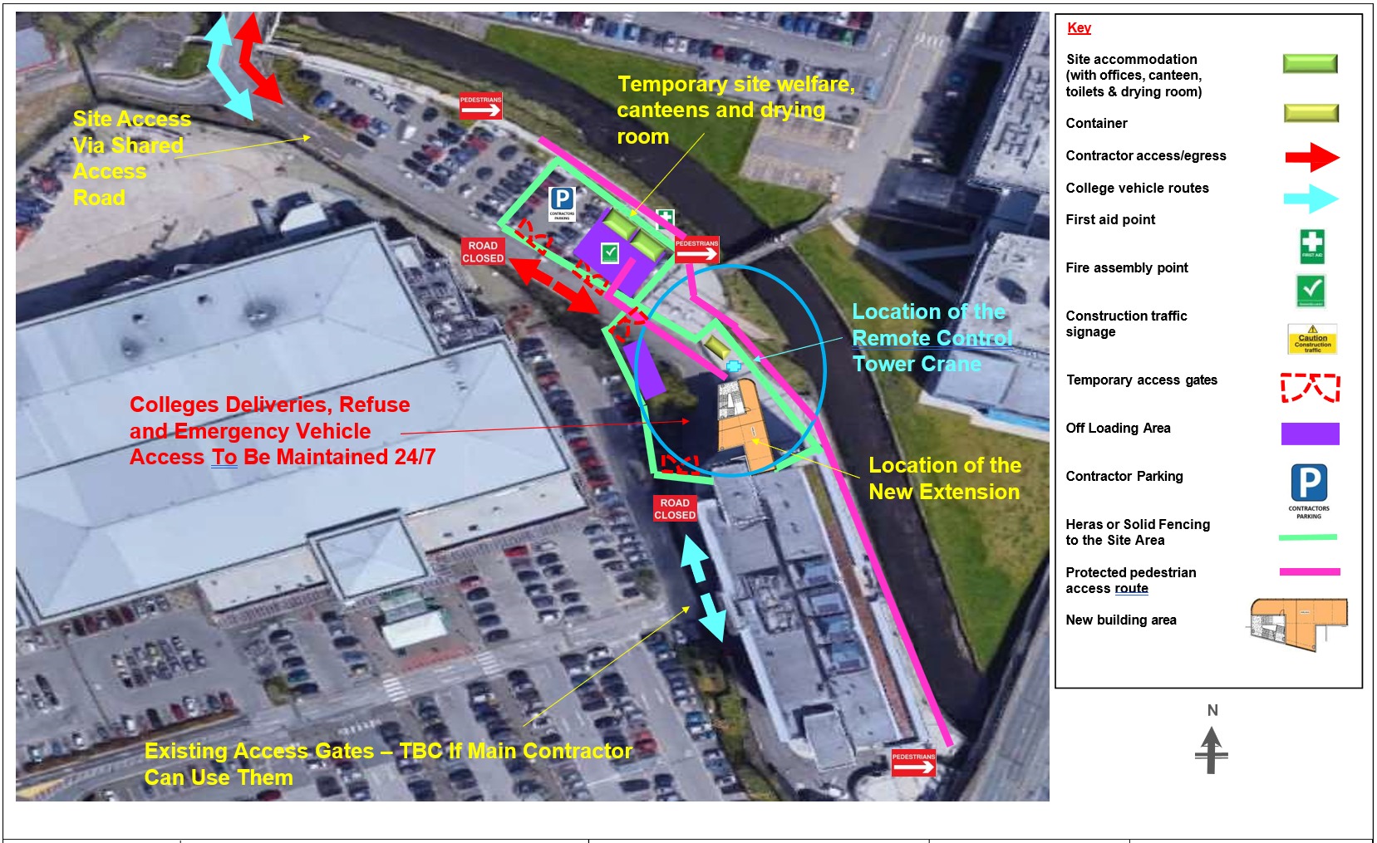

Figure 2 - Site Set Up

The above green area shows the area where the proposed site welfare/ offices will sit, the parking area for all subcontractors and visitors is shown in the adjacent area marked contractor parking. The storage compound will be within an area so placed as to avoid fire risk and respectful to the needs of the college.
Wheel wash facility will not be required as all vehicles visiting site will do so on hard standing.
The Access Control Barrier will be so positioned as to allow vehicles to pull into the site area and off the main highway.

Hoarding

Site hoarding has been placed around the perimeter of site from the first instance. This is to be double clipped Heras fencing with debris netting or a solid timber hoarding braced and stabilized internally.

The site hoarding may be used to advertise the upcoming completed scheme, but primarily will be in place to protect vulnerable pedestrians both during and outside of site working hours.

Please see image below displaying in detail the current hoarding plan layout outlined in green.

Figure 3 - Hoarding Layout

Demolition

There is no Demolition required.

Management Structure

This will be determined by the successful Principal Contractor, however it is envisaged

that for a project of this nature

- 1no Project Manager
- 1no Site Manager
- 2no Banksman
- 1no Forklift Driver
- 2no Labourers/Material Controller
- 2no MEWP Operators
- 1no Crane Operator
- 1no Welfare Officer

Programme Details

Start on Site: End October/November 2023
Approximately 42 weeks construction period.

The projected construction programme of works, consists of: -

Groundworks, foundations, steel erection, concreting and fit out of college building at Rochdale 6th Form College.

Each month a Client meeting will be held with the site management team, prior to each meeting, a Client and Progress Report will be issued.

Hours of Operation for Construction Work

Monday - Friday 07:30 – 18:00 (plant operation times)
Saturdays 08:00 – 14:00 (plant operation times)
Sundays No works planned.
Bank Holidays No works planned.

It will be necessary for site supervision, trade operatives and sub-contractors to arrive 30 minutes prior to the start of each working day to allow their setting up time (unlocking, site safety inspections, setting up, offloading, and internal works) these activities shall be permitted under the direct supervision of the Site Manager.

On site security may be present on site at all times outside of normal working hours, as stated above however it may be acceptable to have a robust CCTV installation to eliminate the risk of a watchman being present alone.

Extended Hours of Operation for Construction Work

There are occasional activities where it will be necessary to work outside of the above stated working hours. These include concreting activities for the superstructure, lifting of large plant, and emergency works. Where extended working is required, this will be kept to the minimum duration to complete the work safely, and noise and vibration will be kept to a minimum for the activity taking place. Where appropriate, additional noise and vibration attenuation measures will be employed and where possible deliveries will be made during normal working hours, to minimise disruption due to transportation.

Construction Method Statement

This section of the CEMP is to provide an overview of the methods by which the proposed building will be constructed.

Rochdale 6th Form College comprise of a steel frame extension and refurbishment of existing classroom space to accommodate new rooms. Works will progress in a logical and orderly manner and some overlap of activities will occur. The general sequence of works will comprise:

    - Soft strip & reconfiguration of existing internal classroom space.

    - The existing ground will be reduced to its new formation level and existing services located (proof dig).

    - Excavation of foundations & drainage will commence.

    - Erect the steel frame and position the metal decking sheets that will ultimately support the new floors.

    - Position precast staircase units with cranes as steel frame progresses.

    - Mobile cranes will be positioned within the construction site for the extension works. However, there may be occasion where mobile cranes will be sited outside of the site to accommodate the lifting of large plant onto the roof.

    - Concrete to floors

    - Progress lift shafts in blockwork (potential for lift shafts to be pre-cast and installed with the steel frame)

    - Commence external elevational treatments.

    - Install new internal partitions.

    - Install M&E services to the various floor levels.

    - Install finishes to the various levels.

    - Complete hard and soft landscaping works.

Installation of Foundations

  - The foundations will either be piled or pad. Area will be excavated to suit and any concrete will be directly discharged from the back of the concrete wagon.

  - Any reinforcement cages will be formed in-situ or assembled adjacent and then lowered by the excavator into the excavation.

  - Once the concrete has been poured and is still wet the holding down bolts will be floated by the Site Engineer to the correct line and level.

  - This method will be repeated until all foundations are complete.

Steelwork and metal decking

  - Having completed the foundations, the steel frame/metal decking will commence.

  - The activity will commence with one crane starting from one side and work its way along the new extension structure.

  - Throughout the erection process bundles of metal decking and pre-cast stairs will be lifted to the required floor areas.

  - Once edge protection and safety netting has been installed, the decking will be laid out and fixed into position.

  - Mesh reinforcement will be installed and then the concrete poured by means of a mobile pump as per the example below:
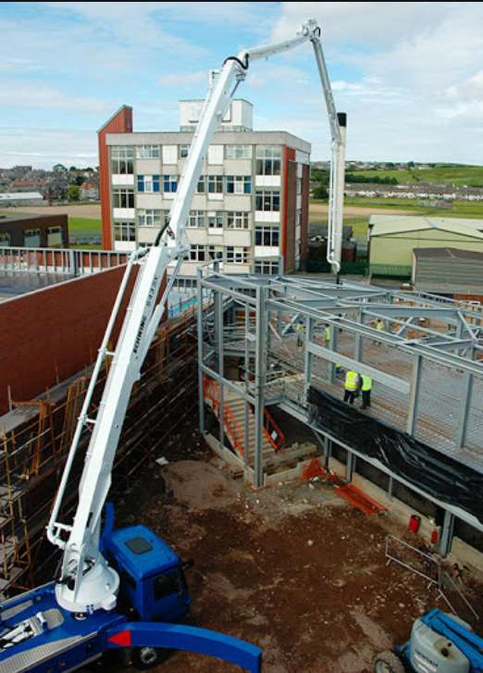

Internal Services & Refurbishment Works

  - Once the building or parts of the building are watertight, the interior fit out of the new extension build can commence. The overall building fit out will include the following:

    - Internal walls, partitions, doors and ceilings
    - Mechanical and Electrical systems ‘first fix’
    - Mechanical and Electrical systems main installations
    - Lift installations
    - Plastering and decorating
    - Classroom fit out.
    - Plant rooms

  - All materials for the building fit out will adhere to the construction site logistics plan and stored in allocated areas on site / compound or next to the point of installation within the building.

  - On completion of the building fit out, the final components and equipment will be delivered to complete each area. These will be delivered just in time to ensure deliveries are controlled and no excessive damage occurs to products or components.

External Elevations

  - The external envelope will commence following completion of the structure.

  - The overall treatment of the Rochdale 6th Form College extension has a number of different materials that will give the final appearance.

  - The method of installation will be by Mobile Elevational Working Platforms (MEWP) or Scaffold.

  - The ground will be prepared using hardcore to enable the MEWP or Scaffold load to be accommodated and utilised safely:
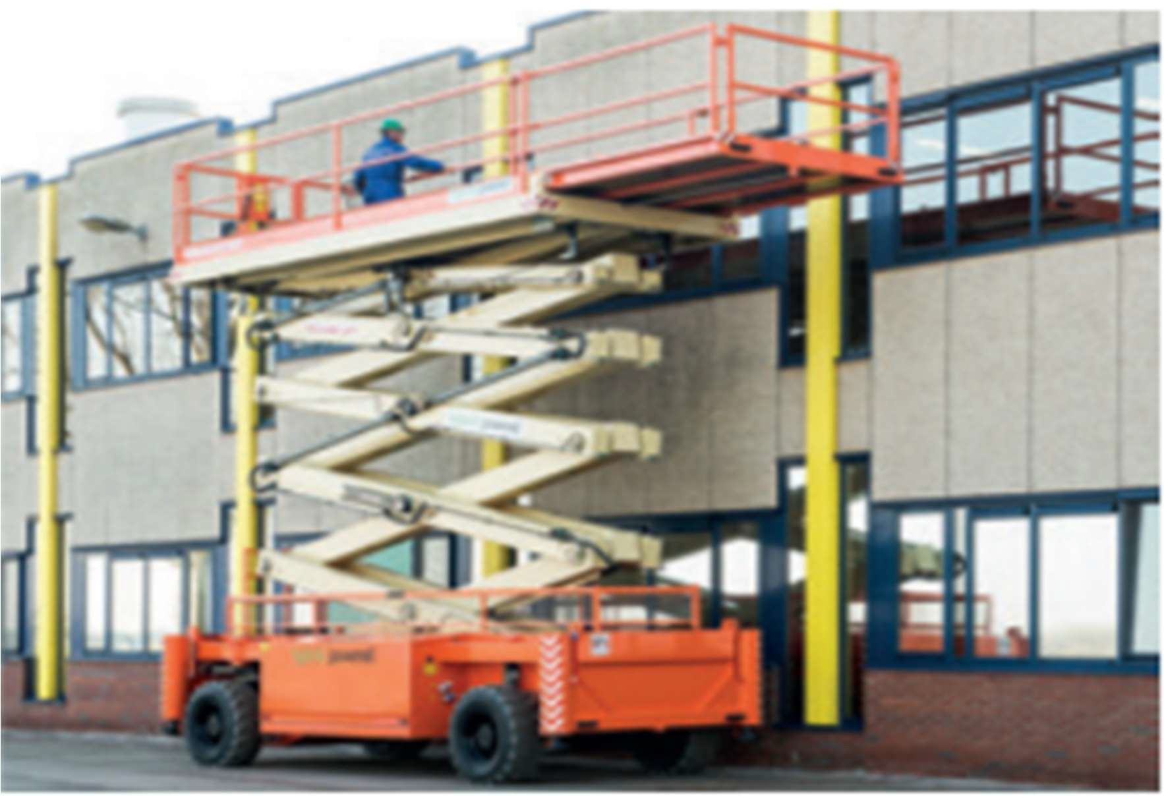
Hard & Soft Landscaping

  - Once areas of external cladding are complete the external hard and soft landscaping will commence.

  - In the final stages before the building is completed, the external areas will be prepared to receive the hard and soft landscaping finishes.

  - All areas will be excavated to the formation level of the receiving construction build up and paving/topsoil. Surplus material will be removed off site to a suitably licensed facility.

  - Planting of vegetation and installation of hard landscaping will complete the works.

Removal of Site Hoarding and Site Compound

  - Once construction has been completed, the temporary accommodation will be removed, associated services terminated, and the affected areas made good.

  - The construction site hoardings will be removed from site.

Control Measures

Dust:

Rochdale 6th Form College insist that the Principal Contractor will reduce any hazards arising from exposure to dust that is produced as far as reasonably practicable. Such measures outlined below and within our policy document, relate to all on site works including enabling and new build activities.

Exposure to (especially containing respirable crystalline silica) can lead to the slow development of the irreversible lung disease Silicosis. Heavy and prolonged exposure under conditions that are sufficient to cause Silicosis can also lead to an increased risk of lung cancer.

All contractors carrying out activities such as mechanical cutting and grinding of stone, concrete and site transport that create substantial amounts of dust will ensure the following hierarchy of prevention is implemented:

- Adequate ventilation provided, or
- Water suppression system used, or
- Local ventilation system (vacuum) system used.

In addition, a dust mask to p3 standard must be worn by the operators of machinery creating the dust by persons carrying out sweeping up activities.

Where the above hierarchy cannot be employed those exposed to the dust must wear Respiratory Protection Equipment (RPE) – to grade APF 40 (full face respirator with filter to p3 standard.

Contractors must ensure that dust created by their work activities does not affect the health of other workers, residents and members of the public.

Noise:

It is a requirement of Rochdale 6th Form College that the Principal Contractor will reduce any hazards arising from noise exposure that is produced on site as far as reasonably practicable. Such measures outlined below and within our policy document, relate to all on site works including enabling and new build activities.

Contractors must ensure that plant and machinery brought onto the site are in good working order and suitably fitted with noise reduction measures, where necessary, and that the assessed level of noise of the plant / machinery is provided by the supplier/owner and made known to those who may be affected.

Where it is not practicable to reduce noise to an acceptable level, the Principal Contractor will arrange for ‘Noise Protection Zones’ to be established with noise warning notices displayed. All persons entering these areas must wear suitable hearing protection. Contractors will be responsible for ensuring their workers are provided with the suitable hearing protection and have received information, instruction and training on noise hazards.

All Contractors must cooperate with the Principal Contractor in compliance with any noise levels and periods of permitted noise activities laid down by local authorities, which are necessary to prevent noise nuisance pollution.

Please find attached link to HSE website www.hse.gov.uk/toolbox/noise.htm

Surface water drainage during construction:

It is a requirement of Rochdale 6th Form College that the Principal Contractor will provide plant and equipment.
to mitigate sedimental surface water entering adjacent water courses, River Roch and surface
water. The Principal Contractor will be required to install and maintain settlement tanks as required.

Details of Site Compound & Storage of Plant and Materials

The site compound will be located is within the proposed Site boundary. The following facilities are proposed:

2no Site Office
2no Canteen / Drying Room
3no Toilet Block
3no Storage Container

All welfare highlighted above in addition to plant and materials will be stored within the boundary of proposed Site Location. Road crossing points will be put in place as required.

Temporary Highway Works or Closures
It is not considered that Temporary closures / licenses will be required. However in the unlikely event this is required, they will be applied for with Rochdale County Council.

Access For Deliveries and Unloading
The access on to site will be off College Road and into the college estate.
A banks man will be used to direct traffic too and from site.
Two-way radios used to communicate between banksman and site.

Existing and newly formed road surface will provide clean running surfaces for all plant and deliveries which will assist in keeping the surrounded adopted highways in good clean condition throughout the contract.

The Principal Contractor will be utilising the permanent entrance and exit opening for the turning of vehicles to and from site.

All subcontractors and suppliers will be provided with information showing the access and egress for deliveries as part of their order. All hauliers will be provided with a Traffic Management Plan on appointment. All drivers will be instructed to contact the site manager prior to arrival on site to ensure a banksman is ready to guide deliveries in and out of site.

Parking of Vehicles for Operatives and Visitors
Vehicle parking provision will be made on Site for Site Management, Subcontractor and visitors parking. Subcontract operatives will be allowed to drive onto site to unload materials and plant where applicable, this will be managed by the banksman.

Wheel Wash Facilities

As access to the site is via the highway and into the college estate, there is no potential
for wheel cleaning or wheel washing.

A Scheme for the Recycling and Disposal of Waste

A SWMP has been developed and will be issued to the tendering contractors.

Site Safety
All persons on site must adhere to the following PPE: -

- Safety Hemet conforming to BS 5240 Part 1.
- Safety Footwear.
- Hi Vis vest/ coat/ jacket/ overalls.
- Gloves where appropriate.
- Glasses/ Eye protection where appropriate.
- FFP3 Compliant Masks (Face Fitted), where deemed necessary.
Site management will be required to remove any person not following the above PPE site requirements.

Security
Site has been secured with the hoarding around the site perimeter to suit the project and activities being carried out at the time. The compound area also secured by hoarding/ Heras fencing.

Security cameras will be deployed throughout which will be designed by the sub-contractor to provide surveillance of the compound and site areas.

