110 Church St, Material selection / specification summary
Requirement: Samples and / or full specification of materials to be used externally on the buildings have been submitted to and approved in writing by the Local Planning Authority. Such details shall include the type, colour and texture of the materials. For the avoidance of doubt, the submitted details should include the composition and source of masonry and roof materials and mortar specification, including samples to be provided on site. Development shall be carried out in accordance with the approved details.

- Composition and source of masonry
Specification: Coursed sandstone grit, pitched face (As per host property), mixed courses 3” – 6” (As per host property)
Source: Marshalls Fletcher Bank Quarry, Ramsbottom

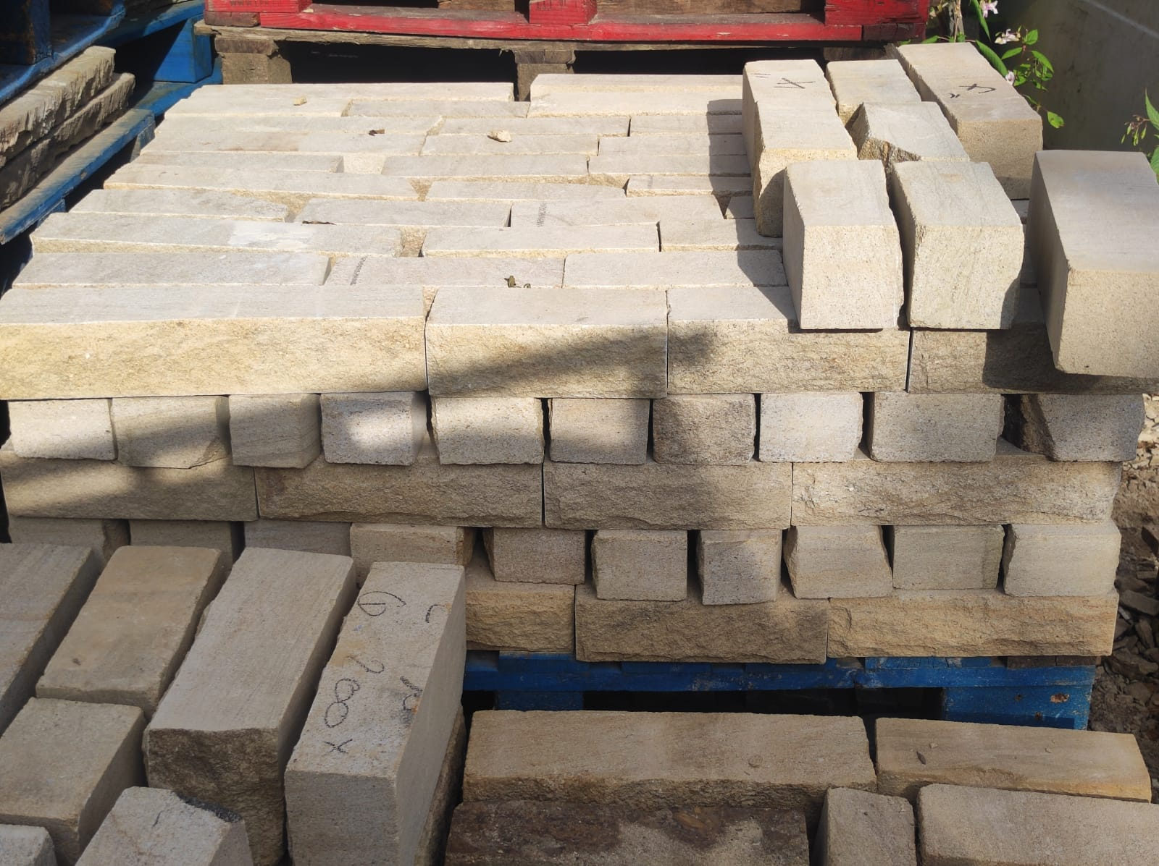

- Composition and source roof materials

Natural slate, 24”x12”x 6mm thick
Supplier, MKM Building supplies, Bury,

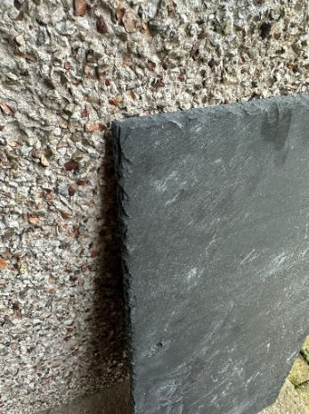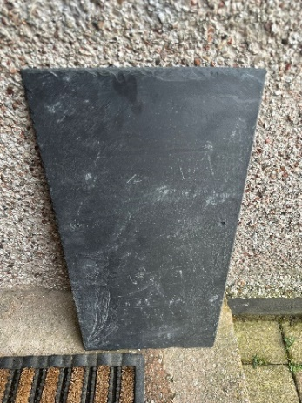

- Details of all windows and doors (including their specification, materials, finishes, recesses and opening profile)
Windows (Min 100mm recess)
- Sapele hardwood.
- 24 mm O/A D/G units
- 26mm wide Astragal Georgian bars
- Painted – Farrow & Ball Jitney (Traditional Neutral)
- Storm proof sashes with casement stays and side fasteners
Doors (Min 100mm recess)
- Utile hardwood
- 68mm thick doors
- 24 mm O/A D/G units
- 26mm wide Astragal Georgian bars
- Painted – Farrow & Ball Jitney (Traditional Neutral)
Source: Leach & Clegg Ltd, Milnrow
Leach & Clegg | Northwest UK Manufacturer of Handmade Timber Windows, Doors and Staircases (leachandclegg.co.uk)
Leach & Clegg | Handcrafted Windows & Doors | Sustainable Timber — Leach & Clegg (leachandclegg.co.uk)
All timber sourced from sustainable forests approved by the FSC (Forest Stewardship Council).
- Roof lights to be installed on the buildings shall be of a 'conservation style', to sit flush with the roof surface and shall not protrude from the roof plane.

Conservation style flush fixed (non-opening) skylights
Supplier – Cambridge Skylights

