
Proposed conversion of the first floor to residential accommodation
Building Design Services (BDS)

Heritage

Statement

2
Market Place

Heywood

Rochdale

OL1
0

4
NL

June 23

CONTENTS

Page
- INTRODUCTION - 2
- PLANNING POLICY – 3
- CONSERVATION AREA & SURROUNDING BUILDINGS - 5
O04. PROPOSAL IMPACT - 10
5. CONCLUSION – 11

APPENDIX

Prepared by: Building Design Services (BDS), 6 Stock Close, Shawclough, Rochdale, OL12 7BB. E-mail: bds2000@live.co.uk
Web:

1.0 INTRODUCTION
This Planning and Heritage Statement accompanies an application for Planning Consent to change the use of the first floor of the building from an existing Optometrist (Use Class E) into a self-contained flat above. No external alterations are proposed to the building itself. The applicant Mr Mohammad Nabeel would like to convert the first floor into a self-contained flat to generate more income for his business which is underrepresented in the centre of Heywood and surrounding areas.
Guidance for heritage statements emphasises the need for the documents to be appropriate in length. The nature of the property encompasses a number of distinct elements and features, the extent of the proposed works and the designation and surrounding architectural buildings have driven the length of this document.
The application site relates to No. 2 Market Place, a two-storey end terraced property positioned in Heywood town centre. In terms of Heritage value, the property itself is not located in Conservation Area, nor is it nationally or locally listed. No. 2 Market place has a contemporary glazed shopfront with an entrance door to the right at ground floor. The first floor of the building is finished in brick painted white with quoins on the corner, the roof material is slate. The rear has been extended by way of a large two storey outrigger and a single storey flat roofed extension.
However, of interest as part of this application is the Parish Church of St Luke’s which is a Grade II* listed building located opposite the proposed site, and two other structures.
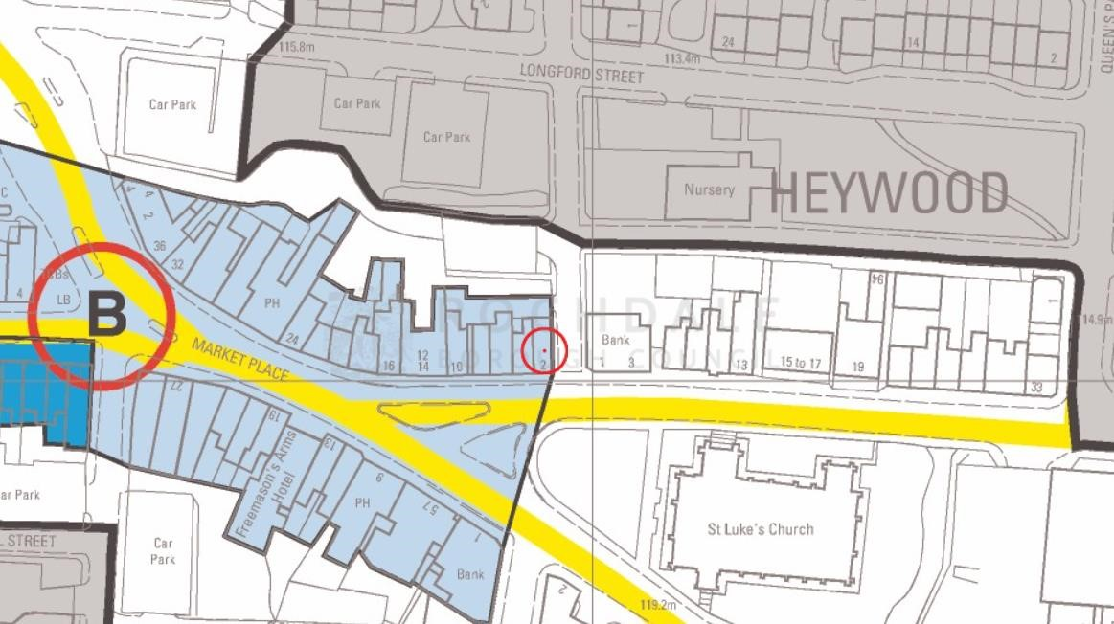
The above image shows the location of No. 2 Market Place in the Town Centre of Heywood (Blue).

2.0 PLANNING POLICY
The key theme of delivering sustainable development is at the core of all the policies and objectives in this document. Sustainable development incorporates not only an environmental role (protection of heritage and townscape assets of value), but also a social role (supporting the communities health and social needs) and economic role (contributing to building a strong, competitive, and responsive economy by supporting growth and the provision of infrastructure).
There is a presumption in favour of sustainable development. This means approving development that accords with the development plan without delay (where the development plan is up to date) and (where the development plan is silent), granting permission unless any adverse impacts of doing so would significantly and demonstrably outweigh the benefits, when assessed against the policies in the Framework taken as a whole.
Section 66 of the Planning (Listed Buildings and Conservation Areas) Act 1990 (as amended) states that in considering whether to grant planning permission for development which affects a listed building or its setting, the local planning authority shall have special regard to the desirability of preserving the building or its setting or any features of special architectural or historic interest which it possesses.
Policy P2 of the Rochdale Core Strategy sets out that the Council will conserve, enhance and promote key
heritage assets, including consideration of their wider settings.
‘Significance’ with regard to heritage assets is defined by the NPPF as: ‘The value of a heritage asset to this
and future generations because of its heritage interest. That interest may be archaeological, architectural, artistic, or historic. Significance derives not only from a heritage asset’s physical presence, but also from its setting.’
Planning practice guidance identifies that substantial harm is a high test and may not arise in many cases. Whether a proposal causes substantial harm will be a judgment for the decision taker, having regard to the circumstances of the case and the policy in the National Planning Policy Framework. In determining whether works to a listed building constitute substantial harm, an important consideration would be whether the adverse impact seriously affects a key element of its special architectural or historic interest. It is the degree of harm to the asset’s significance rather than the scale of the development that is to be assessed. The harm may arise from works to the asset or from development within its setting.

When considering potential impacts, the NPPF provides the guidance below-;
193. When considering the impact of a proposed development on the significance of a designated heritage asset, great weight should be given to the asset’s conservation (and the more important the asset, the greater the weight should be). This is irrespective of whether any potential harm amounts to substantial harm, total loss or less than substantial harm to its significance.
- Where a development proposal will lead to less than substantial harm to the significance of a designated heritage asset, this harm should be weighed against the public benefits of the proposal including, where appropriate, securing its optimum viable use.
- The effect of an application on the significance of a non-designated heritage asset should be taken into account in determining the application. In weighing applications that directly or indirectly affect non designated heritage assets, a balanced judgement will be required having regard to the scale of any harm or loss and the significance of the heritage asset.
- Local planning authorities should not permit the loss of the whole or part of a heritage asset without
taking all reasonable steps to ensure the new development will proceed after the loss has occurred.

ROCHDALE CORE STRATEGY - ADOPTED OCTOBER 2016
Policy DM1: General Development Requirements This seeks to ensure that new development meets a range or criteria including: a) Are of a high quality of design and take the opportunity to enhance the quality of the area b) Are compatible with surrounding land uses c) Do not adversely affect the amenity of residents through visual intrusion, overbearing impact, overshadowing or loss of privacy e) Provide satisfactory vehicle access and parking h) Minimise opportunities for crime against people or property
Policy P2: Protecting and enhancing character, landscape, and heritage. This seeks to protect and enhance the Borough’s character through amongst other things, Conserving and enhancing townscape character and conserving, enhancing and promoting key heritage assets both statutory and non-statutory.
E1 - Establishing thriving town, district and local centres Establishing thriving town centres: with a good range and choice of shops, activities, and facilities, will help make the borough an attractive place to live, work and do business.
G9 - Reducing the impact of pollution: We will reduce all forms of pollution in the borough. A balance is needed between the provision of hot food takeaways and the need to protect the amenity of residents living adjacent or near to such establishments. Compared to other uses, hot food takeaways can generate unacceptable levels of noise, vibrations and odours and it is therefore important that such uses are controlled.

3.0 SURROUNDING LISTED BUILDINGS
CHURCH OF SAINT LUKE, YORK STREET – GRADE II*
Church. 1860-62. Joseph Clarke. Coursed rock faced stone with ashlar dressings and slate roofs. Tall nave with aisle, clerestory, south-west porch, north-west steeple outside the north aisle; chancel with clerestory, side chapels and vestry. 5-bay nave with coupled 2-light Geometrical clerestory windows in recessed panels, 3-light aisle windows, continuous sill band and weathering, gabled weathered buttresses. Porch with elaborate niche and coped gable. 4-stage tower has angled buttresses, 2-light bellstage openings, clock and broach spire with enriched banding and gabled lucarnes. 3-bay chancel with 7-light east window. 6-light west window.
INTERIOR: nave arcade has double-chamfered arches and quatrefoil columns with foliated capitals and small broaches, enriched hammer-beam roof. High enriched chancel arch on marble shafted columns with thin elegant iron screen added in 1888. Chancel has heavily enriched sedilia, Easter sepulchre, arcade to either side with detached shafts and barrel vault roof. A good collection of stained glass: east and west windows, Hardman; aisle windows, largely Clayton & Bell; windows at west ends of aisles, William Wailes; vestry, J B Capronnier. Good choir stalls and benches of time of building, and later C19 marble and alabaster reredos and marble pulpit. This church stands at the heart of Heywood where, with its immensely tall spire, it dwarfs all the other buildings and forms the main focal point of the town.
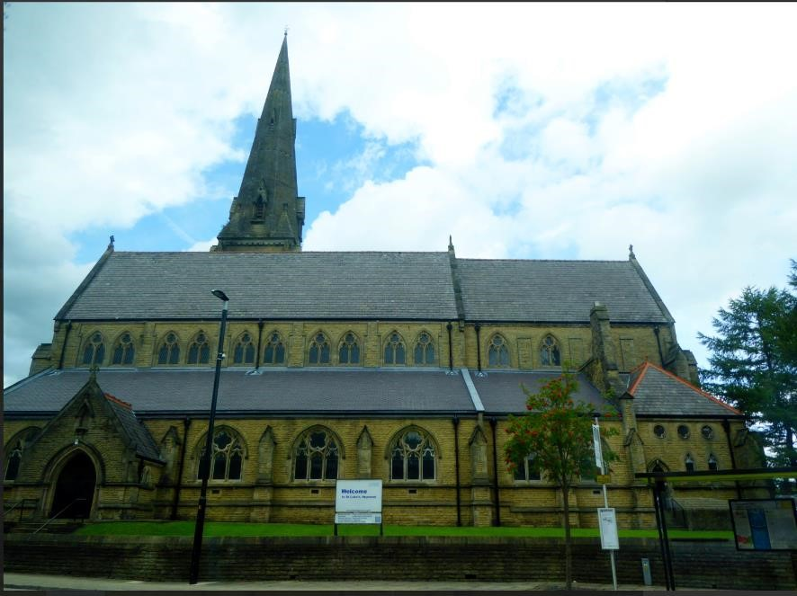

SUNDIAL ADJACENT TO THE SOUTHWEST PORCH OF CHURCH OF SAINT LUKE, CHURCH STREET – GRADE II.

Sundial. "1686 RH 1807" (Robert Heywood) on head "restored 1906" on base. Stone with copper face. Chamfered square shaft stands on an inverted 8-sided cushion-type base with 1906 inscription. Above is a slightly projecting panelled stage with inscription in each face. The face (without gnomon) stands on a cymamoulded cornice which would appear to be of 1906 rather than earlier.

BARCLAYS BANK PLC, 2 CHURCH STREET, HEYWOOD, GREATER MANCHESTER, OL10 1LN - GRADE II
The former Union Bank for Manchester (now Barclays Bank), 2 Church Street, Heywood, of 1909 by JD and SJ Mould, is listed at Grade II for the following principal reasons:

Architectural interest: a good example of an early-C20 bank designed in a robust Edwardian Baroque style imbuing this small building with a monumental and distinctive architectural character; the front elevation is carefully composed with a projecting portico with banded columns beneath a domed corner turret, endowing the building with an eye-catching street presence well in excess of the narrow plot it occupies.
As a building constructed of high-quality ashlar sandstone with carefully crafted detailing and relief-carved embellishments including cartouches and swags of fruit to the outer corner turret. An accomplished design by JD and SJ Mould who designed a number of banks for the Union Bank of Manchester, several of which are listed.

Group value: the bank has a proximity with a number of listed buildings, here St Luke’s Church, a war memorial, and Heywood Area Central Library.
MATERIALS: sandstone ashlar with slate roof and leaded domes.
PLAN: the bank is a narrow, wedge shape and is of two storeys with a basement. The banking hall is on the ground floor with offices on the first floor and a basement strong room.
EXTERIOR The narrow, two-bay front elevation faces north onto Church Street. It has a deep plinth, tall ground floor and lower first floor with a domed turret to the right-hand outer corner and a recessed, slate mansard roof. The plinth is of large, squared blocks. It incorporates a square-headed basement window with a chamfered lintel and a horizontal iron bar to the left and on the right-hand side is angled out from the wall face to meet the large, projecting portico. The angled section is stepped down in the centre and is surmounted by a decorative wrought iron railing. The door portico has alternately blocked columns with ionic capitals supporting an entablature and a broken triangular pediment with relief-carved tympanum and oval cartouche topped with a ball finial. The doorway is recessed to the rear of the portico with panelled double doors and a rectangular, multi-pane overlight. To the left of the portico is a pointed bay window with Gibbs surrounds and alternately blocked pilasters with ionic capitals. The two tall windows have nine-over-nine pane horned sashes. A cash-point machine has been inserted beneath the left-hand window. Above the window there is a stone balcony with bulbous stone balusters supported on large consoles. Over the portico there is a second balcony with a balustrade of solid stone blocks. The right-hand turret has clasping corner pilasters supporting round-headed arches behind which is a lead dome on a low octagonal stone base. The first-floor window has a Gibbs surround and a six-over-single pane horned sash frame, with a relief-carved swag of fruit above and a blind roundel in the arch head. To the left of the turret is a tripartite, square-headed window with alternating block jambs, square-cut stone mullions and six-over-single pane horned sash frames. There is a moulded, modillion eaves cornice. At the left-hand corner is a short stretch of stone parapet.
The seven-bay west elevation faces onto Hind Hill Street with a domed turret at each corner, that to the lefthand end embellished with a relief-carved swag of fruit. It has a deep plinth with five square-headed basement windows with chamfered lintels and horizontal iron bars. The ground floor has alternate banded stonework, with a frieze band between the ground and first floors. The five tall ground-floor windows have small-paned horned sash frames; the windows in the three central bays are more closely spaced. The left-hand first bay has a narrower window and the right-hand seventh bay has a doorway (now - 2022 - blocked) with a Gibbs surround incorporating a round-headed arch with a giant keystone and a relief-carved cartouche in the arch head. On the first floor there is a shallow oriel containing the three central windows with a cartouche beneath the central window. The oriel is flanked by windows in the second and sixth bays. The windows all have alternating block jambs and six-over-single pane horned sash frames. There is a moulded, modillion eaves cornice between the turrets.
The narrow south end bay forms one side of the right-hand Hind Hill Street turret and is blind.
The east side elevation originally abutted a row of shops on Church Street (demolished) and is blind. It is now mostly obscured by modern brick facing and a set-back, two-storey modern brick extension.
INTERIOR The banking hall retains a panelled ceiling with enriched cornices. It also has a partially under-drawn ceiling and a glazed and metal-framed entrance lobby from the modern refurbishment. The offices and ancillary spaces have modern under-drawn ceilings and original doors have been replaced with modern solid doors. The inner wall of the staircase at the rear of the banking hall is built of modern brick.
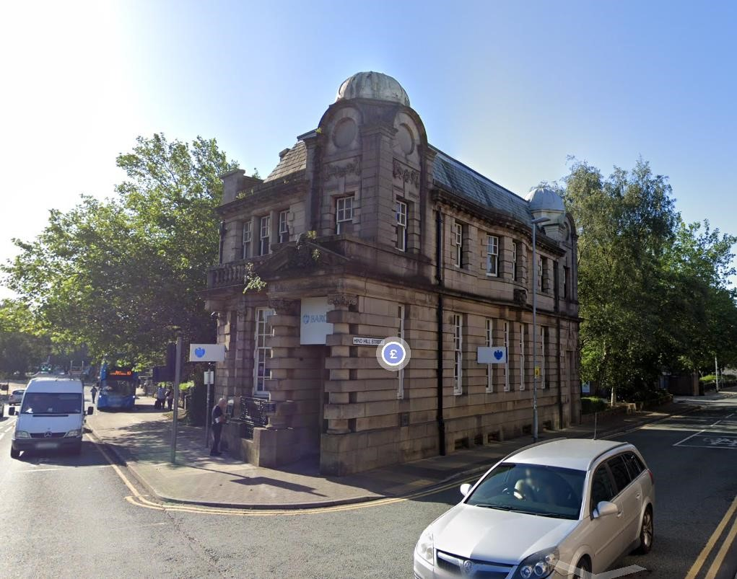

4.0 PROPOSAL IMPACT
This site is located within Heywood town centre Town Centre and is opposite St Luke’s Church and close to
the listed Sundial and Barclays Bank as mentioned and described in detail in the above section. The building itself is not listed and not designated as a having any heritage value.
The application proposes the change of use of a unit at ground and first floor of the building, no external
alterations to the appearance of the building will be made and as such the existing features including the modern shop front would be retained. As such the front, side and rear elevation of the building would preserve the existing historic character of the Area, although it is understood it does not make a positive contribution overall.
It is considered the change of use proposed would help maintain and regenerate this gateway ito Heywood and introduce a continued use for the site to ensure that it is an attractive place to live, work, play and visit. If not supported concerns are raised that the ground floor may remain closed and unoccupied given the current climate in Heywood Town Centre and nationwide.
The public benefits of the change of use and occupation of the site for the future would have a positive but neutral impact on the surrounding Heritage Assets, the application should therefore be supported.

5.0 CONCLUSION
In conclusion, the application would have a neutral impact on the character and appearance of the area by way of the change if use of the first floor. It should be noted there would also be some public benefits of keeping the site occupied which would maintain the upkeep of the conservation area and the setting of the heritage assets - listed buildings. The application therefore accords with Policies DM1, P2 and P3 of the adopted Core Strategy, Policy BE/17 of the UDP and the NPPF, in addition to Sections 66 and 72 of the 1990 Act.

APPENDIX
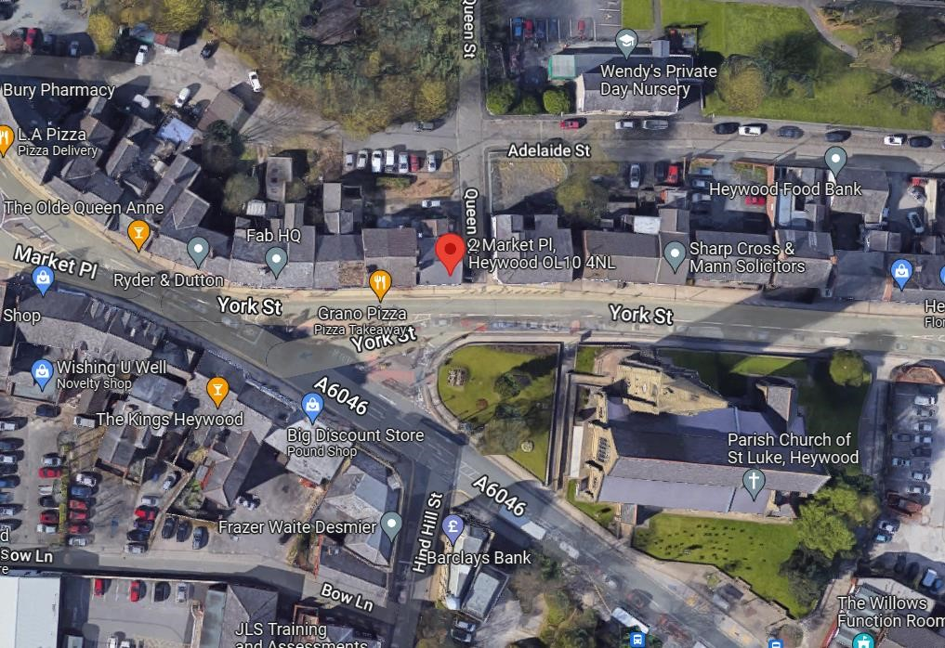
Aerial View of the site along Market Place
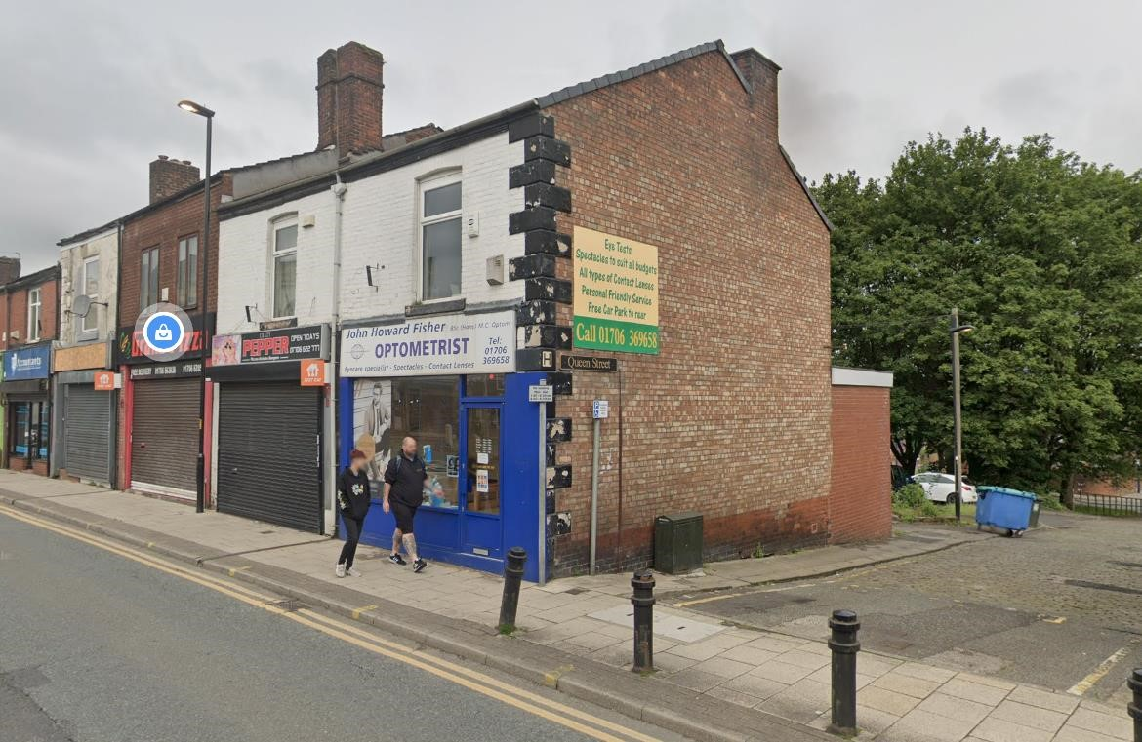
Front and side elevation of the proposed site

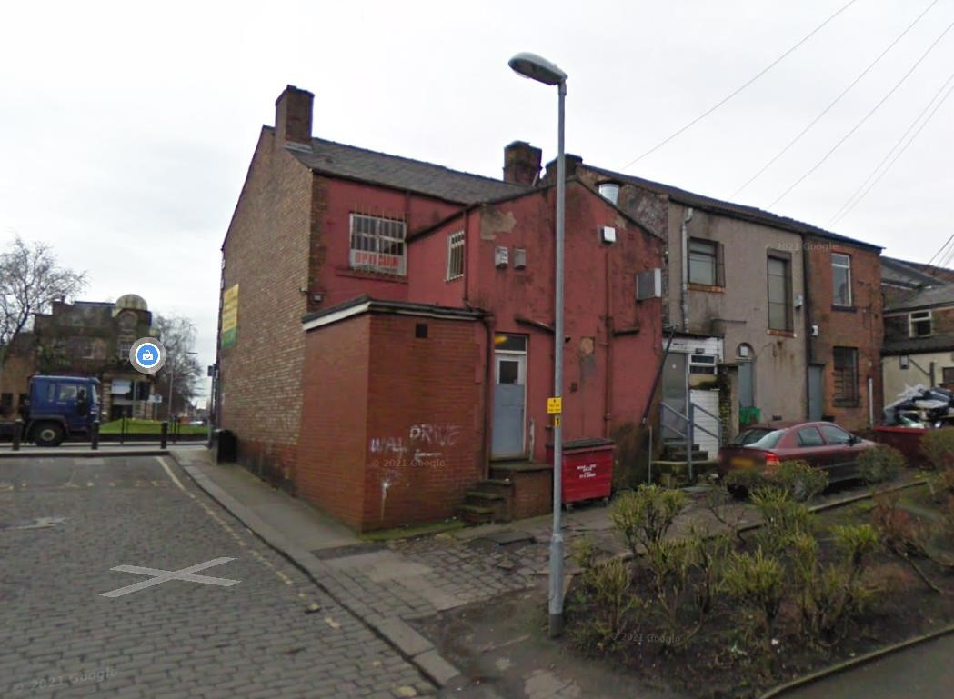
Photo above shows the rear of the building.

