SUSTAINABLE DRAINAGE AND LANDSCAPE MANAGEMENT PLAN FOR FORMER CASTLETON SIDINGS, ROCHDALE

1.0 An introduction to sustainable drainage systems or SuDS
SuDS are a new environmentally friendly approach to managing rainfall that uses landscape features to deal with surface water. SuDS aim to:
    - Control the flow, volume and frequency of water leaving a development area
    - Prevent pollution by intercepting silt and cleaning runoff from hard surfaces
    - Provide attractive surroundings for the community
    - Create opportunities for wildlife

2.0 SuDS at Castleton Sidings, Rochdale.
The site is a brownfield site, which originally drained unattenuated into an existing culvert, which in turns outfalls into Trub Brook to the south of the site.
Unfortunately due to the underlying ground conditions soakaways are not suitable for this site.
Through negotiation with Rochdale Council’s LLFA the surface water discharge rate was agreed to be restricted to 90l/s for the 1 in 100 year event (plus 45% climate change). The storage will be held in oversized pipes and an online storage crate.
In the same email the LLFA advised at the time that a pond would be less expensive than buried tanks, but would ‘leave the details to ourselves’, therefore to maximize usable public open space underground storage crates are required. (See Appendix A)

3.0 Managing the SuDS / Landscaped areas
The underground storage crates and landscaped areas have been designed for easy maintenance to comprise:
The Plan contained in Appendix B shows the areas to be maintained by the proposed Management Company have been coloured blue and green on the plan, with the pink areas being either maintained by the residents or Rochdale Councils Highways Department.
The Sewers shown coloured Red and Blue on the Section 104 Plan contained in Appendix C will be adopted by Murphy Group once the site has completed and following a 12month maintenance period and Kellen Homes have completed any remedial works required by Murphy Group.

Kellen Homes will undertake all maintenance works until such time the areas are adopted.
These works will include the following:
    - Regular “day to day” care - litter collection, grass cutting and checking silt traps, inlets and outlets where water enters or leaves a SuDS feature.
    - Occasional tasks - managing vegetation and removing any silt that builds up in the SuDS features
    - Remedial work - repairing damage where necessary

4.0 Spillage – EMERGENCY ACTION

Most spillages on development sites are of compounds that do not pose a serious risk to the environment if they enter the drainage in a slow and controlled manner with time available for natural breakdown in a treatment system.
Therefore small spillages of oil, or other known organic substances should be removed where possible using soak mats as recommended by the Environment Agency with residual spillage allowed to bio-remediate in the drainage system.
In the event of a serious spillage, either by volume or of unknown or toxic compounds, then isolate the spillage with soil, turf or fabric and block outlet pipes from chamber(s) downstream of the spillage with a bung(s). (A bung for blocking pipes may be made by wrapping soil or turf in a plastic sheet or close woven fabric.)
Contact the Environment Agency immediately.

5.0 Existing Culvert.

The existing culvert shown by a green line on the Management Plan contained within Appendix B will be maintained by the Management Company. (A copy of Trustgreen’s Order Confirmation is included in Appendix E).
Trustgreen’s offer states that the culvert will be inspected in accordance with CIRIA Guidance.
Appendix F contains a “Maintenance Regime for Culverts / Pipes” (Based on CIRIA C689 – Culvert Design and Operation Guide)
The route is protected by an easement preventing home owners from building over the culvert. A copy of the “Overall Plot Deed Plan” is contained within Appendix D.
The culvert is shown on the approved Section 38 Drawings. Rochdale Highways Department have granted Section 38 Technical Approval for the drawings listed in the Planning Decision Notice, a copy of the confirmation is contained in Appendix A

5.0 Typical SuDS and Landscape Maintenance – Summary

 |  | Frequency
 | REGULAR MAINTENANCE
1 | LITTER MANAGEMENT
1.1 | Pick up all litter in SuDS and Landscape areas and remove from site | 12 visits monthly
2 | GRASS MAINTENANCE – all cuttings to wildlife piles
2.1 | Mow all grass verges, paths and amenity at 35-50mm with 75mm max. Leaving grass in situ | As required or monthly
2.2 | Mow all dry swales, dry SuDS basins and margins to low flow channels and other SuDS features at 100mm with 150mm max. Cut wet swales or basins annually as wildflower areas | 4-8 visits as required Annually
2.3 | Wildflower areas strimmed to 50mm in Sept or at end of school holidays  Or  Wildflower areas strimmed to 50mm on 3 year rotation 30% each year | 1 visit annually  1 visit annually
3 | INLETS AND OUTLETS
3.1 | Inspect monthly, remove silt from slab aprons and debris. Strim 1m round for access if required. | 4 visits yearly
4 | WETLAND AND POND VEGETATION
4.1 | Wetland vegetation to be cut at 100mm on 3 – 5 year rotation. 30% each year. All cuttings to be removed to wildlife piles or from site. | As required
5 | SILT MANAGEMENT
5.1 | Inspect crates, swales, ponds and wetlands annually for silt accumulation | 4 visits yearly
5.2 | Excavate and remove silt | As required
5.3 | The existing culvert will be maintained by the Management Company (a copy of Trustgreen’s Order Confirmation is included in Appendix E). Within their quotation it refers inspections to “CIRIA Guidance”.  Appendix F contains a “Maintenance Regime for Culverts / Pipes” (Based on CIRIA C689) | 1 visit annually
6 | REMEDIAL WORK
6.1 | Inspect SuDS system regularly to check for damage or failure.  Undertake remedial work as required. | As Required
5.3 | Existing Culvert – the culvert will be maintained by the management company. Undertake remedial work as required. | As Required

APPENDIX A – Technical Approvals

1.0 - Discharge Rate Approval
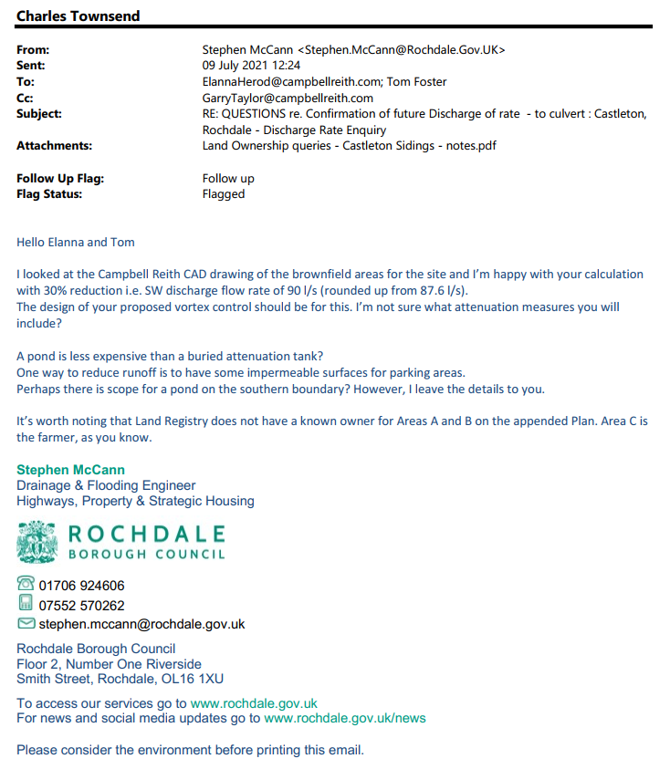

APPENDIX A (cont.)

2.0 - Section 38 Technical Approval
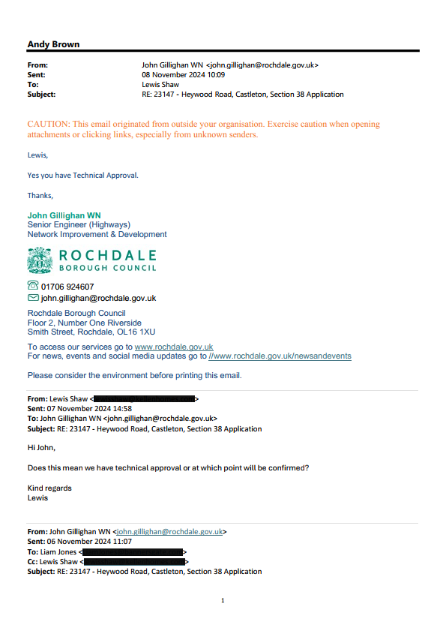

APPENDIX B

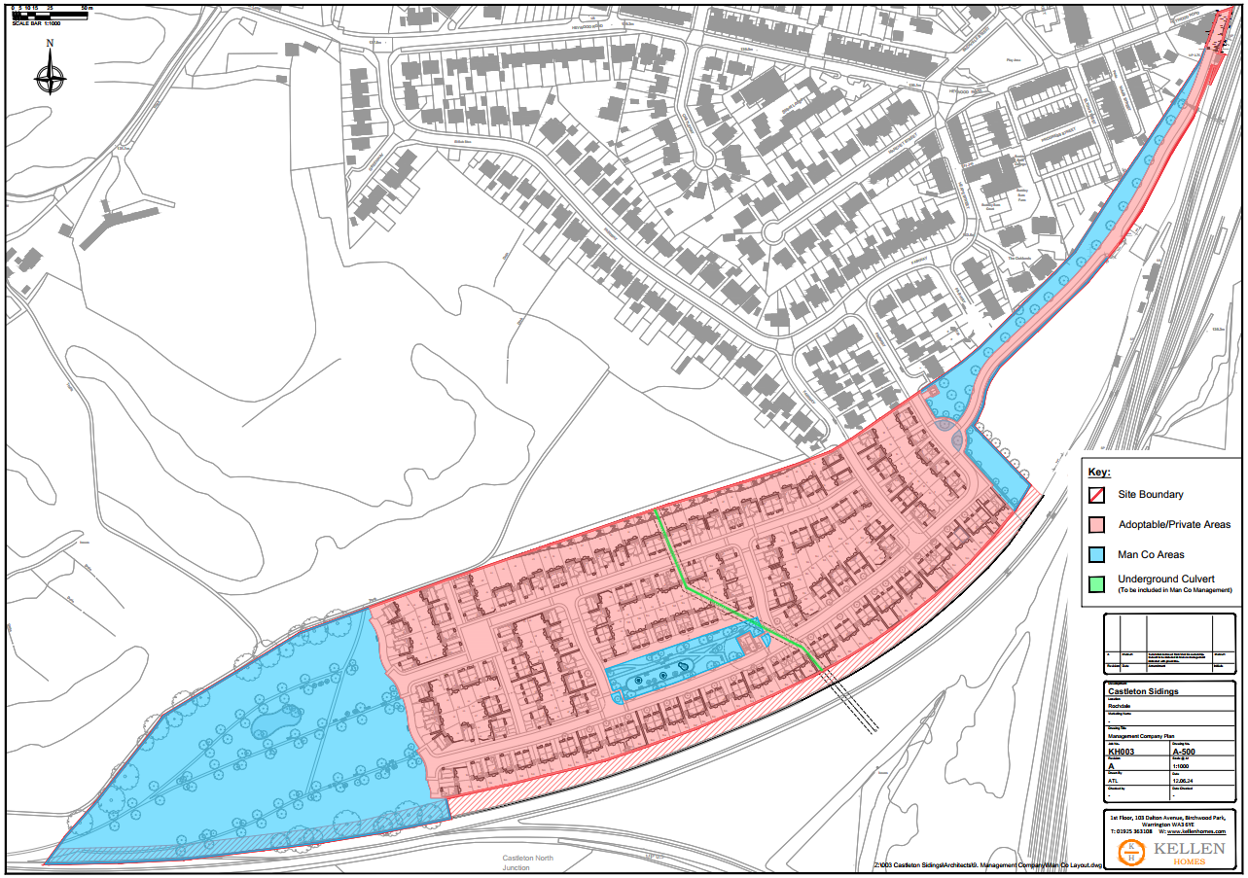

Management Company Plan

APPENDIX C

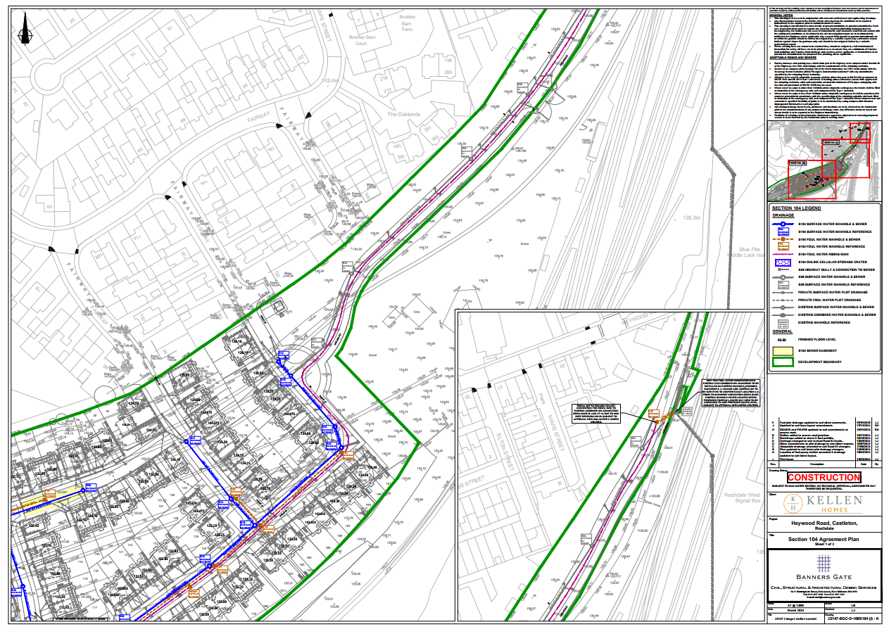

APPENDIX C (cont)

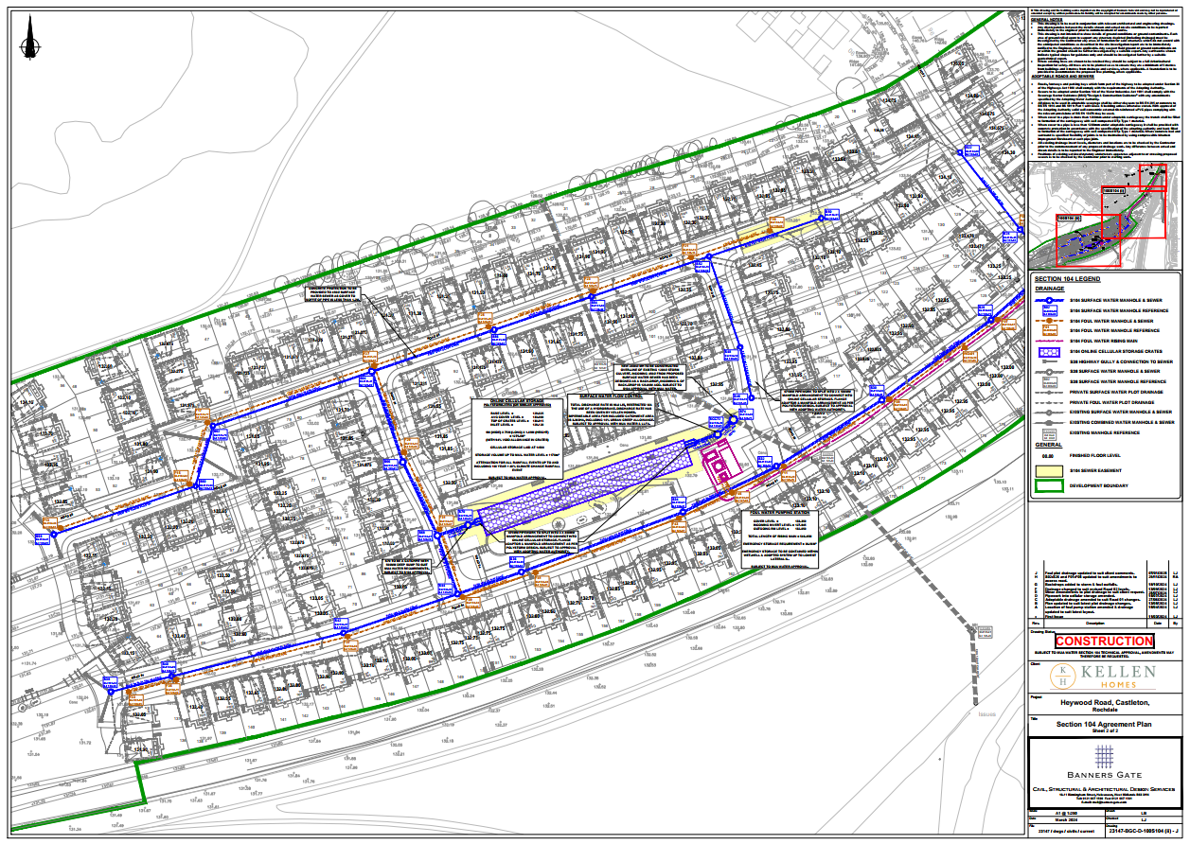

APPENDIX D

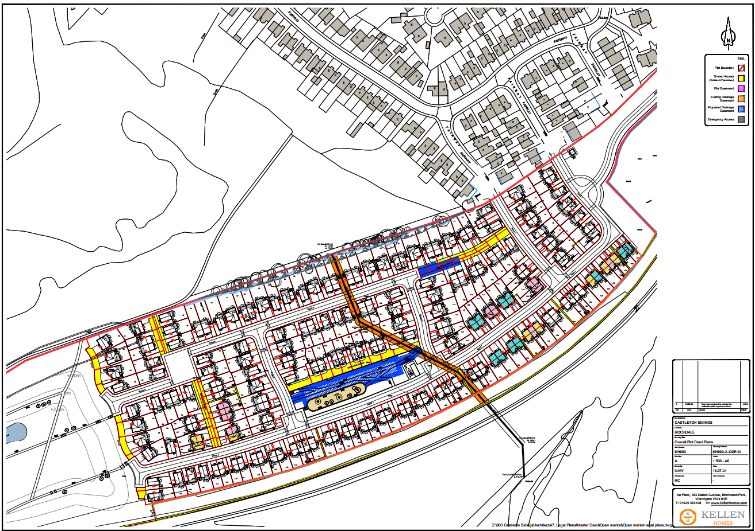

Overall Plot Deed Plan

APPENDIX E

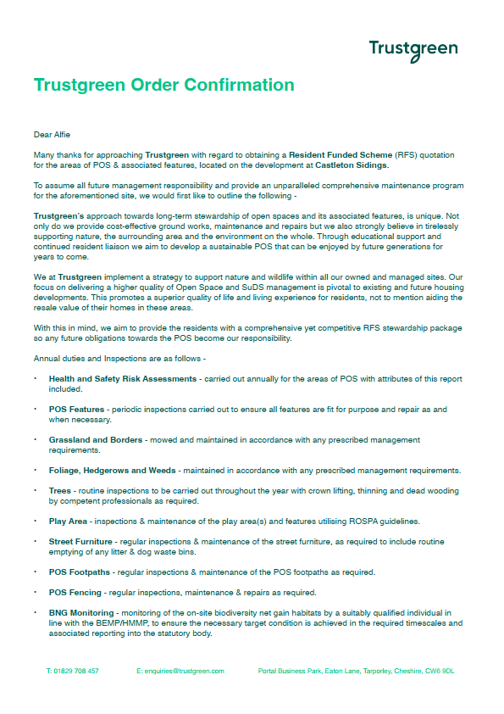

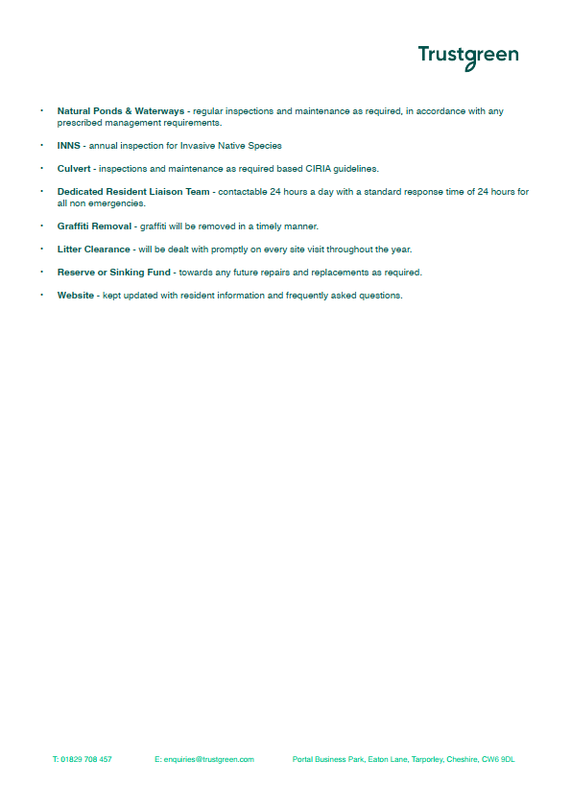

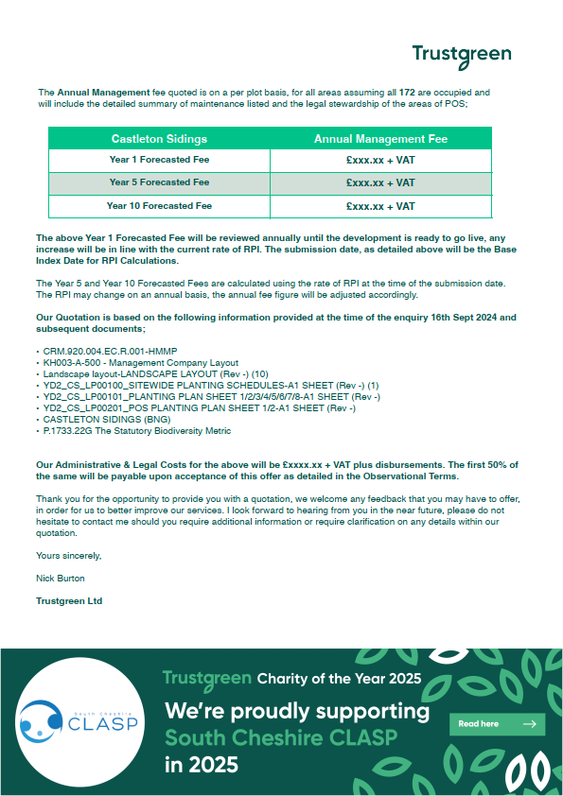

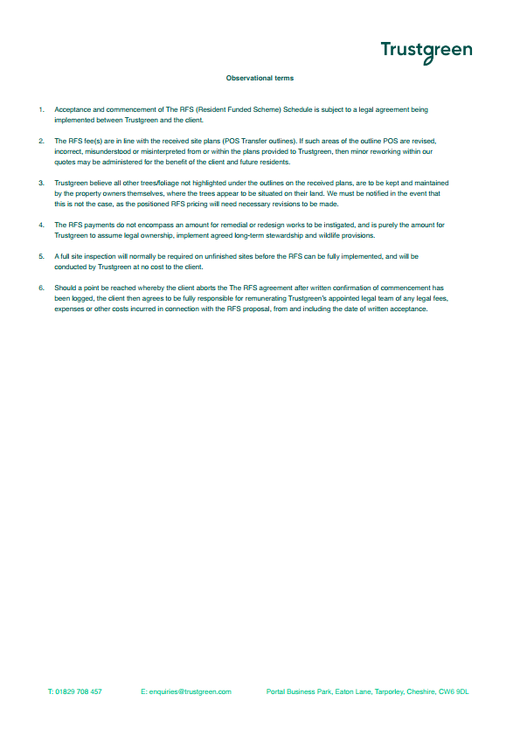

APPENDIX F

Synopsis: Maintenance Regime for Culverts / Pipes (Based on CIRIA C689)
Objective:
To ensure culverted watercourses remain effective and safe, preventing blockages, flooding, and structural failure through a proactive maintenance regime.

Maintenance Regime Overview
CIRIA C689 emphasises a risk-based maintenance approach tailored to the culvert’s location, design, catchment characteristics, and downstream sensitivity. Maintenance should include inspection, cleaning, vegetation control, debris removal, and structural assessment.

Recommended Timescales for Maintenance Activities
Activity | Recommended Frequency | Notes
Routine Visual Inspections | Annually  (typically in spring/autumn) | Adjust frequency based on debris load and risk level.
After Major Storm Events | Within 24–72 hours post-event | Essential to assess for blockage or structural impact.
Debris and Sediment Removal | Annually based on inspection | More frequent in urban/high-debris catchments.
Vegetation Management (at inlets / outlets) | Annually or as required | Prevents root intrusion and flow obstruction.
Structural Inspection | Every 5–10 years (detailed survey) | Align with asset management planning cycles.

Key Considerations
- Maintenance frequency must be adaptive based on performance records and environmental changes.
- Implementing a culvert asset management register supports scheduling and tracking.
- Use remote monitoring (e.g., cameras or telemetry) in inaccessible or high-risk locations for early warning.

Conclusion
A structured maintenance regime with well-defined timescales based on CIRIA C689 helps reduce flood risk, prolong culvert life, and support regulatory compliance. The timescales should be reviewed periodically and adjusted as needed based on asset condition and catchment dynamics.

