Planning Reference PP-12326287

Overview
Application for planning permission to render the external walls and split face tiling of the property at 58 Lawnswood, Rochdale, OL11 3HB.
The property is of standard brick construction with a pitched roof. The current property consists of the original house, a two storey extension over the original garage and a separate detached garage located next to no 60 Lawnswood.
The application is for rendering the exterior walls of the main house as it currently stands and the detached garage. We initially want to render the back wall of the house and budget permitting the remainder, i.e. all 4 sides and the garage. We want to use complementary split faced tiling to the front and rear of the property. On the front to replace the stone effect and also to the ground floor entrance and extension. On the Back, to above door height only, the remainder of the external walls to be rendered.
I have sought advice from local professional traders with regard to type of render and colours, they are listed below.
The exact type and colour will be decided after the planning application process if successful and will give consideration to other houses that have been rendered on the Lawnswood estate and Gipsy lane, we will also look for any advice from the planning application committee.
The split faced tiling will be driven by the colour of the render but will be either complimentary i.e. same/ similar colour as the render or contrasting.
The house has wall insulation, this was done approximately 10 years ago under a government initiative
No structural work is required for the rendering and it is not intended to undertake any reconstruction. Therefore no structural plans and drawings are included in this application.

Reason for the application
The brick work on the house is made of multiple brick types and colour these include the original brick work, extension brick work and a broken stone facade at the front of the house. The back of the house is very much worse in terms of wear and has different brick types. All the brick work shows signs of weathering and general wear. We want to improve the look of the house by using rendering and improvements to the broken stone effect on the house by way of repair or replacing with similar façade as we want to retain the feature.
The application is for rendering of the external walls and also the garage to have the same finish.
I have spoken to Building Control and they have informed me that I will need to apply for building control as part of this project.

Local area and other properties on the estate and nearby
There are two types of detached properties on the Lawnswood estate, our part of the estate is built as a horse shoe and is a cul-de-sac on both ends.
This consists of double storey detached properties in the centre of the horse shoe with bungalows facing them on the opposite site of the road.
The original construction had an original broken brick façade on most if not all properties. UPVC cladding / coverings in various colours have been applied to most houses to cover the original broken stone, some houses including ours still has the broken stone effect to the front of the house. Now, many houses have their own look and feel. Some houses have kept their original features intact but most have changed and applied the UPV cladding.

House render types under consideration

Table
Type | Under consideration
Silicone | Yes – Option 1
Polymer | Yes – Option 2
Cement | Undecided – based on cost of above options
Acrylic | No
Lime | No
Cork | No

Overview of options (taken from various sites)

Silicone
Silicone render is available in a wide range of colours and finishes – it’s a popular choice and a low maintenance option, offering a water-repellent finish that’s also breathable. Surfaces that are more exposed to natural washing by rainwater will be self-cleaning, and those areas that need it can be jet-washed on a gentle fan setting to keep them looking fresh.
Silicone render has a long life-span – 15 to 30 years depending on your location and factors like exposure to extreme weather, with some providers offering long warranties of up to 25 years. So, make sure you choose a colour you can live with for a very long time.
K-Rend is the option we would use. Due to its longevity it offers a cost-effective option in the long run due to its low maintenance and long life.

Acrylic render
Like silicone, acrylic render is another synthetic option that can offer you a water repellent finish and it’s available in a range of colours. it’s not self-cleaning with rainwater like silicone, unlike silicone, is not a breathable product.

Polymer render
Like acrylic, polymer render is also extremely weatherproof, but unlike acrylic render it offers a more breathable solution. Polymer render offers a much more flexible alternative and is highly resistant to cracking. It is stickier and so bonds better with the surface of your walls, which may be helpful if you’re covering tricky surfaces.

Cement
Cement render is one of the more affordable options on the market. Cement is mixed with lime and sand and applied in a thick coat to a hard substrate like brick or blocks. It is available in different colour options and can improve your home’s insulation – it’s an extra layer to help trap heat inside.
However, it isn’t suitable for use on surfaces that aren’t solid – for example, it can’t be used directly on top of exterior wall insulation. It is porous and inflexible, so cement tends to crack quite easily and has a shorter lifespan than some other alternatives like lime or silicone. You can expect cement render to last between 7 to 15 years.

Lime render
Lime render or plaster is a traditional finish that’s porous and breathable and usually finished with a coat of lime wash paint. It offers a huge variety of textured finishes and colour options. It is naturally quite flexible, which means it’s perfect for older buildings that shift about, expanding and contracting with the temperature and humidity. It’s a better insulator than cement and can contribute to regulating the interior temperature of your home. Perhaps surprisingly for a seemingly ‘old fashioned’ product it offers many of the benefits of a high-performance modern render – it’s water repellent and resistant to mould. It also has longevity.
However, it can be tricky to work with and there are fewer skilled tradespeople who have experience with traditional lime render compared to other products.

Cork render
Cork render offers a natural and sustainable alternative to traditional and high-performance modern renders. It’s waterproof, lightweight and adheres to just about any surface, including metal.

Additional information - Colours available for K-Rend
https://www.externalrendering.net/faq/krend-colour-chart/
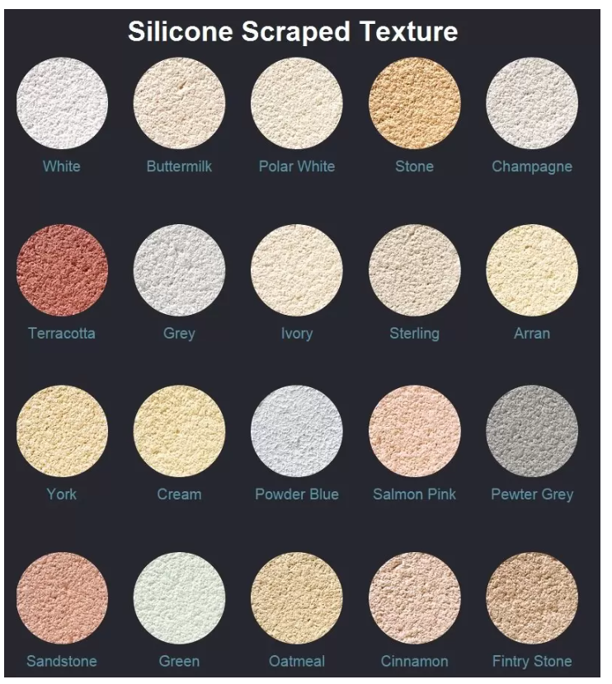
Cracked Face tiling example
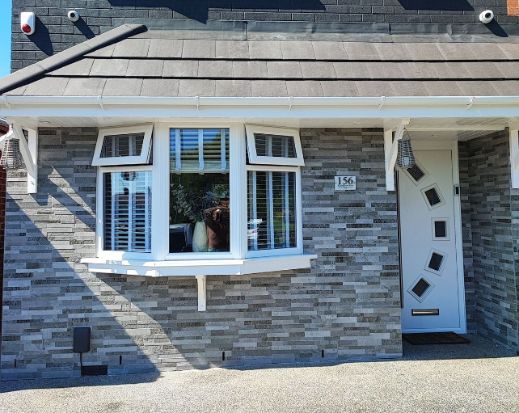

Property Images – Google Maps

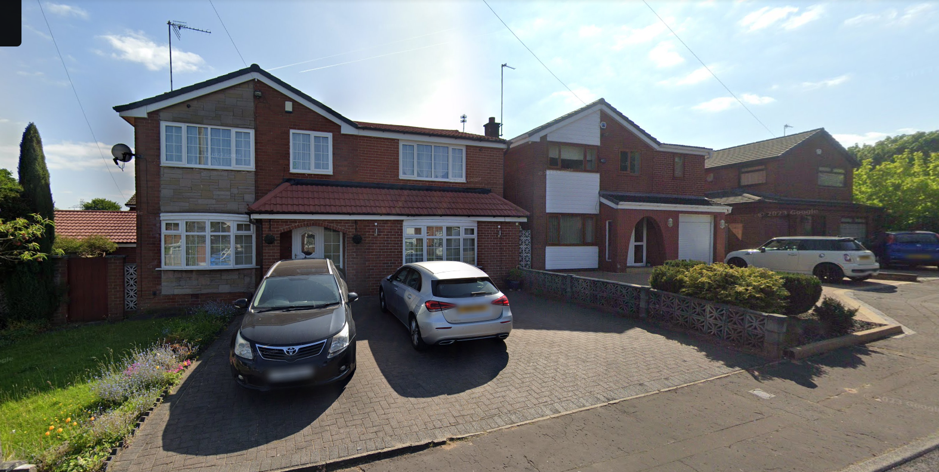
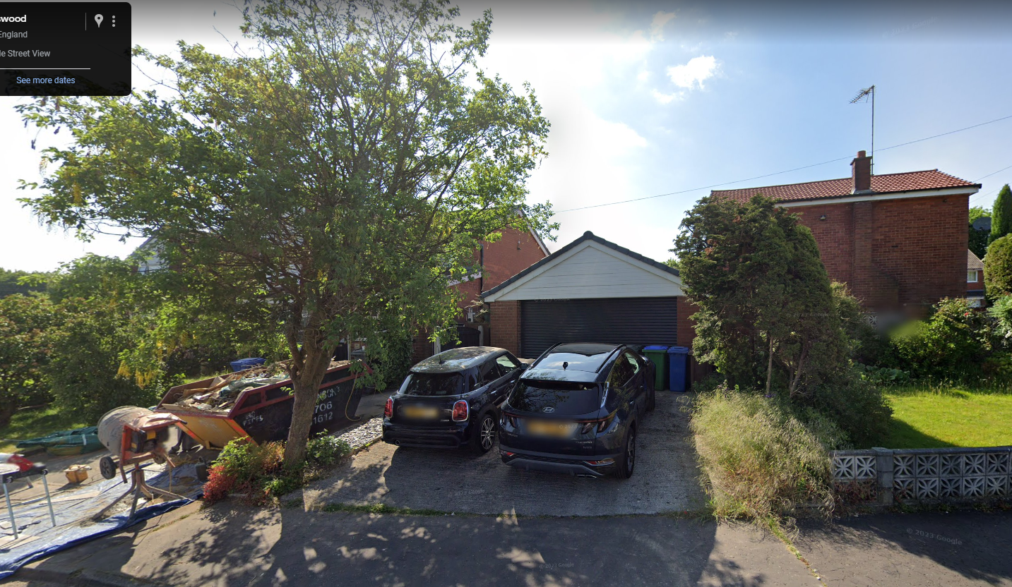

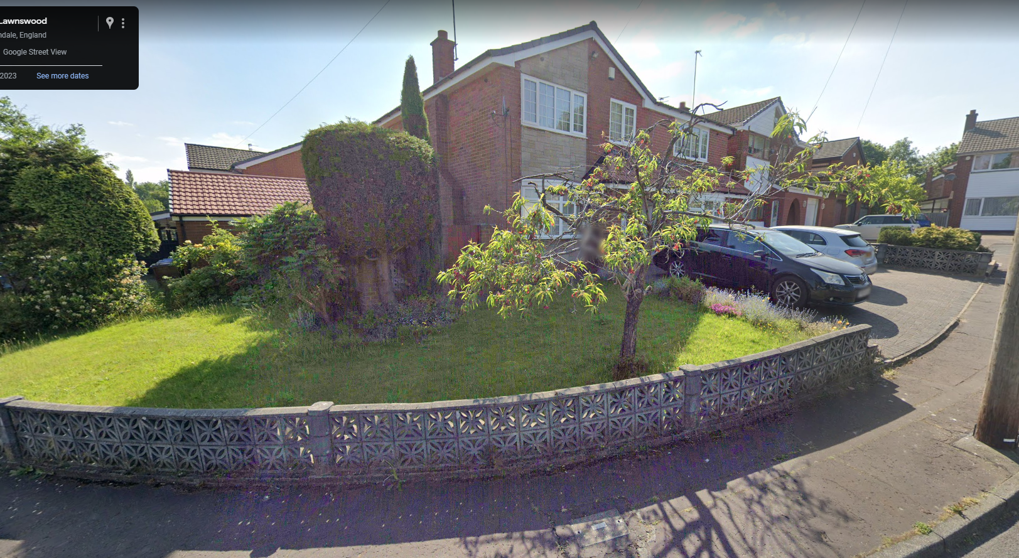

Visual Summary of project
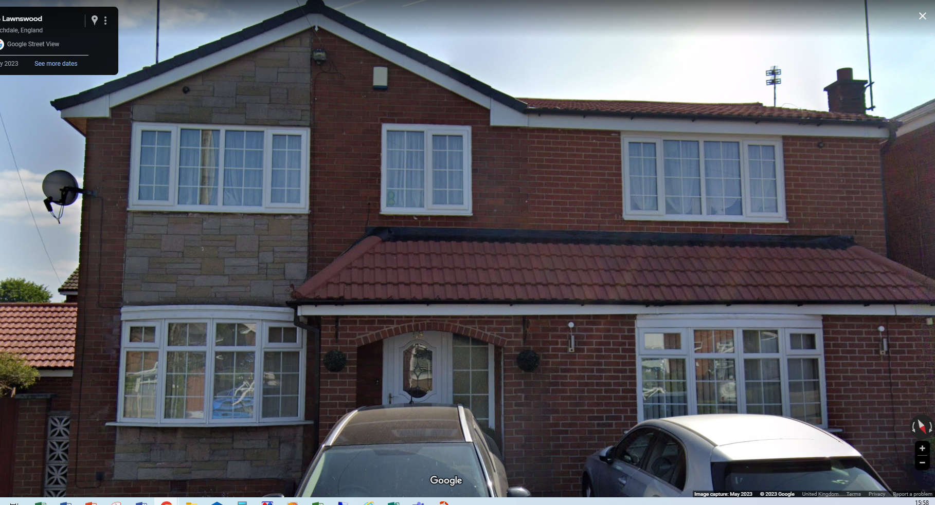
Render
RENDER / Split Faced Tiling to front, sides & Entrance
Split Face Tiling / Render
RENDER

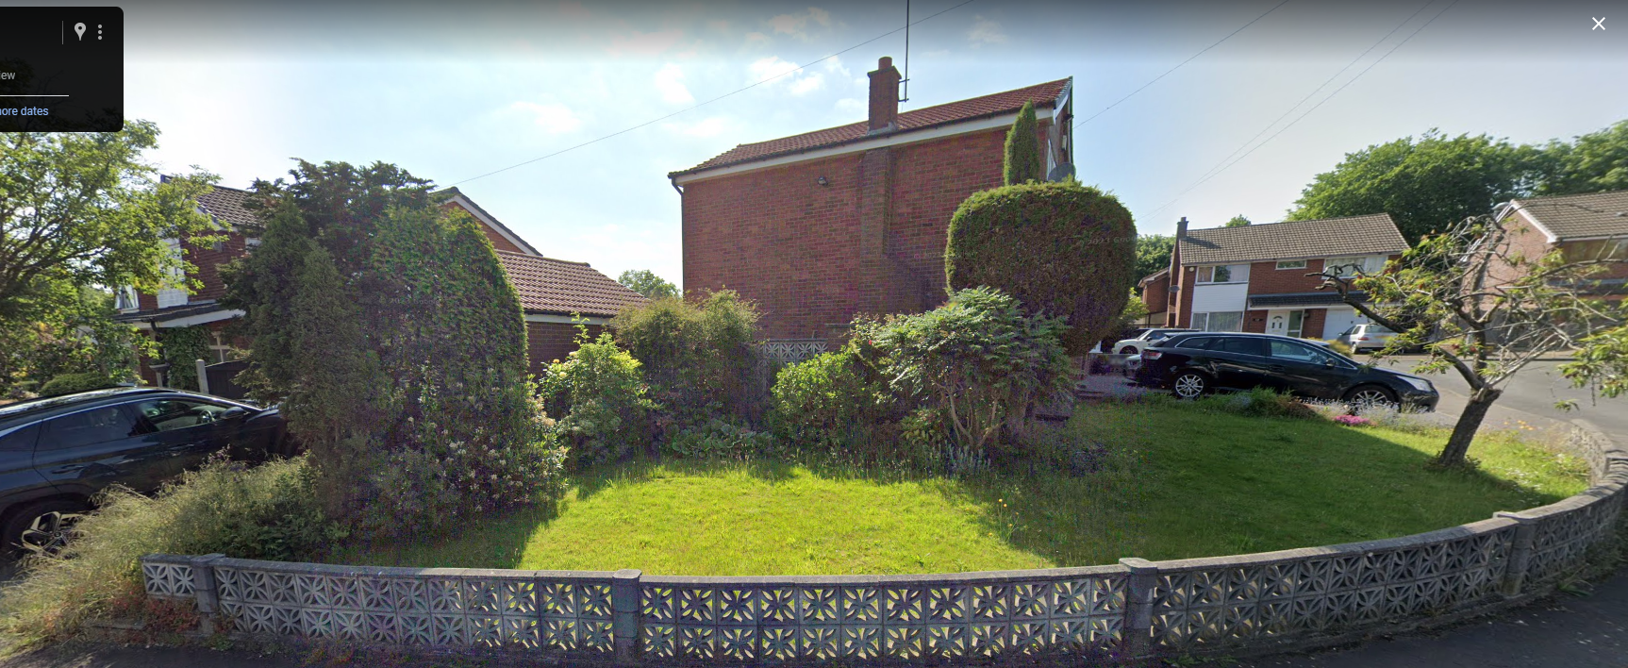
RENDER

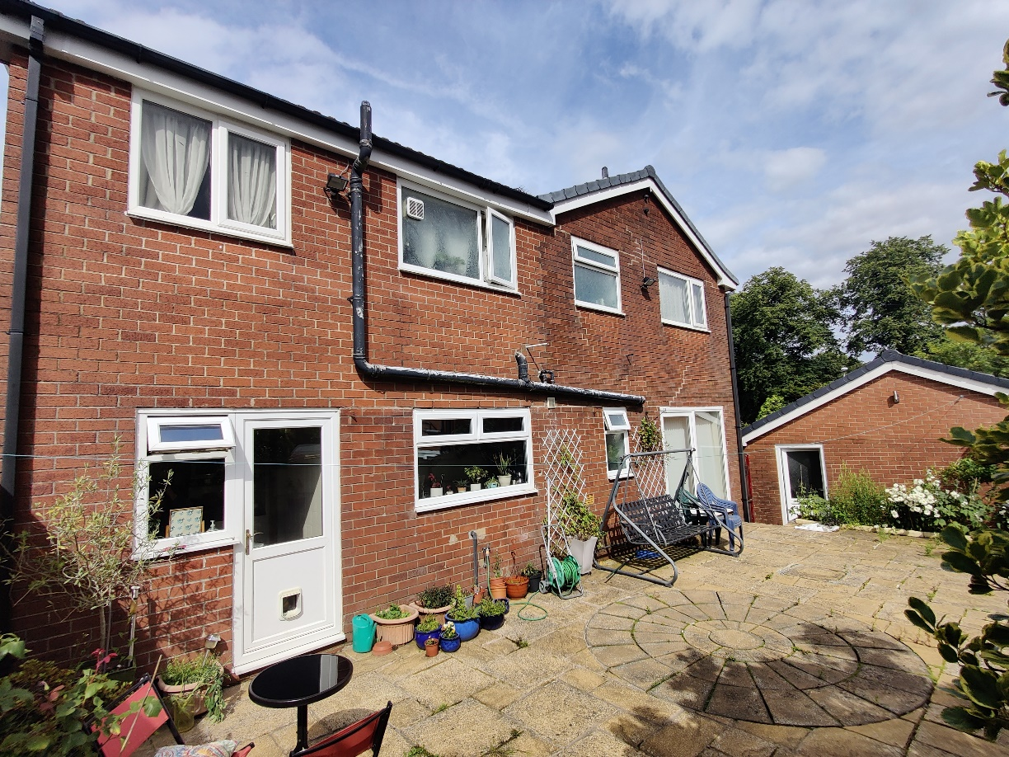
RENDER
Split Faced Tiling / Render
RENDER

Other property images – Google Maps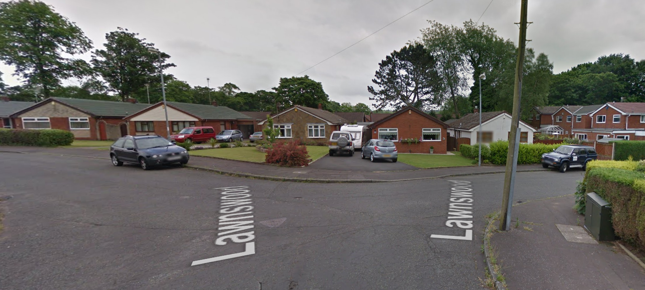
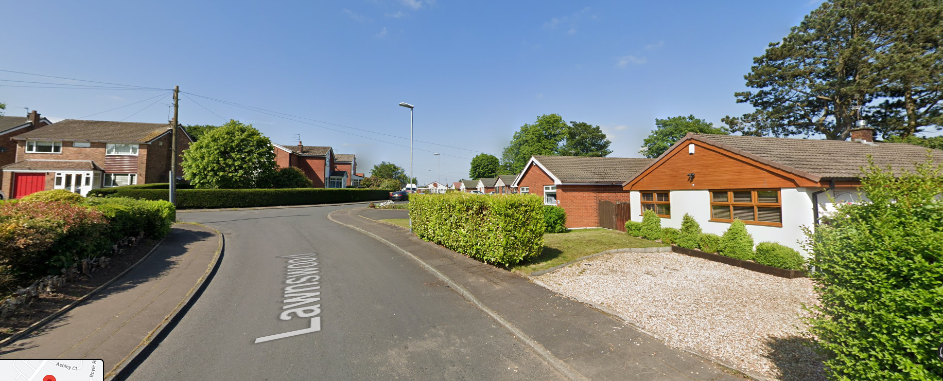
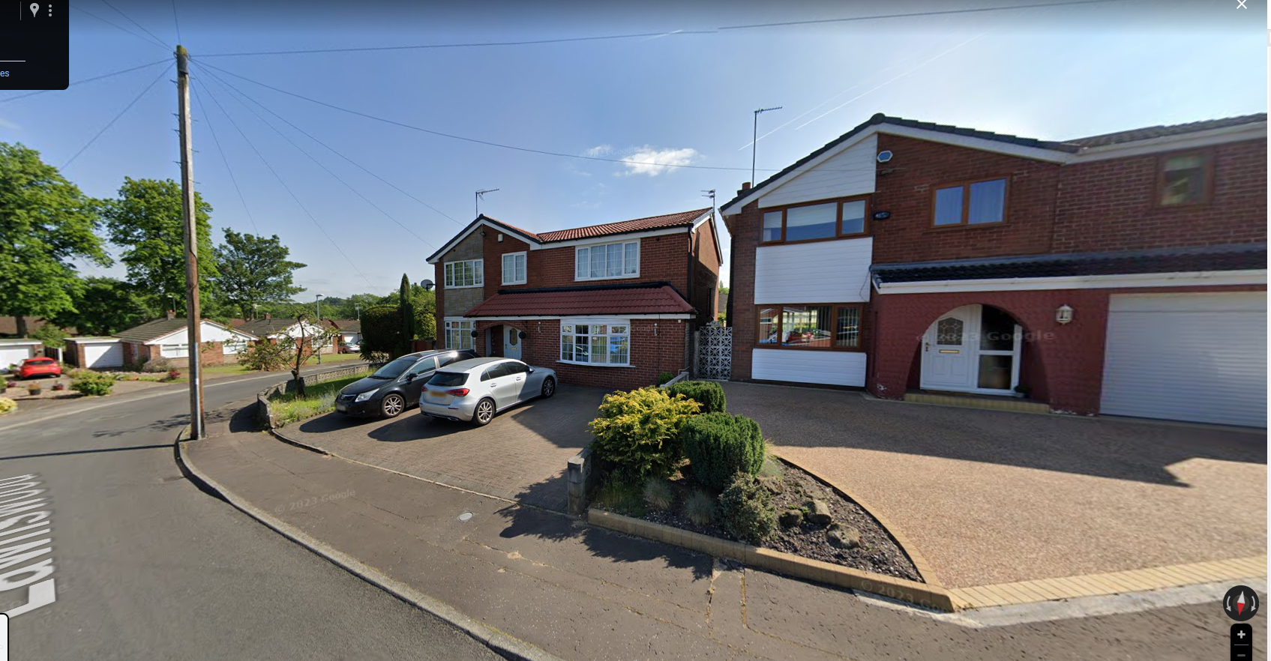
Rendered

Gipsy Lane
