SPECIAL BRANCH
`

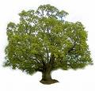
Tree Surgeons Ltd
Top O’th Meadow Farm
Meadowhead Lane
Norden, Rochdale
OL11 5UL
Tel: 01706 658771

Mini Tree Report Date: 1/03/23

Amjad Ali
16 Kemp Avenue, OL11 4LR
Rochdale
As requested, please see my mini tree report, as previously mentioned this offers no guarantees as trees are living organisms and can fail at any time. We would also like to point out no indemnity or insurance cover is offered. This report is in “my opinion” only and covers only the trees that have been inspected.

Trees in question subject to Tree Preservation Order TPO146

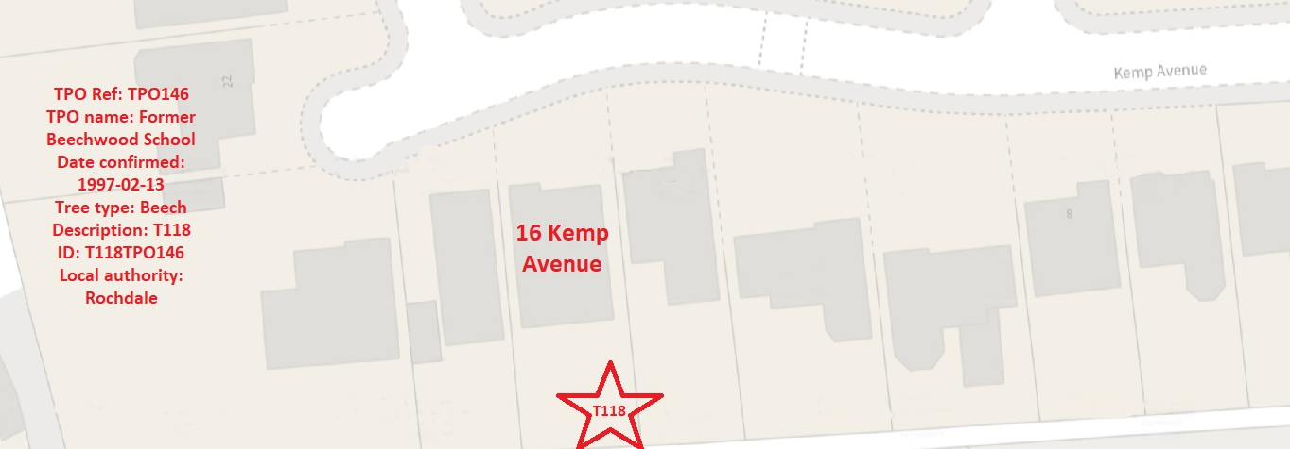

Work done

Site visit, arboricultural inspection, photography and report.

Tree in question

T118 Beech, Mature tree approximately 28 meters high with a good even spread crown Referenced T118 on the plan and annotated photography.

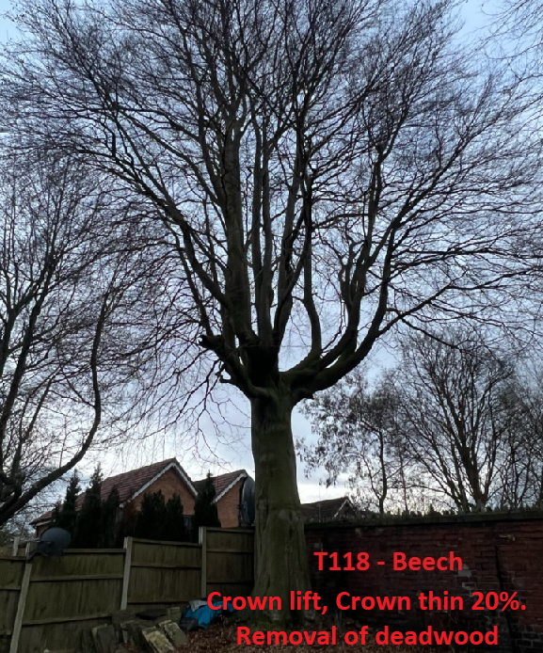

Problem
The tree in question is within close proximity to residential properties. The tree owner is very satisfied with tree and the trees health. With the Beech tree being of such size it is casting shade within properties and gardens during the summer period.

Recommendation

T118 – Crown lift with only removing secondary branches, crown thin of 20% to allow light through the canopy and removal of any deadwood. This work will not have any detrimental effect to the trees health.
Amenity value should not be affected to the general public.

Regards

Ryan Slack
Mr Ryan Slack cert Arb L2 (ABC)

