Application for the discharge of conditions relating to Listed Building approval 21/01467/LBC.
Demolition of existing side porch and replacement with enlarged porch
incorporating shower room
Duffins Cottage, Shawclough Road, Rochdale, OL12 7HL

Planning statement 2 for discharge of remaining pre construction conditions

H | P
D | A

January 2023
Prepared by Hartley Planning and Development Associates Ltd

Introduction
Application is made for those conditions imposed upon Listed Building approval 21/01467/LBC. which require the specific written approval of the local planning authority and which have not yet been discharged: -

(Some conditions were discharged on 26October 2022 under application no 21/01467/LBC)

3. No above ground construction works shall take place until samples and/or full
specification of materials to be used in the construction of the building hereby approved shall be submitted to and approved in writing by the Local Planning Authority. For the
avoidance of doubt, this shall include details of:
- the service runs;
- the construction of external walls including details of the masonry and mortar;
- the construction of the roof including details of the stone slate and lead
- detailing;
- paving;
- rain water goods, soffits and fascias; and
- windows and door details at a scale of 1:10 or 1:20, including the longitudinal
and cross-sectional detailing, depth of reveal, cill and lintel detailing, and
means of opening together with any finished treatment.
Such details shall include the type, colour and texture of the materials. Development
shall thereafter be carried out in complete accordance with the approved details.

Applicant comments
Under application 22/00948/DOC, determined on 26 October 2022, the local planning authority approved the following matters: -

- The service run details as shown on the floor plan are considered to be
acceptable.
- The use of ‘reclaimed natural York flags’ for the paving as identified in the
‘Planning Statement for Discharge of Conditions’ document, dated June 2022
and prepared by Hartley Planning and Development Associates Ltd, is
considered to be acceptable
- The use of ‘cast iron to match existing’ for the rainwater goods as identified in the ‘Planning Statement for Discharge of Conditions’ document, dated June 2022 and prepared by Hartley Planning and Development Associates Ltd is considered to be acceptable.

Application is made for the discharge of the following , remaining aspects of the conditions

The construction of external walls;

The natural stone from the existing side extension to be re-used in the new extension and with coursing to match the host dwelling’s side elevation.

The LPA has commented that ‘ as the existing porch is smaller than the extension that has been granted planning permission it is expected that additional stone would be required. That has proved to be the case, but additional natural stone has been found in the garden of the property.
Photo of the new porch
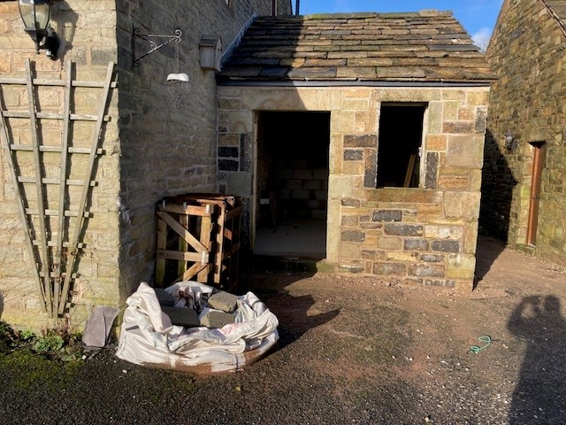

Mortar
Mortar to be sand and cement. to match the existing dwelling which at some stage has been repointed with the same.

While the LPA has written that ‘ the use of a cement based mortar is also not acceptable on a listed building’(LB), the LB has been repointed several years ago with a cement mortar and the original porch was likewise treated. In addition , the adjoining garage, approved by the LPA is also constructed in a cement mortar.

Alternatively, the walls, by condition, to be repointed using a lime mortar (though it would look odd against the abutting part of the house and the garage).

The construction of the roof
The LPA has commented that ‘ Further details including samples of the existing and proposed stone slabs are required to ensure a good match’.
The roofing to the original porch has been re-used and augmented by matching materials

Photo of roof
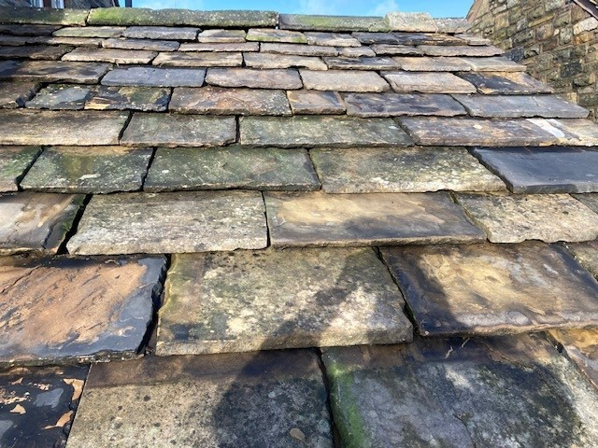

Fascias
The LPA has commented ‘ the use of Accoya fascias as identified in the ‘Planning Statement for Discharge of Conditions’ document, dated June 2022 and prepared by Hartley Planning and Development Associates Ltd, is considered to be acceptable. The
use of composite fascias is considered to be unacceptable.

For the avoidance of doubt, Accoya fascias are to be used

Window and door details
The condition states: -

‘Windows and door details at a scale of 1:10 or 1:20, including the longitudinal
and cross-sectional detailing, depth of reveal, cill and lintel detailing, and
means of opening together with any finished treatment.

The LPA has written

‘ This part of the condition has not been satisfied.
The condition requires drawings at a scale of 1:10 or 1:20 with longitudinal and
cross-sectional detailing, depth of reveal, cill and lintel detailing, and means of
opening together with any finished treatment. For the condition to be satisfied
these drawings will be required.

Windows

- Vertical window as shown on the approved plans and to be manufactured from timber to match the existing windows in the dwelling, with finished treatment to be painted ‘Old English white’ to match existing.

See submitted cross sections for window

Door
Door to be wood and with Sikkens dark wood stain, to be the same as the existing and approved garage door:
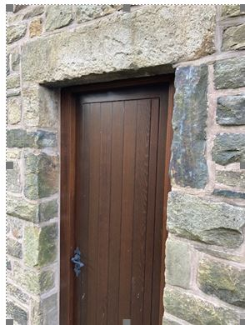

See submitted cross section

