Ecological Appraisal

Executive Summary
Ostara Ecological Services were commissioned by BTP Architects to undertake an Ecological Appraisal at Bury Old Road, Heywood, OL10 3PD. This comprised an online desk study, habitat survey of two land parcels (area A and area B) and an ecological scoping survey which assessed the potential of the site to support species of conservation concern or other species which could present a constraint to the development of the site. The proposals include c.20 residential properties with associated infrastructure.
The site comprises developed land; sealed surface, neutral grassland, bramble scrub and trees. It was concluded:
- No significant impacts upon designated sites are anticipated.
- Habitats present on site are common and widespread. However, due to an overall loss of grassland, scrub and trees, the proposed development does not currently deliver a 10% biodiversity net gain. This may need to be addressed via offsite means.
- The proposed development is considered highly unlikely to support protected and/or notable species, with the exception of nesting birds.
- 12 trees are proposed for removal suitable for nesting birds, which should be timed to avoid the nesting bird season.
- Other enhancements including the incorporation of bat boxes, bird boxes and/or bug boxes are recommended as well as gaps in boundary fences to provide opportunities for small animals to disperse through the site.

Introduction
Site name | Bury Old Road, Heywood
Purpose of report | To undertake an assessment of the potential ecological impact of the proposals; an online desk study, habitat survey and protected species scoping survey were carried out.  This report is a stand-alone Ecological Appraisal (EA) or Low Impact Ecological Impact Assessment (EcIA) which has been prepared following current guidance (CIEEM, 2018) and can be used to lawfully determine a planning application in line with current planning policy. This report does not form part of a wider discipline Environmental Impact Assessment (EIA) or Environmental Statement (ES), nor does it confer the need for any such documentation.  The report will also provide an overview of the Biodiversity Net Gain Good Practice Principles (Baker, Hoskin & Butterworth, 2019) and legislation and planning policy.
Aim(s) | - Undertake a desk-based review of designated sites and records of protected species and other species that could present a constraint;  - Assess the habitats present on site;  - Assess the site for potential to support protected species or other species that could present a constraint, and make appropriate recommendations for further survey work if necessary;  - Provide outline options for mitigation measures as appropriate; and  - Make recommendations for appropriate biodiversity enhancements in line with national and local planning policy.
Development proposals | The proposals include c.20 residential properties with associated infrastructure.
Location | Bury Old Road, Heywood, OL10 3PD. UK Grid reference: SD 83470 10402. Approximately 0.6 hectares (ha).
Map | 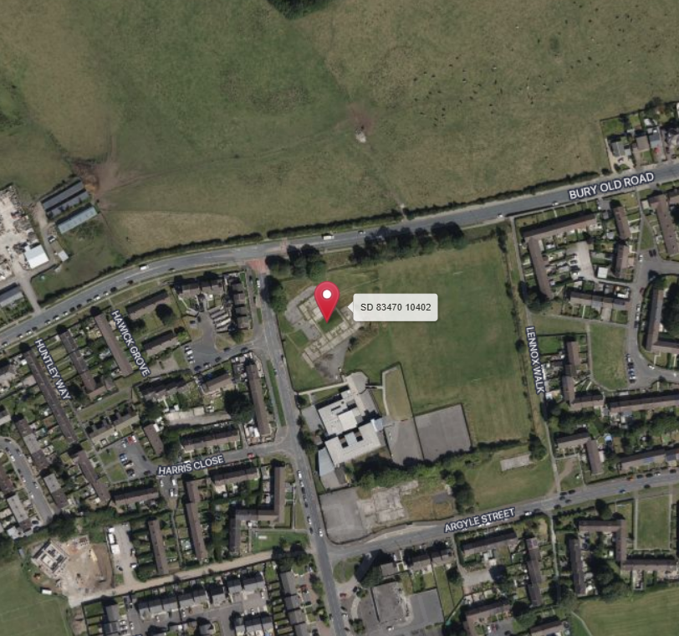  screenshot extracted from: https://gridreferencefinder.com/ on 19th June 2024
Zone of Influence | The term Zone of Influence is used to describe the geographic extent of potential impacts of a proposed development. The Zone of Influence is determined by the nature of the development and also in relation to designated sites, habitats or species which might be affected by the proposals.  For this site, the Zone of Influence is considered to be land on and immediately surrounding the site due to the urban context and commercial developments surrounding the site. In relation to great crested newts, the Zone of Influence was extended to 250 m from the site boundary to identify any water bodies which this species could use for breeding.

Methodology
Desk Study | The ecological records obtained as part of this assessment within a 2 km radius of the site were analysed, using online records. The analysis of data requests was limited to records for protected species recorded within the last ten years and sites of nature conservation interest within 2 km of the site. This included a review of existing statutory sites of nature conservation interest, such as Sites of Special Scientific Interest (SSSIs), Special Protection Areas (SPAs), Special Area of Conservation (SACs) and National Nature Reserves (NNRs).  A 1:25,000 OS map was used to identify nearby features such as ponds or green corridors that could provide habitat or connectivity to other areas.  Natural England’s bat and great crested newt granted European Protected Species Licence (EPSL) return data.
Habitat Survey | A habitat survey based on UK Habitat Classification methodology whereby habitat types present were noted and mapped, together with an assessment of the general ‘ecological value’ of each habitat. A detailed species list was compiled for each habitat type, and from this, the botanical composition of the site was classified into areas of similar community types. Species identification is based on the Botanical Society for the British Isles (BSBI) Checklist.  Two areas are proposed, area A to the north west and area B to the south east, refer to plans for two areas.
Metric Principles | The statutory Biodiversity Metric User Guide (Defra, 2024) was used as guidance on how to use the statutory biodiversity metric calculator tool.
Biodiversity Units | The biodiversity metric tool was used to calculate the change in biodiversity units and the overall percentage of gain / loss and should be read in conjunction with this report.  Pre-development baseline habitats were calculated using measurements from the baseline habitat plan (as detailed within this document). Post-development habitats and areas were calculated and based on the proposed site layout plan provided by the client at the time of this assessment.
Condition Assessment | Each habitat was assigned a condition using the statutory biodiversity metric condition assessments Excel spreadsheet. Habitat parcels have been assessed individually; however, where habitats have scored the same condition, the areas have been combined in the biodiversity metric tool i.e. all areas of hard standing and buildings.
Strategic Significance | The strategic significance of the habitats was assessed by determining if the habitats are identified within published plans, strategies or policies which are relevant to the habitats location.
Trading Rules | The biodiversity metric tool sets minimum habitat creation and enhancement requirements to compensate for specific habitat losses (up to the point of no net loss). These requirements are based on habitat type and distinctiveness.
Protected Species Assessment | A protected species scoping survey was carried out in conjunction with the habitat survey. The site was assessed for its suitability to support protected species, in particular bats, birds, great crested newt Triturus cristatus, otters Lutra lutra, reptiles, badgers Meles meles, and other species of conservation importance that could pose a planning constraint.
Daytime Bat Assessment | The built structure and trees on the site which may be affected by the proposed works were visually inspected and potentially suitable entry / exit points for bats such as holes and crevices were noted together with any evidence of bat presence such as droppings or feeding remains.  Following standard best practice methodology (Reason, P.F. and Wray, S. (2023). UK Bat Mitigation Guidelines: a guide to impact assessment, mitigation and compensation for developments affecting bats), each building which is to be affected by works, was classified either as confirmed roost, high, medium, low or negligible potential, which informs the need for and survey effort of any nocturnal surveys required.
Impact Assessment | The ecological impact assessment is based on the standard best practice methodology provided by the Guidelines for Ecological Impact Assessment (CIEEM, 2018). The assessment identifies important sites, habitats, species and other ecological features that are of conservation value based on factors such as legal protection, statutory or local site designations such as SSSI or Local Wildlife Sites (LWS) or inclusion on Red Data Book Lists or Local Biodiversity Action Plans. The importance of an ecological feature is considered within a defined geographical context. The following frame of reference is used, or adapted to suit local circumstances:  - International and European  - National (England)  - Regional (North West of England)  - County (Lancashire)  - District (Rochdale)  - Local (Heywood)  - Below Local Level: Site Level Only.  Consideration of impacts at all scales is important, and essential if objectives for no net loss of biodiversity and maintenance of healthy ecosystems are to be achieved. In identifying impacts, the review considers the Client’s Site proposals and any subsequent recommendations made are proportionate / appropriate to the site and have considered the Mitigation Hierarchy as identified below:  - Avoid: Provide advice on how the development may proceed by avoiding impacts to any species or sites by either consideration of site design or identification of an alternative option.  - Mitigate: Where avoidance cannot be implemented mitigation proposals are put forward to minimise impacts to species or sites as a result of the proposals. Mitigation put forward is proportionate to the site.  - Compensate: Where avoidance cannot be achieved any mitigation strategy will consider the requirements for site compensatory measures.  - Enhance: The assessment refers to planning policy guidance (e.g. NPPF) to relate the ecological value of the site and identify appropriate and proportionate ecological enhancement in line with both national and local policy.  Effects are considered significant at the range of scales from international to local. A significant effect is an effect that is sufficiently important to require assessment and reporting so that the ecological consequences of the project are understood. In broad terms, significant effects encompass impacts on the structure and function of defined sites, habitats or ecosystems and the conservation status of habitats and species (including extent, abundance and distribution).
Surveyor | The surveys and assessments have been overseen, led and verified by full members of CIEEM who are bound by its code of professional conduct. All surveys and assessments have been undertaken with reference to the recommendations given in British Standard BS 42020, and as stated within specialist guidance, as appropriate, and are referenced separately. On-site surveys and report have been undertaken by:  Lizi Pimlott BSc (Hons) MSc MCIEEM who has been an ecologist for 11 years, and who also holds Natural England survey licences for bats (class 2), great crested newts (class 2), hazel dormice (class 1) and barn owl.  The report has been reviewed by:  Ceridwyn Adkins BSc (Hons), MCIEEM who has been an ecologist for 16 years, and who also holds Natural England survey licences for bats and great crested newts (Level 2).  Due to the sensitive nature of the licence numbers, these can be supplied separately and should not be available in the public domain.
Survey Date & Weather | 19th June 2024. 14℃, 1mph wind, 67% humidity, no precipitation, scattered cloud clover.

Limitations
Desk Study Records | A biological records data search has not been undertaken. However, given the location of the site, the nature of the habitats present, and the assessed suitability of the site for protected or notable species, it is not anticipated that the purchase of biological records data will add any significant weight or alter the conclusions and recommendations outlined in this report.
Habitat Survey | Ecological surveys are limited by factors that affect the presence of plants and animals such as time of year, weather, migration patterns and behaviour. The surveys were undertaken in June and therefore represent a valid sample of ecological evidence present during that season. The report is not designed, nor is it required to present a complete inventory of flora and fauna or NVC surveys. The survey team comprised suitably qualified ecologist(s) with good plant identification skills, these ecologists were not skilled in bryophyte or fungal identification; therefore, these elements were not included within the habitat survey.  Whilst the majority of the site was examined at the macro scale, many species will have been overlooked at the micro level because it is not the purpose of a habitat survey to classify all taxa occurring in the site and due to the proposed works.  The ecological walk-over surveys have not tried to produce a comprehensive list of plants and animals, as any ecological survey will be limited by factors such as the time of year, migration patterns and behaviour that affect the presence of plants and animals. Consequently, a complete list of plants and animals resulting from the ecological surveys undertaken at the site have not been produced, however, the absence of evidence of any particular species should not be taken as conclusive proof that the species is not present or that it will not be present in the future.  The list of invasive plant species included on Schedule 9 of the Wildlife and Countryside Act 1981 (as amended) is extensive and these plants are found in a range of different habitats, including aquatic habitats. The ecology surveys checked, in particular, for the presence of Japanese knotweed Reynoutria japonica syn. Fallopia japonica, giant hogweed Heracleum mantegazzianum, Himalayan balsam Impatiens glandulifera and Cotoneaster species. However, there may be other invasive plant species present within the site which were not recorded, but it is considered that this survey is sufficient to identify any significant constraints posed by invasive plants.
Calculator | Defra intends to make improvements to the statutory biodiversity metric calculator tool over time. Accordingly, the calculations made in this assessment may require updates to align with any future changes to the metric and best practice standards.
Metric | The metric details ‘ha’ should be to two decimal places, which therefore could remove habitats from the calculation. In addition, the calculation spreadsheet can produce errors with scattered trees as it can double count them.
Valid | The results and recommendations within this report are valid for up to two years from the date of survey, assuming there are no significant changes to the site or its immediate surroundings.

Desk Study Results (2 km)
Statutory Protected Sites | - No statutory protected sites or SSSI Impact Risk Zones were identified within 2km.
Priority Habitats | - Priority habitats:  - Deciduous woodland- 320m north  - Open mosaic habitat on previously developed land - 640m east  None of these habitats are present on site nor are there any green linkages from the site to priority habitats. Therefore, these habitats are not considered further.
Granted EPSL(s) | - EPSM2010-2617: common pipistrelle 2011-2012 - 215m south west
Magic Map | 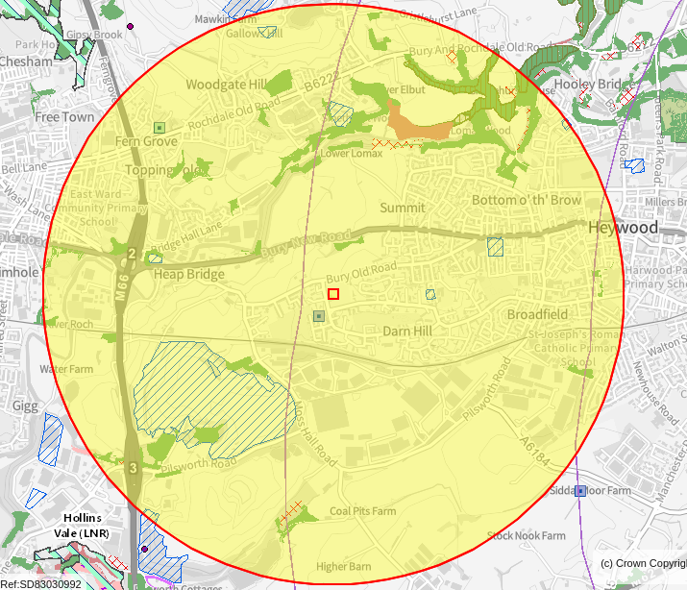  https://magic.defra.gov.uk/MagicMap.aspx accessed on 14th June 2024

Baseline Field Survey Results
Confirmed Presence CP  Potentially Present PP  Unlikely Presence UP  No Possibility NP | Code | Consider Further | Risk to Project (H/ M/L/N) | Reason/Notes  (e.g. field signs present or desk study revealed presence  in area and/or suitable habitat present)
Habitats | CP | N | N | - u1b 81 developed land sealed surface with ephemeral vegetation  - u1b5 building  - h3d bramble scrub  - g3c 10 521 unmanaged other neutral grassland with scattered scrub  - g3c 106 mown other neutral grassland  - g3c 32 scattered trees
Target Notes | CP | N | L | TN1:  A fox Vulpes vulpes den is present adjacent to the east site boundary. It has a single west facing entrance which is oval in shape and the tunnel extends into the west facing embankment adjacent to the site boundary (i.e., away from the site). Fresh, sandy spoil was present around the entrance and fox prints were observed as well as a strong smell of fox. Two adult foxes were observed within the grassland during the survey.
Biological Important Hedgerow | NP | N | N | None present on or adjacent to the site.
S41 (only) Habitats | NP | N | N | None present on or adjacent to the site.
Trees on, or within 15m of site | CP | N | M | 12 trees are present on the site, all comprising Malus sp, Sorbus sp, sycamore Acer pseudoplatanus, lime Tilia sp species and ash Fraxinus excelsior.  Nine of the trees are greater than 30cm and less than or equal to 60cm diameter at breast height and therefore are classified as medium sized trees.  Three of the trees are less than 30cm diameter at breast height and therefore are classified as small sized trees.  Further offsite trees are present within 15m of the site, to the northeast adjacent to Bury Old Road.
Protected Plants (WCA Sch.8, CHSR Sch.5) | NP | N | N | None present.
Invasive Plants | NP | N | N | None present.
Great Crested Newts | NP | N | N | No ponds were present on site or within 250m of proposed development. Therefore, are not considered further in this report.
Bats | PP | N | L | Building concluded as negligible potential. Trees were age and structure for bats but no features were identified at ground level. The trees in the north of the site may provide limited foraging and commuting opportunities, however lighting is present along Bury Old Road which may reduce suitability. The remainder of the site is largely unsuitable for bats.
Badgers | NP | N | N | No evidence present, no setts present on site or within 30m. Therefore, are not considered further in this report.
Reptiles | NP | N | N | Limited suitability of site due to lack of structural diversity and regular disturbance, the site is isolated within surrounding urban development. Therefore, are not considered further in this report.
Riparian species | NP | N | N | No suitable habitats present on site. Therefore, are not considered further in this report.
Nesting Birds | PP | N | L | No nesting behaviour was noted at the time of the survey but birds could nest in the trees and bramble scrub on the site.
Other Species | PP | N | L | The unmanaged grassland could support foraging hedgehog Erinaceus europaeus and the bramble scrub could provide opportunities for refuge.

BNG Results
Summary | The site is not allocated for nature conservation under local planning policy, nor is the site subject to any statutory or non-statutory nature conservation designations. Therefore, all habitats were assessed as having a Low Strategic Significance.  The current proposals result in the loss of 0.2 ha developed land, sealed surface, 0.438 ha neutral grassland, 0.002 ha bramble scrub and 12 trees.  New habitat creation will include 0.393 ha developed land, sealed surface comprising houses, parking spaces and an access road,0.187 ha vegetated garden, 0.04 ha other neutral grassland, 0.008 modified grassland and the planting of 42 trees in total - 27 small sized trees in public open space (POS) and 15 trees in residential gardens (these 15 trees have not been included in the calculation).
Developed Land Sealed Surface | The site comprises hardstanding which is the foundation of a building which was demolished over 10 years ago. A small brick outbuilding is present on the west site boundary, adjacent to Sutherland Road, which appears to house pipework.  Total area: 0.2 ha
Bramble Scrub | A small parcel of bramble scrub is present in the north of the site, adjacent to the fence line demarcating the boundary of the school.  Total: 0.002ha. This area is below ‘de minimis exemption’’ and therefore not included in the calculator.
Other Neutral Grassland | Area A and area B both contain several parcels of other neutral grassland. Three of these parcels appear to be routinely mown to a sward height of approximately 10cm. The remaining areas appear to be unmanaged with a sward height varying between approximately 10-50cm. Scattered scrub was present in places but this provided sparse cover.  Species list and abundance*:  - Yorkshire fog (D)  - Red fescue (A)  - Sweet vernal grass (F)  - False oat grass (O)  - Rough meadow grass (O)  - Creeping bent (O)  - Creeping buttercup (O)  - Meadow buttercup (O)  - Common sorrel (O)  - Lesser trefoil (O)  - Horsetail species (O)  - Yarrow (O)  - Oxeye daisy (O)  - Red campion (O)  - Cleavers (O)  - Cock’s foot (R)  - Hedge woundwort (R)  - Cranesbill species (R)  - Wood avens (R)  - Nettle (R)  - Daisy (R)  - Perennial ryegrass (R)  - Common ragwort (R)  - Ribwort plantain (R)  - Common mouse-ear (R)  - Dandelion species (R)  - Vetch species (R)  - Wild strawberry (R)  - Broad-leaved dock (R)  - Red clover (R)  - White clover (R)  - Great willowherb (R)  - Rosebay willowherb (R)  Scattered scrub species included rare willow species, bramble, dog rose and self-seeded ash saplings.  Total area: 0.321 ha  Condition assessment: Moderate - passes 3 criteria including essential criterion A and criteria D and E. Fails criterion B due to limited variation in sward height and none of the grassland was shorter than 10cm. Fails criterion C due to a lack of bare ground. Fails criterion F as the maximum species count within the square metre samples was eight.
Trees | 12 trees are present on the site, all comprising whitebeam species, sycamore, lime species, apple and ash.  Nine of the trees are greater than 30cm and less than or equal to 60cm diameter at breast height and therefore are classified as medium sized trees.  Three of the trees are less than 30cm diameter at breast height and therefore are classified as small sized trees.  Total area: 0.159 ha  See Tree Helper Tool in Statutory Biodiversity Metric.  Condition assessment: Moderate - passes 4 criteria. Fails criterion E due to a lack of ecological niches and 41% of trees were native.
Baseline Habitat Impacts | The table below provides a summary of the impacts to the baseline habitats as a result of development. For full details see the associated Statutory Biodiversity Metric.
  Habitat | Condition | Impact of Proposal
  Urban Individual Tree | Moderate | To be lost: 12 trees.  Proposed: 42 trees (27 in POS and 15 in private residential gardens)
  Bramble scrub | N/A | To be lost: 0.002ha. No retained or created habitat proposed. not included in calculation.
  Neutral grassland | Poor | To be lost: 0.438 ha  Proposed: 0.04 ha in POS
  Developed Land/Sealed Surface | N/A | To be lost: 0.2 ha  Proposed: 0.39 ha
  Native hedgerow | Poor | Proposed: 0.14 km in POS
Trading Rules Satisfied | Trading rules are not currently satisfied, as the proposals result in a net loss of neutral grassland, and trees within the site boundary.

Discussion and Recommendations
Desk study | There are no statutory designated sites or priority habitats within the zone of influence and therefore no impacts are anticipated.
Habitat Survey | The majority of habitats on site were generally of limited botanical interest. No protected or priority plant species were observed and all plant species encountered were common, widespread and characteristic of the common habitat types they represent. Parts of the site are subject to regular disturbance.  The proposed development will result in the removal of all habitats from the site. This will be partially compensated by the creation of areas of new neutral grassland, the planting of 32 trees, native and ornamental hedgerows, wildflower meadows along with vegetated gardens are proposed.  There are offsite trees within 15m of the site boundary. It is recommended that these are protected during construction works through the provision of suitable fencing such as Heras fencing. Heras fencing should follow BS standard BS 5837: 2012 Trees in relation to design, demolition and construction.
BNG | The proposals equate to 81.01% net loss. The biodiversity metric tool automatically sets a target of 10% net gain. Based on the current design it is unlikely that the onsite biodiversity value can be maximised further. Redesign to retain additional trees or create further areas of public open space for neutral grassland creation and shrub planting may reduce the overall net loss but is unlikely to result in a net gain onsite.  Therefore a 10% biodiversity net gain must be delivered via offsite means. Based on the current BNG calculations there is a deficit of 3.87 habitat units which must be delivered in order to achieve the 10% net gain target. To satisfy trading rules this must comprise habitats of medium or higher distinctiveness including grassland, shrubs and trees. This could be delivered on offsite land under the client ownership, if available, or via a financial contribution to a third party habitat bank in the locality. If these options are not feasible then purchase of statutory credits may be an option but this should be a last resort.  A 30 year management plan for onsite habitats will be required to secure onsite net gain, once the development proposals and landscaping measures have been finalised.
Daytime Bat Assessment | There is one built structure on the site which appears to house pipework. It is constructed of brick walls with a flat concrete roof. There are no doors or windows and therefore no internal access to the structure. The brick and concrete was intact and sealed. No external features or potential access points were observed on the building and therefore this is assessed to have negligible potential for roosting bats.  None of the trees were found to contain roost features.  The trees in the north of the site may provide limited foraging and commuting opportunities, however lighting is present along Bury Old Road which may reduce suitability. The remainder of the site is largely unsuitable for bats.  As lighting already exists surrounding the site, a lighting strategy is not required. However, any additional lighting, if installed, should aim to reduce light spill via the use of low-level lighting used in conjunction with hoods, cowls, louvres and shields. Lights will also be directional to ensure that light is directed to the intended areas only.  External lighting will be on PIR sensors that are sensitive to large objects only (so that they are not triggered by passing bats) and will be set to the shortest time duration to reduce the amount of time the lights are on. Wall lights and security lights will be ‘dimmable’ and set to the lowest light intensity settings. There are several products on the market that allow the control of the light intensity and the duration that the lights are on. All lighting on the developed site will make use of the most up to date technology available.  The site is unlikely to be of any specific value to bats and is unlikely to support anything other than occasional foraging by the most disturbance resistant bat species.
Nesting Birds | The trees and bramble scrub on the site could support common nesting bird species.  All site clearance and preparations work must consider the presence of bird nests. Vegetation clearance should take place outside the bird nesting season to ensure compliance with the general protection afforded to wild birds under the Wildlife and Countryside Act 1981 (as amended). If this is unavoidable, the vegetation should be carefully checked, by a suitably qualified ecologist, prior to removal. Where active nests are found, working restrictions would be put in place until a follow-up survey can demonstrate that all chicks have fledged.  The site will support a small number of bird territories associated with shrub and tree habitats and displacement of this is inevitable. However, as the site will not support key species the significance of this is low. No further surveys are considered necessary to demonstrate the current baseline in respect of birds.
Protected Species | The site is unsuitable for amphibians, reptiles, badgers and riparian animals due to a lack of suitable habitat and the location of the site, amongst surrounding built development and busy roads.
Other(s) | The site could support hedgehogs. Foxes were observed to be present on the site and whilst this species is not legally protected, they offer protection under the Wild Mammals Act and efforts should be made to minimise the risk of injury or effects.  In order to minimise the risk of harm to hedgehogs and foxes, and other animals passing through the site it is recommended that preventative measures are in place during construction. These precautions are:  - Staged approach to clearance of grassland and scrub, starting with a pre-commencement check before strimming to 30cm and leaving overnight to allow animals such as hedgehog to disperse off site before cutting to ground level. Vegetation clearance must be undertaken in a single direction to avoid isolating animals in islands of uncleared vegetation.  - Mammal ladders (such as a plank) or earth ramps to be placed in any open excavations at the end of each day;  - Cap off any open pipes at the end of each day;  - Cover any open holes, or install mammal ladders or earth ramps in any open excavations at the end of each day to prevent animals from becoming trapped;  - Keep all fuel and other harmful substances in a locked area;  - Ensure any spillages are treated with spill kits; and  - Night work should be avoided where possible, and any flood lighting should face away from the site boundaries.  - If works to the embankment are proposed, in the vicinity of the fox den then this should be undertaken by hand insofar as possible.

Ecological Enhancements
Below is a summary of measures aiming to achieve a minimum habitat enhancement for biodiversity for long-term wildlife benefits on site.
Good horticultural practice should be utilised during the creation of new habitats, including the use of peat-free composts, mulches and soil conditioners, native plants and avoidance of the use of invasive species listed on Schedule 9 of the Wildlife and Countryside Act 1981 (as amended).
Additional enhancements that could easily be met within the development scope include the incorporation of bat boxes, bird boxes and/or bug boxes. Boxes could be placed on new buildings.
Gaps could be created under boundary fencing to allow the free movement of hedgehogs and other small animals through the site.

References
- Botanical Society of the British Isles (2013) Online atlas of the British and Irish Flora. [online] Available at: http://www.brc.ac.uk/plantatlas/index.php?q=title_page.
- British Standards Institute (2013) Biodiversity – Code of Practice for Planning and Development. BS 42020:2013.
- CIEEM (2017) Guidelines for Preliminary Ecological Appraisal, 2nd Edition. Chartered Institute of Ecological and Environmental Management, Winchester.
- CIRIA (2015) Environmental good practice on site guide, 4th Edition. Construction Industry Research and Information Association, London.
- JNCC Report no. 259. Joint Nature Conservation Committee, Peterborough.
- Joint Nature Conservation Committee (2010) Handbook for Phase 1 Habitat Survey: A technique for Environmental Audit. JNCC, Peterborough.
- Stace, C. (2019) New Flora of the British Isles. [4th Edition] C&M Floristics.
- https://magic.defra.gov.uk/MagicMap.aspx accessed on 19th June 2024.

Legislation
Relevant legislation, policy guidance and both Local and National Biodiversity Action Plans (BAPs) are referred to throughout this report where appropriate. Their context and application is explained in the relevant sections of this report. The relevant articles of legislation are:
- The National Planning Policy Framework (NPPF, 2021);
- ODPM Circular 06/2005 (retained as Technical Guidance on NPPF 2019);
- Local planning policies;
- The Conservation of Habitats and Species (amendment) (EU Exit) Regulations 2019;
- The Wildlife and Countryside Act 1981 (as amended);
- Local Biodiversity Action Plan for Greater Manchester.

Existing Site Plans
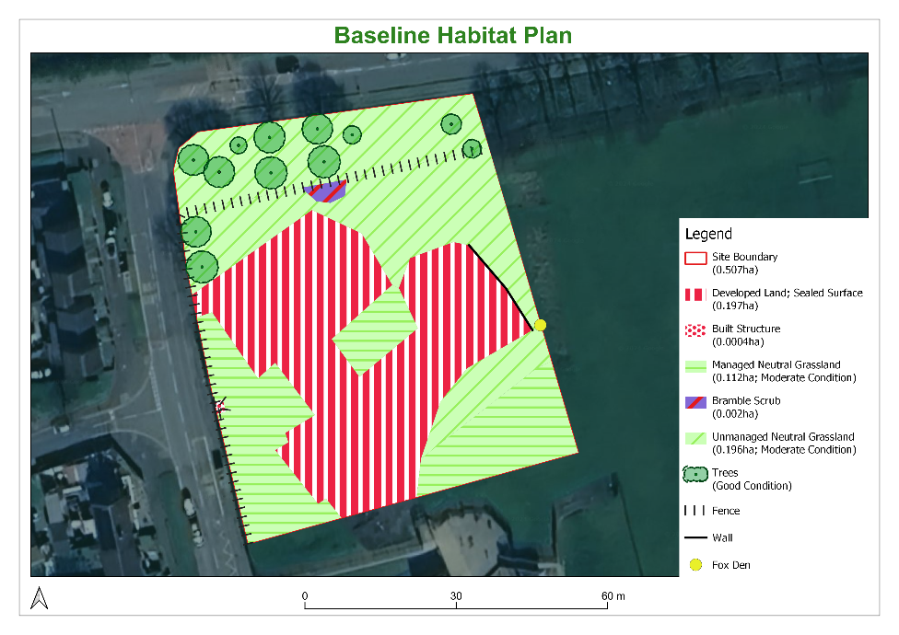
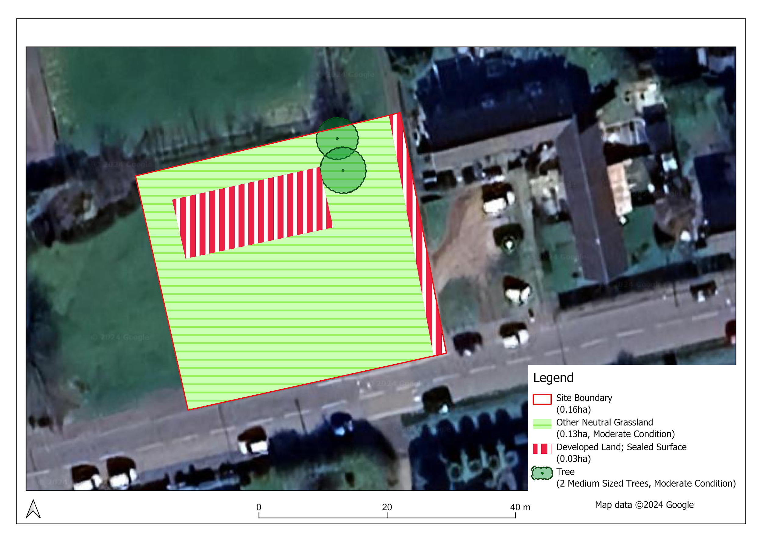

Proposed Site Plans
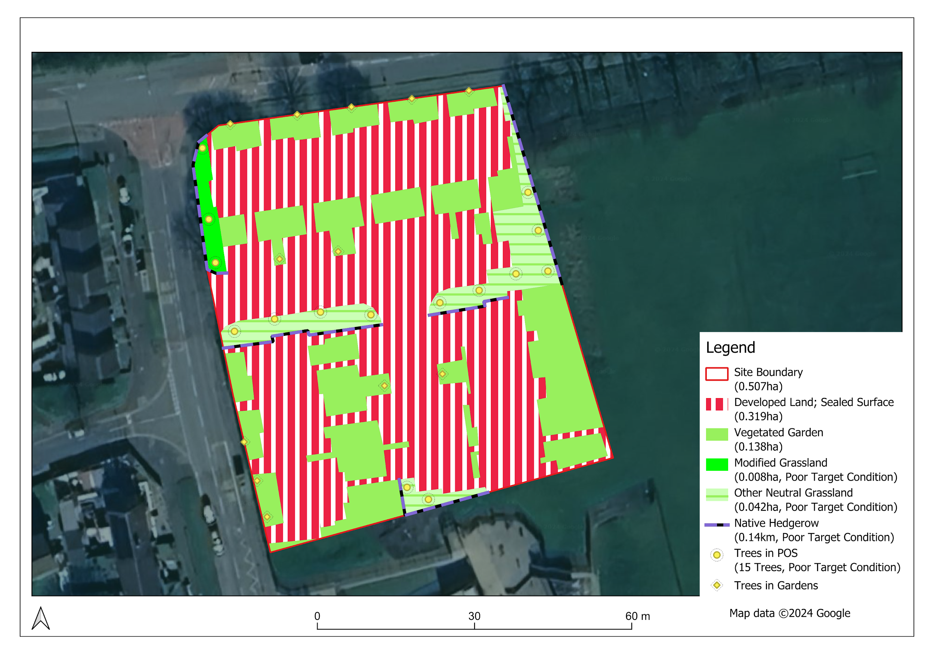

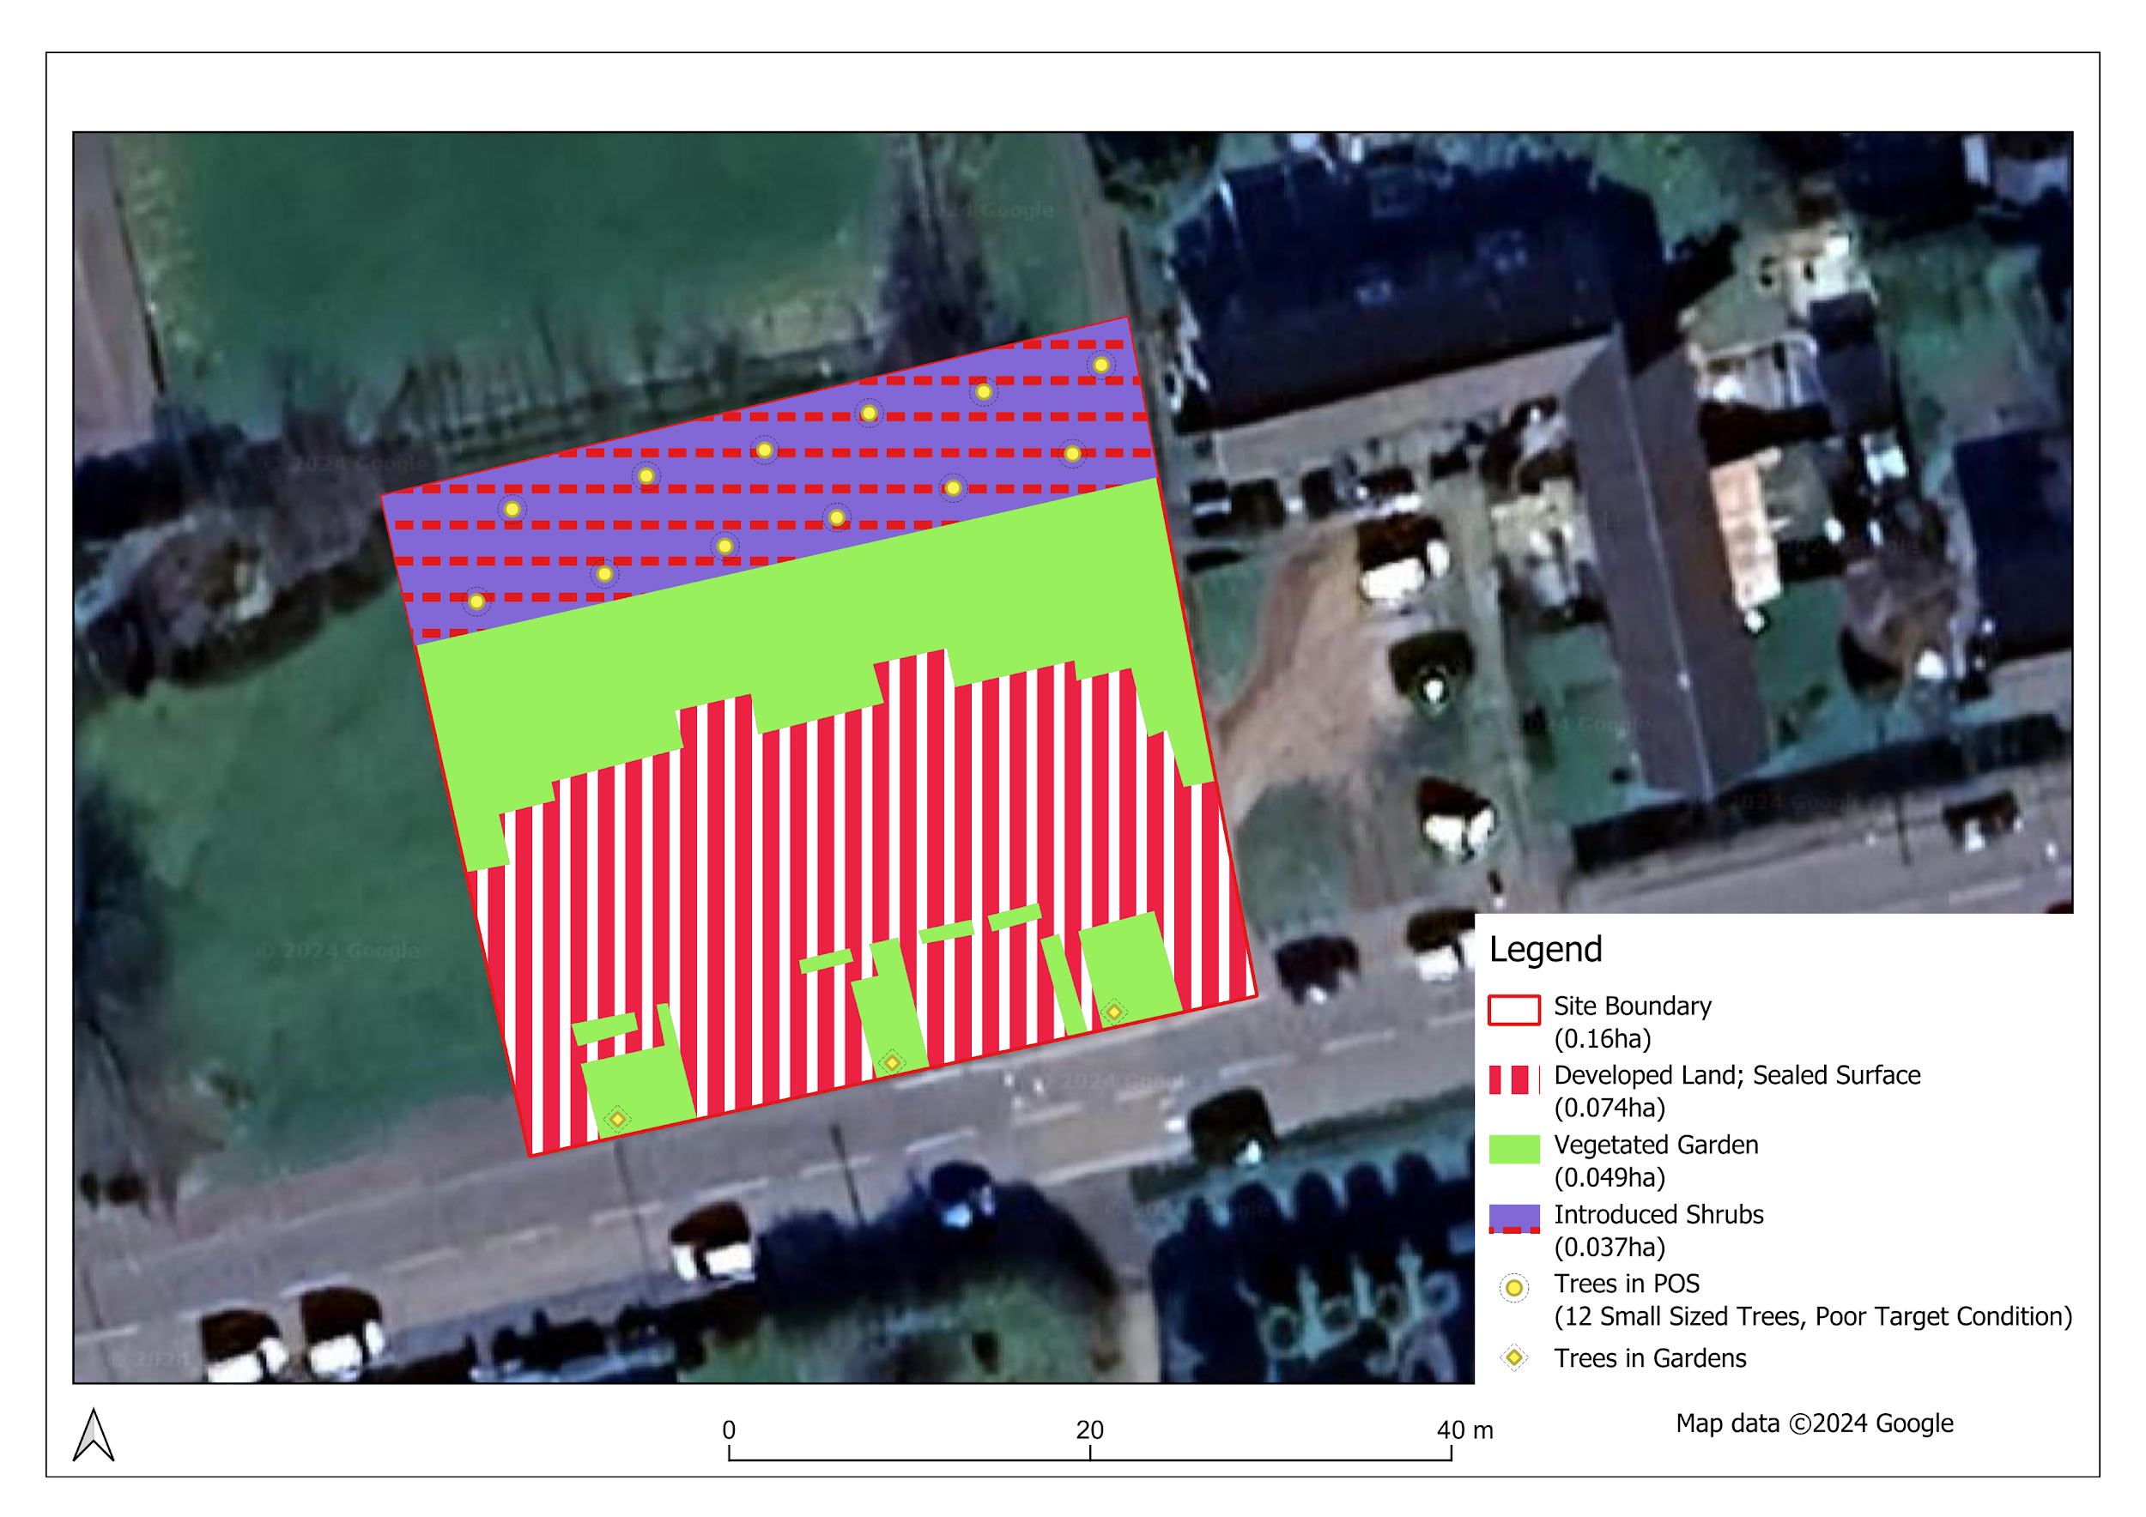

Site Photos
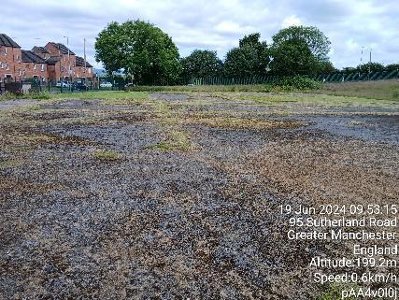  View of site from south boundary, looking north | 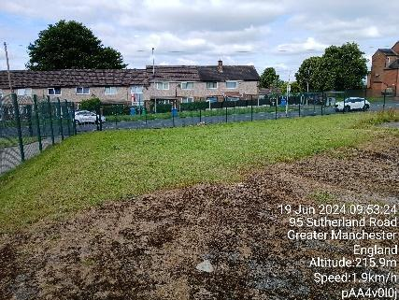  View of southwest corner of the site | 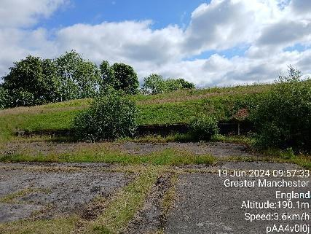  View of east site boundary with adjacent embankment | 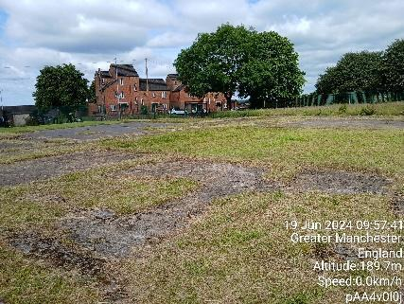  View of site from southeast site boundary, looking northwest | 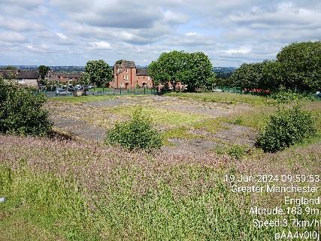  View of site from top of embankment in the southeast, looking northwest
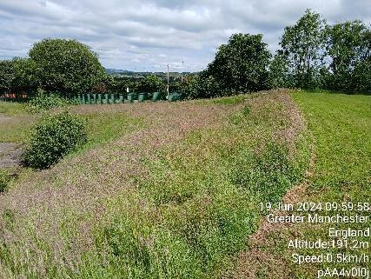  Embankment in the west of the site | 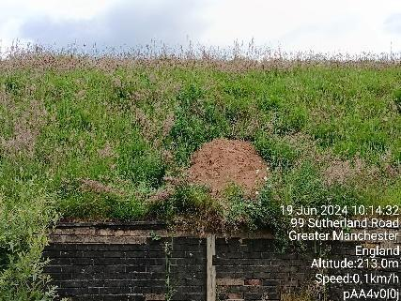  Fox den in embankment | 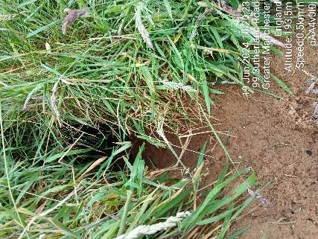  Entrance to fox den | 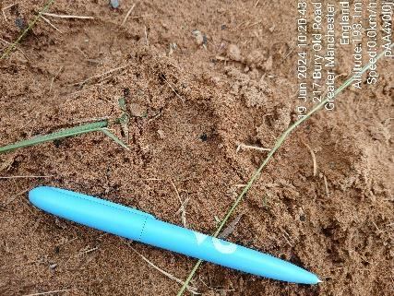  Fox print with pen for scale | 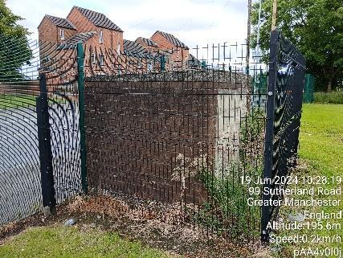  Built structure in the west of the site
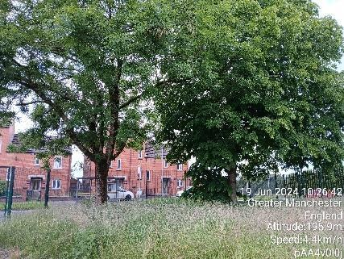  Onsite trees to be retained | 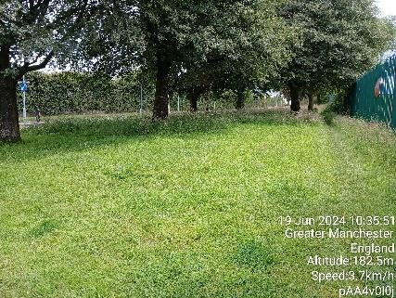  Trees and grassland in the north of the site | 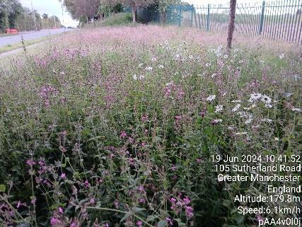  Grassland in the north of the site

Office of the Deputy Prime Minister Circular 06/05: Biodiversity and Geological Conservation - Statutory Obligations and Their Impact Within The Planning System
Butcher, B.,Carey, P., Edmonds, R., Norton, L. and Treweek, J. (2020). The UK Habitat Classification User Manual Version 2.0 & Butcher, B.,Carey, P., Edmonds, R., Norton, L. and Treweek, J. (2020). UK Habitat Classification – Habitat Definitions V2
High: Further surveys required prior to the commencement of works / Medium: Precautionary measures and/or further surveys may be required, particularly if the recommended avoidance or mitigation measures cannot be implemented /Low: A low risk to the project. No further surveys are deemed to be required unless the scope of works differ to those anticipated and described above /Negligible: Negligible foreseeable risk to the project.
Section 41 (S41) of the Natural Environment and Rural Communities (NERC) Act 2006 published lists of habitats and species of principal importance for biodiversity conservation in England (succeeded the UK Biodiversity Action Plan (BAP).
Wildlife & Countryside Act 1981 (as amended)
Conservation of Habitats and Species (Amendment) Regulations 2019
Wildlife & Countryside Act 1981 (as amended) Schedule .9, Injurious weeds (Weeds Act 1959)
Development subject to the de minimis exemption. Development that does not impact a priority habitat and impacts less than 25 square metres (e.g. 5m by 5m) of onsite habitat, or 5 metres of linear habitats such as hedgerows.

