

Top O’th Meadow Farm
Meadowhead Lane
Norden, Rochdale
OL11 5UL
Tel: 01706 658771

27th February 2025

Report for
Adam Sadok
1 Beaumonds
Meadowcroft Lane, Rochdale
OL11 5HN

As requested, please see the completed tree report, as discussed this offers no guarantees as trees are living organisms and can fail at any time. We would also like to advise that no indemnity or insurance cover is offered. This report is in “my opinion” only and covers only the trees that have been inspected.

Trees in question are subject to a Tree preservation order – TPO113

Local authority; Rochdale

Location
Rear of 1 Beaumonds.

TPO Ref: TPO113
- TPO name: Beaumonds, Bury Road, Rochdale
- Date confirmed: 1992-02-06
- Tree type: 12 Sycamore 2 Lime 3 Beech 1 Horse Chestnut 1 holly
- Description: G1
- ID: G1TPO113
- Local authority: Rochdale

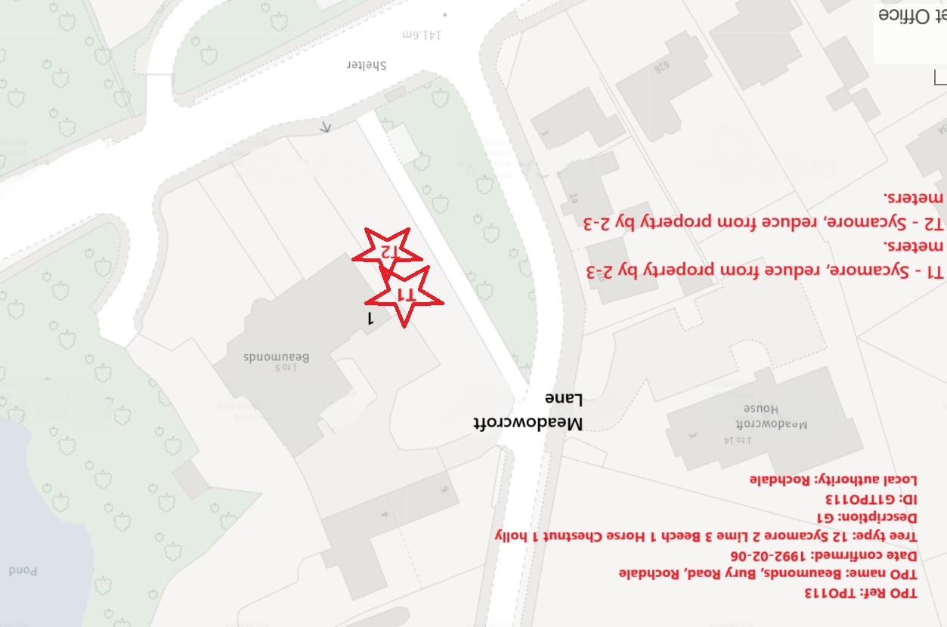

Work provided

Site visit, arboricultural inspection, photography, report, and quotation.
All trees have been thoroughly inspected and only the tree with any defects or concerns have been noted.

Trees included

T1 – Sycamore
T2 - Sycamore

Issues found

T1, T2 – Growing within close proximity of the building and also overhanging the building.

Recommendations

T1 Sycamore, T2 Sycamore – reduce from property by 2-3 meters. Pruning T1 and T2 Sycamore trees away from a property by 2-3 meters to suitable growth points is a prudent practice for several reasons. Firstly, maintaining proper clearance between trees and buildings minimizes the risk of structural damage. By selectively cutting branches back to suitable growth points, the potential for limbs to grow towards structures is reduced, mitigating the threat of branches rubbing against roofs or walls during windy conditions.

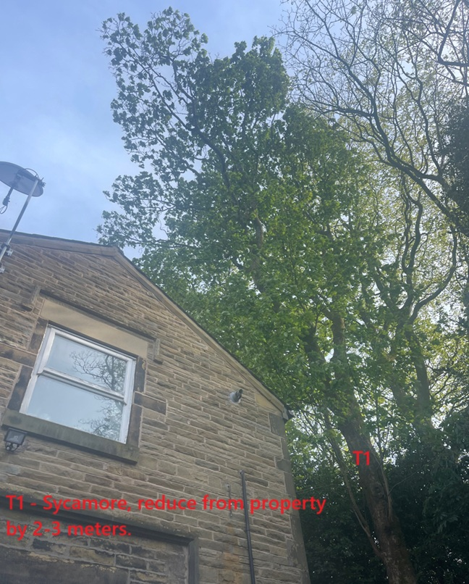
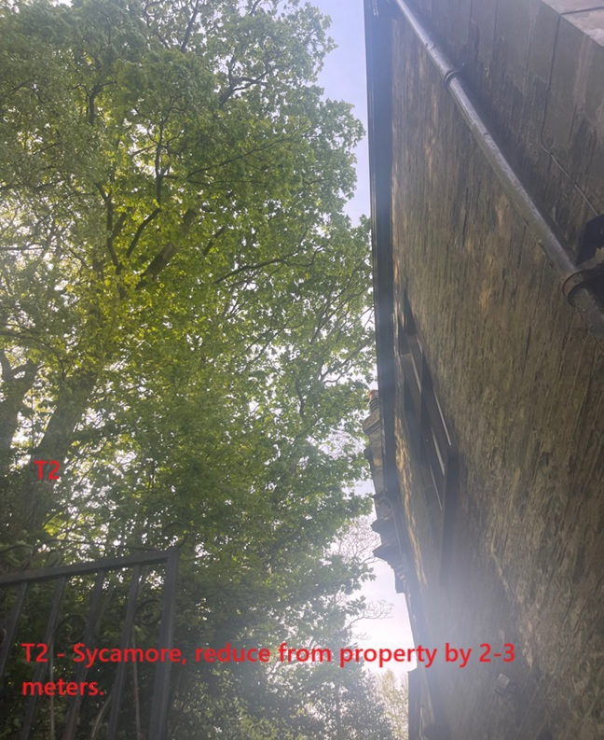

Kind regards,
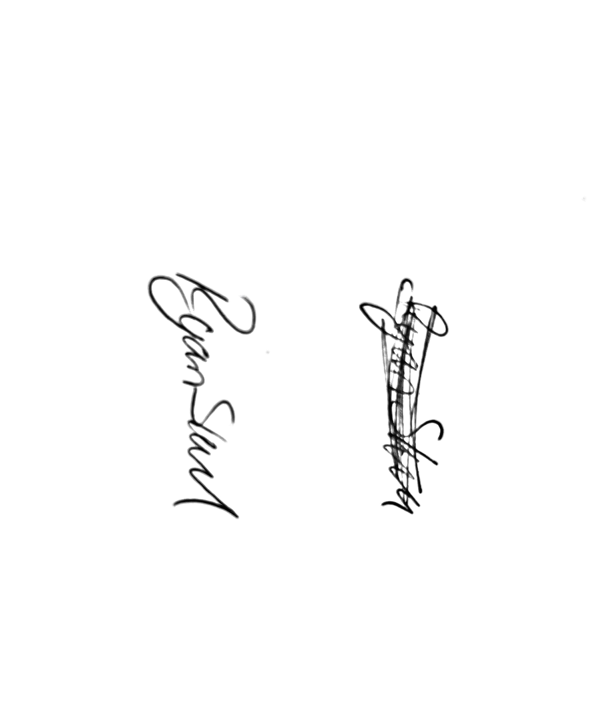
Mr. Ryan Slack
General Manager and Director
SEG Award, Cert Arb L2 (ABC)

