

Top O’th Meadow Farm
Meadowhead Lane
Norden, Rochdale
OL11 5UL
Tel: 01706 658771

17th June 2023

Mrs. Elsie Fletcher
1 Egremont Road
Milnrow, Rochdale
OL16 4EP

As requested, please see the completed tree report, as discussed this offers no guarantees as trees are living organisms and can fail at any time. We would also like to advise that no indemnity or insurance cover is offered. This report is in “my opinion” only and covers only the trees that have been inspected.

Tree in question are subject to a Tree preservation order TPO 187

TPO Ref: TPO187
TPO name: Land at Harbour Lane, Milnrow.
Date confirmed: 2000-04-06
Tree type: Ash
Description: T3
ID: T3TPO187
Local authority: Rochdale

Location

Rear garden of 1 Egremont Road.
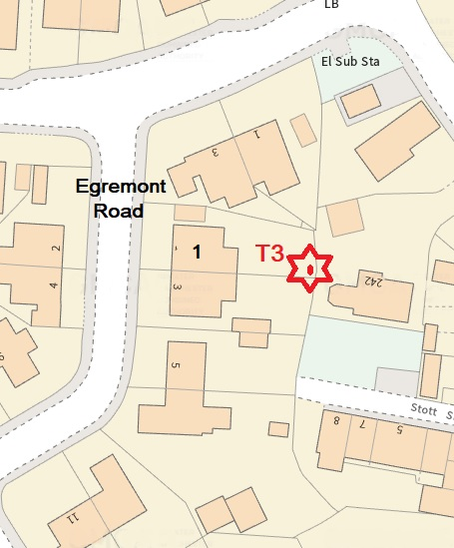
Work done

Site visit, arboricultural inspection, photography and report.

Trees in question

T3 Ash

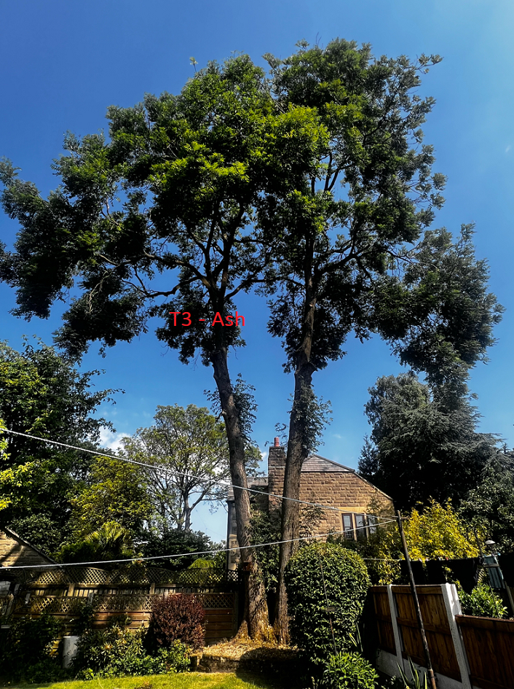

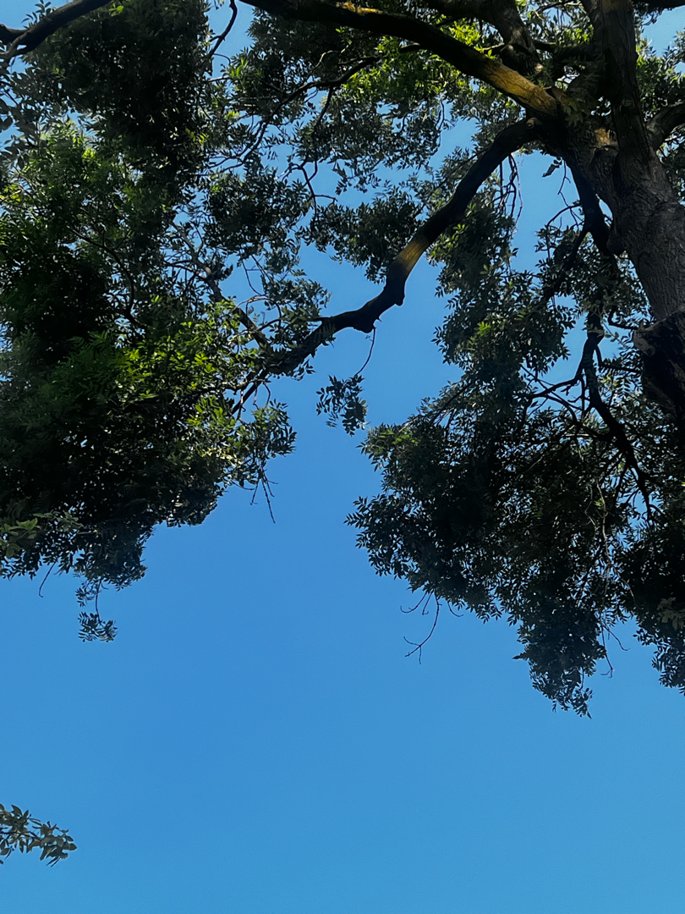

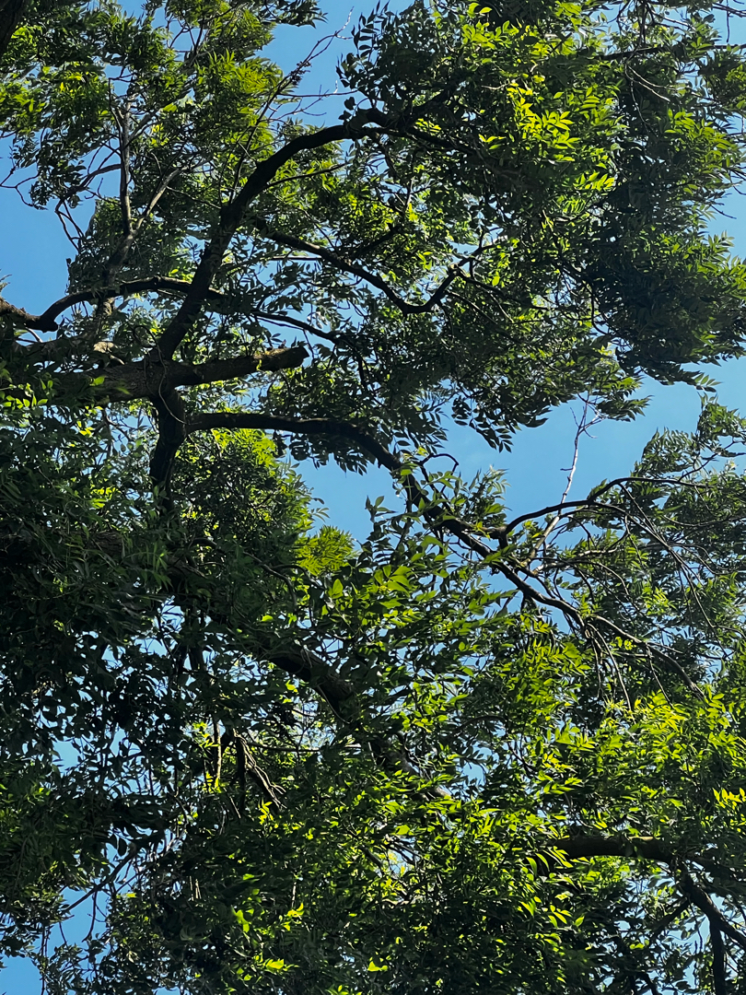

Problem

- The tree is causing excessive twig/branch dropping into 1 Egremont Road and to the two gardens immediately next to it.
- The tree is now showing signs of the Ash die back disease and Mrs Fletcher who is an elderly lady has been collecting twigs and branches weekly for the majority of this year.
- The residents are suffering anxiety over fears the tree will blow over or a larger limb would fail.

Recommendation

I strongly recommend the removal of T3 (Ash) due to succumbing to the Ash die back disease. Unfortunately, there is no known cure for the disease and the trees health will begin to diminish more in the future. There is no vehicle or mewp access to this tree and currently the tree in question is still safe to climb and dismantle minimising damaging to property, larger expenses to remove and risk of arborists climbing to dismantle.
Mrs Fletcher also agrees to replant three new trees if permission is granted for the removal.

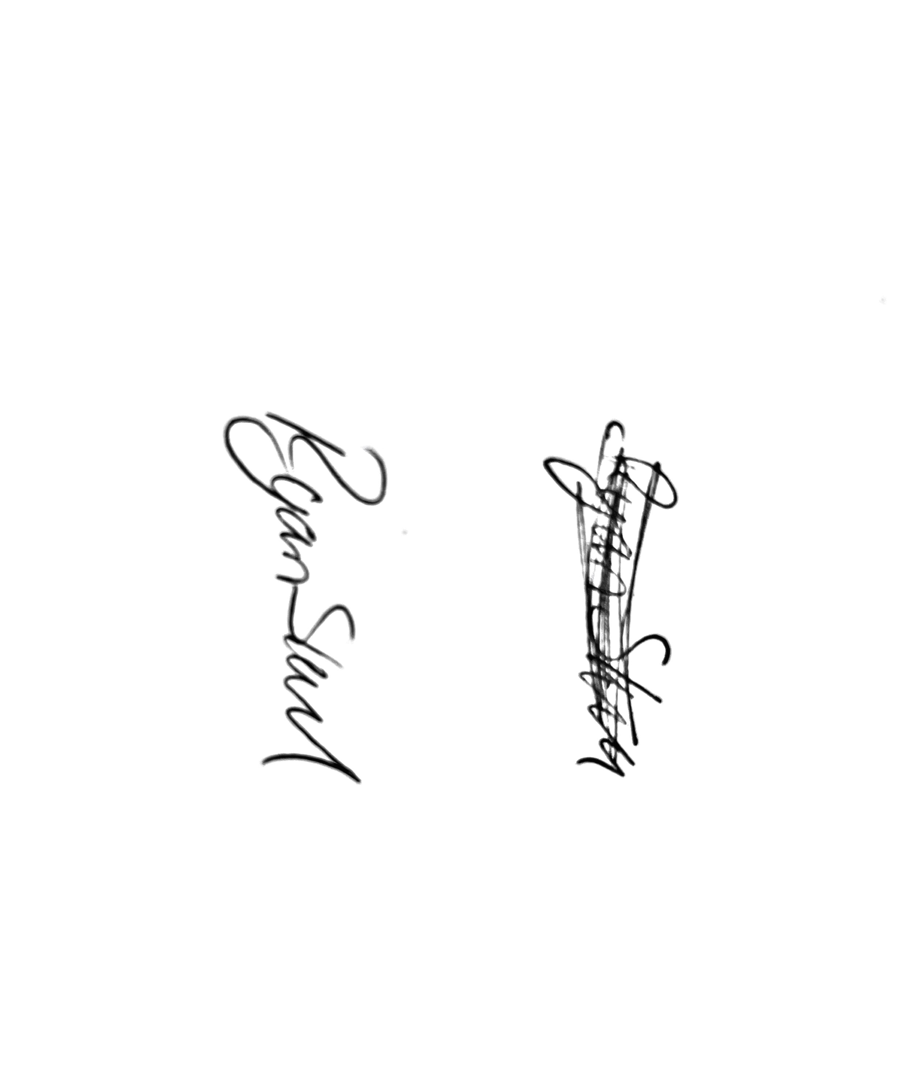
Kind regards,

Mr. Ryan Slack
General Manager and Director
SEG Award, Cert Arb L2 (ABC)

