

ROCHDALE SACRED HEART FOOTBALL CLUB
Michael Stewart Club Secretary Report

Response to Sport England.
Thank you for your recent document regarding our application for planning permission. We fully appreciate your response and understand the rationale for your objection, but we request that you reconsider after we fully explain the club’s vision for future growth, improvement and hopefully alleviate your two main points of concern.
We have recently put together a six-year growth plan for both the club and facilities as we look to not only expand our accessibility to football within our local community but improve the clubs’ standards to be able to play at a higher level with promotion to step 6 the priority.
We are at present a one-star FA accredited club with the aim of achieving full three-star accreditation soon. To achieve this, we need the right structure within our club which is something we are currently working towards. We are dedicated to building a structure that can sustain both growth and accessibility over the coming years and one that has all the correct training in place.

I have listed the football development plan below:
Year 1 - 2025-26 SEASON |  |  |  |  | Year 2 - 2026-27 SEASON |  |  |  |  |  | Year 3 - 2027-28 SEASON
THREE TEAMS |  |  |  |  | SIX TEAMS |  |  |  |  |  | EIGTH TEAMS
MALE | FEMALE |  | YOUTH |  | MALE |  | FEMALE |  | YOUTH |  | MALE |  | FEMALE |  | YOUTH
First  Reserve |  |  | U15 |  | First  Reserve |  | Adult |  | U14  U15  U16 |  | First  Reserve |  | Adult  U16 |  | U13  U14  U15  U16
Year 4 - 2028-29 SEASON |  |  |  |  |  | Year 5 - 2029-30 SEASON |  |  |  |  |  | Year 6 - 2030-31 SEASON
THIRTEEN TEAMS |  |  |  |  |  | SIXTEEN TEAMS |  |  |  |  |  | NINETEEN TEAMS
MALE |  | FEMALE |  | YOUTH |  | MALE |  | FEMALE |  | YOUTH |  | MALE |  | FEMALE |  | YOUTH
First  Reserve  Development  Sunday |  | Adult  U16  U15 |  | U11  U12  U13  U14  U15  U16 |  | First  Reserve  Development  Sunday |  | Adult  U16  U14  U12 |  | U9  U10  U11  U12  U13  U14  U15  U16 |  | First  Reserve  Development  Sunday |  | Adult  U16  U14  U12  U10 |  | U7  U8  U9  U10  U11  U12  U13  U14  U15  U16

To run alongside the football development plan, we have a club development plan that again is set over six year with the end goal of achieving not only better facilities for all our teams but to achieve the correct standard to facilitate our first team playing at step six. To achieve this, we must meet the right criteria in terms of our facilities which we currently do not. I’ve attached the basic outline of the requirements we need to meet to be accepted to play at step six.

REQUIRMENT | STANDARD
Standing Capacity | No Minimum Standard
Dugouts | Minimum for 8 people
Public Address System | Not Needed
Turnstiles | Minimum of one
Hardstanding | Minimum Two Sides
Covered Stand | Minimum Capacity 100 People (50 of which can be below)
Seating | Minimum Capacity 50 People
Press Seating | Not Needed
Floodlights | Yes, Required Minimum of 200 LUX
Spectator Toilets | Male: 2 x Urinals 1 x WC  Female: 2 x WC
Players Changing Rooms | 12SQM  4 x Showers  1 x WC
Officials Changing Rooms | 4 SQM  1 x Shower  1 x WC
Medical Room | Stretcher Only

The main issues we have is with the Hard standing on two sides, The Floodlighting, The covered stand/seating and the turnstiles. These are the biggest cost and although we fully intend to look for funding we are also aware that this along will not fully cover the cost.
The sale of the land will fully go towards the improvement and construction on the above facilities. Without this extra injection of money we do not believe we would be able to solely fund these projects by grants alone.
We also believe that having a team playing at step six initially will benefit the club and give us greater opportunity to expand our accessibility to the community to play football as we grow our Youth, Female and adult teams.
I have put together three reports that will hopefully alleviate your concerns they are
- The land and its issues.
- The Clubs future Requirements.
- Ball strike assessment.
We have also contacted and worked with the following people to request in the first instance their opinions on the application but also their support in our plans and vision for the future.
- Manchester Football League Limited
- The Lancashire FA
- Rochdale Council
- Paul Waugh MP for Rochdale
We would be grateful if you would take the time to read their comments of support for our application.

INSERT EMAILS OR LETTERS OF SUPPORT

- The Land and its current Issues
The land we are looking at gaining planning permission is currently an unused piece of waste land elevated above the current playing field and is very uneven and not suitable for us to use as a sporting facility. In separating this land from the club, it will not affect our ability to satisfy the requirements for step 6 football. Adjacent to this land we have a large piece of flat land that we intend to develop for a new covered stand with seating and incorporate a training pitch.
Our pitch is currently being used by our male senior first and reserve teams.
Our ground is less than 70m away from Firgrove playing fields and our club house is 400m away from the changing rooms on Firgrove playing fields. Our under 14s currently use Firgrove and it is where we intend to base all our youth teams and female teams in the future.
Please see the below photos of the land.

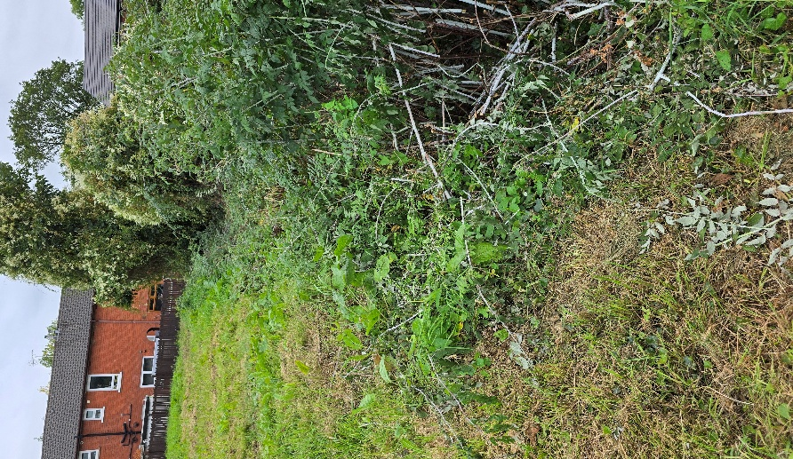
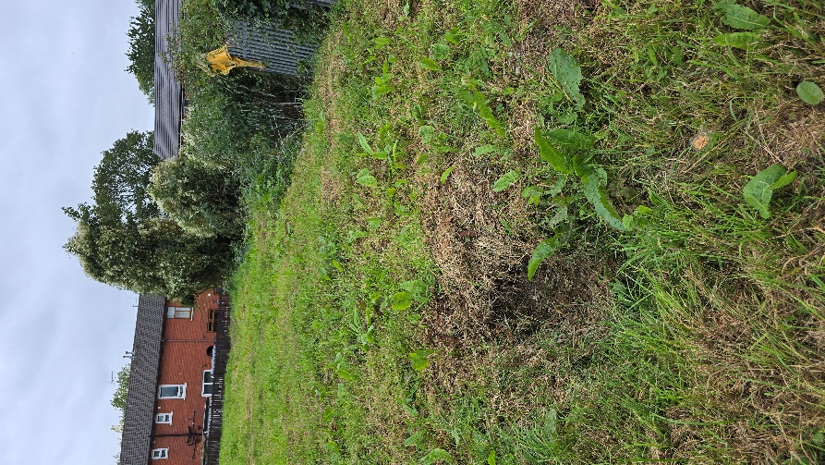
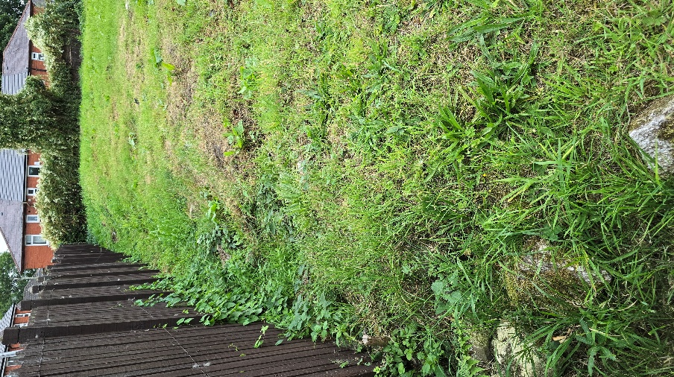
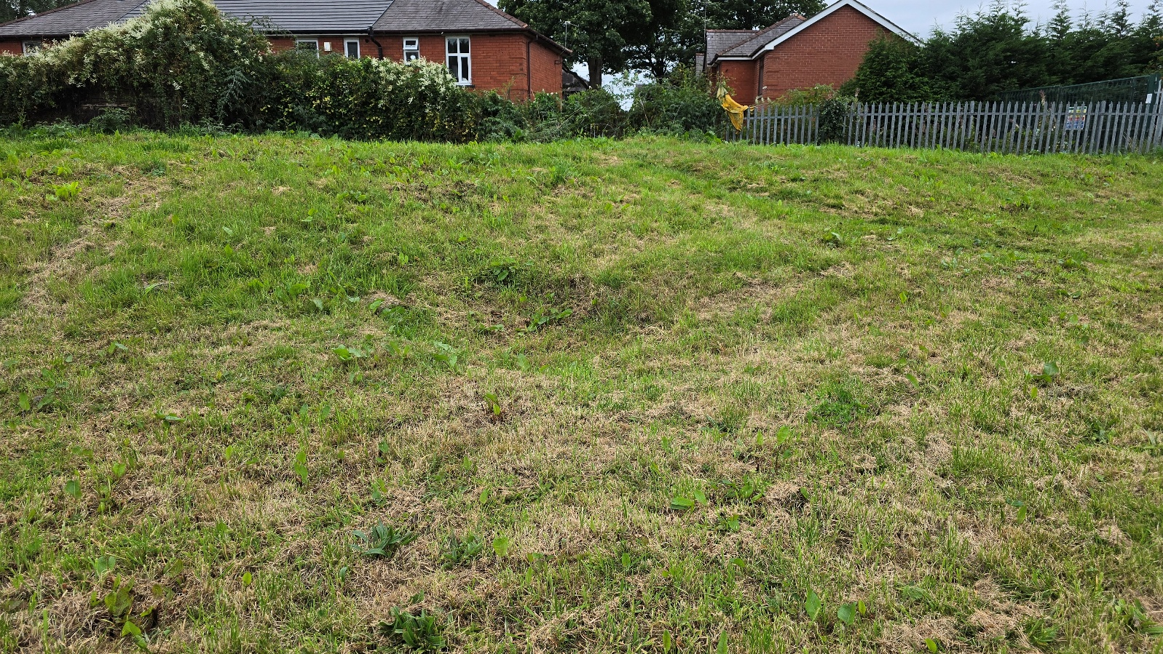

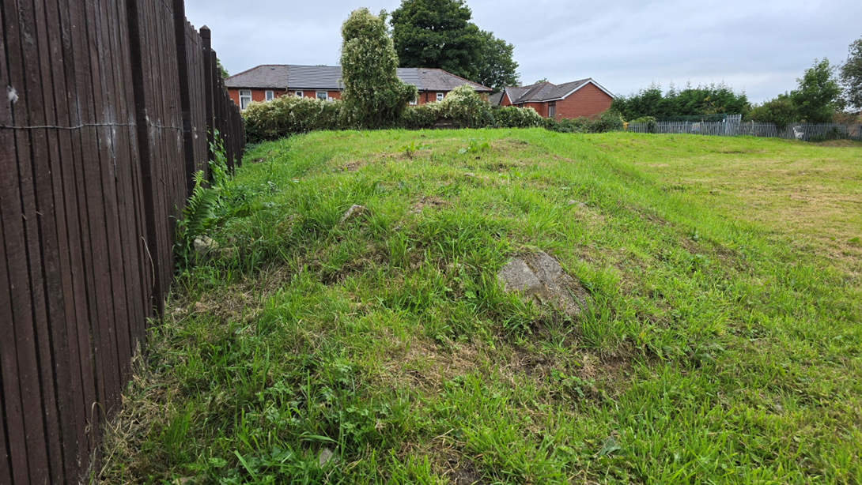

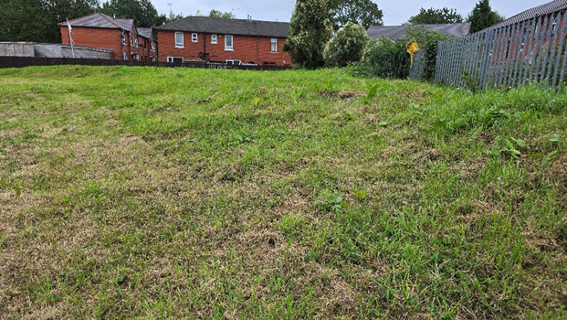

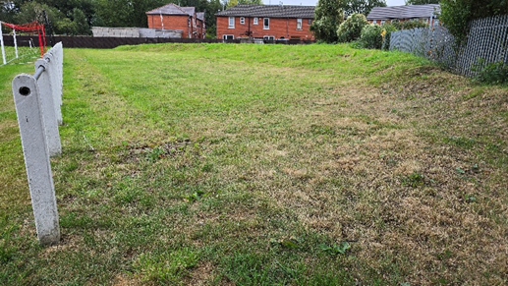

The land is a raised plateau of rough and uneven ground with a ditch running around the back and sides.
Large brambles and weeds overgrow the surrounding edges.
This is a consequence of us levelling the ground at the side of the pitch to enable supporters to stand and is the waste product of that piece of work.
Over time large holes have appeared on the top due to the compression of the ground below.
Large rocks and stones create and health and Safety risk if walked upon.
The cost to clear this land and renovate it to a standard that would enable us to use as a sporting facility is more than the club can afford.
In its current state we believe the land is dangerous if left as it is and do not allow supporters to access it.
All proceeds raised from this land will help develop other parts of the ground which we urgently need upgrading.
The groundsman tries his best to keep it from becoming totally overgrown for aesthetic purposes, but he has reported that this is getting more difficult due to the terrain.

- The Clubs Future Requirements
As the club grows and develops our Youth Academy, we believe we can facilitate a possible further two youth pitches on our current ground alongside our current main pitch. This could accommodate a further six teams on a rotational league basis playing on a Saturday morning.
Firgrove playing fields (RBC) is within 400m of our club and has Ten pitches available for use on application.
Bowlee playing fields (RBC) in Rochdale has a further six pitches available for use on application.
Heywood Sports Centre (RBC) has three grass pitches and two full size 4G pitches
Along with those council run pitches numerous 4G pitches and grass pitches are available though the borough including Kingsway High school, Soccer Factory, R-Kix performance Centre, Fallinge Park High school, Oulder Hill High school, Littleborough High school, Rochdale sports Club and many more.
We are currently in open dialogue with Rochdale Council around provisions they could supply on Firgrove that has a very substantial changing room facility.
Access to Firgrove can be had via a lane leading from our ground to Firgrove playing fields and can be walked in under five minutes.

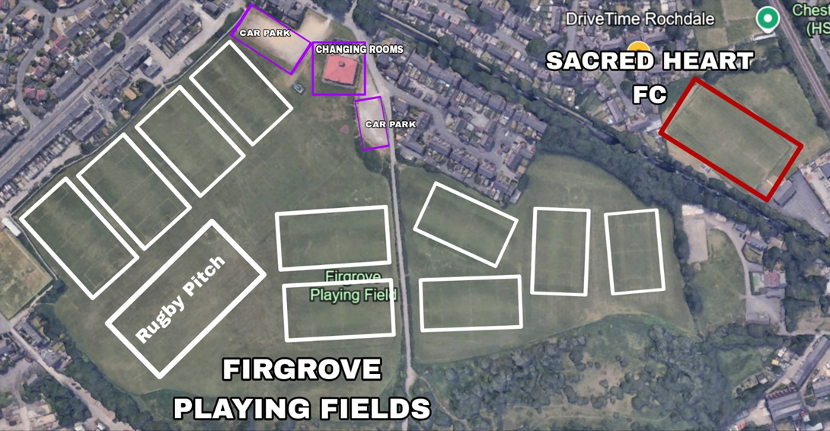

Removal of the rough land at the back of the goals at our current ground would not impact on our ability to facilitate growth in our youth teams or our open age teams if promotion is gained.
With the local facilities on our doorstep and the support of Rochdale council we are more than confident that all future football development plans can be accommodated.
Below is a basic outline of our planned development within our six-year development plan. The below will conform with the expected standards to achieve step six football should promotion be gain to the NWCL.
The required standard for step six can be achieved without the land (marked A ) and removal of this land would not impact on any further promotion ambitions.

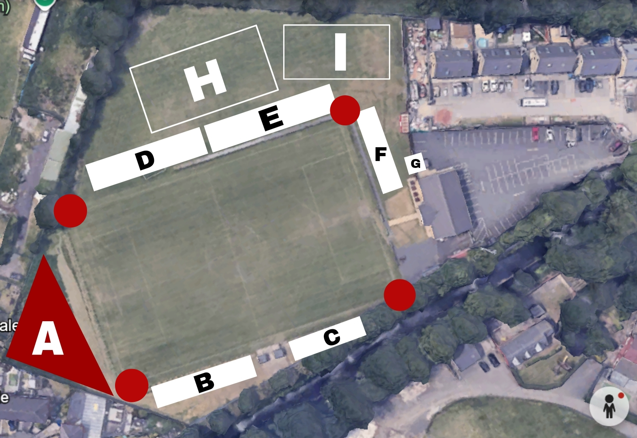

- Land For Planning
- Hard Standing
- Hard Standing
- Covered Terrece
- Covered Seating
- Hard Standing
- Turnstiles
- Possible small youth pitch development
- Possible small youth pitch development
RED DOTS – Indicate Flood lighting

Our Club development plan is focussed on developing the ground to the standards required by the FA to enable us to play in the first instance step six.
Without the sale of the rough land, we will not be able to fund the development required and in doing so this will have a detrimental effect of the club’s ability to grow.
By competing at a higher level, we believe we can raise the profile of the club with the benefits of making the club more attractive to investors and sponsors.
Further investment will only help in helping us achieve our goal of becoming an all-inclusive club that can cater for boys and girls within our local community of all ages and ability.

- Ball Strike Assessment
When the club built the current two storey club house it quickly became apparent for the need to put in some anti ball strike netting behind the goal to prevent the ball hitting the windows.
With this in mind we have looked into the cost of erecting similar netting at the end of the pitch that the proposed land is at.
Early indications are that the cost will be between £3000 and £4000 for professional grade netting and posts.
The quote attached is an indication of what we will put in.
At 6m high and running the entire length of the playing surface behind the goals this will massively negate the chances of the ball striking any objects beyond if not illuminate it all together.
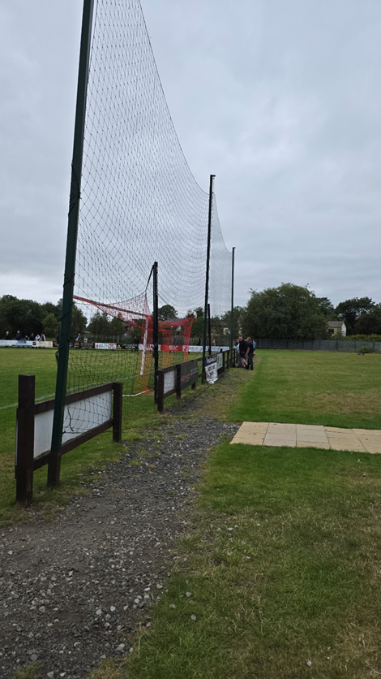
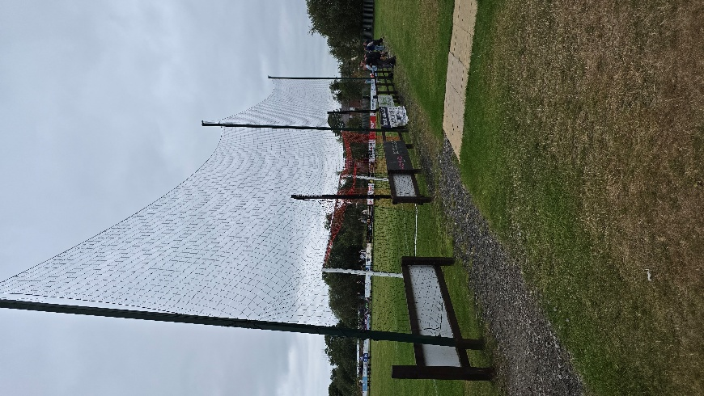
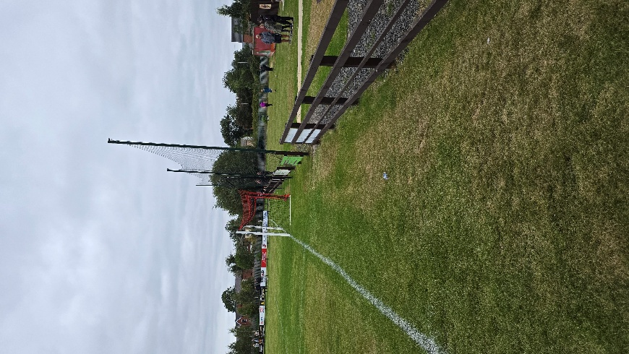

Above: The clubs current ball strike preventing netting
We find the current netting to be very affective in preventing ball strikes to the club house building. Since its erection the club has incurred no damage to the building and has incurred no extra costs.

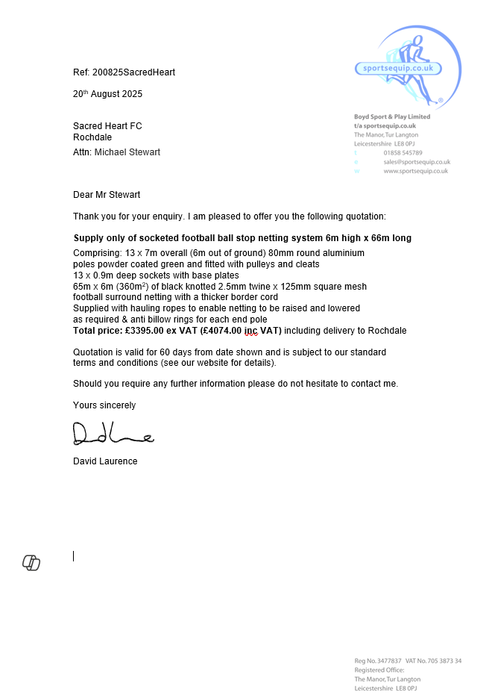

IN SUMMARY
Sacred Heart football club believe that we have put forward compelling rationale and answers to the concerns from both Sport England and the Football foundation.
Football Foundation:

• Although the application site is not used for any football purposes as the moment the adjacent pitch is used by an FA affiliated club.
SHFC: This is correct we are an Affiliated club and accredited club and proud to be so and we are working hard to gain or three-star accreditation. The land is not used for anything at the moment as we believe it is dangerous to do so in its current state.

• Rochdale Sacred Heart FC is made up of 11 teams across Rochdale Sacred Heart Seniors and Rochdale Sacred Heart Tigers (Youth). Lancashire FA data from the 22/23 season shows that 1 youth and 2 adult teams use this site.
The Rochdale Sacred Heart first team play at the site and are members of the Manchester Football League Premier Division – a regional feeder league to the NLS.
SHFC: This is no longer correct we at present only have three teams, Two adults’ teams and a Youth Team. Only the two adult teams currently play on the ground the youth team play on the local council pitches at Firgrove.

• Site is too small to facilitate laying out a football pitch but could provide supporting facilities should the club progress beyond their current National League System position to Step 6. For example, for spectators/a stand.
SHFC: We agree that the site is too small for a pitch and agree that in the future it could be used for spectators but the cost of levelling and laying hardstanding is not within the reach of the club at present. We also have able space on the three other sides of the ground to accommodate sporting facilities such as stands that will meet the requirements for step six.

• There is a realistic possibility that the club could progress to Step 6 given their regional feeder league.
SHFC: We agree and hope we do progress, and the sale of this land will make that prospect more achievable than if we cannot sell it,

• The new changing pavilion at the site was built in 2015, and FF (via Football Stadia Improvement Fund, now Premier League Stadium Fund) contributed £50k towards the project. At the time, this scheme could fund clubs at step 7/ regional feeder league.
SHFC: This is correct, and the facility is fantastic way above the current level the club plays at and is one of our plus points in gaining step six.

• The FF will need assurances that the proposal will not compromise the future potential ambitions of the club.
SHFC: We believe we have demonstrated and can assure the FF that this proposal will not compromise our future ambitions, but it will lay the path for us to do exactly that. We want and deserve to be at a higher level and to get the ground to the required standard sale of this land and the injection of funds that will create to be fully put back into the facilities of the club can only help and not hinder.

• A Noise Risk and Ball Strike Risk Assessment would be required.
SHFC: We have provided the noise risk assessment and detailed plans for the ball strike netting that we will guarantee will be installed.

Sport England’s position

Given the above, the latest submitted information does not alter Sport England’s previous objection, and we need to maintain a statutory objection to the application because currently the proposal will use playing field land which could be used by the Rochdale Sacred Heart should they gain promotion to Step 6 of the NLS and which would be compromised by the proposal.

A noise assessment has been submitted and as Sport England do have the expertise to comment on its content, we defer to the Local Authority’s noise expert and their view of the suitability of any proposed mitigation.

As such, it is not considered to accord with any of the exceptions to Sport England’s Playing Fields Policy or paragraphs 104 or 200 of the NPPF. Potential to overcome the statutory objection

• Demonstration that the proposal can be accommodated without prejudice to the future promotion ambitions of Rochdale Sacred Heart FC.
SHFC: We believe we have fully demonstrated that we can accommodate this proposal without prejudice to the future promotion ambitions of the club. In fact, we believe not supporting this proposal will hinder out ability for promotion in terms of financing the ground improvements we need to do to hit the criteria for step 6.

Nothing will stop our ambitions to get to step six. We have won the Manchester League Premier Division title numerous times including last season and have never had the opportunity for promotion to step six due to the ground not meeting the criteria.

This proposal will help along with grants solve that problem so we can finally reach our goal of step six football.

We have seen teams from our division and below us achieve step six and we draw inspiration from them.

Having said that and even though this is such an important issue to us this proposal will help us being able to grow or club on the field with girls and boys youth teams. To provide local children of all abilities to be able to access affordable football at a club with the right ethics and standards to give them the chance to improve is as important to us.

• Provision of a ball strike assessment on the basis of the above.
SHFC: We have provided details of our existing ball strike netting and shown confirmation via quotes of the high standard and quality of new netting which we commit to purchasing if this proposal is approved. The new netting is more than adequate to prevent ball strikes on a single dwelling which would be smaller than our current club house.

We thank you for your time and welcome any feedback or suggestions you may have and we ask for your support in approving this proposal by withdrawing your objection.

Thank You
Michael Stewart
(Club Secretary)
6 belle Isle Av
Whitworth
Rochdale
OL12 8TJ
078969185632
SecretarySHFC@Mail.com

